Tools for investing with a gender perspective

April 13th 2021

Tools for investing with a gender perspective

Table of Contents

Introductionc 3
Investing with a gender perspective 5
Self-diagnosis of the gender approach in business management 16
Tools for Investing with a Gender Perspective 28
Lens 1. Women in leadership 29
Tool 1. Path towards integrated and inclusive governance 30
Tool 2. Inspiring women's experiences. 34
Tool 3. Test for an integrated governance with a gender perspective 35
Tool 4. Plan of action for gender equality 44
Tool 5. Manifesto for gender equality 64
Tool 6. Agile leadership: Culture of innovation with a gender perspective 67
Lens 2. Equality in the workplace 75
Tool 1. Guide to promote gender equality and diversity in organizational culture 76
Tool 2. Staff induction policy 89
Tool 3. Compensation and benefits policy 93
Tool 4. Telework policy 97
Tool 5. Wellness wheel 102
Tool 6. Analysis of gender gaps in talent management 107
Lens 3. Products and services that benefit women and girls 111
Tool 1. Creation and development of products with a gender perspective 112
Tool 2. In-depth interview 117
Tool 3. Person’s Path of understanding 127
Tool 4. Empathy map 140
Tool 5. From findings to opportunities 148
Tool 6. Storyboard: The product idea 162
Tool 7. Three-dimensional balance 172
Tool 8. Prioritization of ideas 184
Tool 9. Role play 193
Tool 10. Usability test 197
Tool 11. Elevator pitch: The sales pitch 205
Tool 12. Data analytics for my company 209
Tool 13. Analysis of gender gaps in the sales process 218
Tool 14. Customer segmentation 223
Tool 15. A/B testing: Product testing 229
Lens 4. Equality in the value chain and advocacy practices 237
Tool 1. Guide to creating an inclusive value chain 238
Tool 2. Inclusive and non-sexist language for companies 245
Tool 3. Inclusive and non-sexist digital communication for companies 249

Tools for investing with a gender perspective

Introduction

Investing with a gender perspective is a growing practice that consists of using capital to simultaneously produce financial returns and promote gender equality, and that has the potential to increase economic development, change the way we do business and contribute to gender equality, as it addresses the gaps that persist for women in the job market and when owning companies

The Ilu Women's Empowerment Fund, a joint effort from Pro Mujer and Deetken Impact, is generating investments with a gender focus in high-impact businesses in Latin America and the Caribbean (LAC). Its portfolio encompasses financial institutions that provide integrated services to low-income women, companies dedicated to renewable energy, affordable housing, and social enterprises that incorporate gender strategies into their business models. Within this framework, and with the support of the United States Agency for International Development (USAID), a toolbox of actions with a gender approach is made available to companies to promote gender equality as an investment strategy

Promoting gender equality in job markets is not only the right thing to do, it is also the smart thing to do, for governments and companies alike. For this reason, the tools created through the alliance between Pro Mujer and Deetken Impact, and with the support of USAID, are aimed to all companies, in the region, interested in taking advantage of the potential of gender equality to improve their competitiveness, their market value and its work environment, as well as becoming key actors to achieve the egalitarian and inclusive society that we so badly need.

This document shows an overview of the different experiences lived by women and men in the economic field. It exposes what it is and what are the benefits of investing with a gender perspective and of establishing diversity and inclusive action in companies, therefore, it can be of interest and use for the government and civil society, whose roles are essential to achieve gender equality and women’s economic empowerment.

To make the toolbox user-friendly and responsive to the priorities of the companies, it begins with a self-diagnosis of the gender approach in business management. The purpose of which is to identify the integration status of mechanisms put in place by the organizations to promote gender equality, regarding the four lenses of investment with a gender perspective: women in leadership positions, equality in the workplace, products and services that benefit women and girls, equality in the value chain and incidence. This should be the first step in using the tools and planning strategies based on them.

Once the self-diagnosis has been carried out, companies will have the support of tools specially generated to address these four aspects, with which they will be able design and implement their own strategies. In this way, they will be able to make informed decisions to put their commitment to gender equality into practice. The tools include various strategies to activate gender equality in the organization's processes, and cover governance, leadership, human resources management, product development, data analysis, relationship with the value chain and communication inside and outside the company.

From Pro Mujer, Deetken Impact and USAID, we hope the tools to are useful for companies, as we are convinced that gender equality has multiple benefits, including the full exercise of women's and girl’s rights, the strengthening and growth of businesses and the economic development of the countries, and that to obtain these gains we need everyone’s participation.

Investing with a gender perspective

Investing with a gender perspective is using capital to generate financial returns and promote gender equality simultaneously. A growing trend that has shown that investment can be a powerful tool to promote gender equality because, by incorporating gender analysis in investments, it is ensured that capital generates financial returns and positive results for women and girls.

Put into practice, it means investing in companies that meet any of these characteristics:
- Businesses owned by women.
- Offer products and services designed to meet the specific needs of women and girls or those that intentionally seek to close gender gaps.
- Promote gender equality in the workplace.

For a business to be considered as owned by women, it must meet several criteria:
- One or more women own at least 51% of the business.
- One or more women perform the day-to-day management of business operations and make long-term decisions.
- Do not depend on other companies that are not owned by women.

To know that capital is being used with a gender perspective, investors can identify and evaluate businesses that promote gender equality, while generating solid investments, through four lenses: women in leadership positions, equality in the workplace, products and services that benefit women and girls, equality in the value chain and advocacy practices.

Investing lenses with a gender perspective
Women in leadership positions | Equality in the workplace | Products and services that benefit women and girls | Equality in the value chain and advocacy practices
The presence of women in leadership positions is essential to close gender gaps, as it allows companies to have better policies and programs to promote equality and evaluate their diversity and inclusion. | Actions in favor of gender equality in the organization, which improve the environment and productivity, such as equal pay, co-responsibility work life/personal life and prevention of workplace violence. | Consideration of the impact of the company on the lives of women and girls. It allows analyzing whether they are taken into account in the company's mission, understanding their needs as consumers and developing markets focused on them. | Generation of business opportunities for businesses led by women. Collaboration with civil society, local or global organizations and companies that work for equality and the empowerment of women.
Source: Pro Mujer (2020). A gender lens investing scorecard helps investors and companies advance gender equality. Available on: https://promujer.org/2020/08/26/gender-lens-investing-scorecard-helps-investors-companies-advance-gender-equality/

In the 2019 report “Panorama of impact investing with a gender perspective in Latin America”, Value for Women points out that, although this movement has attracted the attention of investors worldwide, interest in the region is still incipient. Through interviews with 48 investment companies that finance businesses with social impact, they identified the following challenges:
- Data on investment with a gender perspective and gender equality in the impact investing sector are scarce.
- Of the total venture capital and investment capital funds, 6% are placed in companies owned by women and 94% in companies owned by men.
- Although they consider investing with a gender perspective, the organizations that want to do so lack strategies. They require advice to do so and to develop the capacities of the companies in their portfolio to produce business models with a gender perspective.
- Half of the investors use sex-disaggregated indicators, but do not measure the gender impact of their actions, for example, whether access to employment or financial services increases income or the empowerment of women.

GLI LATAM Forum
Pro Mujer held the first Gender Lens Investing Forum in Latin America (GLI LATAM Forum) in 2020 in Mexico. Over 120 leaders, experts and investors participated, sharing experiences, good practices and innovative solutions to promote investment with a gender perspective in the region. The conclusions can be found here:
https://promujer.org/content/uploads/2020/03/GLI_CONCLUSIONS_FINAL.pdf

Investing with a gender perspective in Latin America
Pro Mujer’s Ilu Women's Empowerment Fund (https://promujer.org) and Deetken Impact (https://deetkenimpact.com/) is the result of innovation and joint work between an impact asset manager and a leading organization in the empowerment of women, which has made it possible to generate investment with a gender focus in high-impact businesses in LAC. Its portfolio encompasses institutions that provide integrated services (including finance, technical assistance, health, and educational loans) to low-income women, as well as renewable energy providers, affordable housing, and social enterprises that incorporate gender strategies into their business models.
https://promujer.org/ilu-womens-empowerment-fund/

VIWALA is an impact investor focused on closing the gender gap, operating in Mexico. It offers credit and access to workshops and a mentoring network to companies led by women or that benefit women or girls. It is distinguished by adjusting the payments to the monthly sales of the company, not requiring credit history and having flexible terms. It also finances companies that have a positive impact on the lives of other discriminated groups.
https://viwala.com/

Trusts Instituted in Relation to Agriculture (FIRA, by its acronym in Spanish), Mexican government’s agency, placed in 2020 the first Social Gender Bond in the country's debt market with the collaboration of private banks, to improve the financial inclusion of women from the rural sector. The financing from the issuance is granted exclusively to projects led by women, through productive loans for working capital and acquisition of capital goods.
https://fira.gob.mx/SalaPrensaXml/Pdf?pdfNum=447

The participation of women in the economic sector

Although gender equality is a right enshrined in the legislation of LAC countries and in international treaties, it is far from being a reality. This concept should translate into equal opportunities to participate with an economic life and in general in all aspects of society, which is not currently the case. The Global Gender Gap Report 2020, the World Economic Forum predicts that in LAC it will take 59 more years for women and men to have equal access to resources and opportunities.

Certainly, the presence of women in the economic sphere has been increasing: 53% of Latin American women aged 15 and over participate in the labor market. However, when comparing the participation rate of men in the region, which is 77%, we find that the gap amounts to 24%. This is one of the most relevant inequalities between one and the other, either in terms of opportunities to access the labor market or in the decision to participate in it. Adding the fact that women wanting to enter the labor market is not enough for it to happen, since they face numerous obstacles.

For women, having a job means facing multiple barriers every day, including wage inequality, occupational segregation, workplace violence and conflicts to reconcile work and personal life. For every hour worked, they receive an income 17% lower than that of men of the same age, education, presence of girls and boys in their homes, rural condition and type of work. The wage gap persists despite significant developments such as more years of education among women than among men.

Occupational segregation is, largely, the product of gender stereotypes, that is, what is considered culturally appropriate for women and men, which limits the activities and identities of both, and it is even more obvious when observing their higher education choices. Women are 60% of those who graduate from college, but they represent only 30% in science, technology, engineering and mathematics studies (also known as STEM), high productivity careers and higher salaries.

According to data from the World Bank, only 30% of formal small and medium-sized enterprises (SMEs) worldwide are owned or led by a woman, and as entrepreneurs they do not exceed 15% of the economic participation. The region is the second globally with the highest record of business failures by women. Lack of access to financing is the first obstacle to continue their ventures, in addition to access to market opportunities and training. In developing countries, 70% of women are unable to obtain the capital they need to start a business, from either a financial institution or another source, resulting in a deficit of $300 billion.

An extremely important impediment for women to undertake or participate in the labor market is the overload of responsibilities and time allocated to maintaining their household, caring for childrem, the elderly, sick or disabled, as it limits opportunities to integrate and stay in a job, access decision-making positions or have time to take business training or get a loan.

Women in LAC dedicate more than twice as many hours to domestic and care work as men: 38 and 16 hours a week, respectively. They need to play their part: in housework, in their own care, and in caring for other people. The valuation of domestic and care work is one of the biggest obstacles to overcome in order to achieve gender equality, as it continues to be one of the least recognized contributions of women to the household economy and to the country's growth. UN Women has called this burden the highest hidden tax applied for women, both in economic and time consuming terms.

Challenges for the economic empowerment of women

Women face particular challenges in each lens of gender-focused investment.

Women in leadership positions
In the region, women occupy only 8% of the seats on company boards of directors and 1.2% of companies have a woman as CEO (Chief Executive Officer). Only 4.2% of the executive board of the businesses operating in the stock market are women and only 7.2% of all the executive positions belong to them. When they reach a decision-making position, it is usually in support roles, for example, human resources managers. In the public administration, it is no different: they represent a fifth of senior management positions.

Although there are proven benefits for companies that promote women's participation in leadership - for example, a third of women on the board of directors is 18% more likely to improve business results – Latin America has the highest proportion of companies without women in executive positions (22%). To change this situation, eliminating stereotypes and taking advantage of women’s talents, organizations need affirmative actions and programs that promote their presence both in management positions and on the board of directors.

Equality in the workplace
Workplaces often reproduce the discrimination that exists in society. Stereotypes about the type of tasks, positions and responsibilities that women and men should have are taken into consideration by human resources management, which limits the opportunities for them to occupy decision-making positions, it hinders co-responsibility between work and personal life and allows organizational cultures where violence and sexual harassment are allowed.

Ten of the 32 countries examined in LAC by the World Bank's “Women, Business and the Law 2021” study do not have laws that prohibit sexual harassment at work. And even with legislation in this regard, it is a problem for women: in Mexico, 27% of female workers have experienced violence in the workplace; and in Chile a survey found that 28% of women and 13% of men have suffered workplace sexual harassment. On the other hand, in addition to affecting the rights and safety of women, sexual harassment has economic costs for companies and countries. A study by the International Labor Organization (ILO) and UN Women estimates that between 0.5% and 3.5% of the Gross Domestic Product (GDP) is lost due to the detriment in productivity resulting from workplace sexual harassment in Argentina, Brazil, Chile, Costa Rica, Jamaica and Uruguay.

Companies have the responsibility to maintain violence and discrimination free environments, with equal opportunities and treatment, and can contribute significantly to the redistribution of domestic and care work that women perform on a daily basis. Implementing actions of co-responsibility to help balance work life and personal life. Taking into account the diversity of households, encouraging the professional trajectory of their employees, not punishing them for the time spent on maternity leave and care, not extending the working hours outside the hours previously established, offer breastfeeding rooms and granting longer and non-transferable paternity leave are practices that establish a ground floor to recognize unpaid work and favor its equal distribution, with which It contributes to removing the barriers that women face to enter and remain in the labor market.

Products and services that benefit women and girls
In the same way that companies reproduce gender-based discrimination in the work place, the design of their products and services usually take up the ideas that exist in society about the behaviors and attitudes that are considered appropriate for women and men. This can transmit gender stereotypes to the strategies they use to reach their market.

Although there is still a long way to go, the LAC countries are - compared to the rest of the world - the ones that have experienced the greatest growth in the participation of women in the labor force during the last two decades, which has implications for their purchasing power and savings. Understanding the interests and expectations of women is good both for companies and for bridging gender gaps. For example, in the region there are still small differences in women's access to mobile phones and internet. The main barriers they state are affordability, safety, and skills. Knowing and satisfying these needs represents an opportunity to reach an unserved market, at the same time that it can have benefits for them in terms of connectivity and access to all kinds of information.

Businesses are required to focus their attention on women and girls as consumers, and consider them in the design, production and marketing of products and services, without reinforcing gender stereotypes, without contributing to the increase in inequality gaps and without charging more for it.

Equality in the value chain and advocacy practices
Women-led companies have less access to finance and capital, have trouble establishing strong business networks, tend to resort to informal contacts, and face stereotypes about sectors and responsibilities in which they should work. This places them at a disadvantage to integrate into the value chains of large companies, there is evidence that they receive less than 1% of the amount that large companies invest in supplies and services, therefore, specially designed actions are required to ensure that women and men have the same opportunities to participate in this aspect and access commercial opportunities.

Simultaneously with the implementation of measures to promote gender equality with their business network, suppliers and distributors, companies have the possibility of taking advantage of their sphere of influence to promote gender equality. For this reason, inclusive and non-sexist communication is a valuable strategy to interact with its value chain and with society in general, since it expresses the potential of words and images to promote equality and recognizes the diversity of people who make up the organization and its market.

In addition to the inequalities that women face because of their gender, it is necessary to take into account that different forms of discrimination can be superimposed on the same person or group. Ethnic or national origin, skin color, culture, age, disability, religion, physical appearance, immigration status, sexual orientation, marital status, are variables that affect the lives of women and men differently. Although there are shared problems, rural, indigenous, disabled, young, elderly, and migrant women have specific needs that require particular attention.

Women facing the COVID crisis

Added to the inequality that women already face in the economic sphere are the consequences of the COVID-19 pandemic. The Economic Commission for Latin America and the Caribbean has estimated that the effects will represent a setback for women of more than 10 years in their participation in the labor market. It has also identified that the sectors with the highest risk of job loss, such as commerce, manufacturing, tourism and paid domestic work, concentrate 57% of the employment of women in Latin America and 54% in the Caribbean, putting them in greater vulnerability to the repercussions of the economic crisis.

In relation to the effects on women-owned businesses, a survey conducted by WeConnect International in April 2020 found that 95% of female entrepreneurs interviewed in LAC saw a significant reduction in their sales or income. As challenges derived from this scenario, 88% identified that they will need to postpone or have their tax obligations forgiven, 58% support with staff salaries, 55% extensions in their credits or forgiveness of fines by banks and 22% financed health care by the government.

Added to the economic impact is the overload of unpaid work and care that women face, now exacerbated, which even forces them to exclude themselves from the labor market. During quarantine, over 70% of the fathers think that they are dividing the housework equally with their partner, but only 44% of the mothers say the same. One in four women in high-level positions is considering reducing their job responsibilities, taking leave or leaving the workforce altogether, due to the excessive housework and care load that they are required to perform. These decisions, not necessarily made willingly, have consequences on the empowerment and autonomy of women, as well as on the growth of countries and their post-pandemic recovery.

Women are in a situation of greater vulnerability to the economic effects linked to the coronavirus due to the gender inequalities that already existed. Taking immediate action to achieve equal opportunities in the labor market, which counteracts the job loss that women are experiencing and which is greater compared to that of men, would add $13 trillion to the global GDP in 2030. The integration of gender approach in the response to the virus is a matter not only of justice, but also of economic interest.

To mitigate the deepening of gender inequalities and avoid inadmissible setbacks of the rights already achieved, international organizations have issued recommendations so that government and companies actions, in the face of the crisis, incorporate the gender perspective:
- Involve women in national and local decision-making, especially those who, due to their work or family context, have received a greater impact.
- Avoid reproducing gender stereotypes about the importance of income: when faced with the decision to lay off employees, managers should not assume that men are the economic support of a family as an excuse to lay off female personnel.
- Send a clear message from the head of the company so that all staff recognize the burden generated by the context of the pandemic.
- Guarantee women's access to financial services and products, without reproducing gender bias in risk assessment, credit history, guarantees and interest rates.
- Ensure an inclusive public-private dialogue so that business women express their concerns and priorities regarding new projects of public policies.
- Prepare gender budgets to ensure adequate measures in fiscal stimulus packages, and that governments understand their collective impact on equality.
- Understand the economic and fiscal investment in care services that allows and contributes to productive work and social life. Incorporate care as a public and private matter, for women and men.
- Systematically collect and analyze data detailed by sex, age, and other significant variables in health, economics, and politics, to ensure a response that includes women and girls.

Benefits of gender equality

The economic autonomy of women is an indispensable factor in closing gender gaps and achieving equality. Additionally, it is important to recognize and take advantage of the role it plays as a development promoter, both for countries and companies. Given the need to resort to innovation and use all available resources to mitigate the effects of the pandemic, it is appropriate to expose the potential it has as a strategy to strengthen economic growth, productivity and people's well-being.

Various studies have provided evidence that greater economic participation by women will bring economic growth to countries. A 2018 International Monetary Fund research indicates that employment discrimination against women is economically inefficient and costly even for men, and that a greater participation of women would benefit their income. In countries with the greatest differences in labor market participation between women and men, closing gender gaps would add an average of 35% to the GDP.

An analysis carried out by the Inter-American Development Bank in 2019, found that the implementation of measures to close gender gaps in the labor market would contribute to increasing the GDP of Argentina, Chile, Colombia, Mexico and Peru between 4% and 22%. They analyzed the impact of two types of policies: the generation of care services for children that allow their mothers to integrate into paid work, and the implementation of affirmative actions to eliminate discrimination against women and promote their productivity.

Increase in GDP per capita generated by the implementation of policies.
Country | Day Care Service | Affirmative Actions to Eliminate Discrimination Against Women and Promote Productivity
Argentina | 5.0% | 22.0%
Chile | 4.6% | 13.0%
Colombia | 3.9% | 13.4%
Mexico | 6.4% | 14.0%
Peru | 5.0% | 20.5%

The Mexican Institute for Competitiveness (IMCO, by its acronym in Spanish) offers another example of this: it has estimated that, if the economic participation rate of women in that country increased 11% by 2030 and went from 45% to 56% (average participation in the countries of the Organization for Economic Cooperation and Development), the country would achieve a 15% increase in its GDP.

Regarding benefits for companies, ILO conducted a study with over 4,800 companies in LAC, to see if they had increased their results due to the initiatives on gender equality: 6 out of 10 answered yes. Of these, 58% said they had improved their profitability and productivity, 54% improved their talent pool and retention, 51% improved their creativity, innovation and openness, 52% improved their reputation and 29% increased the ability to read interest and consumer demand. All these examples show that equality and inclusion are good for people, companies and countries.

Tools for action

Gender equality is a human right, it leads to economic prosperity and can become a strategy for companies to be more competitive, increase their market value and improve their work environment. Investing with a gender perspective is a practice to achieve these benefits while improving the quality of life of women, so it is necessary to encourage its expansion in the LAC, so that companies and society, particularly those women and girls, can take advantage of such benefits.

There are impact investor organizations that have pointed to the lack of women-led companies ready for investment as a challenge to invest with a gender perspective. It is true that in the region entrepreneurship among women needs to be promoted along with the consolidation of their companies, since there are multiple obstacles for them, but it is also true that this resistance may be due to biases or ignorance on the subject, since, together with women-owned businesses, it is possible to invest in companies with products and services designed to meet the needs of women and girls or that promote gender equality in the workplace.

Given the effects of the crisis caused by the COVID pandemic, which have added to the discrimination and disadvantages that women already experienced, public policies for recovery must contemplate a renewed approach, incorporating the gender perspective as an essential component of the crisis response and using its transformative power to close inequality gaps. If this view is not included across the board in economic policies, there is a risk of losing the progress made up until now. Faced with this challenge, investment with a gender perspective is revealed as a strategic action to achieve two essential objectives for sustainable development: economic growth and gender equality.

To extend the use of investment with a gender perspective, guidance aimed at companies is required, which helps them become potential candidates to receive this type of capital that seeks to generate financial returns and promote gender equality simultaneously. It is necessary to work outside and inside the company, with tools that support organizations to overcome the obstacles set out above and transfer the concept of equal opportunities and treatment to their operations.

For this reason, this toolbox for investment with a gender perspective is made available to all LAC companies, which contains strategies that will allow them to implement actionable practical solutions that respond to the particular needs detected through a self-diagnosis and that promote gender equality in the organization's processes, structured in the four proposed lenses:
- Promote women to be present in leadership positions and the board of directors, through professional growth and access to decision-making.
- Establish assessment measurements of equality and inclusion in the workplace, which ensure spaces that are free from discrimination and violence, with joint responsibility between work and personal life, which allow the integral development of employees.
- Identify the needs of women and girls to offer products and services that free of stereotypes, which contribute to achieving equality and closing gender gaps.
- Promote actions with supplier and distribution organizations to turn the value chain into an alliance in favor of gender equality and communicate internally and externally using inclusive language and images.

Self-diagnosis of the gender approach in business management

As part of its commitment to the empowerment of women, Pro Mujer has partnered with Deekten Impact to create the Ilu Women's Empowerment Fund, with the purpose of investing in a diversified portfolio of high-impact businesses in Latin America and the Caribbean (LAC) that incorporate gender strategies into their business models. To identify these companies, which show leadership and commitment to promote gender equality and the economic empowerment of women, four lenses have been defined for investment with a gender perspective: women in leadership; equality in the workplace; products and services that benefit women and girls; and equality in the value chain and advocacy practices.

In this framework, while recognizing the importance of having instruments that guide investors who wish to join this growing trend, Pro Mujer has identified the need to generate tools that guide companies to become promoters of equality and potential candidates to receive investment with a gender perspective. This is how, with the support of the United States Agency for International Development (USAID), which shares the solid commitment to women's economic empowerment, that Pro Mujer makes available to companies in LAC a box of actionable tools with a gender perspective, to promote gender equality as a smart investment strategy.

Among the instruments that make up the toolbox is the "Self-diagnosis of the gender approach in business management", which purpose is to measure the situation of companies with respect to the integration of practices in favor of gender equality, in relation to the four lenses of investment with a gender perspective mentioned, as a first step in the use of the tools and the design of strategies based on them.

The self-diagnosis is made up of a series of questions that allow companies to examine themselves and obtain a description of their situation at three levels (basic, intermediate and advanced) regarding the implementation of practices to incorporate the gender approach in internal and external operations. In this way, they will be able to make informed decisions regarding the actions needed to advance their commitment in favor of gender equality. Based on the results and with the support of tools specially designed to address the four lenses, the company will be able to prioritize the design and implementation of its strategies in favor of equality.

Answering the questions presented below implies having the information and knowledge of various areas that make up the company, since gender equality must be a cross-cutting principle in business management. For its completion, it is recommended to form a team that has the ability to identify the situation of the company in the four lenses for investment with a gender perspective, in which the self-diagnosis is organized:
- Lens 1. Women in leadership
- Lens 2. Equality in the workplace
- Lens 3. Products and services that benefit women and girls
- Lens 4. Equality in the value chain and advocacy practices

Self-diagnosis of the gender approach in business management

Instructions: The self-diagnosis consists of a section of general company data plus 22 questions planted according to the four lenses for investment with a gender perspective, which have 3 possible answers: “a”, “b” and "C". Please select the option that best describes the situation of the company.

General information about the company

Country: __________
Sector: __________
Total amount of staff members: __________
Women: __________ Men: __________

Lens 1. Women in leadership

- Does the company have a commitment to gender equality and the incorporation of a gender perspective in business management?

- a) Yes, the company has made a commitment to gender equality:
- The mission or objective of the company is explicitly intended to promote gender equality.
- The company recognizes its responsibility to its staff and to society.
- We issued a formal written and signed document an shared it with all the company.
- There is mention to a strategy or action plan to put the commitment into practice.
- All the staff is aware of such commitment.

- b) The company is moving towards it:
- The company intends to promote gender equality.
- The company recognizes its responsibility to its staff and to society.
- The company has taken sporadic actions ion order to put the commitment into practice.
- Such commitment is not written and not all staff is aware of it.

- c) Right now, the company has not adopted the commitment to gender equality, but it is interested in learning about it.

- Does the company have an action plan from an inclusive governance approach with a gender perspective?

- a) Yes, the company has a strategy or action plan:
- A strategic document was prepared that guides the organization's actions both internally and externally.
- It considers guidelines for the design of policies on equality in the four lenses for investment with a gender perspective: women in leadership, equality in the workplace, products and services that benefit women and girls and equality in the value chain and advocacy practices.
- The plan includes goals, objectives and indicators detailed by sex, as well as the actions to be carried out, who is responsible for implementing them, and deadlines are defined for carrying them out.
- The sustainability of the action plan was ensured through the allocation of material resources, personnel, and a budget.
- Senior management and all the staff are aware.

- b) The company is moving towards it:
- There is a document that describes the action plan and responsible parties.
- Considers guidelines for the design of policies on equality in one of the four lenses for investment with a gender perspective: women in leadership, equality in the workplace, products and services that benefit women and girls and equality in the value chain and advocacy practices.
- The allocation of material and personnel resources is variable.
- Awareness among the staff is variable.

- c) Right now, the company does not have an action plan, but is interested in learning more information on the subject.

- Does the company have a diagnosis about the participation of women within the company?

- a) Yes, the company has an analysis on this subject:
- We gathered gender sensible information regarding the composition of the personnel in all levels and positions.
- We sought to identify gaps between women and men, as well as areas in which women were underrepresented or overrepresented.
- The analysis included the study of the obstacles that women face in accessing decision-making positions.
- The results were used to design strategies to promote the participation of women in decision-making and management positions.

- b) The company is moving towards it:
- We gathered gender sensible information regarding the composition of the personnel in all levels and positions.
- We sought to identify gaps between women and men, as well as areas in which women were underrepresented or overrepresented.
- We implemented some actions taking the diagnosis under consideration.

- c) Right now, the company has not prepared such a diagnosis, but it is interested in learning more information on the subject.

- Is the business owned by women (at least 51% of the business is owned by one or more women and they are the decision makers)?

- a) Yes, the company is owned by women.

- b) Only 30% of the company is in the hands of one or more women.

- c) The company is not owned by women.

- Is the amount of women on the board of directors proportional to the amount of men (50% of the members are women and 50% are men)?

- a) Yes, the company's board of directors is proportional.

- b) We are moving towards it:
- The proportion of women on the board of directors is 30%.

- c) Right now, the board of directors is made up only of men or the proportion of women is less than 30%.

- Is the number of women in management positions proportional to the number of men?

- a) Yes, the number of women and men in management positions is proportional

- b) We are moving towards it:
- Only 30% of management positions are held by women.

- c) Right now, the management positions are made up only of men or the proportion of women is less than 30%.

- Has the company implemented concrete actions to promote the participation and presence of women in decision-making and management positions?

- a) Yes, the company carries out actions to promote the leadership and participation of women:
- The company has a training or mentoring program with a gender perspective for the development of women’s skills and competencies as leaders.
- One of the objectives is to train women with the necessary skills to occupy decision-making positions.
- There is a target regarding the proportion of women in leadership positions that eventually seek to achieve parity.

- b) We are moving towards it:
- The company has a training or mentoring program with a gender focus for the development of women’s skills and competencies as leaders.
- One of the objectives is to train women with the necessary skills to occupy decision-making positions, but we have not set any goals.

- c) Right now, the company has not implemented any actions, but it is interested in learning more information on the subject.

- Can you find the implementation of affirmative actions among the organization's strategies to promote the participation and presence of women in decision-making and managerial positions?

- a) Yes, the company has implemented affirmative actions:
- We established a 50% equal proportion for the presence of women in decision-making and managerial positions.
- We take special measures for promotions such as having candidates in all shortlists, privileging the promotion of women when there is a tie or exclusive positions directed at women.

- b) We are moving towards it:
- We established a minimum of 30% for the presence of women in decision-making and managerial positions.
- We take special measures for promotions such as having candidates in all shortlists, privileging the promotion of women when there is a tie or exclusive positions directed at women.

- c) Right now, the organization does not incorporate affirmative actions as one of its strategies, but it is interested in learning more information on the subject.

Lens 2. Equality in the workplace

- Does the organization promote human resource management with equal opportunities?

- a) Yes, the company has human resource management processes that guarantee equal opportunities:
- Human resources staff have been trained on gender equality.
- There are standardized processes to carry out the recruitment, selection, induction, training, evaluation and promotion of personnel, which ensure equal opportunities.
- The processes are made known to all staff.
- There are profiles according to the technical, professional and training competencies necessary for the position.
- Job offers are designed with inclusive and non-sexist language and images.
- Gender equality training is available for all staff and is offered within working hours.
- The balanced participation of women is encouraged at all levels and areas of the company.

- b) We are moving towards it:
- There are standardized processes to carry out the recruitment, selection, induction, training, evaluation and promotion of personnel, which ensure equal opportunities.
- Human resources staff and general staff have received training on gender equality from time to time.
- The processes are made known to all staff.

- c) Right now, the organization does not have such processes, but it is interested in learning more information on the subject.

- Does the company use data analysis tools for equal opportunity human resource management?

- a) Yes, the company makes use of these tools:
- Personnel gender-sensitive information is recorded according to the level of position, area or department.
- Indicators are established to allow monitoring.
- The data is strategically analyzed using a business intelligence tool.
- Through this tool, reports are generated, which are used for decision-making and as support to promote the balanced participation of women at all levels and areas of the company.

- b) We are moving towards it:
- Personnel gender-sensitive information is recorded according to the level of position, area or department.
- Some business intelligence tool is used for the registration and analysis of personnel information.

- c) Right now, the company does not use such tools, but it is interested in learning more information on the subject.

- Has the company implemented measures in favor of co-responsibility between work and personal life?

- a) Yes, the organization has implemented measures in favor of co-responsibility:
- There are formal processes to access the co-responsibility measures.
- The actions are aimed at all staff and it is guaranteed that they are aware of them.
- The measures were designed with a gender perspective, in order not to reinforce stereotypes and roles.
- We monitor the number of people who use the measures of co-responsibility by sex and their comparison between women and men.
- The company has implemented various measures, for example: teleworking, flexible hours, compressed work weeks, paid and unpaid leave, lactation room, daycare services.
- The working hours are respected.
- Maternity and paternity leave is offered for a period greater than that established in the legislation, either for birth or adoption, and the breastfeeding period is respected.

- b) We are moving towards it:
- There are measures in favor of co- responsibility and they are aimed at all staff.
- Some of the measures that have been implemented are subject to the decision of the hierarchical superior, since they are not in formal processes.
- The working hours are respected.
- Maternity and paternity leave is offered, as well as the breastfeeding period, in accordance with current legislation.

- c) Right now, the organization has not implemented measures in favor of co-responsibility, but it is interested in learning more information on the subject.

- Has the company implemented actions to guarantee the principle of equal pay?

- a) Yes, the company implements actions to guarantee equal pay:
- A comparative analysis was carried out on the remuneration received by women and men according to the positions they occupy, to determine whether or not there is wage inequality.
- The analysis is carried out in a systematic way and the results are used to implement actions that correct the wage inequality.
- There are salary scales according to the objective characteristics of each of the positions.
- Compensations, as well as raises, are established in a documented and transparent process.
- There is a record of sex-disaggregated data and level of positions according to remuneration.

- b) We are moving towards it:
- There are salary scales.
- Compensations, as well as raises, are established in a documented process.
- There is a record of sex-disaggregated data and level of positions according to remuneration.

- c) Right now, the company does not have actions that guarantee equal pay, but it is interested in learning more information on the subject.

- Does the company have a mechanism to prevent and address workplace violence, including sexual harassment and stalking?

- a) Yes, the company has a prevention and address mechanism:
- Zero tolerance is one of the values of the company.
- There is a protocol to prevent and address workplace violence, including sexual harassment and stalking.
- Confidentiality is guaranteed and there is no retaliation.
- Consider events outside the workplace and include telecommuting.
- The personnel related to the design and implementation of the protocol are trained in gender equality, workplace violence, and sexual harassment and stalking.
- Staff were trained on the subject and are familiar with the protocol.

- b) We are moving towards it:
- There is a mechanism to prevent and address workplace violence, including sexual harassment and stalking.
- Confidentiality is guaranteed and there is no retaliation.
- Consider events outside the workplace and include telecommuting.
- The mechanism is not well known among the staff.

- c) Right now, the company does not have a mechanism to address such problems, but is interested in learning more information on the subject.

- Does the company carry out a measurement of the work environment with a gender perspective?

- a) Yes, the company performs a measurement of the staff's perception of the work environment:
- A work climate diagnosis with a gender perspective is carried out, applied to the personnel, using comparable variables, carried out in a systematic, periodic and confidential manner.
- Gender gaps and different opinions between women and men are identified.
- The results are used to address the problems identified and guide the action plan to implement measures to promote gender equality in the workplace.

- b) We are moving towards it:
- A work climate diagnosis with a gender perspective is carried out, applied to personnel in a confidential manner.
- Gender gaps and different opinions between women and men are identified.
- The results are used to address the problems identified.

- c) Right now, the company does not analyze the work environment with a gender perspective, but it is interested in learning more information on the subject.

- Does the company have any badge or certification regarding gender equality?

- a) Yes, the company has a badge or certification obtained by an external institution:
- UN Women Empowerment Principles (WEPs) and the Global Pact.
- National seal or gender equality seal from the United Nations Development Program.
- International certification.
- Another badge or certification.

- b) We are moving towards it:
- The company had a certification, but it is no longer valid.
- The company is in the process of obtaining some certification regarding gender equality.
- The organization has been included in a ranking of companies for its commitment and practices in matters of gender equality.

- c) Right now, the company does not have a badge or certification, but is interested in learning more information on the subject.

Lens 3. Products and services that benefit women and girls

- Does the company develop or provide any product or service with a gender perspective aimed at women or girls?

- a) Yes, the company has a product or service develops with a gender perspective:
- We guarantee the participation of women in all work teams that are involved in the process of a product or service.
- Staff receive awareness and training on equality.
- Strategies are used to know the needs, interests and expectations of women and girls, and the information is used for the development of the product or service.
- We investigate the context and inequalities related to the product or service experienced by women and girls.
- Objectives are established to contribute to reducing the gaps between women and men through the product or service.

- b) We are moving towards it:
- We guarantee the participation of women in all work teams that are involved in the process of a product or service.
- We investigate the context and inequalities related to the product or service experienced by women and girls.

- c) Right now, the company does not develop a product or service with this characteristic, but it is interested in learning more information on the subject.

- Does the company implement an inclusive marketing strategy for its products or services?

- a) Yes, the company implements an inclusive marketing strategy:
- The company works actively to position and identify itself as a promoter of gender equality.
- Gender equality and inclusion are reflected in photographs, videos, illustrations, icons, colors and all material used to advertise products or services.
- We guarantee the representation of women, in all their diversity, without stereotypes and gender roles.
- The language used is inclusive and non-sexist.
- Advertising campaigns actively seek to contribute to a cultural change in favor of gender equality.
- We document all elements used in the strategy.

- b) We are moving towards it:
- The company intends to position and identify itself as a promoter of gender equality.
- Gender equality and inclusion are reflected in photographs, videos, illustrations, icons, colors and all material used to advertise products or services.
- We promote the representation of women, in all their diversity, without stereotypes and gender roles.
- The language used is inclusive and non-sexist.

- c) Right now, the company does not have such strategy, but is interested in learning more information on the subject.

- Does the company monitor the use and impact of its products or services on women or girls?

- a) Yes, the company tracks the use and impact:
- Research is conducted on the user experience that women have and the feedback is used in the product or service.
- The benefit of the product or service on reducing inequality gaps in women and girls is analyzed.
- We study about how accessible and affordable the product or service is for the market segment of women and girls, to which they are directed.
- We analyze the achievement of objectives.
- The gender approach is incorporated in the analysis of the sales and loyalty processes.

- b) We are moving towards it:
- Research is conducted on the user experience that women have and the feedback is used in the product or service.
- We study about how accessible and affordable the product or service is for the segment of women and girls, to which they are directed.
- We analyze the achievement ofobjectives.
- There are sales and loyalty processes.

- c) Right now, the organization does not carry out such monitoring, but is interested in learning more information on the subject.

Lens 4. Equality in the value chain and advocacy practices

- Has a gender-based diagnosis been carried out on supplier and distribution companies?

- a) Yes, the company has carried out a diagnosis on the supplier and distribution companies:
- A mapping was carried out of the organizations that comply: they are owned by women; offer products and services designed to meet the specific needs of women and girls or that intentionally seek to close gender gaps; and those that promote gender equality in the workplace.
- We identified the amount and value of the contracts with these companies.
- There is information on the ownership of the companies that are left out of the competitions and on the obstacles that prevent women's companies from participating in the value chain.

- b) We are moving towards it:
- There is a registry of companies owned by women.
- We identified the amount and value of the contracts with these companies.

- c) Right now, the company has not made such diagnosis, but is interested in learning more information on the subject.

- Does the company implement actions to incorporate the gender perspective in the value chain?

- a) Yes, the company implements actions:
- Women-owned supplier and distribution companies are valued positively, offering products and services designed to meet the specific needs of women and girls or intentionally seeking to close gender gaps; and those that promote gender equality in the workplace.
- Objectives related to the increase of contracts and the value of these with said companies are established.
- It collaborates with associations of businesswomen and organizations that promote purchases with a gender perspective.
- There are special measures for companies that meet equality and inclusion criteria: indicators, goals, scores, tiebreaker criteria, detection of needs, training.
- Feedback is given to companies that do not win a tender.

- b) We are moving towards it:
- Women-owned supplier and distribution companies are valued positively, offering products and services designed to meet the specific needs of women and girls or intentionally seeking to close gender gaps; and those that promote gender equality in the workplace.
- Objectives related to the increase of contracts and the value of these with said companies are established.
- There are special measures for companies that meet equality and inclusion criteria, for example: indicators, goals, scores, tiebreaker criteria, detection of needs, training.

- c) Right now, the company is not taking actions to incorporate the gender perspective in the value chain, but it is interested in learning more information on the subject.

- Does the company implement an inclusive communication policy?

- a) Yes, the company has an inclusive communication policy:
- Inclusive communication is a transversal axis in the organization.
- The criteria for inclusive communication is documented in a manual for the use of all staff.
- Staff are trained in inclusive and non-sexist language and images.
- Inclusive communication is applied inside and outside the organization in all its documents and images.

- b) We are moving towards it:
- The criteria for inclusive communication is documented in a manual for the use of all staff.
- Staff are trained in inclusive and non-sexist language and images.
- The use of inclusive communication inside and outside is recurrent but not transversal.

- c) Right now, the company does not have an inclusive communication policy, but it is interested in learning more information on the subject.

- Do you have a corporate social responsibility program or actions that promote gender equality?

- a) Yes, the company has a program or actions in this area:
- The company is a promoter of equal opportunities, as well as the benefits and potential that women-owned companies have.
- Suppliers and distributors have been invited to make a commitment to equality.
- It collaborates with key actors such as civil society, government, international organizations to promote gender equality.
- Actions are carried out that seek to close gender gaps directly with the population.

- b) We are moving towards it:
- The company is a promoter of equal opportunities, as well as the benefits and potential that women-owned companies have.
- Suppliers and distributors have been invited to make a commitment to equality.
- Actions are carried out that seek to close gender gaps directly with the population.

- c) Right now, the company is not carrying out actions in terms of social responsibility that promote gender equality, but it is interested in learning more information on the subject.

Self-diagnosis results

According to the score obtained in the questions, a total is calculated per lens, so that the company identifies its specific situation in each of them. The results outline three possible levels of advancement (basic, intermediate or advanced) and recommend visiting the tools for each lens. The purpose of this exercise is for the organization to be able to make informed decisions to prioritize actions and put its commitment to gender equality into practice.

- Self-diagnosis can be done on the Tools for Investing with a Gender Perspective page.

Tools for Investing with a Gender Perspective

The tools presented below are innovative strategies to incorporate gender equality in the processes of the company and have been created by specialists in the subject. As can be seen in the table, which shows them according to the investment lens with a gender perspective that they seek to serve, they contemplate key areas for the business such as governance, leadership, talent management, product development, data analysis, value chain and communication, so that the perspective of equality and inclusion is present in the internal and external operations of the company.

Tools for Investing with a Gender Perspective
Lens 1 | Lens 2 | Lens 3 | Lens 4
Women in leadership | Equality in the workplace | Products and services that benefit women and girls | Equality in the value chain and advocacy practices
- Path towards integrated and inclusive governance.  - Inspiring women's experiences.  - Test for an integrated governance with a gender perspective.  - Plan of action for gender equality.  - Manifesto for gender equality.  - Agile leadership: Culture of innovation with a gender perspective. | - Guide to promote gender equality and diversity in organizational culture  - Staff induction policy  - Compensation and benefits policy  - Telework policy  - Wellness wheel  - Analysis of gender gaps in talent management | - Creation and development of products with a gender perspective  - In-depth interview  - Person’s Path of understanding  - Empathy map  - From findings to opportunities  - Storyboard: The product idea  - Three-dimensional balance  - Prioritization of ideas  - Role play  - Usability test  - Elevator pitch: The sales pitch  - Data analytics for my company  - Analysis of gender gaps in the sales process  - Customer segmentation  - A/B testing: Product testing | - Guide to creating an inclusive value chain  - Inclusive and non-sexist language for companies  - Inclusive and non-sexist digital communication for companies

Lens 1. Women in leadership

This lens addresses the presence of women in leadership positions and the adoption of an inclusive governance approach with a gender perspective, as this allows companies to have better policies and programs to promote equality and close gender gaps, as well as assess their diversity and inclusion.

It is composed of the following tools:
- Path towards integrated and inclusive governance.
- Inspiring women's experiences.
- Test for an integrated governance with a gender perspective.
- Plan of action for gender equality.
- Manifesto for gender equality.
- Agile leadership: Culture of innovation with a gender perspective.
.

Tool 1. Path towards integrated and inclusive governance

The lowest representation of women on boards of directors is found in Central and South America, and in Asia, according to the result of a survey conducted in 2015 by the Women Corporate Directors Foundation that analyzed 4,000 women and men who are directors in companies based in 60 countries

The countries have voluntary initiatives; they have established goals, in addition to quotas required by law, to promote gender equality. Securities market institutions publish codes of governance that require the public be informed of the composition of the board of directors by gender, and in the event that diversity objectives have not been achieved the the reasons for it. Information related to gender equality is being included among environmental, social and governance (ESG) data that are analyzed by investors as part of their investment and risk analysis. Various studies indicate that equality has an impact on results, whether in terms of creating value for shareholders, retention of talent or innovation.

During the last ten years, all these initiatives and trends have generated an increase in the number of women in leadership positions and in their participation in different governance bodies within a company. However, the incorporation of a single woman (or more than one, but without this implying a real participation) has not been enough to reap the benefits offered by gender equality.

To achieve a true impact on the economy, on people and communities, companies - large market players and drivers of change - have a long way to go in order to embrace the key role they are called upon to play in compliance of the Sustainable Development Goals (SDGs), in particular SDG 5 (Gender equality), SDG 8 (Decent work and economic growth) and SDG 10 (Reduction of inequalities).

They need to become aware of the importance of developing a culture of inclusion and equality with a gender perspective at all levels, and how this cultural change coincides with the progress proposed by the SDGs. According to a report from the International Labor Organization (ILO), gender equality is the nexus of all the interconnected and interdependent SDGs, since decent work for all women contributes not only to alleviating poverty but also to achieving education, peace and security.

Cultural change: the sole commitment of senior management is not enough, since, in order to generate culture, this commitment must be present in the leaders, middle managers and staff of the entire company, as well as in suppliers and throughout the value chain, and in the corporate community as a whole, since it is in the day-to-day and behind each action that the 2030 Agenda for Sustainable Development effectively materializes.

Gender equality is included in various international standards, conventions, declarations and principles, such as those detailed in the table below, which shows the evolution of women's human rights and their acceptance by international organizations. This shows that gender equality is at the center of human rights and fundamental freedoms enshrined in international human rights regulations, in order to improve the lives of women by giving visibility and legal enforceability of their rights.

The legal standards contained in these international instruments undoubtedly serve as the basis for companies to establish, strengthen and legitimize their actions related gender equality. They serve as a guide for companies to align and base their businesses on these standards.

“International instruments and frameworks, along with national laws, are crucial to the realization of gender equality at work and the economic empowerment of women, but alone they cannot address all the gaps that contribute to inequality. No legislative solution could work without meaningful and proactive action from the social partners and, in particular, from employers in the public and private sectors. Correcting gender inequalities is an end in itself, but also a fundamental means to achieve broader economic growth and social justice.”

Achieving gender equality is essential for sustainable, fair and equitable development. In this regard, the resolution approving the 2030 Agenda for Sustainable Development expressly states: “The achievement of gender equality and the empowerment of women and girls will decisively contribute to progress regarding all objectives and goals. It is not possible to realize the full human potential and achieve sustainable development if half of humanity continues to be denied the full enjoyment of its human rights and opportunities”. And even more, it highlights that: "The systematic incorporation of a gender perspective in the implementation of the Agenda is crucial."

International standards, declarations and principles on gender equality:

Women’s human rights
- Universal Declaration of Human Rights (1948)
- Convention on the Elimination of All Forms of Discrimination against Women (1979)
- Declaration on the Elimination of Violence Against Women (1993)
- Inter-American Convention on the Prevention, Punishment and Eradication of Violence against Women [Belém do Pará Convention] (1994)
- United Nations Beijing Declaration and Platform for Action (1995).
- Gender Equality Policy (2010)
- Sustainable Development Goals: SDG 5.
- United Nations Guiding Principles on Business and Human Rights (2011)

Labor
ILO Conventions and Recommendations:
- C111 - Discrimination (Employment and Occupation) Convention (1958)
- C100 - Equal Remuneration Convention (1951)
- C156 - Workers with Family Responsibilities Convention (1981)
- R165 - Workers with Family Responsibilities Recommendation (1981)
- C183 - Maternity Protection Convention (2000)
- C190 - Violence and Harassment Convention (2019)

Integrated and inclusive governance

Governance in a company fulfills vital functions -both in its internal and external sphere- for the creation of sustainable value, and this includes that it achieves gender equality in a comprehensive manner in all its areas and levels. Therefore, this first tool on integrated and inclusive governance aims to:
- Understand the fundamental and strategic role of governance, in the guidance and operation of a company.
- Know how the new global demands and trends in sustainable development impact on the governance of companies, causing it to evolve towards a capitalism of interest groups, which requires to incorporate the environmental, social and governance factors (ESG) in management and decision-making.
- The role of governance in incorporating the gender perspective.

In the following link you can access the video in which these central issues are addressed: https://drive.google.com/file/d/1cxjldbU8dgpdYDaInES2hazUxGIyuRqJ/view

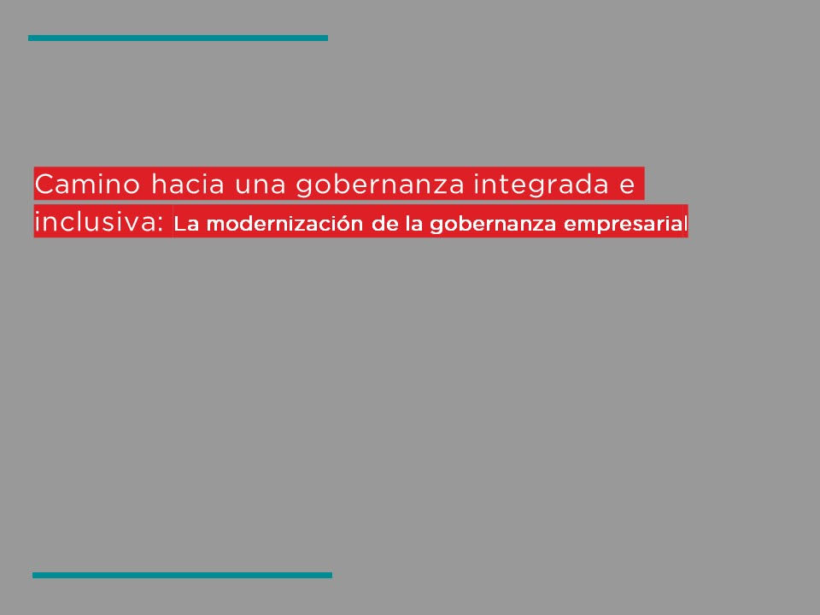

Tool 2. Inspiring women's experiences.

Knowing other experiences gives us access to different perspectives, knowledge and information that inspire and provide new ideas or ways to get involved and implement actions to incorporate the gender approach in companies. We invite you to listen to a 20-minute podcast that contains an interesting conversation with the experts Isela Constantini and Beatriz Pellizzari, in which they share their views and experience on the following topics:
- How diversity adds value to organizations and makes them grow.
- The role of companies in promoting equality with a gender perspective.
- Barriers that contribute to the persistence of the gender gap in the labor market today.
- What are the development bases to be a leading woman.
- The value of programs that establish objectives to achieve gender equality.

Isela Constantini has a degree in communications. She began her career at General Motors Brazil in 1998, where she held various roles, becoming president and CEO of General Motors Argentina, Uruguay and Paraguay, becoming the first woman to hold that position. In 2013 she was recognized among the 50 most powerful women in the business world by Fortune magazine and in 2015 she was voted CEO of the year. In 2016 Isela became president of Aerolineas Argentinas. In 2018, she was awarded a Konex-Diploma of Merit Award from the Konex Foundation for her career as an executive in the industry in the last decade in Argentina. She is the author of the book "A leader in you, leadership management and motivation." | Beatriz Pellizzari is a consultant for companies, governments and civil society organizations accompanying strategic processes and inclusive value chains. She directed the PAR Foundation, was an advisor at CONADIS (National Council for the Development and Inclusion of People with Disabilities, by its acronym in Spanish), founded La Usina, an organization that generates work for people with disabilities from a network of productive enterprises that employ them. redACTIVOS -a social company that was born from La Usina to give work to people with disabilities by promoting conscious consumption (people) and inclusive purchases (companies) -, and Libertate -a social consultancy specialized in accompanying the transformation of organizations with a focus on diversity, disability and gender perspective.

Click here to listen to the podcast: [enlace pendiente]

Tool 3. Test for an integrated governance with a gender perspective

The expansion of the concept of value (economic, social and environmental), based on the integration of sustainability and environmental, social and governance factors (ESG) in the business and activities of the company, directly impacts its governance. As the concept of value broadens, so does the consideration of stakeholders for whom value can be created. Diversity and gender equality is an ESG factor, which can be considered as a social or governance factor.

Addressing the gender perspective necessarily requires the commitment and involvement of the board of directors. Due to its functions and role, the board of directors - as the maximum administrator of the company - can define behaviors and objectives to achieve gender equality in a transversal way, integrating this perspective in all areas and levels of the company.

The purpose of this tool is to evaluate, in a transversal manner, the governance state situation of companies with respect to the adoption of the gender perspective in their different interventions -in the internal and external sphere- and with their different groups of interest. It is aimed mainly at medium-sized companies in Latin America and the Caribbean, but it can be carried out by all organizations interested in knowing their situation in this regard.

Its use is a first step to assess, understand and identify a baseline of the company's situation in terms of gender in order to advance in the design of an action plan and to implement integrated governance with gender perspective.

What does the test consist of?

Based on 58 questions grouped under 5 axes: inclusive governance with a gender perspective; women in leadership; equality in the workplace; products and services; and value chain, with 3 answer options: yes / no / I am considering it. These questions are the means to generate conversations, to mark a north regarding actions that could be addressed in a company to promote gender equality.

The results of the test for an integrated governance with a gender perspective seek to facilitate a better understanding of the state of integration in the different scopes of its role. This, in turn, will make it possible to identify where the strengths and weaknesses of each governance are found and the actions that are decided to prioritize can be reviewed, improved or deepened, according to the characteristics of each company, industry, sector, size and the economic, social and cultural context of the country where it is operating.

Recommendations for application

- Its use by the higher management of the company and working with the leaders of the different areas: contrasting responses from the different departments or people, and generating spaces for conversation to share visions or opinions on the topics that the tool approaches.
- Have the necessary information and/or documentation that the different areas of the company may have to provide to answer the questions.
- To advance on a path of continuous improvement, it is advisable to complete the test annually to measure the improvements and communicate the progress achieved.

The participation of the board of directors, senior positions and middle managers of the company promote:
- Transversal commitment to achieve gender equality.
- Appropriation and good execution of the strategy to achieve the planned goals.
- The culture of gender equality.

Test for integrated governance with a gender perspective

Instructions: Based on the following table, answer the test questions by selecting the appropriate option. When finished, add the results in each axis or section according to the score assigned to the answer options.

Answer options: | Yes | No | I am considering it
Score: | 2 points | 0 points | 1 point

Inclusive governance with a gender perspective
The board of directors:
1 | Have you defined responsibilities, roles and resources?
2 | Have you foreseen the promotion of a culture of gender equality on your agenda?
3 | Have you adopted a formal commitment or declaration of principles to achieve gender equality in the company?
4 | Have you carried out evaluations and diagnoses to know the situation regarding gender equality in the company?
5 | Have you developed a gender equality strategy and implementation plan?
6 | Have you established specific, measurable objectives on gender equality that serve as a guide for the execution of the strategy, its evaluation, monitoring and measurement?
7 | Do you find it necessary the specific assignment of a member of the board of directors, or specific area (committee or similar body), to lead the gender equality strategy?
8 | Do you allocate resources (economic, non-economic or material) for the development of the gender equality strategy?
9 | Do you promote the existence of communication channels - internal and external - to publicize actions with a gender perspective?
10 | Do you report internally and publicly on your actions and objectives in terms of gender equality?
11 | Do you recognize the existence of gender roles and stereotypes within the company?
Results

Women in leadership
The board of directors:
1 | Did you set specific and measurable goals to promote gender equality in decision-making positions?
2 | Do you address in any way the socio-cultural, structural and organizational barriers that make it difficult to meet these objectives?
3 | Did you assume a quantitative goal to promote the participation and presence of women on the board of directors?
4 | Did you assume a quantitative goal to promote the participation and presence of women in middle management and higher positions?
5 | Did you issue guidelines so that existing policies integrate guidelines to equalize the composition of men and women on the board of directors in the face of appointment, succession or retirement processes?
6 | Did you issue guidelines so that existing policies integrate guidelines to equalize the composition of men and women in middle management and senior positions in the face of appointment, succession or retirement processes?
7 | Do you address the need to build capacities to promote women in decision-making positions and/or middle management and senior positions (for example, providing resources for training programs or talent production)?
8 | Do you promote the empowerment of women for their promotion in decision-making positions, middle management and senior positions (for example, providing resources for sponsorship, mentoring and/or coaching programs, establishing open communication channels free of gender prejudice)?
9 | Do you periodically evaluate, monitor and measure - directly or indirectly - the application and progress of the objectives adopted to achieve gender equality?
10 | Do you generate economic, non-economic and material incentives for middle managers and senior managers to achieve gender equality (for example, performance evaluations aligned with the fulfillment of actions to achieve equality)?
 | Results

Equality in the workplace
The board of directors:
1 | Did you set specific and measurable goals to promote equality in the workplace?
2 | Did you provide guidelines so that existing policies contain provisions to promote equal opportunities and integrate the gender perspective in recruitment, selection and hiring processes?
3 | Did you provide guidelines so that existing policies contain provisions to promote equal opportunities and integrate a gender perspective in talent development and promotion programs?
4 | Did you issue guidelines so that salary and/or compensation and/or incentive policies are transparent and ensure equal pay for equal work?
5 | Did you provide guidelines on prevention and address of harassment and violence in the workplace that promote healthy working conditions for staff?
6 | Did you provide guidelines to promote a work and personal life balance?
7 | Do you promote the existence of anonymous and secure reporting channels?
8 | Do you allocate resources for the education and training on gender and gender violence for the staff?
9 | Do you periodically evaluate, monitor and measure - directly or indirectly - the application and progress of the objectives adopted to achieve equality in the workplace?
10 | Do you generate economic, non-economic and material incentives for middle and senior managers to achieve gender equality (for example, performance evaluations aligned with the fulfillment of actions to achieve equality in the workplace)?
 | Results

Products and services
The board of directors:
1 | Do you consider what is different in the way women and men use your products or services, or the effects they have on their lives?
2 | Did you set specific and measurable objectives to promote gender equality through the products and services that the company markets (for example, to transform gender roles and unequal power relations between women and men, have a favorable impact on the equal opportunities and treatment between women and men)?
3 | Did you provide guidelines for conducting gender impact evaluations in the processes and systems for creating your products or services?
4 | Did you provide guidelines for conducting gender impact assessments in the development of your products or services in order to promote the elimination of gender stereotypes?
5 | Did you provide guidelines for conducting gender impact evaluations in the sales processes of your products or services?
6 | Did you provide guidelines for policies to incorporate the gender perspective in the creation, development and sale of products and services?
7 | Did you provide guidelines for communication and marketing policies to incorporate the gender perspective?
8 | Do you evaluate the gap between what men and women pay for the same type of product?
9 | Do you allocate resources to training and education programs on gender equality for the areas of creation, development and sales of products or services (for example, product design with a gender perspective, gender stereotypes in design and how to avoid them)?
10 | Do you periodically evaluate, monitor and measure -directly or indirectly- the application and progress of the objectives adopted for the incorporation of the gender approach in the creation, development and commercialization of the company's products and services?
11 | Do you generate economic and non-economic incentives for middle and senior managers to incorporate a gender perspective in the creation, development and marketing of the company's products and services?
 | Results

Value Chain
The board of directors:
1 | Do you think you can promote gender equality through the company's supply and value chain?
2 | Did you set specific and measurable goals to promote inclusion and gender equality throughout the company's supply and value chain?
3 | Did you provide guidelines for conducting gender impact assessments in your supply and value chains?
4 | Did you issue guidelines so that policies with supplier companies contain an approach that promotes inclusion and equality with a gender perspective?
5 | Did you issue guidelines so that policies with distribution companies contain an approach that promotes inclusion and equality with a gender perspective?
6 | Do you know what percentage of purchases were made from companies that are majority owned by women?
7 | Do you know what the policies of the most significant supplier companies are regarding gender equality?
8 | Do you know what are the policies of the most significant distribution companies regarding gender equality?
9 | Did you provide guidelines to encourage stakeholders in the supply and value chains (suppliers, customers and others) to adopt a commitment to achieve gender equality?
10 | Did you issue guidelines for the granting of incentives, benefits and/or preferences in favor of supplier companies whose majority is owned by women?
11 | Do you provide guidelines to incorporate due diligence processes in procurement and contracting processes, integrating criteria with a gender perspective?
12 | Do you provide guidelines to incorporate communication practices to promote the gender perspective in the value chain?
13 | Do you allocate resources to carry out actions that aim to achieve gender equality in the population of the territory where the company operates?
14 | Do you allocate resources for training and development of the supply and value chain on gender equality and gender-based violence?
15 | Do you periodically evaluate, monitor and measure -directly or indirectly- the application and progress of the objectives adopted for the incorporation of the gender perspective in the company's value and supply chains?
16 | Do you generate economic and non-economic incentives for middle and senior managers to incorporate a gender perspective in the company's value and supply chains?
 | Results

The score obtained in each section will be translated into three possible actions:

Axis | Score | Suggestion
Inclusive governance with a gender perspective / Products and services | 1 to 7 points | Commit
 | 8 to 11 points | Plan strategically
 | 12 to 22 points | Deepen impact

Axis | Score | Suggestion
Women in leadership / Equality in the workplace | 1 to 6 points | Commit
 | 7 to 10 points | Plan strategically
 | 11 to 20 points | Deepen impact

Axis | Score | Suggestion
Value chain | 1 to 10 points | Commit
 | 11 to 16 points | Plan strategically
 | 17 to 32 points | Deepen impact

At the end of the 5 sections, a table will be integrated into which the scores and indications obtained can be entered to facilitate the understanding of the diagnosis in each axis addressed. We suggest the following template:

Axis | Score | Suggestion
Inclusive governance with a gender perspective | Enter the obtained score | Enter the suggestiong related to the obtained score
Women in leadership
Equality in the workplace
Products and services
Value chain

Here is an example of what the table would look like once it contains the results in terms of score and the corresponding suggestion. The information presented by the company must reflect the results obtained.

Axis | Score | Suggestion
Inclusive governance with a gender perspective | 1 to 7 points | Commit
Women in leadership | 7 to 10 points | Plan strategically
Equality in the workplace | 11 to 20 points | Deepen impact
Products and services | 8 to 11 points | Plan strategically
Value chain | 17 to 32 points | Deepen impact

- Once the test is completed, we recommend continuing with the tool 4. Plan of action for gender equality from lens 1, which proposes to advance in the development of a plan.

Tool 4. Plan of action for gender equality

This tool aims to prepare a roadmap with suggested steps to the company's board of directors on how to plan, develop and implement integrated governance with a gender perspective.

- For the use of this tool, it is suggested to have carried out the 3. Test for an integrated governance with a gender perspective, described in lens 1.

In such a way that the board of directors, prior to carrying out the action plan (hereinafter "Plan"), has achieved the following:
- Make visible the main and strategic role it plays -together with senior positions- in the development of inclusive governance with a gender perspective.
- Show that addressing this issue requires a long-term strategic vision, in order to achieve the objectives and changes that are necessary in a company.
- Understand the opportunities for a company to work in an inclusive organizational culture with a gender perspective.

With this tool, we expect that the boards of directors of the companies will have the design of a guide to prioritize integrated governance with a gender perspective and determine what actions they must take to establish the objectives and strategic goals of gender equality and how to implement said Actions.

Design stage of the plan

- Commitment: materialize the will to formally incorporate the gender perspective.
- Evaluation and diagnosis: evaluation and understanding of the situation of the company in terms of gender.
- Design strategy and action plan: combination of commitment + concrete actions to achieve gender equality. Establish objectives that contribute to the strategy. Set specific and measurable objectives (KPI).
- Policy Design: prepare the policies that establish the way in which these objectives will be implemented.
- Evaluate, monitor and measure: establish the way to evaluate the objectives, their form of management and monitoring. Establish metrics to evaluate if the defined objectives were met, the selected KPIs must be reviewed and updated. This also implies proactively supervising by establishing mechanisms, processes and systems to supervise the execution of the strategy, both internally and externally.
- Report and communicate: communicate the actions that are promoted in gender matters to achieve equality. When disclosing information, it must be adjusted, coherent and transparent in relation to the actions that were actually carried out, so as not to cause reputational damage to the company.

However, for the execution of the pertinent actions in each of these stages it is important to adopt a proactive approach for continuous improvement, for which it will be necessary to:
- Allocate resources (material, economic and non-economic) to achieve the goals;
- Assign responsibilities;
- Set deadlines (short, medium and long term);
- Train and sensitize; AND
- Create communication channels to publicize the actions with a gender perspective that are carried out.

The stages of the Plan and a description of each of them are detailed below. Likewise, the information presented includes what actions the board of directors could take at each stage and how to implement the actions through different practical recommendations, which consist of suggestions or advice.

Commitment

Who? The board of directors.

Actions

- Declare the will to promote gender equality, for example, through a declaration of principles or manifesto.
- Appoint a person who is a member of the board of directors as responsible for the commitment and the Plan and ensure that gender equality is incorporated into the agenda of the board of directors (in its debates and decision-making).
- Form a gender committee with people from different areas of the company to be the ones who lead the actions of the Plan.
- Identify leading people on the subject who are an example for the rest of the organization or who can fulfill specific roles:
  - Sponsor: person of high hierarchical level, without distinction of sex, who uses their influence in an intentional and positive way to promote gender equality in the company. Collaborate in its external and internal exposure;
  - Mentor: the mentoring role is performed by a person who, due to her knowledge or experience, shows intentions to accompany and guide women. With her career path, she provides advice, feedback and coaching that serve as a guide for women to advance in their careers, adopt a leading position and an attitude that favors their own change; Y
  - Champion: the role is played by a leading person who is visibly committed to gender equality in the workplace, promotes change, showing conviction and the need for change to occur to achieve gender parity.

- We suggest consulting tool 5. Manifesto for gender equality, from lens 1, which aims to exemplify a corporate manifesto model.

Practical recommendations

To formalize and specify the commitment assumed, the board of directors may:
- Join the United Nations Global Pact/World Pact Network:
https://www.pactomundial.org/wp-content/uploads/2018/02/Flyer-New-Strategy-GC-2018_20180126.pdf
- Adhere to the Women's Empowerment Principles (WEPs):
https://www.unwomen.org/~/media/Headquarters/Attachments/Sections/Partnerships/Businesses%20and%20Foundations/Women-s-Empowerment-Principles_2011_es%20pdf.pdf
- Adopt the badge of gender equality existing in your country or the badge for gender equality of the United Nations Development Program:
http://americalatinagenera.org/newsite/index.php/es/iniciativas-destacadas/empresas-por-la-igualdad.
- The board of directors may also incorporate the following guidelines into the company's values, corporate mission, declaration of principles and corporate strategy: “Gender equality is recognized as an essential value in the company's strategy to guarantee competitiveness and sustainability. of the business ”,“ Equal opportunities and treatment will be a transversal axis in all the policies, procedures and practices of the company ”.
- Collaborate with civil society, governments and international cooperation organizations to promote gender equality.

Assessment and diagnosis

Who? Initially: the board of directors with an active participation of middle management and senior positions. Periodically: the board of directors with middle and senior managers and leaders of the different areas of the company.

The evaluation and diagnosis is divided into two stages: evaluation and initial diagnosis; and periodic evaluation and diagnosis.

Actions

- Set up focus groups with the aim of gathering aspirations, expectations and meeting the needs of women within the company.
- Conduct individual interviews with staff in relation to gender equality.
- Incorporate questions related to the subject in the work environment surveys, in order to have the opinion of women and men regarding issues such as the development opportunities they see or not in the company, salary parity, promotion processes , and all this from a gender perspective.
- Incorporate questions regarding reasons for leaving in the graduation interviews, in order to identify causes such as lack of opportunities or career blockages due to gender issues..
- Carry out a market study on the actions that other companies have in this area, to learn about different business practices and promote and guarantee gender equality.

Practical recommendations

- To carry out the evaluation and diagnosis stage and identify the situation and / or baseline, it is recommended to answer the 3. Test for an integrated governance with a gender perspective, described in lens 1.

In this matter you can also consult:
- WEP Gender Business Tool, from the Principles for the Empowerment of Women: https://weps-gapanalysis.org/
- The Bloomberg Gender Equality Index (GEI): https://www.bloomberg.com/gei
- PAR ranking: https://par.aequales.com/

Strategy and execution plan

Who? The board of directors, senior managers and middle managers, in order to ensure the transversality of the strategy. It is also recommended that the designated responsible persons involve the management areas of the company.

Actions

- Determine key performance indicators (KPI) for each of the sub-axes that are detailed in the policy stage.
- Indicate the timetable for reaching the KPIs, when and how often their progress will be evaluated.
- Determine the resources for the implementation and review of progress in the aforementioned measures.
- Assign responsibilities for the application of the above measures and for monitoring the different areas of the company.
- Define prevention and protection measures associated with the issue, as well as sanctions for non-compliance.
- Establish evaluation and monitoring methodology.
- Determine reporting and communication mechanisms.
- Instruct the development of guidelines, guides, protocols, policies or codes of conduct that translate the leadership's commitment to a business culture that promotes gender equality.

Practical recommendations

- Identify within the company the existence of unconscious biases in order to be aware of them and thus be able to work on reducing gender gaps in the workplace. For more information we recommend: https://drive.google.com/file/d/18sMY7J0xg6Xpe24PI76E8Sa2nfX2ZYkY/view?usp=sharing
https://www.youtube.com/watch?v=5bN9AGr51DQ&ab_channel=AsuntosP%C3%BAblicos
- Participate in forums and business exchanges in order to learn about different practices. For example: Network of Companies for Diversity of the Di Tella University:
https://www.utdt.edu/listado_contenidos.php?id_item_menu=23712 or Network of Latin American and Caribbean Women in Organization Management: http://www.wim-network.org/
- Determine how to set the remuneration of senior and middle managers (economic incentive) with the fulfillment of some of the established KPIs (example: bonuses or awards).
- Focus the development of training around these two axes: women in leadership and equality in the workplace.
- Form a technical team (with internal and external members) to act as an advisor for the construction of the strategy and implementation of the Plan.

Policy design

The policies: | Ways to implement them:
- They must have authority and responsibility for its application.  - You can refer to the laws in force in the jurisdiction on gender equality.  - It can be short or long enough to provide definitions and describe responsibilities.  The purpose of the gender equality policy may be guaranteed through the qualitative and quantitative objectives, set in the strategy that is approached according to the four lenses for investment with a gender perspective. | - Declaration of principles on gender equality.  - Gender equality policy.  - Code of ethics / conduct.  - Protocols.  - Guides.  - Manuals.  - Internal procedures.

Who? The board of directors with middle and senior managers and leaders of the different areas of the company.

Proposals for actions to address gender equality within the company are presented according to the four lenses for investment with a gender perspective.

1. Women in leadership

Actions

- Establish a goal of gender parity that includes setting a term within which women must join the board of directors, senior positions, and middle managers.
- Privilege the promotion of women by establishing the obligation to incorporate them into the selection lists.
- Recognize the existence of roles and functions free of gender stereotypes.
- Allocate resources for the education and training of women, and for mentoring, coaching and sponsorship programs.
- Establish goals for women in leadership at the time of performance evaluations, aligned with the fulfillment of actions to achieve gender parity.
- Ensure that women who are part of the board of directors, as well as those who occupy high positions and middle hands, carry out the substantive functions related to the job profile and not activities based on gender stereotypes.

Practical recommendations

- Incorporate economic and non-economic incentives, as well as specific KPIs, for evaluating the performance of the members of the board of directors, senior managers and middle managers, aligned with the fulfillment of actions to achieve gender parity.
- Select and, when necessary, replace those who occupy the main executive positions and have an appropriate plan for their succession, so that the candidates meet the necessary requirements to manage the entity, taking into account the criteria of gender parity. .
- Implement special measures for promotions such as favoring the promotion of women when there is a tie.
- Create exclusive contests aimed at women.

- It is suggested to review and implement the tools that are linked to lens 1. Women in leadership, according to the results obtained in the Self-diagnosis of the gender approach in business management.

2. Equality in the workplace

Actions

- Establish a personnel hiring procedure, including planning, job description, recruitment, selection, induction and probation processes, based on: the principle of equal opportunities and treatment; the position of zero tolerance to all forms of violence and discrimination; and transparency in the forms of decision-making, so that all parties involved understand the criteria on which they are based.
- Provide information, tools and training in accessible formats on the risks and dangers of violence and harassment, as well as the rights and responsibilities of staff.
- Guarantee a work environment free of violence, by designing a policy for the prevention, care and punishment of violence in the workplace, which includes sexual harassment and harassment.
- Establish the principle of equal pay for equal work and equal value, which also addresses the issue of compensation and benefits.
- Guarantee the necessary conditions for the balance of work with personal life, implementing co-responsibility measures that recognize the diversity of homes and families.
- Develop effective policies and practices to ensure equal career flows and cultural inclusivity.
- Create confidential channels through which issues can be safely raised for consideration (eg if they have experienced discrimination).
- Incorporate women in all functions and operations of the company.

Practical recommendations

- Incorporate economic and non-economic incentives and specific KPIs for the evaluation of the performance of those who make up the board of directors, senior managers, middle managers and the company's staff in general, aligned with the fulfillment of actions to achieve equality in the workplace .
- Make available to job applicants a mechanism to which they can go if they consider that their selection process has not been carried out objectively and following the principle of equal opportunities and treatment.
- Prepare a job manual to incorporate their descriptions, document the functions of each job, clarify the job structure, and facilitate the processes of hiring, training, performance evaluation, and salary and compensation administration (must consider non-sexist language and inclusive).
- To have maternity, paternity and care policies with a gender focus, so that staff have the possibility of attending to care responsibilities for girls, boys, sick people, older adults and people with disabilities.
- Provide subsidies or other financial support for the care of children, the elderly and people with disabilities.
- Have a co-responsibility policy that considers licenses or permits with or without pay, flexible work and telework, among other measures.
- Carry out surveys on the average remuneration of employed persons by sex and occupational hierarchy, in order to identify the existence of income gaps within the company, where they are generated and what their causes are; as well as the fulfillment of equal remuneration for work of equal value, understood as similar or identical work.
- Talent development and promotion programs.
- Creation of spaces for dialogue and privacy to improve work coexistence.
- Establish negotiation and mediation procedures to resolve conflicts in the workplace, except in cases of harassment and sexual harassment.
- Make suitable channels available to staff to which they can turn in case they have complaints about the compensation system or their own compensation.
- Organize training and awareness workshops on gender equality and violence in the workplace, including sexual harassment and harassment.
- Avoid carrying out activities, giving prizes or gifts to staff based on gender stereotypes.

- It is suggested to review and implement the tools that are linked to lens 2. Equality in the workplace, according to the results obtained in the Self-diagnosis of the gender approach in business management.

3. Products and services that benefit women and girls

Actions

- Incorporate the gender perspective in the creation, development and sale of products or services.
- Carry out evaluations of the impact of gender in the creation and development of products or services.
- Review guidelines so that communication and marketing policies incorporate the gender perspective.
- Collect feedback, complaints or claims made by clients, within the communication channel of the company, linked to each other from the product or service that is marketed or promoted -or not- to gender equality.
- Conduct market research to analyze what similar companies are doing.
- Create areas of innovation and development on products and services with a focus on gender equality.
- Generate incentives for staff for the creation, development and commercialization of this type of products and services.

Practical recommendations

- Organize training and awareness-raising on the need for product design with a gender perspective, what are gender stereotypes in design and how to avoid them, impact of the product or service on the lives of women and men.
- Design policies that promote the elimination or reduction of price differences between the same products depending on whether they are for women or men, or between products for women and products without gender stereotypes.
- Set a quantitative goal to promote the participation and presence of women in the product and service development team.
- Allocate resources to survey the real needs of women and girls, in order to know them as consumers and develop markets focused on them: design products and services that address women and girls and meet their needs, eliminate stereotypes of have a favorable impact on equal opportunities and treatment between women and men.

- It is suggested to review and implement the tools that are linked to lens 3. Products and services that benefit women and girls, according to the results obtained in the Self-diagnosis of the gender approach in business management.

4. Equality in the value chain and advocacy practices

Actions

- Set objectives with a gender perspective in the organization's value chain.
- Invite supplier companies, distributors, customers and the interest groups with which it interacts to adopt a commitment to gender equality.
- Carry out actions to close the gender gap in the population of the territory in which it operates.
- Carry out auditing processes in the company's procurement and contracting procedures, integrating gender equality criteria.
- Generate the granting of incentives, benefits and / or preferences in favor of supplier companies whose majority members are women.
- Build capacity in the value chain in matters of gender and gender violence.

Practical recommendations

- Map which supplier, distribution and customer companies have adopted a commitment to gender equality.
- Design flexible processes to consider and include as suppliers companies that are majority owned by women and / or that meet certain standards for the promotion of gender equality (for example: access to advance payments, granting of financing or credit, flexible guarantees , etc.).
- Incorporate in contracts with suppliers and customers the assumption by the parties of the commitment to equality.
- Set specific targets to increase the percentage of supplier companies owned by women.
- Design tools or mechanisms to establish purchasing preferences in favor of companies owned by women and / or that comply with certain standards with a view to promoting gender equality in the workplace.
- Establish sanction mechanisms (disciplinary procedure: serious or very serious offense) and reparation for breaches of the policies issued.
- Organize by itself or together with actors from civil society, governments, business organizations or international cooperation organizations, awareness-raising workshops and training for interest groups on gender equality.

- It is suggested to review and implement the tools that are linked to lens 4. Equality in the value chain and advocacy practices, in accordance with the results obtained in the Self-diagnosis of the gender approach in business management.

Cross-cutting recommendations

- Use inclusive and non-sexist communication.
- It is advisable to use the word “equality” and not “equity” throughout the documents. For more information:
https://www.americalatinagenera.org/es/documentos/centro_gobierno/FACT-SHEET-1-DQEH2707.pdf
- Use information disaggregated by sex in reports, goals and indicators in all areas of the company and use it systematically to make decisions.
- Adopt and define general concepts on gender equality, such as the following: “Gender parity is the guideline that aims to equalize the participation of men and women in decision-making work spaces and guarantee the right to equal rights opportunities and non-discrimination based on gender”.

- To learn more about inclusive and non-sexist communication, visit the tools on this topic in lens 4: 2. Inclusive and non-sexist language for companies and 3. Inclusive and non-sexist digital communication for companies

Evaluate, monitor and measure

Who? The board of directors with middle and senior managers and leaders appointed from the different management areas of the company.

Actions

- Establish processes and systems that allow the board of directors to supervise the implementation of the Plan by leaders appointed from the different management areas of the company.
- Verify that decision-making in the board of directors, middle managers and senior managers is in accordance with the Plan and considers gender equality in the aforementioned areas.
- Evaluate whether the board of directors has attributed responsibilities to one or one of its members.
- Establish monitoring functions of the gender committee.
- Carry out periodic reports on the application of the Plan and the measurement of the KPIs by the responsible persons.
- Have solid and two-way communication channels with all its stakeholders.
- Create confidential channels through which staff can safely raise issues for consideration (eg if they have experienced discrimination).
- Carry out evaluations in order to determine the status of the Plan, degree of effectiveness and identify possible actions for a continuous improvement approach.
- Periodically review the content of the policies to adjust them to changes in the gender focus and the needs of the company.
- Evaluate compliance with established policies and sanction and discipline mechanisms.
- Implement measurement systems that allow, based on said data, to verify the achievement of the Plan's objectives. This measurement should be done regularly.

Practical recommendations

- Carry out the materiality analysis. The study involves analyzing the relevant aspects for each of the interest groups linked to a business: person, community in which it operates, customers, those who provide, etc. This will allow you to know if gender equality issues are relevant to stakeholders. Bear in mind that when the analysis is carried out, it could happen that the interest groups do not consider the issue of gender equality to be relevant due to ignorance or gender biases. In this case, we refer to the practical recommendations provided in the value chain on awareness-raising and training of interest groups on gender equality.
- Establish metrics for the impact of gender equality that allow determining the benefits of the Plan. Examples:
  - Measure this aspect using the equal pay for equal work diagnostic tool:
https://lac.unwomen.org/es/que-hacemos/empoderamiento-economico/epic/herramientas-de-auto-uso
  - Measure what percentage of women the company is hiring and what percentage of women is losing, and contrast these results.
  - Track the percentage of women in the company: measure the percentage of women in managerial positions and of women in non-managerial positions full-time and part-time, evaluate the relationship between one and the other.
  - Measure what percentage of male and female employees who return after parental leave remain in the company.
  - Measure in which areas of the company women work.
- Appoint a person as internal auditor for the evaluation, monitoring and measurement of the Plan.
- Hire an external technical team to help monitor the Plan and establish continuous improvement plans.
- The Global Business Certification Standard for Gender Equality is a global methodology for evaluating and certifying companies for gender equality. For more information on EDGE certification: https://edge-cert.org/

Report and communication

Who? The board of directors

Actions

- Carry out periodic reports and internal communications on the progress of the Plan.
- Carry out press releases and reports on the progress of the Plan for stakeholders.
- Use two-way communication channels with all its stakeholders.
- Supervise that company communications (internal and external) promote the use of inclusive and non-sexist language and images and guarantee their accessibility.
- Show the contributions of women when testimonials, quotes, examples or success stories are required.
- Review and question, if necessary, the reports, compliance and policies to allow continuous improvement of the Plan.

Practical recommendations

- Develop a communication strategy.
- Verify that the message and narrative of the board of directors in their communications is consistent across all channels.
- Incorporate the commitment to gender equality into corporate communications.
- Include women as spokespersons for the Plan's progress.
- Keeping staff updated on the Plan in the various channels: email, Intranet, company or staff newsletter, staff bulletin board, periodic informational meetings, company image campaigns.
- Establish procedures to determine if the actions of the board of directors and the company are in accordance with the objectives communicated internally and publicly.
- Encourage staff to use communication channels to express or communicate concrete and positive actions on gender equality that they have experienced or witnessed in the company.

Tips to optimize the action plan:
- Authority: existence of support from senior and middle managers;
- Material, economic and non-economic (human) resources;
- Assigned responsible persons;
- Participatory validation;
- Schedule; AND
- Attitude open to continuous improvement, review and strengthening of weak points.

The actions and good practices mentioned are general and their use requires analysis by each company according to its industry / sector, and the economic, social and cultural context of the country in which it operates.

All measures are useful, but they depend on the analysis of the situation in each company. Likewise, they require periodic review to adapt and respond to changes and dynamism in practices to incorporate the gender perspective, and the needs of the company at a given time.

Business Cases: Inspiration for Action

Below is a compilation of cases of companies, their practices, initiatives and programs, which stand out for some particular aspect. This with the purpose of inspiring and motivating those who make up the board of directors to action, and making visible examples of companies that have carried out various plans to incorporate the gender approach and promote equal opportunities and treatment, as well as promote diversity.

Company: BLC Bank
Action: Economic empowerment of women.
Country: Lebanon
General characteristics:
- 40 branches in Lebanon and 16 in Cyprus.
- Women represent 56% of the workforce, 35% of middle managers and 43% of senior managers.
- 50-50 target for senior management by 2020.
- 15% of women in the senior management group.
- A woman on the 13-member board of directors.

BLC Bank is the first bank in the Middle East and North Africa region to become a member of the Global Banking Alliance for Women. At the international level it has become a point of reference and the subject of several publications and case studies by renowned institutions.

The World Bank Group's International Finance Corporation (IFC) and the World Banking Alliance for Women invited BLC Bank to share best practices on women's empowerment programs at a world conference. The Bank has received several awards from renowned international institutions, such as the Women's Empowerment Leadership Award from The New Economy Magazine.

“WE” initiative for the empowerment of women
In 2012, it launched the "WE" initiative, the first banking program in the Middle East and North Africa region dedicated to the economic empowerment of women. This goes beyond financial solutions, to expand non-financial services such as training, networking, mentoring, allowing women to improve their professional and personal lives.

This initiative has created tangible value for women, reaching more than 15,000 small and medium-sized businesses since 2012, and has been integrated into all the bank's products and activities, ensuring its sustainability.

By measuring performance, the bank has ensured an adequate governance structure. The main results obtained are: year-on-year increase in business volume, as of November 2015 an increase of 128% had been achieved in deposits of medium-sized companies owned by women; and a 40% increase in loans disbursed to women small business owners.

More information available at:
https://www.we-initiative.com
https://www.linkedin.com/company/we-initiative/videos/

Challenges
One of the biggest challenges is understanding that promoting gender equality does not mean upholding a “women only” policy. The key to achieving this cultural change is through continuous training.

Banco BLC understands that the change process has only just begun, and that it needs to maintain and apply different initiatives in order to promote cultural change, education and awareness. It also intends to continue introducing operational changes, in support of gender equality, with further adaptation of its products.

Company: Gire
Action: Financial Inclusion. Sustainability strategy
Country: Argentina
General characteristics:
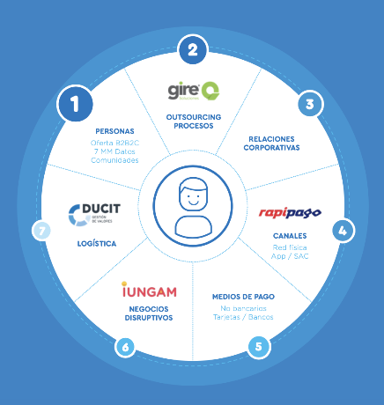
- A company with more than 25 years of experience in the intelligent information processing market and in the development of collections and payments for companies of all sizes, sectors and industries. It has the backing of three large banks: Citi, Santander Río and HSBC.
- Staff: +900.
- Women represent 44% of the workforce, 34% of middle managers and 25% of senior managers.
- Women are concentrated in operational positions (cashiers).
- Company B Certified.

Sustainability strategy: The 4 Is
Gire's management strategy is oriented towards sustainability based on 4Is: inspiration, innovation, inclusion and impact to transform realities. These 4 articulated pillars form the basis for promoting more opportunities for development, inclusion and equality for people and the organization's ecosystem. By identifying the material issues of its stakeholders, Gire's projects were aligned with the following SDGs:

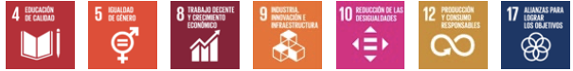
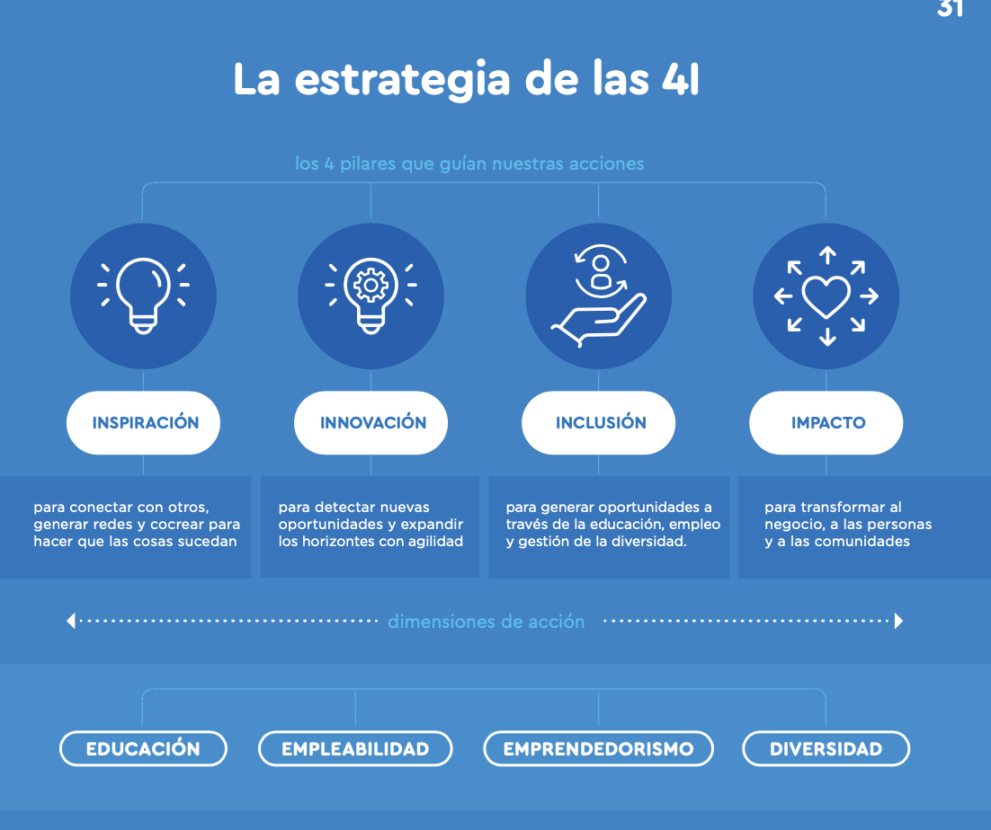

More information available at:
https://drive.google.com/file/d/1YSJUuBMPi8W4AyQAdQU4-INIkLXra47S/view?usp=sharing

Financial inclusion
The premise: implement initiatives aimed at financial inclusion. To this end, they developed a local Rapipago model that brings their services (payments, withdrawals, etc.) to sectors in vulnerable conditions. This process was accompanied by the training of the people who attend the branch, who are neighbors of the community.

To measure the impact generated in these communities, the performance indices of Transactions and Users were taken, understanding that it is the most transparent way of measuring financial inclusion, indicating how many people they reached through this model. On the other hand, Gire has a commercial and mutual support agreement with RADIM (Red Argentina de Microfinanzas) for the development of new products and financial education initiatives.

Diversity, the axis of organizational culture
At Gire, diversity is the axis of its culture and the basis of its business model, due to its role as a generator of work and opportunities for training and job placement, within a framework of promoting equality, inclusion and diversity.

Inclusive value chain
Gire developed a Responsible Purchasing Guide through which it intends to contribute to the generation of economic, sociocultural and environmental value, through the adoption of criteria and practices for making purchases. They established standards linked to the 10 Principles of the United Nations Global Compact to identify and select products not only based on their quality and price, but also on their environmental and social impact, and on the conduct of the companies that provide them and / or elaborate.

As of 2018, 4% of its purchases were focused on social and impact providers, which employ people from sectors in vulnerable conditions. These providers meet needs related to catering services for events and training, massage services for staff, healthy snacks for the office, stationery, consulting for the incorporation of people with disabilities into the company and financial education.

Company: East African Breweries Ltd. (EABL)
Action: Inclusion in the supply and distribution chain
Country: Kenya
General characteristics:
- Regional alcoholic and non-alcoholic beverage company based in Kenya. Subsidiary of Diageo (UK).
- 1,500 employees.
- Women represent 25% of the workforce, 30% of middle managers and 25% of senior managers.
- The board of directors is 50% women.
- Women's roles focus on sales and administration.

Supply and distribution chain
Outlets and wholesale distributors of EABL products that are managed or owned by women are often the most successful. They sell the highest volumes and meet their training and sales targets. Thus, EABL works with more women than men at its points of sale. EABL even works with female distributors. EABL seeks to buy from women farmers and is aware of the gender dynamics in farm families, where the men in the family control most of the productive resources and income.

Other actions
- Objective of 40% women executives by 2020.
- Target 50-50% of senior managers by 2020.
- Hiring policy to attract women and promotion based on merit.
- Remuneration policy based on performance, achievement, potential, value, quality and attitude, regardless of gender.
- Annual assessment of training needs to promote equal opportunities linked to job requirements and staff potential.
- There is a policy of complaints for unfair treatment, sexual harassment and abuse of authority.
- After maternity leave, women are entitled to 2 months of short hours (working only until 2:00 pm instead of 5:00 pm with full pay).
- Paternity leave.

International research linking productivity improvement with diversity and gender equality in the workplace encourages EABL to continue promoting good practices and measures that favor the advancement of women in the company.

Results and challenges
The diversity strategy, combined with initiatives to break down the organizational hierarchies of the company, led to improved productivity, revenue and return for shareholders in recent years. However, finding the right balance (education, experience and attitude) of women for senior management levels remains a challenge for EABL. Currently, their retention rate for men is lower than that of women, but many talented women continue to leave the company.

Company: Crepes & Waffles
Action: Inclusion through job creation for communities in vulnerable conditions and in the value chain
Country: Colombia
General characteristics:
- Gastronomy and food. 100% Colombian family business, 40 years of tradition. International presence in Spain, Mexico, Panama, Ecuador and Chile.
- Number of employees: 6,000.
- Certified B Companies.
- Women represent 92% of the staff, of which 75% are mothers and the sole income of their households.

Empowerment of women, economic independence, access to health and education
Crepes & Waffles has always viewed the company as a vehicle for social transformation. They do business with the purpose of generating opportunities for development, evolution and progress, promoting cultural and social change.

Beatriz Fernández, co-founder of Crepes & Waffles, affirms that investing in women has been the greatest and most rewarding success they have had as a company and as people. Crepes & Waffles offers its staff prepaid medicine, homeownership programs, constant training and a work environment where banishing racism and supporting mothers who are heads of families is an essential philosophy. As a result of the pandemic, she ventured into bringing her letter to homes, but with her own fleet of women.

Inclusive value chain
At Crepes & Waffles, products are not products, fruits are not fruits, vegetables are not vegetables, but rather ways to help remote communities that need to integrate into the licit economy, progress, and peaceful resistance. They "rescue" local products transforming them into haute cuisine. They convert cocoa, vanilla and other products into the new currency of peace. Because if the Tumaco cacao is profitable, the power of the coca crops is diminished; If cocoa triumphs in the form of Dulce Tumaco ice cream and chocolates, the jungle is preserved, which is the natural corridor of the marmoset, the marmoset and other species. Through purchasing conditions, working conditions or support for suppliers in vulnerable situations, they work to reduce poverty.

Resources

Below is a list of resources to support the design of measures that can be included in the action plan for gender equality.

Leadership

Mentoring in the Workplace, a guide based on international experiences for companies to develop mentoring programs:
https://www.weps.org/resource/mentoring-workplace

Measurement of the work environment with a gender perspective

Support tools of the Mexican Standard NMX-R-025-SCFI-2015 on Labor Equality and Non-Discrimination / Measure the work environment and non-discrimination in the workplace:
https://www.gob.mx/inmujeres/documentos/herramientas-de-apoyo-5-norma-mexicana-nmx-r-025-scfi-2015-en-igualdad-laboral-y-no-discriminacion

Co-responsibility work life and personal life

Attracting and Retaining Talent through Inclusive Family-Friendly Policies:
https://www.weps.org/resource/attracting-and-retaining-talent-through-inclusive-family-friendly-policies

Family, personal and work conciliation during COVID-19:
https://www.ilo.org/sanjose/publicaciones/WCMS_764687/lang--es/index.htm

Support tools of the Mexican Standard NMX-R-025-SCFI-2015 on Labor Equality and Non-Discrimination / Carry out actions for joint responsibility in work, family and personal life with equal opportunities:
https://www.gob.mx/inmujeres/documentos/herramientas-de-apoyo-12-norma-mexicana-nmx-r-025-scfi-2015-en-igualdad-laboral-y-no-discriminacion

Work and still have a life: Best practices for life-work integration in Mexico:
https://imco.org.mx/practicas-vida-y-trabajo/ (reporte)
https://imco.org.mx/wp-content/uploads/2019/11/2019_21_10_Trabajarsindejardevivir_Toolkit.pdf (full document)

Workplace violence, harassment and sexual harassment

Tackling Sexual Harassment in the World of Work:
https://www.weps.org/resource/tackling-sexual-harassment-world-work

Gender-Based Violence and Harassment at Work Policy Template:
https://www.weps.org/resource/gender-based-violence-and-harassment-work-policy-template

Model Protocol for Prevention and Action in Cases of Discrimination, Harassment and Sexual and Labor Harassment in Civil Society Organizations:
https://fundar.org.mx/protocolo-modelo-de-prevencion-y-actuacion-en-casos-de-discriminacion-acoso-y-hostigamiento-sexual-y-laboral-en-organizaciones-de-la-sociedad-civil/

Tool 5. Manifesto for gender equality

This tool seeks to offer the boards of directors (boards of directors) of the companies a model of corporate pronouncement, through which they can formally communicate the commitment to achieve gender equality and the incorporation of the gender approach in management. business. The manifesto is intended to exemplify a way in which engagement can extend both within and outside of the organization.

With the approval of this model, companies will be able to formalize a first strategic step to address the issue in a transversal manner and constitute the commitment to achieve equality as a value of the organization and, therefore, one of the pillars of their culture.

The use of this tool subsequently supposes to strategically actuate the commitments contained herein, to support them and make them tangible, in such a way that it allows evaluating and demonstrating their results. Which will also give credibility and authenticity to the commitments made.

- It is suggested, before using this tool, to review the 4. Action plan for gender equality, described in lens 1, to facilitate the planning, development and implementation of the different actions necessary to make the commitments assumed in this statement effective.

The manifesto model for gender equality is a proposal that contains general guidelines, which are recommended to be adapted and complemented by each company according to the elements they require or taking into account their mission, vision and objectives.

Manifesto for gender equality

Our Commitment

We recognize as an essential value of our corporate strategy to achieve gender equality and develop an inclusive organizational culture, to guarantee the competitiveness and sustainability of the business.

We want to communicate our commitment to meeting Sustainable Development Goal 5, as a reference framework to achieve gender equality in the company.

Our commitment extends to all the interest groups of the company, and translates into the will to carry out significant, concrete actions of a transversal nature to the organization.

To this end, the company creates a favorable environment to promote gender equality in all company procedures, policies, procedures and practices, including those of this same body, and formulates an action plan for their implementation, as well as an evaluation, reporting and measurement system.

Our commitment extends to four fundamental areas, in which we assume specific and measurable objectives:

Women in leadership

  - Promote equal participation of women and men in company decision-making, from the board of directors and at all levels and areas.
  - Contribute to the individual and collective empowerment of women, because we consider it to be an essential condition for achieving gender equality and sustainable development.
  - Provide training to personnel in the promotion of gender equality and the eradication of violence.
  - Establish talent development and promotion programs.

Equality in the workplace

- Promote equal opportunities and treatment established in the laws in force in the country and international conventions ratified by it.
- Foster an inclusive work environment, guided by mutual respect, openness, honesty and a spirit of trust and cooperation, in order to achieve maximum productivity, creativity and efficiency.
- Guarantee that the men and women of the company receive the same remuneration and benefits for work of equal or equal value.
- Guarantee the balance between work life and personal life of the employees as a whole, implementing co-responsibility measures that recognize the diversity of homes and families.
- Prevent and end harassment and violence in the workplace, including sexual harassment and harassment.

Products and services that benefit women and girls

- Use an inclusive and non-sexist language in communications, and as a transversal axis in the company.
- Encourage the creation, development and commercialization of products and services with a gender perspective.
- Know the context and inequalities experienced by women and girls to develop products or services according to their needs, interests and expectations.
- Contribute to reducing gaps between women and men through the company's products or services.

Equality in the value chain and advocacy practices

- Articulate with the company's value and supply chains, with a focus on supplier companies and customers, so that they adhere to the commitment to achieve gender equality.
- Collaborate with the community of the territory where the company operates to reduce the gender gap.
- Collaborate, whenever possible, with key actors such as civil society, government and international organizations to promote gender equality.

We are committed to maintaining an open dialogue with our staff, shareholders and other stakeholders to ensure that we continue to meet expectations and remain true to our values.

With our differences, together we succeed.

The board of directors

This manifesto requires the execution of actions that put into practice the commitments assumed. The application of the measures on gender equality is a journey in time in which the results are evaluated and adapted to later perfect the actions.

Recommendations

- Communicate the commitment made to all staff.
- Assign resources and people responsible for executing the actions.
- Train and raise awareness about the commitments assumed in each of the axes mentioned in the manifest model (and those that the company suggests adding) to staff and stakeholders.
- Define the strategy and action plan to execute, through programs and policies, the actions or practices that promote gender equality.
- Set specific and measurable objectives on the commitment assumed in the different axes.
- Establish the way to evaluate these objectives, their way of management and monitoring.
- Establish metrics to evaluate whether the defined objectives were met.
- Create communication channels to publicize actions with a gender perspective that are carried out inside and outside the company.

It is essential to review the manifesto periodically to adapt and respond to changes and dynamism in practices to incorporate the gender approach and the needs of the company at a given time.

Tool 6. Agile leadership: Culture of innovation with a gender perspective

This tool proposes a series of guides to create an inclusive innovation culture in your company, which fosters the empowerment of women, around the concept of diversity of thought and psychological safety, framed from the agile perspective.

Tool benefits

- Build a culture of innovation that promotes gender equality, forming diverse and inclusive teams, and structuring work dynamics that facilitate the participation of women and make their voice visible.

- Improve the work environment, increase the level of motivation and capacity for accountability of the teams. Mainly motivating women to share their ideas, contribute their points of view and take calculated risks to contribute to the company's innovation processes.

- Innovation processes are not only made up of technologies and capital investment. The capacity for leadership-digital-, the diversity of thinking in the teams, added to the appropriate frameworks to do so, are also essential. In this way we strengthen the ability of entrepreneurs not only to adapt to the present, but also to be proactive towards the future of their companies.

- By reducing risk in the design of new products, improving the capacity for agility and adaptation. Entrepreneurs will be equipped with a tool that will increase their possibilities to be more competitive in the market and thereby improve their financial performance, probabilities of obtaining financing, while attracting, selecting and retaining talent.

- From the consumer side, the benefit will be to obtain and make use of products / services that are better suited to their needs.

What do I need to put this tool into practice?

- Have innovation projects in your company. Some examples are: developing new products, making improvements to current products, generating new or improved processes, creating new business models and even markets.

- Ideally, have a basic-intermediate level of maturity in the company of agile methodologies: Lean Startup, Scrum, Kanban, Design Thinking.

- Have at least a team of at least three people, willing to lead and execute innovation processes. With the willingness to promote the participation of women in teams (ideally tending towards equality) and encourage their presence as members and leaders, in addition to ensuring that their voices are heard.

- Basic knowledge of digital tools including Google Analytics and collaborative tools such as Miro, Trello and Google Docs.

- Basic infrastructure: at least one computer (ideally, that the collaborators with whom you will develop innovation projects also have a computer) and a stable internet connection.

Let's get started! We will create a culture of innovation with a gender focus in your organization.

Why does the gender approach add value to the company's innovation processes?

Innovating is the process of introducing changes with tangible value for the business and for people. They can be changes aimed at products, processes, business models, markets and customer experience. Regardless of the type of innovation, level of disruption to the market and the degree of maturity in your organization, the quality of innovation processes is highly impacted by the level of diversity of thought contained in the team that participates and leads it..

While it is true that technology and digitization tools are relevant to the success of innovation, they by themselves do not achieve greater results, since they need a solid base of strategy and a vision that gives them shape and directs them towards a purpose. specific. This vision is built and enriched from the creativity of the team, the mentality of the leaders, the exchange of different points of view that enhance the quality and power of innovation. In such a way that, by choosing to include women in the innovation teams, give them a voice and make visible both their ideas and their contributions, the company benefits from enriching its own organizational capacity for diverse thinking in which the gender approach adds value to the innovation processes in your company.

How agile methodologies help to achieve this?

Let's remember basic principles and concepts of the agile mindset:

- Agile as a framework for innovation, has principles and components that enable the formation of inclusive and diverse teams, understanding that quality in innovation processes is the result of the diversity of thought contained in the team that participates and what lead.

- In addition, agility facilitates the structuring of egalitarian work dynamics in which it is guaranteed that the voices of women and men who make up the team will be heard and situational leadership - regardless of gender - based on competencies is motivated. This is possible thanks to agile performance mechanisms focused on self-management of teams, their ability to adapt to changes, open communication and transparency, making visible the contribution of all and everyone, promoting leadership rotation according to needs. of the situation.

- Likewise, agile principles focused on creating collaborative team environments and with horizontal hierarchies, reduce the possibility that unequal power relations that exist between men and women in society are replicated in work teams. Also highlighting the “psychological safety” component within these methodologies, the aim is to create a work environment of openness, respect and trust in which all the people who make up the team feel safe to express their opinions, disagreements and questions.

- Addressing the usefulness of agile methodologies -with a gender approach- towards the development of new products. We see that by including techniques such as design thinking, businessmen and women will not only have the opportunity to better understand their clients, but will also have the ability to develop differentiated products, functionalities and attributes for women and girls. Thanks to the principle of observation, empathy and questioning of the assumptions that give customers a real voice, recovering the needs of women and girls in product design.

- Hand in hand with the previous point, the flexibility of the agile frameworks allows incorporating the gender perspective throughout the development of the product, to guarantee that it is really applied from start to finish. For example, it can be included as a criterion to filter and prioritize the objectives, features and functionalities of the product, be incorporated within the acceptance criteria, made visible within the Kanban board and included within the planning and within the review of the results of the sprint.

General utility of agile methodologies

- They manage to reduce the risk in innovation processes: scenarios of high uncertainty and high potential for added value.
- Helps reduce financial, time and effort costs.
- It encourages teams to work collaboratively, autonomously and horizontally.
- Increases the ability of the company to be faster, flexible and adaptable (through agile principles, Scrum, Kanban, Scrumban, Lean Startup).
- By including techniques such as design thinking in the package, female and male entrepreneurs have the possibility of better understanding their clientele and implementing that knowledge in the design of their products, services and business model.
- As a result, it increases the competitiveness and innovation of companies.

What is and how is psychological safety installed in innovation teams?

Several studies and research on gender equality in the workplace, point out a series of inequalities and invisible efforts that women must assume when participating in meetings, working as a team and contributing their ideas. For example, assertiveness is usually frowned upon by women when expressing a clear opinion or disagreement, they are also interrupted more often than men during meetings and are accused of being insecure in expressing their position or point of view, when In reality, what usually happens is that the environment is not very favorable for them to express their opinions. Therefore, installing psychological security within teams is essential to design spaces that facilitate the participation, visibility and leadership of women.

In this sense, and focusing on scenarios of uncertainty and interdependence -in other words, on innovation scenarios-, we define that psychological safety is the belief and sense of confidence that the team will not embarrass, reject or punish someone for speaking out, for exposing your questions, opinions or disagreements. It describes a team climate characterized by interpersonal trust and mutual respect in which people feel comfortable being themselves and contributing their diverse thinking.

To learn more about psychological safety, you can watch Amy Edmondson's Ted Talk video:
https://www.youtube.com/watch?v=LhoLuui9gX8
And this video from Harvard Business School:
https://www.youtube.com/watch?v=eh4iUU22REQ&t=155s

Psychological safety, in addition to being key to forming high-performance teams, is also a fundamental enabler to create dynamics in your organization that facilitate innovation, promote the inclusion and empowerment of women in your company. When a workplace feels psychologically safe, mistakes are seen as a natural part of the learning process and an openness to opinions, questions and disagreements is promoted. This in turn means that your team on the one hand will generate higher levels of creativity and will dare to take risks in their ideas. On the other hand, it means that you will be creating a type of environment designed to make visible and promote the voice of each and every collaborator, generating highly favorable environments for gender equality in your organization.

Guides to create a culture of innovation with a gender and inclusive approach

Communication from your role as a leader

1. Make the uncertainty scenario and the importance of the contribution of each and every team member explicit, with conversations such as:
- "The team faces enormous uncertainty and we don't know exactly what the path will be like, but we fundamentally need everyone to contribute their ideas and voice, as well as their ability to listen and build together."
- “It is good that we do not know all the answers at this time, precisely for that reason we are innovating, to find out. But what I do hope and should be the expectation of the whole group, is that we solve it by contributing ideas and listening to each other as a team ”.

2. Recognize your own limitations or shortcomings with simple phrases like:
- "It is possible that I have overlooked something in this approach, if you see something let me know."
- "It is the first time I have faced this type of challenge, but I am sure that with our team we will solve it, tell me what ideas you have in mind."
- "It's a good question, I don't know, let's find out what actions do you propose?"

3. Guide your questions toward curiosity, not judgment, or criticism. Be proactive in asking intentional, open and focused questions:
- I would love to know, what is your perspective on this issue, tell me what you think?
- We currently have this challenge and I would like to know how do you recommend tackling it?
- What worries you about this project?
- The results of the last iteration were not ideal, do you know what happened? What can we learn to incorporate it into the next sprint?

4. Receive responses in an appreciative, constructive way, focusing the conversation towards solutions:
- I think it is a valuable comment, we had not considered that point.
- That is a point contrary to what we have planned, if you are sure of that statement, let's review the issue in more detail, can you take care of that?
- I understand, how do you think we can reframe this problem in order to move forward?

Designing and facilitating meetings

Remembering that there is a trend of inequalities and invisible efforts that women must assume when participating in meetings, working as a team and contributing their ideas. We see that it is precisely in these spaces where incorporating changes in these dynamics will be critical to generate a transformative impact towards gender equality in your organization.

Within the agile perspective, we design meetings with a specific time frame, frequency and objective. We create rituals. These articulated to the roles, objectives and artifacts implemented continuously create a system of innovation and a climate of inclusion.

1. Guides at a general level to apply as a leader in meetings with your team

You can apply them in traditional Scrum meetings (backlog grooming, sprint planning, sprint review, daily standup, retrospective), as well as ad-hoc meetings that are presented.

- Participants will include representation of women, ideally tending towards parity. Check the list of people invited with these glasses before sending the invitation on the calendars.

- Rotate in each sprint (every 2 weeks) the facilitators or leaders of fixed meetings, ensuring that the women in your team have their turn equally.

- Horizontal hierarchy: includes as a rule of the game and tone of conversation “we are all colleagues and peers”, no matter the role or position, what matters is the quality of the ideas contributed and the construction that is generated on it.

- Ask questions, request reasoned opinions, call by names (in a respectful and cordial way). Design meeting dynamics in such a way that it is more uncomfortable to keep quiet than to participate.

- Ensures that all people have had the opportunity to participate and have been heard at the meeting. Identify particularly that they have listened to the ideas of the women on your team.

- Amplify the voice of women: highlight the contributions of women in your team. Express comments or arguments that they have contributed as a reference, also include it in the summary and plan of next steps that you do at the end of the meeting.

2. Alternative meeting design

- Retrospective meeting: This key meeting within the Scrum framework, focused on creating an open and transparent conversation between team members, to reflect on the work processes and dynamics that applied the last sprint, is a great setting to talk openly with your team about what consider what they can do to improve psychological safety with a gender perspective, in the context of their innovation project.
  - Key questions:
    - Common questions about team dynamics in the project: What worked well in the previous sprint that we should continue to apply? What did not work, what should we change?
    - Add a maximum of 2 open questions to specifically address the level of psychological security, observing if there is any difference between the perception of the men and women in your team: How do they feel about our work environment to ask, comment and express disagreement? What do you think we can improve?

- Failure sharing sessions: a once-a-month space dedicated to sharing failure stories, with the focus of normalizing failure to empower experimentation, learn faster, continually improve, and innovate. Shaping the mindset towards innovation, problem solving and resilience. It is essential that the participants include representation of women, ideally tending towards parity.

- Brainstorming: conversations in which the team brainstorms in a creative and focused way toward achieving a common goal.

- One on one: Informal meetings of the leaders with the collaborators, where different topics are discussed openly, emphasizing how they perceive and what level of enjoyment they enjoy in the face of the psychological safety of the team.

- Mentoring sessions: this is a space of trust and learning in which particular challenges of the collaborators are identified, they are advised or formulated tactical questions so that he / she clarifies their doubts, reaffirms their sense of purpose with their role , team and company. As a leader, observe and identify patterns in the challenges faced by women in your company and take action against them.

Indicators and measurement

1. Design indicators to map and measure the diversity of thinking in your company:
- What is the percentage of women compared to men?
- What generations do they represent? (millennials, generation Y, X, etc.)
- What is the percentage of women from other ethnic groups?

In addition to the gender variable, you can add all the variables that you consider important to measure diversity: age, ethnicity, nationality or if you have lived in another country, etc.

2. Design indicators to measure the level of psychological security in your company:
A practical mechanism is to conduct surveys of your team, to identify the following information and put together an action plan for continuous improvement:
- How often do collaborators express their questions, opinions and disagreements? What makes you uncomfortable or challenging about doing it?
- What is the variation between the perception of psychological security between women and men? In what aspects?
- What is the level of motivation and accountability felt by employees?

With this graph it is possible to map the state of psychological security in your organization, considering the psychological security variables versus the level of motivation and accountability.

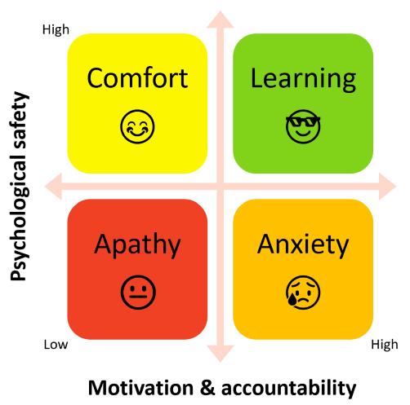

Lens 2. Equality in the workplace

This lens presents actions in favor of equal opportunities and treatment between women and men, which seek to improve the work environment through the implementation of strategies that promote the participation of women at all levels and areas of the organization, equal pay, co-responsibility work life/personal life and the analysis of possible inequality gaps within the company.

It is made up of the following tools:
- Guide to promote gender equality and diversity in organizational culture
- Staff induction policy
- Compensation and benefits policy
- Telework policy
- Wellness wheel
- Analysis of gender gaps in talent management

Tool 1. Guide to promote gender equality and diversity in organizational culture

This tool will help you identify how inclusive, balanced and diverse leadership is in your company, why it is important to improve its performance and how to incorporate actions to move towards a work environment that enhances the capabilities of all people, especially of women, taking advantage of diversity (gender, age, ethnicity, race, knowledge and other aspects) at all levels of the organization, as a catalyst for better results.

The guide allows for a simple diagnosis using three instruments that will help identify:
- How is the labor structure composed at each of the levels of the company?
- How much does the culture or environment of the company favor gender equality and diversity at all levels (in entry positions, middle management, executive team and board of directors or board of directors)?
- How to develop action plans based on the findings?

Throughout the document, recommendations and examples are included that could inform the company's action plan for closing gender gaps and improving the diversity of its teams, as well as promoting a more inclusive organizational culture. They are references to guide the discussion within the organizations, since the plans and objectives will depend on the commitment and possibilities of each one.

Understanding the challenge and benefits of equality in leadership

“We have been trying to solve the most complex problems in the world, with only 50% of our intellectual power. It is time to change this. By bringing more women to positions of power and influence, we will be able to use the full talents and ambitions of humanity. We need all the best ideas, and the most courageous leaderships, to face the challenges that we have in front of us ".
Melinda Gates, Co-Chair, Bill & Melinda Gates Foundation.

In Latin America, as in the rest of the world, there are great inequalities regarding the participation of women in corporate leadership positions. Despite the fact that women represent 51% of the region's population, they occupy only 6.4% of the seats on the boards of directors of the 100 largest companies in the territory while men occupy 93.6%. In 60% of companies, the boards of directors are composed only of men and women occupy only 5% of executive positions.

Even in sectors where women represent more than 50% of the workforce, such as commerce, healthcare, the financial sector or the public sector, they are underrepresented in executive positions. The gap is even greater when other characteristics such as race, gender identity, disability and other conditions of discrimination are added. For example, in Brazil (where the Afro-Brazilian population represents almost half its inhabitants), a study carried out by the Ethos Institute in the 500 largest companies in the country reports that only 16% of Afro-Brazilian women hold managerial positions and 0.4% executive positions..

These discouraging figures coincide with data from the World Economic Forum, which identified that under current conditions it will take us 257 years to close the gender gap in the world of work..

In contrast, when women actively participate in the management teams and boards of directors of companies, the positive impact is notable and is reflected in their performance indicators. However, in order to reap greater benefits from this diversity in company results, it is not enough to add a woman to the board of directors or include a handful of people with diverse characteristics on teams. Additionally, it is necessary to promote a culture that enhances diversity and inclusion at all levels of the organization.

According to Credit Suisse Gender 3000 (CSG3000), based on a data collection exercise between 2014 and 2017 in 3,000 global companies from countries belonging to the Organization for Economic Cooperation and Development, having diverse boards of directors translates into greater creation of long-term value. Companies that have at least one female director obtain 3.5% higher returns than companies that do not have women on their boards. In addition, those companies that have more than 15% women as part of their executive teams have up to 50% more profitability than those that have less than 10% women in leadership positions.

Companies must promote the leadership of women in their structures to enhance their talent and to reap better results. According to information from Deloitte , teams with inclusive leadership report being 17% more likely to perform better, 20% consider that they make better decisions, and 29% that they work more collaboratively. Additionally, the analysis shows that by increasing the perception of greater inclusion in teams by 10%, the cost of absenteeism is reduced.

Definitions and key terms

In order to promote a better understanding of this tool, some key terms related to inclusive leadership, gender and diversity are presented, with the aim that there is a common language regarding the concepts that will be addressed in the following sections.

Inclusive leadership : leadership style that ensures that all the people in a team feel that they are treated with respect and in a fair way, are valued and have a high sense of belonging, have confidence and feel inspired.

Gender balance: refers to the equal distribution of opportunities and resources for life between women and men, as well as the same representation of women and men (in the public and private sphere).

Gender parity: is another term for equal representation of women and men in a given area. For example, gender parity in institutional leadership or higher education. Working to achieve gender parity (equal representation) is a key component to achieve substantive equality and, together with the incorporation of the gender perspective, they make up twin strategies.

Gender equality: equal rights, responsibilities and opportunities for women and men and for girls and boys. Equality does not mean that women and men are equal, but that the rights, responsibilities and opportunities of one and the other will not depend on being born with a certain sex.

Diversity: proportion of people who are different from each other (in terms of sex, race, nationality, marital or marital status, sexual orientation, gender identity, disability, migration status, religion, age, socioeconomic level, among others). For an organization and its leadership to be considered diverse, its composition must be representative of the community where it operates.

Intersectionality: is a tool for analysis, advocacy and policy making that addresses multiple discriminations and helps us understand how different sets of identities influence access to rights and opportunities. It begins with the premise that people live multiple identities, made up of several layers, derived from social relationships, history, and the operation of power structures.

Multiple discrimination : concept used to describe the complexity of discrimination involving more than one ground. It is also known as intersectional, additive, cumulative, compound, complex discrimination, or multidimensional inequalities. Although the terminology may seem confusing, it tends to describe two situations: 1) the situation in which a person faces more than one ground of discrimination (for example, discrimination on the basis of sex and disability, or on the basis of age and orientation sexual). In such circumstances, all women and all people with disabilities (both men and women) have the potential to be discriminated against; 2) the situation in which discrimination affects only those who belong to more than one group (i.e. only women with disabilities and not men with disabilities).

Tool benefits

By applying this tool, the people who are part of the company will be able to:
- Analyze and understand the composition of the workforce, disaggregated by sex and other factors of discrimination, such as age, ethnic group membership, disability status, sexual orientation or gender identity.
- Understand how much the organizational culture promotes gender equality and diversity.
- Define action plans to enhance the leadership of people who have been underrepresented in managerial and directive positions.
- Promote the generation of an inclusive culture that promotes gender equality.

Steps for implementation

For a successful application of the tool, it is recommended that the company reflect on the general problem of inequality in the workplace, becoming aware of gender gaps in the corporate world, emphasizing the situation in Latin America based on data as presented at the beginning. It is also important that you understand the effects that gender gaps in leadership have on the performance of companies, as well as the potential that greater gender equality and diversity have on results - financial and otherwise - and that it can be used when implementing actions such as those proposed here.

- Visualization and analysis of the workforce composition

"Companies should start by using people analytics , the data and informed decisions must know how their workforce is formed in terms of gender, generations, disability, representation of the LGTBIQ + community based on reality and not on assumptions”.
Gabriela Bustamante, leader of Propósito e Inclusión at PWC.

The first step to knowing how diverse the company is at all levels (entry positions, middle managers, executive team and board of directors), is to carry out a basic census on the composition of the workforce within it. For this, Table 1 is suggested as a tool, which is completed by placing the amounts that correspond to each column, according to the number of people employed and their characteristics.

Table 1: Workforce composition
Complete matrix | Total | Male (M) | Female (F) | People from the LGBT + community ª |  | People of an ethnic group^{b} |  | People with disabilities^{c}
 |  |  |  | M | F | M | F | M | F
Members of the board of directors.
Employees
Employees in leadership positions (CEO, COO, management).
Employees in middle management (managements, heads).
Employees in entry positions.
ª People from the lesbian, gay, bisexual, transsexual, transgender, transvestite and other (LGBT +) community, according to their sexual orientation, gender identity or gender expression.
^{b} People belonging to an ethnic group in the place where the company operates, for example, indigenous and Afro-descendant population, among others.
^{c} People with physical or intellectual disabilities.

Once the information in the table has been completed, it will serve as an input for the second step, which consists of calculating the percentages that correspond to each sex or discrimination condition, for each hierarchical level, with respect to the total number of people who work in the company and the total number of people per level within the structure. This percentage analysis will serve to measure how balanced is the composition of the company in terms of women and men, together with its level of inclusion with respect to people who experience a situation of discrimination. Additionally, the intersectional analysis will allow to identify if there are people or groups that are suffering multiple discrimination.

Additionally, if the company wishes to know more details about the disaggregated composition, an analysis can be included by areas (human resources, technology, operations, marketing), by type of contract (fixed term, indefinite), working hours (full time, time partial), by generations (millennials, centennials, genX, baby boomers), among others, which will provide information that leads to data-based decisions and actions to close gaps.

- For this task, tool 5. Analysis of gender gaps in talent management can be very useful, which also appears in lens 2.

- Analysis of the promotion of gender equality and diversity in the organizational culturel

After having identified the composition of the people who collaborate within the work structure, it is necessary to understand how much inclusion and diversity permeates the company culture and decision-making. The promotion of diversity is not only a matter of number or percentage, and it is not only working from recruitment, but it is also about promotions, leadership, access to opportunities within the company and organizational culture. In this regard, it is very important to identify biases or stereotypes that are obstructing the advancement of women.

To promote an organizational culture that promotes gender equality and diversity, it is important that the practice of inclusion is carried out across the board at all levels of the company. To achieve a true transformation and a commitment to equality, this must start from the board of directors and the executive team (CEO and general management). The commitment to gender equality must be manifest, shared and communicated throughout the organization.

An example of manifest commitment that thousands of companies have adopted around the world is the signing of the Women Empowerment Principles (WEPs), a set of principles that offer guidance to companies on how to promote gender equality and the empowerment of women in the workplace, the marketplace and the community developed by UN Women and the United Nations Global Compact. In addition to the letter of commitment, the WEPs present a self-diagnosis and a guide for companies to move towards gender equality in four dimensions: leadership, workplace, markets and community. More information in: https://www.weps.org/

To know the level of commitment that the company has with gender equality and diversity, it is suggested to use the following matrix, answering the guiding questions for senior management, boards of directors and companies that want to have greater diversity and equality gender in their strategies. Upon completion, it will be possible to identify opportunities for improvement and establish action plans according to your own reality.

Diagnostic matrix of commitment to gender equality and diversity
Question | Yes/No | If the answer is “No”: | If the answer is “Yes”
 |  | Define improvement plan | It is communicated to stakeholders | The progress of the goals is measured | Assign a responsible for making significant changes
Does the company define ambitious goals to achieve a gender balance and greater diversity at all hierarchical levels?
Is the company's board of directors and management team diverse enough?
Are women invited to participate in strategic projects for the business?
Does the company have processes and policies to avoid bias in the recruitment, promotion, performance evaluation, and opportunity allocation processes?
Do the people who lead the organization and its different areas hire diverse and different people?
Is there equal pay for women and men doing the same job?
Does the company have leadership, mentoring and sponsorship programs for women and other groups in situations of discrimination?
Is training offered on gender equality and discrimination?
Does the company promote parental leave for everyone?
Have work life-personal life co-responsibility measures been implemented?
Is there a protocol for the prevention and care of workplace violence, including sexual harassment and harassment?
Does the measurement of the work environment consider the gender approach?

- Preparation of the action plan

It is not enough to have a heterogeneous and diverse composition at all levels of the organizational hierarchy, but it is also necessary to understand the dynamics of decision-making, growth and participation, inviting the introduction of different points of view in the processes and decisions of the company. To create a culture that promotes inclusion and diversity, Korn Ferry identifies four essential elements:
- Inclusive leadership: recruiting and developing inclusive leaders at all levels of the organization. Those who lead must have vision, take responsibility and be an example to the rest of the team.
- Structural inclusion: building egalitarian and transparent structures, designing processes and practices in an inclusive way.
- Inclusive behaviors: support the development of an inclusive mindset, as well as skills and tools that enhance the characteristics of this leadership style.
- Actions for inclusion: implement plans and tools that contribute to an adequate management of change, maintaining the commitment of all people in the adoption of an organizational culture of equality and non-discrimination.

Korn Ferry developed a self-awareness test so that anyone within the company, regardless of their hierarchical level, can determine how inclusive their leadership style is: https://www.kornferry.com/challenges/leadership/inclusive-leader/inclusive-leader-quiz

From the diagnostic tools presented in steps 1 and 2 of this guide, companies will have inputs to build their action plan. For this, the following steps are recommended:
- Carry out a participatory process with representatives of the areas that make up the company, to generate a brainstorming of projects that the company could promote to ensure gender equality and greater diversity, at all levels. It is essential to ensure the active participation of all the diversity of the staff in this exercise, in order to guarantee an inclusive ideation process.
- Prioritize the actions identified, according to the feasibility of implementation in the short, medium and long term.
- Define measurable objectives and goals, with data disaggregated by sex.
- Appoint the people responsible for carrying out the prioritized plans and, if necessary and feasible, assign a budget.
- Communicate within the organization the results of the process and support the agreements with a manifest commitment from the executive team.
- To periodically monitor the progress of the objectives and goals, and notify it in a timely manner.

- To communicate the company's commitment, tool 5. Manifesto for gender equality in lens 1 offers a model of statement to be signed and disseminated by senior management.

The action plan must contain measures that address key issues to promote gender equality and diversity in the organizational culture: staff management with equal opportunities, leadership, training, co-responsibility work life-personal life, prevention and care of violence work, including sexual harassment and harassment, as well as measurement of the work environment with a gender perspective. These are some examples of affirmative measures or actions that address various aspects and contribute to closing any gaps that may exist within the organization:

- Recruitment and selection with equal opportunities. Some actions to reduce bias in hiring and encourage greater participation of women and diverse people are:
  - Design standardized and documented processes for the recruitment, selection, induction, training, compensation, evaluation and promotion of personnel, which ensure equal opportunities and treatment for those who participate.
  - Prepare job profiles and job offers with non-sexist and inclusive language, with the explicit prohibition of requests for non-pregnancy and HIV certificates.
  - Use a blind resume in recruitment and selection: the first entry filter to the company is the incorporation of a CV process that does not contain name, sex, marital or marital status of the candidate, to exclusively assess whether the person covers with the requirements for the position. In the interview process, establish that you should not ask about marital or marital status, or previous wages or salary that you are looking for.
  - Ensure that there is at least one woman on all the short-lists of the recruitment processes.

- Gender balance goals. Establishing goals for the promotion of women in the different positions of the company, with equal criteria, taking into account the differentiated needs of women and people in situations of discrimination, is an excellent path towards gender parity. A common goal adopted by many companies is to achieve at least 30% participation of women in boards of directors and executive positions (C-suite). There is a global initiative called the 30% Club (https://30percentclub.org/) that aims to achieve at least 30% representation on all boards of directors and executive levels globally. On the other hand, the B-Team (https://bteam.org/) - group of business leaders who seek to redefine the culture of accountability to create sustainable conditions for companies, society and the environment, creating new norms of corporate governance–, has defined a goal of gender balance to achieve at least 40% representation of women on boards of directors and management and executive teams.

- Mentoring and leadership programs. It is a frequent strategy among companies that want to promote a greater presence of women in decision-making positions, since existing knowledge within the organization can be used. Good practices such as those of NetSuite and PayPal serve as inspiration, in both cases mentoring plays a specific role: women in leadership positions become success stories within the same company. With a personalized approach, the goal is to give participants the support they need to be able to achieve their own version of success.

- Educational programs with a gender perspective and reduction of biases. The lack of women in leadership positions and key areas for the business has been attributed many times to the career interests of women. However, part of these differences is explained by social norms and gender stereotypes that perpetuate them. It is quite common that, due to the family burden that is socially assigned to women, they are offered support or non-strategic assignments or projects. There is a prejudice that they will not be able to balance both responsibilities, however, these premises do not recognize the insufficiency in the supply of care services, nor the lack of respect for established work schedules, and foster a generalized belief about the role of caregivers. women as sole caretakers. Companies are also jointly responsible for an adequate work-life balance. To break these stereotypes, it is necessary for companies to provide training and spaces for reflection so that all people know how to include the gender perspective in their decisions, identify unconscious biases and learn to see the full potential of diversity for their businesses, and that this training happens within the working day.

- e) Co-responsibility work life-personal life. There are various measures that favor the right of women and men to paid work without having to give up their personal life, such as: flexible or staggered hours, teleworking, maternity, paternity and parental leave, leave and leave with or without pay. , lactation rooms and dependent care supports. In all cases, it is essential to recognize the unequal distribution of domestic and care work faced by women, which limits their opportunities to develop within organizations and access decision-making positions, in addition to taking into account the different types of homes and families that exist in society. It is necessary to distinguish that care is not only provided to infants or couples, but also to elderly, sick or disabled people, who may or may not have a consanguineous relationship with the staff. To be successful and have a positive impact, stewardship measures need to be documented and standardized, made available to all staff, and encouraged by men and managers to use them.

- Prevent and address workplace violence. Companies must have mechanisms for the prevention and care of workplace violence, including harassment and sexual harassment. It is advisable to act to prevent, promoting a work culture of zero tolerance for violence, creating an environment for reflection on its causes and manifestations, and eliminating the difficulties to report it. A protocol for the prevention and care of workplace violence, harassment and sexual harassment can include the regulatory framework that supports it, contain definitions and basic concepts, establish the explicit prohibition of certain behaviors, include dissemination and prevention strategies, institute formal complaint procedures, and provide protection measures for the alleged victims, solutions for the victim and sanctions for the aggressor.

- Measuring the work environment with a gender perspective. The analysis of staff satisfaction and their perception of the organizational culture that is usually done within companies must be carried out with a gender perspective so that it becomes a mechanism that fosters equal opportunities. This allows us to have first-hand information, detect gender gaps and situations of discrimination and workplace violence, prevent negative behaviors and their consequences (decrease in productivity, absenteeism, staff turnover and loss of talents) and implement measures specifically designed to address the problematic ones.

- Communication. Annual and transparent publication of figures for women at each level and in promotions. Some indicators that can be considered in the report include: percentage of women, men and people in conditions of discrimination in managerial or leadership positions, percentage of job rotation by sex, number of requests for parental leave, hiring rate by sex, percentage of internal talent promotion by sex and conditions of discrimination. Likewise, include in the dissemination the results of the implementation of actions in favor of gender equality.

- Tool 4. Action plan for gender in lens 1 offers a proposal to incorporate the gender approach in the company in a transversal way, since it considers, in addition to the organizational culture, actions related to governance, products and services of the company and its value chain.

Companies are key elements within the social and economic system in which they operate; they undoubtedly constitute an engine of socioeconomic impulse, through the generation of employment and the creation of value. However, in order to multiply their transformative potential, they must take advantage of 100% of the talent, generating workspaces that promote equal opportunities for all people throughout the organizational structure. In this process, women's leadership and growth certainly represents a huge opportunity for companies to be catalysts for gender equality.

Resources

Below is a list of resources to support the design of measures that can be included in the action plan, organized according to key themes to promote gender equality and diversity in the organizational culture.

Leadership

Mentoring in the Workplace, guide based on international experiences for companies to develop mentoring programs:
https://www.weps.org/resource/mentoring-workplace

Educational programs with a gender perspective

Puntogénero: Training for equality / Educational resources:
http://puntogenero.inmujeres.gob.mx/materiales.html

Co-responsibility work life and personal life

Attracting and Retaining Talent through Inclusive Family-Friendly Policies:
https://www.weps.org/resource/attracting-and-retaining-talent-through-inclusive-family-friendly-policies

Family, personal and work conciliation during COVID-19:
https://www.ilo.org/sanjose/publicaciones/WCMS_764687/lang--es/index.htm

Support tools of the Mexican Standard NMX-R-025-SCFI-2015 on Labor Equality and Non-Discrimination / 12. Carry out actions for joint responsibility in work, family and personal life with equal opportunities:
https://www.gob.mx/inmujeres/documentos/herramientas-de-apoyo-12-norma-mexicana-nmx-r-025-scfi-2015-en-igualdad-laboral-y-no-discriminacion

Working without ceasing to live: Best practices for life-work integration in Mexico:
https://imco.org.mx/practicas-vida-y-trabajo/ (reporte)
https://imco.org.mx/wp-content/uploads/2019/11/2019_21_10_Trabajarsindejardevivir_Toolkit.pdf (full document)

Workplace violence, harassment and sexual harassment

Tackling Sexual Harassment in the World of Work:
https://www.weps.org/resource/tackling-sexual-harassment-world-work

Gender-Based Violence and Harassment at Work Policy Template:
https://www.weps.org/resource/gender-based-violence-and-harassment-work-policy-template

Model Protocol for Prevention and Action in Cases of Discrimination, Harassment and Sexual and Labor Harassment in Civil Society Organizations:
https://fundar.org.mx/protocolo-modelo-de-prevencion-y-actuacion-en-casos-de-discriminacion-acoso-y-hostigamiento-sexual-y-laboral-en-organizaciones-de-la-sociedad-civil/

Measuring the work environment with a gender perspective

Support tools of the Mexican Standard NMX-R-025-SCFI-2015 on Labor Equality and Non-Discrimination / 5. Measure the work environment and non-discrimination in the workplace:
https://www.gob.mx/inmujeres/documentos/herramientas-de-apoyo-5-norma-mexicana-nmx-r-025-scfi-2015-en-igualdad-laboral-y-no-discriminacion

Tool 2. Staff induction policy

During the induction, the new staff will become familiar with the culture and processes of the company, so it represents a key moment for them to also learn about the organization's commitment to gender equality, the co-responsibility measures between working life and personal life, reporting mechanisms in the event of discrimination or workplace violence, as well as all those practices that help identify that you are joining a company where gender equality is an essential part of the operation.

This tool consists of a model induction policy for male and female employees, which companies can adapt according to their needs.

Goal

Welcome the new collaborators of the organization and share the organizational culture from day one so that they can experience and transmit it.

Our collaborators are responsible that acting is a reflection of our principles, always aware of our commitment to equity, to guarantee a workplace that favors equal opportunities for all staff:
- We believe that gender equality is a fundamental human right and that women must participate equally in all areas of society.
- We view women as formidable agents for positive change and recognize their creative potential to generate value and prosperity in their families, communities and economies.
- Our imperative is to continuously identify and provide solutions, based on a deep understanding of needs.
- We consider our human capital to be one of our most important resources. We strive to foster a purposeful work environment so that the most motivated staff can excel. We value collaboration and responsibility and reward results.
- We believe that our success depends on the collective diligence of our entire team, our partners, and the women we serve.
- We rely on alliances with strategic partners to take advantage of complementary resources and we work collaboratively to expand our presence and impact.
- We are a social enterprise driven by a mission that harnesses the power of innovation so that transformative and sustainable ideas have a greater reach.

Specific goals

- Identify the collaborators with the organization so that they know and integrate with their work team.
- Ensure support for new staff so that they understand and convey the vision, mission and mandate of the organization.
- Provide specific information about the position and accompany the learning process in their new role, providing tools to facilitate the Induction process for all staff alike.
- Set performance expectations and expected results.
- Generate a sense of belonging and commitment to the organization by sharing the code of ethics that includes the manifesto of equality at all levels.
- Disseminate the organization's commitment to gender equality to create a work environment where staff can develop comprehensively in an environment free of discrimination and violence in all areas.

Reach

This document applies to new collaborators and to all personnel who have a change of role within the organization.

General notes

- The development of the induction program will be in charge of the human resources area, as part of its processes, however the leaders and guides of the areas play a very important role in the learning and adaptation period of the new personnel.
- Those who enter must receive the induction no later than 7 business days after the date of their hiring. In the case of small groups, human resources may have a suitable date within the first month to generate a group larger than three people and start the induction process.
- Each stage of the induction process will be composed of activities that are intended to put into practice the stages contained in the induction process and raise awareness about the importance of a workplace free of discrimination, harassment and sexual or occupational harassment in all levels.
- Those who enter as a substitute will be exempted from the program if the period for which they are hired is less than 3 continuous months. In the same way, the leader will establish the guidance and orientation that is required.
- In order to avoid practices that may affect the normal development or the objectives of this process, it is recommended to take into account the following:
  - Personnel must be provided with information relevant to the function and their knowledge of the organization, to guarantee a workplace where well-being and practices free of discrimination, sexual harassment, and violence are favored.
  - It is recommended to submit the main instructions for the function in writing.

All communication and information provided during the induction process must promote messages with inclusive and non-sexist language, without gender stereotypes or discrimination, recognize the work of women and promote a positive image of their contribution to society.

Content

In the induction process the following information will be provided:
- History, vision, mission and mandate of the organization.
- Information pertinent to the business area to which it will belong.
- Information from the support areas.
- Presentation of the code of ethics, which includes information regarding the company's gender equality manifesto.
- Training on the different initiatives related to gender equality in the company.
- Information on measures that promote gender equality in professional development: training, co-responsibility, equal pay, leadership programs for women.
- Inclusive communication guide.
- Protocols to prevent and report workplace violence, including sexual harassment and harassment.
- Information on certifications or seals on gender equality, if available.

An induction program that considers the gender approach, in addition to these elements, must include basic training on gender equality in the company's area of competence. A course developed specifically by the organization can be offered or served through online courses whose content meets the knowledge needs of the industry.

Responsibilities

This section defines the positions and areas responsible for carrying out each instance of the induction process.

Functional area leaders
- Ensure compliance with the induction plan.
- Define the specific induction plan for new collaborators entering their respective areas.
- Officially welcome you to the team, relying on the various tools that human resources will share with you.
- Complete the instructions together, using the welcome kit.
- Prepare for the induction process.
- Appointment of a person from the area to carry out the specific induction program (guide).
- Monitoring of compliance with the specific induction plan and regulatory courses.
- Feedback and work plan to cover specific induction gaps.

Local human resources area
- Carry out face-to-face or digital institutional induction, as the case may be.
- Ensure that leaders are prepared and have the necessary tools for the new entry.
- Coordinate visits to the designated branch to learn about the business.
- Monitor compliance with specific induction plans and take the necessary actions to carry them out.
- Collection of feedback on the program from new collaborators through the induction satisfaction survey.
- Report indicators of satisfaction and compliance with the induction process.

Global attraction and development management
- Definition of the global induction strategy.
- Ensure the monitoring of the updating of resources for the Induction program.
- Follow up on compliance with the face-to-face, digital and specific induction plan at a global level.
- Follow up and train local Human Resources teams to better implement the program in each of the countries.
- Report indicators of satisfaction and compliance with the induction process.

Global Human Resources Directorate
- Give feedback on the induction strategy.

Employees and new employees
- Actively participate in the induction process and comply with regulatory courses.

Induction program evaluation

The induction process is the key to providing new employees with a memorable experience in the process of introducing themselves to the organization. For this reason, satisfaction is measured with a questionnaire, available at:
https://forms.office.com/Pages/ResponsePage.aspx?id=GmReyEjxYkulvNcsQzrV-oDkWCe3e0dFtvEosCrvS55UQ1k5MVRWRVFFOTkxSzlOWlhOVVpTS1NNUC4u

Resources

In this link you can consult an example of all the materials used in the induction process of a company: https://bit.ly/3sZRyCD

Tool 3. Compensation and benefits policy

A compensation and benefits policy with a gender perspective must guarantee equal opportunities and treatment between women and men in any type of compensation, as well as include actions to eliminate wage inequality if it is identified through the use of indicators. . Companies must ensure that both salaries and benefits (commissions, bonuses, life insurance, health insurance or scholarships, to name a few possibilities) are awarded without discrimination between women and men.

Having a clear, documented policy based on job descriptions helps to avoid possible gender bias in the allocation of salaries. This tool consists of a compensation and benefits policy model, which companies can adapt according to their needs.

Goal

Establish the bases on which the strategic management of compensation and benefits of the company is based, complying with the local regulations in each country, in order to guarantee that employees receive a remuneration whose internal comparative value is appropriate to the responsibilities of the position and, at the external competitiveness level, is aligned with the market median for that position, guaranteeing equal opportunities and treatment between women and men.

Reach

Applicable for all active personnel in all legal entities of the company.

Conceptual framework

The analysis of the remuneration strategy depends on the following main factors:
- Job description: consists of defining the mission, main responsibilities, level of autonomy and main knowledge, experiences and skills required in the position.
- Position evaluation: allows determining the level of the position in the organization through an evaluative methodology.
- Leveling with the market: determines the external competitiveness framework, through the participation and analysis of market survey values developed by prestigious compensation consultants.
- Analysis and metrics: allows you to analyze and identify salary gaps in the same salary category, analyzing salaries according to levels, experience and performance. Likewise, distribution by sex in each country and organizational level is reviewed.

The processes included in the strategic management of compensation must be objective and subject to a methodology with high quality standards, which does not include biases in the analysis by sex, age, marital or marital status, ethnic origin, disability, orientation sexual, gender identity or any other possible variable of discrimination.

For this, the indicators are reviewed quarterly and thus guarantee equality:
- Analysis of salary gap: in the same salary category, average salary of women / average salary of men * 100, the objective being less than 20% with a tendency to 0.
- Relationship by sex of the company.
- Proportion by sex of managerial positions.
- Analysis of the distribution according to sex and age in each country.
- Analysis of said dispersion according to organizational level.

If evidence is found that there is wage inequality, the company must take measures to correct it.

Legal framework

In the event of a conflict between this policy and local legislation, the latter will prevail, prior communication to the global management of human resources and the global person responsible for payroll.

Responsible

Compensation and benefits area:
- Ensure that this policy is communicated, complied with and reflects the vision of the company, with gender equality in compensation and benefits.

Local HR leader
- Comply with and enforce the guidelines of this policy

Application period

This policy is for the exclusive use of the company. Its application and interpretation is in charge of the global management of human resources. It has a period of application from the date established in its disclosure until its modifications, improvements or updates.

Confidentiality and distribution

As it is an intellectual property document of the institution, the collaborators must keep the corresponding confidentiality and use this document internally only.

Rules

Salary review
- Annually the compensation and benefits area will carry out the salary analysis in comparison with the market and adjustments will be made to the salary bands in order to maintain external competitiveness.
- The responsible area, together with the global finance and human resources department, will authorize the salary review and adjustment process, in accordance with the results context of each entity.
- Salary increases generated by an exceptional review that responds to the needs of the organization at a certain time will be called off-cycle increases and must be approved by the global human resources department.
- Proposals for increases must be aligned with the matrix of maximum increases in force for the country where each legal entity is located. The issuance of said matrix will be the responsibility of the global compensation, benefits and payroll management and will be validated annually.
- Legal entities will respect and apply the increases by law and conventional agreements approved in each country where they have operations, with the prior approval of the global human resources department.
- The local human resources management will evaluate if the proposed increases:
- They are in accordance with current local salary policies.
- In joint review with the local finance management and validation of the global finance department, if the final amount is within the expected range of increased spending.
- Increases for promotion or promotion will have a maximum limit, defined in the matrix of maximum increases in force, taking into account the situation in each country and the financial results of each entity.
- In exceptional cases of promotion or promotion, increases may be made in two or more sections during the year up to a limit determined by the global human resources department.
- Salary increases must be reflected in the approved budget for the current year.
- The global compensation, benefits and payroll management validates compliance with the salary compensation policies before processing the information and returns to the legal entity if there is any inconsistency or non-compliance.
- Exceptions to the rules described above must be authorized by the global human resources department, the global finance department and the local general management.

Job evaluation
- All legally constituted entities must have a job structure that allows equal distribution of salaries.
- On a regular basis, the compensation, benefits and payroll management will coordinate with the local human resources management of each entity the stages of the updating process of job descriptions and valuation.
- Job descriptions will be the responsibility of the local human resources area of each entity.
- The local human resources management must consolidate and validate with direct managers that the information recorded in the job descriptions is current.
- The compensation and benefits area of the global human resources department will evaluate the positions under the methodology adopted by the company.
- To avoid inaccuracies, a position that does not have a job description in the current format approved by the compensation and benefits area will not be assessed.
- In the event that an unforeseen and important change arises in the functions and / or structure of a position, it is the responsibility of the person leading the area to communicate it to the local human resources management and the global human resources department so that it can be evaluated. the impact on the job structure.
- For the analysis and design of compensation plans or structures, salary information from the general market will be taken, as well as from the sector in which the company operates.
- The assignment of a certain comparison percentile to establish the salary band of a position will be made taking into account the scope (global, regional or local), salary grade and segment (front office or back office) to which it belongs.

Tool 4. Telework policy

Companies can do a lot to contribute to the well-being and integral development of their employees with the implementation of measures of co-responsibility work life-personal life that take into account the diversity of homes and the professional trajectory of their collaborators, without punishing them for time dedicated to maternity leave and care, or for not extending the day outside the hours established by the organization. With these practices, a minimum level of recognition for domestic and care work is established, an equal distribution within households is favored and it contributes to removing gender gaps to enter and remain in the labor market. Additionally, greater productivity is promoted, as a result of the satisfaction and commitment of the personnel who experience the benefits.

Teleworking is an option that can be profitable for companies at the same time as for people.It allows some flexibility to organize care tasks, which contributes to increasing the opportunities for women to enter the labor market and encourage the involvement of men in domestic activities, and provides greater accessibility, helping to break down some of the barriers that people with disabilities face in accessing employment.

The COVID-19 pandemic imposed teleworking as a necessity, rather than as a measure of co-responsibility. Even so, this has left lessons for the future: a first lesson is that teleworking is possible and valuable. This tool consists of a policy model that companies can adapt according to their needs. For this, a fundamental element that the company must take into account when designing its own system is the interrelation that exists between domestic work and work for the market, since only in this way can this modality occur under the principle of co-responsibility between life work and personal life.

General goal

Establish a guide to good telework practices, a special scheme to carry out the organization's work using information and communication technologies (ICT), guaranteeing the good performance and development of the activities of the collaborators, as well as the co-responsibility work life-personal life.

Reach

This document applies to all personnel, according to their needs and functions in each country. The teleworking modality will be applicable only in those positions whose specific activities allow it.

In the event of a conflict between this policy and local legislation, the latter will prevail, after communication with the global management of human resources and with the global payroll management. The company reserves the right to modify and cancel this document based on commercial and operational needs.

Definition

Teleworking: way to organize and carry out the work relationship remotely, without physical presence in the workplace. The collaborating person (who hereinafter will be called a teleworker) can carry out their tasks from their home or the space they decide for the development and fulfillment of their functions and activities, using ICT. It can be done in the following ways:
- Permanent: when the teleworker provides services outside the facilities and only goes there occasionally for the necessary coordination.
- Temporary: when the teleworker provides their services outside the facilities for a specified time or established period.
- Mixed or mobile: when the teleworker performs alternate tasks, some days at the facilities and other days from their home or any location.

Teleworker person: who carries out their work from their home or another place that she or he has chosen or the company has assigned, using ICT.

Information and Communication Technologies (ICT): equipment that allows the use of different computer applications such as: presentations, multimedia applications, programs, etc. Also communication networks and the internet, which allow interaction from anywhere.

Co-responsibility work life-personal life: implementation of schemes and mechanisms that allow the staff and the organization to negotiate schedules and spaces, as well as define flexible work programs to harmonize personal, family and work life, in such a way that the probability of compatibility between the demands of these spheres is increased.

Confidentiality and distribution

This document will be known to all staff. As it is the intellectual property of the organization, the corresponding confidentiality must be kept and used exclusively internally.

Considerations for co-responsibility work life-personal life

For co-responsibility practices to guarantee the right of women and men to paid work without having to give up personal life, it is necessary that they meet certain characteristics:
- Take into account all types of homes and families, and not start from a traditional family imaginary.
- That there are provisions for both women and men of all hierarchical levels to use the measures.
- While telecommuting by its nature offers flexibility, it should not cause workloads to extend outside of the weekly working day or hours established by the organization.

COVID-19: Response with gender equality in the workplace

UN Women has published some suggestions for companies to implement teleworking in the context of the COVID-19 pandemic with a gender perspective and co-responsibility:
- Assume that women are usually in charge of education, cleaning, logistical coordination of the home and entertainment for families, due to gender stereotypes, and their domestic tasks have possibly increased.
- Send a clear message from the head of the company to all staff to acknowledge the burden of care.
- Identify staff who have an extra burden of care due to the situation. Request that each team seek a temporary division of urgent tasks, to free up part of the time of those who attend to care tasks.
- Guarantee that the situation does not affect the evaluation of people's performance, nor their salary income.

To read the full document, visit: https://coronavirus.onu.org.mx/wp-content/uploads/2020/03/Covid-19.pdf

Teleworking mechanics

The company defines the mechanics of telecommuting as follows.

Teleworking mechanics
- The application of the teleworking modality will be carried out only in those positions whose specific activities allow it, that comply with the following particularities:
  - They can be developed in a non-presential way.
  - They can be evidenced under a results management model.
  - It does not affect other areas, services or customer service internal and external.
- The company evaluates the feasibility of the positions in which telework can be carried out.
- The company will comply with all the benefits provided under the teleworking modality, corresponding to the countries where it operates.
- Teleworkers are responsible for protecting assets, both physical and data protection, and for complying with confidentiality and information protection policies.
Mutual agreement | Mode | Follow-up
- The implementation must be carried out in mutual agreement between the company and the person through a contract or addendum, in case the collaborator has an initial contract.  - It can occur due to exceptions in circumstances where the authorities indicate the impossibility of face-to-face work (such as protection for COVID-19). | - The implementation can be applied in three ways:  - Permanent telecommuting  - Temporary telework  - Mixed or mobile telework  - Collaborators who telework in any of the modalities must comply with the agreed work schedule. | - The company will implement a mechanism to monitor and safeguard the information, as well as the monitoring and fulfillment of the objectives.

Intended goods and services

The company may provide goods and services to teleworkers, depending on the modality in which they work (permanent, temporary or mixed). Some examples are:
- Desktop or laptop computers, according to the policies of the ICT area.
- Keyboard, mouse (mouse), headphones and microphone.
- Standard software with company licenses.
- Cellular, in accordance with the company's mobile phone policy.
- Data storage in the cloud of mandatory use, with the support of the company's IT team if necessary
- USB storage unit (pen drive).
- Wireless router.
- Printer and supplies.
- Bases or workstations for portable devices.
- Virtual and face-to-face support and maintenance by the IT team.
- Payments for miscellaneous expenses incurred as a result of teleworking, for example, energy or internet service, for a specified amount (with provision of expenses according to regulation or local process).

Any exception of equipment, internet services or data storage in the cloud will be approved by the respective authorities of the company.

In cases in which the company accepts that the person makes use of any good or equipment they own (BYOD, which means bring your own device), maintenance costs may be covered, without assuming any responsibility for the depreciation, replacement, rent or other related expense, provided that the value and description are equivalent to an asset that the company would offer. Such assets must be declared in the adhesion form to be signed by the collaborating person and must be in good condition.

At any time, the teleworker may desist from using their personal property and accept the offers provided in this guide, having to observe the corresponding stages of the evaluation and authorization process.

Tool 5. Wellness wheel

The Wellness Wheel is a useful self-analysis tool for prioritizing, inspired by the Wheel of Life of the Tibetan Buddhist religion. It seeks to measure well-being in various axes and find a better balance of life for people. It is useful for all people, as they will be able to identify the aspects of their lives that need specific support to function better as professionals.

Women who participate in the labor market, whether as employees, managers or business owners, often face an overload of domestic and care work. Although there have been changes in recent decades, in Latin America and the Caribbean women dedicate more than twice as many hours to domestic and care work as men: 38 and 16 hours a week, respectively. This limits your opportunities to integrate and stay in a job, access decision-making positions, have time for training, or start and grow your business. Additionally, by having so many hours of additional unpaid work, the spaces to take care of physical and mental health are scarce.

The Wellness Wheel is a self-exploration tool that can help measure decisions and situations that impact overall wellness. Although the axes and the questions that define it may vary depending on who uses it, it is recommended to include gender equality as a transversal axis. Each of the 8 dimensions is interconnected and equally important, how balanced is your wellness wheel?

Tool benefits

The wheel of life is a graphic tool from the field of coaching, which allows you to have a greater awareness of the aspects that make it up, what is the degree of perceived satisfaction of each of them and also start the process of self-improvement.

In general, it helps to measure the balance between the different aspects (axes) of life, in this case the focus is on the balance between personal and work. For all people, but particularly for women, it is of great importance to identify and measure the perceived and real balance of their professional and personal lives, due to the overload generated by the sum of paid and unpaid work. A significant factor in achieving the expected balance is having the time and space necessary for self-care, which are often scarce for women, both employees and entrepreneurs.

Steps for implementation

Although the technique itself is easy to develop, a number of steps must be followed to ensure that the self-test is performed in the most satisfactory way.

- Define and represent the areas in a circle

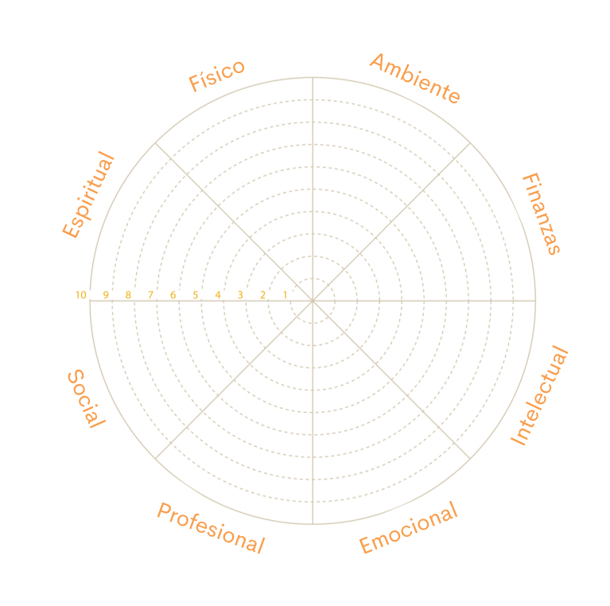

- Define the questions for each axis

Here are some sample questions to ask yourself. Each person will determine what is relevant to having well-being in her life and achieving an appropriate balance between the personal and the professional.

In each question, within the wheel, the corresponding response from 0 (low satisfaction) to 10 (high satisfaction) is marked with an X.

Physical well-being  Recognize the need for physical activity, diet, sleep, and nutrition during those times. | - Do you eat healthy and nutritious food? Do you have a daily or weekly plan for your meals?  - Do you have time to exercise regularly and feel fit and strong?  - Tip: sometimes gender stereotypes limit us to carry out certain physical activities, are you a woman and have you always wanted to play soccer or baseball, are you a man and do you like modern dance? Dare to practice them.  - Do you get enough sleep, in your usual routine, to maintain your health?  - On average, do you wake up at the same time every day?  - Do you take a day off when you are not feeling well, or do you go about your daily routine?
Environmental  Good health by being in pleasant and stimulating environments that in turn support general well-being. | - Do you find time to connect with nature and spend time outdoors?  - Tip: take a short walk or do visual meditation outdoors. If you don't have access to the outdoors, seeing a photo of yourself in nature can help you connect.  - Do you feel security and comfort in your home or your main living space?  - Is your space tidy? Is there a distinction between your place of work / rest / reading or meditation, no matter how small it is?  - Is your workspace conducive to bringing out your best self? Does it foster a positive relationship for your work, with a comfortable chair, good lighting, and perhaps a connection with nature?  - Do you have a place where you can sit and reflect, or that is conducive to reflection?
Professional  Personal satisfaction and enrichment derived from work | - Do you experience any kind of gender inequality in your work environment?  - Are you satisfied with the career path you are in now?  - Do you find joy and meaning in your work?  - Are you committed to your current job?  - Are you creating spaces during quarantine to invest in your professional development in your field of work, or to acquire new skills?  - Does your company promote co-responsibility between work and personal life?  - Is the division of housework and care work equal in your family?
Intellectual  Recognize creative abilities and find ways to expand your knowledge and skills. | - Do you take time to develop self-study activities?  - Do you reserve time to learn something unfamiliar, read a new genre, or delve into a topic of interest?  - Are you reading articles or books beyond the news?  - Do you question the information you receive by comparing it with other sources?  - Do you make an effort to broaden your perspective or intellectual range?
Financial  Satisfaction with current and future financial situations. | - Do you feel like you have a healthy relationship with money?  - Are you in control of your finances and those of your home?  - How satisfied are you with your current and future financial situation?  - Do you keep a budget or your own way of managing your finances?  - Do you feel prepared or prepared for future expenses, including short-term and long-term emergencies or potential emergencies?
Emotional  Coping with life effectively and creating satisfying relationships. | - Do you consider yourself optimistic (most of the time)?  - Do you have a strategy for when you get stressed?  - Do you see challenges as opportunities rather than obstacles?  - Do you have strategies or time to express and reflect on your emotional well-being?  - Tip: in society there is a prejudice that men should not express their emotions, but this is harmful for them. The expression of emotions is vital to the well-being of all people.  - Do you take responsibility for your own behavior or do you blame other people?
Social  Develop a sense of connection, belonging, and a well-developed support system. | - Do you like yourself as a person?  - Do you connect well with other people and foster healthy friendships?  - Do you have a strong network of close friends and family?  - Do you find it valuable to create networks with other women to support, strengthen and share experiences?  - Tip: sorority is an alliance that seeks to generate positive relationships between women, mutual support for the empowerment of each one and to work to eliminate discrimination that is commonly experienced and thus achieve a just and equal society.  - Can you communicate your feelings effectively to other people?  - Are you actively expanding your social circles and social interaction with people of different ages, ethnic origins, races, and lifestyles?  - Do you keep in touch with friends and family you trust to see how they are doing and keep the connection alive?  - Do you know what helps you to feel less alone or alone?  - If you have difficult times, have you approached trusted people to share your feelings and ask for social-emotional support?
Spiritual  Expand the sense of purpose and meaning of life. | - Do you have a tradition, practice, or ideas that connect you to a broader and deeper purpose or meaning?  - Do you create space in your life to explore the deeper questions that life offers?  - Do you take the time to experience new things?  - Is there a book, meditation, movement practice you can try to foster your spiritual connection?  - Do you create space during your days to pause, sit and reflect?

- Score each aspect

Once the number of areas considered fundamental in the life of the person has been selected, they are given a score based on the degree of satisfaction perceived for each one of them.

Typically, the scores range from 1 not at all satisfied to 10 for fully satisfied. The lower the score, the closer to the center of the circle the point will be placed for that particular aspect:
- Scores from 8 to 10 mean that the person is very satisfied in the particular area.
- From 5 to 7 represent that, although it is not very unhappy, an improvement should be initiated.
- Less than 4 indicate that a way to improve them must be urgently sought.

- Join areas and analyze

Once values have been assigned to each area, they proceed to join them by drawing a line and thus a geometric figure is drawn. When the values for each aspect have been joined, it will be possible to see what the life of the person is like in broad terms, according to the methodology of the wheel of well-being.

If the figure that has been drawn is more or less harmonic, similar to a circle, it means that there is a certain balance. On the other hand, if the figure is irregular, with ups and downs, it indicates that there are areas that are less satisfied than others. It should be noted that the fact that there is a certain harmony does not mean that the person feels completely satisfied. It is possible that all aspects are so low that there is harmony as to how dissatisfied you are in general with his life.

- Start the change

Once the points where there is less satisfaction have been identified, it is time to make changes. To achieve transformations it is necessary to develop an improvement plan. It is very important to meditate in depth what actions are to be taken in the selected aspect, and possible obstacles that may be encountered along the way should also be taken into account.

Brainstorming ideas can be helpful at this point, as well as asking others what ways they have used to find balance in the short and long term. It is quite productive to select goals to be achieved in the short term, which are realistic, but, at the same time, stimulating, since they will facilitate reaching the final objective and will help to maintain focus and motivation.

In the case of carrying out this activity in a group, it is recommended to share findings and learnings from the exercise, as well as steps to follow to achieve the expected balance.

It is advisable to carry out, after a certain time, a new wheel of life, comparing how it was when starting the process and how it is now.

Resources

Wheel Quiz: https://wheelofwellbeing.com/quiz/

Wellness Wheel: http://www.tritechsc.org/wellness/

UMatter is an initiative of Princeton University that seeks to provide the necessary tools to create a safer world and communities that cater to their members. They define wellness as a life-long process that consists of making decisions to live a more balanced and meaningful life; it is not just the presence or absence of disease. The university's tool consists of doing a self-examination and developing an action plan for the students.
https://umatter.princeton.edu/action-matters/caring-yourself/wellness-wheel-assessment

In response to the COVID-19 pandemic, Indiana University launched psychological support programs, believing that it is more important than ever to practice self-care, resilience and maintain connections despite being in lockdown.
https://healthcenter.indiana.edu/health-answers/psychological-stress/wellness-wheel.html

Tool 6. Analysis of gender gaps in talent management

The disaggregation of information by sex is an indispensable tool and a first step to use the gender approach in the operation of the company. Its importance lies in the fact that it allows to make visible the differentiated situation of women and men, calculate gender gaps, choose the highest priority actions, plan in an informed way and monitor the impact of the actions.

To generate and use sex-disaggregated data in the organization on a permanent basis, it is recommended:
- Exploit the available data including the sex variable, especially those that can be taken from administrative records.
- Identify the gaps between women and men, do not only present data on women.
- Cross the sex variable with other relevant characteristics to deepen the analysis.
- Present reports with statistics and indicators disaggregated by sex on a regular and systematic basis, as well as use the results for decision-making.

This tool aims to highlight the importance of adding disaggregation by sex and age in talent management in a company, to identify gender gaps. It is a medium level of complexity and requires a basic understanding of Power BI Desktop.

- Tool 12. Data analytics for my company from lens 3 is an introduction to data analysis or data analytics.

This guide is focused on a managerial profile and the team of human resources analysts of a company. It explains which graphs allow a better visualization of the distribution by sex and age in various areas of a company. It also explains how to perform the sex ratio calculation using Power BI.

Talent management is a central aspect in companies. Recognizing the importance of having employee growth and retention plans implies having key information about the people who make up teams, such as sociodemographic characteristics and performance. You can seize the opportunity to strategically use that data and learn about retention and performance trends by looking at gender and other demographics.

Tool benefits

Deepening the knowledge of the personnel is essential in any analysis of human resources. Having sociodemographic information that characterizes people can enhance the development of growth plans aligned with their profiles and close gender gaps in positions and areas where they exist. For example, a company can detect that there are different proportions according to sex and age, depending on the position, leadership level or area. Analyzing the data, questions such as: are there certain occupations with a greater presence of men in the company? Are women receiving the same training as men? Are leadership positions equal between them and them?

The analysis should be considered from the recruitment and selection phase. Are women and men applying for vacancies equally? Are people of both sexes making progress in the selection processes? Data analysis tools allow a simple and clear visualization of gender gaps within a company, which is the first step in designing strategies to start closing them.

Definitions and key terms

In order to promote a better understanding of this tool, some key terms are presented that will be covered in this guide.

Stacked bar charts: when wanting to visualize whether within a company there are differences between groups of people by variables such as sex and age, it is significant to reflect on the type of graph that best expresses the distribution. Line, pie, and bar charts are the most common, but they fail to adequately display the composition of groups of people.

In order to be able to see in a simple and easy way distributions by sex and age, the use of bar graphs stacked at 100% is suggested. These types of graphs expose the percentage of the totality of each group and are represented by the percentage of each value against the total amount in each group. This makes it easier to see the relative differences between the quantities. They are useful to reveal the compositions, for example, to analyze if the distribution by sex of the people is equal in the areas of a company or to see the distribution of women and men according to their seniority.

Sex ratio: the ratio or proportion of sex (also known as sex ratio) is calculated as the quotient between the number of men (numerator) and the number of women (denominator). The calculation is completed by normalizing the result by 100. How do you read this ratio? If the sex ratio is greater than 100, it means that there is a higher proportion of men than women. If the sex ratio is less than 100, it means that there is a higher proportion of women than men.

The sex ratio is a simple and easy-to-read metric that can be used when it is necessary to synthetically view the distribution of a group of people by gender. It is practical and allows you to see with a single number how balanced a population is in terms of the proportion of women and men that make it up. It can be used in all types of analysis of groups of people within a company, suppliers or clients..

Steps for implementation

To exemplify the use of this tool, the case of a company with 1,300 male and female employees is presented and two ways of graphing the distribution by sex according to their age are used: stacked bars and 100% stacked bars.

The graph on the right shows that the higher the seniority (measured in years), the higher the proportion of women. Among those who have been here for less than a year, the proportion of men is almost equal to that of women, while among those with more than 5 years of age, 77% are women.

In the graph to the left, it is not at first glance that the proportion of women is constantly growing, group after group. That is why it is recommended to use 100% stacked bars to better visualize these differences.

Graph 1. How to better visualize gender and age distribution with 100% stacked bars.
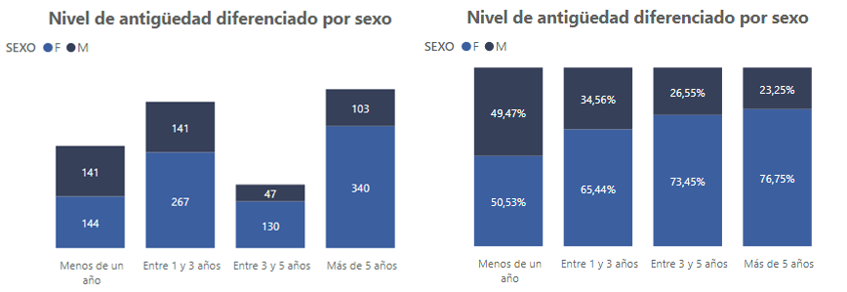
Source: Own elaboration based on the information of the use case

This video details the process of preparing the dashboard that shows different examples of how to visualize disaggregations based on the use case:
https://drive.google.com/file/d/1J8Acux-Gsyq0vjQsxnskDb8Mx40Ox_do/view?usp=sharing

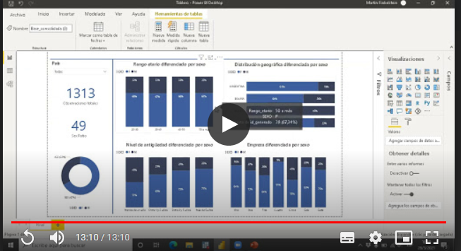

In this link you can download the Excel file with the data used for the example and video tutorial:
https://drive.google.com/file/d/1BiH1QDOcsQNV8OLiGWklORODXCAES_Hq/view?usp=sharing

Steps to build a stacked bar chart in Power BI

- Select the fifth available graphic in the "visualizations" tab.

- Once the graph to be used has been selected, to replicate the graphs presented in the video, it is necessary to complete three boxes within the “fields” section: axis, legend and values.
  - In the "axis" box, put the variable that we decide to implement to make the division between bars.
  - On the other hand, in the "legend" box, the variable that we want to use to perform the division within each bar is inserted. In the case of the example, given the nature of the board presented, the variable “sex” was always used.
  - Finally, inside the "values" box, insert the variable that indicates the value that we need the bars to take. In the presented board, we tried to make a simple count of all the observations. For this reason, the count of the variable "generated_id" is used, which is a unique identifier for each of the observations presented in the database.

Steps for calculating the sex ratio

- The first step in calculating the sex ratio analogous to the one presented in the video is the creation of a measure. To do this, it is necessary to go to the "fields" tab, touch the right button on the name of the loaded database and select the option "new measure".

- Once the index is created, the calculation of the sex ratio itself will have three steps.
  - First, the number of observations in the database that have been identified as male is counted and divided by those that have been identified as female. For this, the “calculate” function is used, followed by the “count” function.
  - To differentiate the calculation from the observations of men and the observations of women, it is necessary to filter it with the variable “sex” and the respective value of its categories (in this case it will be M for men and F for women).
  - Finally, the calculation is closed by multiplying the division by 100 to normalize the result obtained.

Formula for calculating the sex ratio

Sex Ratio = (CALCULATE(count(‘Consolidated_base´[generated_id]), ´ Consolidated_base ´[SEX] = “M”)/ CALCULATE (count ‘Consolidated_base‘[generated_id]), ‘Consolidated_base‘[SEX] = “F”))*100

- Consolidated_base is the name of the database
- generated_id is the name of the database field that allows us to count the number of people in our database
- Sex is the name of the database field where the declared sex of the person is specified. It has two values, F=Female, M=Male.

Resources

Microsoft Power BI. Visualization types in Power BI. Available in:
https://docs.microsoft.com/es-es/power-bi/visuals/power-bi-visualization-types-for-reports-and-q-and-a

Lens 3. Products and services that benefit women and girls

This lens addresses the impact of the company's products and services on the lives of women and girls. It allows analyzing whether they are taken into account in the company's mission, understanding their real needs as consumers and developing markets focused on them.

It is composed of the following tools:
- Creation and development of products with a gender perspective
- In-depth interview
- Person’s Path of understanding
- Empathy map
- From findings to opportunities
- Storyboard: The product idea
- Three-dimensional balance
- Prioritization of ideas
- Role play
- Usability test
- Elevator pitch: The sales pitch
- Data analytics for my company
- Analysis of gender gaps in the sales process
- Customer segmentation
- A/B testing: Product testing

Tool 1. Creation and development of products with a gender perspective

Welcome to the mistake zone. In this section, you must forget everything you have learned in order to learn again, it is time to unlearn unlearn.

This set of tools for creating and developing products with a gender focus is based on the design thinking methodology and is designed to challenge the beliefs of the members of the company, open a world of possibilities, a space where intrinsic capacity Acting creatively will reach its peak in a revealing, enriching, multidisciplinary and sensory experience.
Oops… Our first mistake.

With which you can answer:

Can products be an agent of change?
The tools on the creation and development of products with a gender perspective have been prepared by product designers who seek, through methodological transfer, that companies can take the process of creating and developing their products or services as their own. It is postulated that these tools teach companies to innovate and continue to do so, in addition to the fact that the look from the field of design will always be beneficial.

“According to the North American magazine Business Week, the innovation process consists of recreating business models and building totally new markets that target unmet human needs, especially to select and execute the right ideas, bringing them to market in record time."

The methodology proposed in this set of tools is design thinking, which opens up new paths for business innovation, from product creation to improvement in the work environment.

A product is the manifestation of the multiple decisions, initiatives and steps that a company has had to take to get its ideas to materialize into something tangible and valuable. A product is the reflection of the various environments in which we develop as people and design is the agent of change responsible for integrating both aesthetic, cultural and social trends into them.

The discipline of product design seeks in the first instance to generate well-being in people's lives. The question then arises: How can a product help generate well-being in people if, unintentionally and inadvertently, it promotes gender inequality and increases the gap of opportunities between men and women or groups in situations of discrimination?

The products and services that companies market can be an agent of change in society by focusing their efforts on meeting the needs of populations that have not been served until now. And this approach not only benefits the image of the company in front of society, but also provides a vision that will allow it to open a range of possibilities for profitable solutions and innovative products in unexplored markets.

To read an article on "How design thinking can help address gender bias in the workplace," visit:
https://www2.deloitte.com/us/en/insights/topics/value-of-diversity-and-inclusion/design-thinking-business-gender-bias-workplace.html

Why is it important for companies to create products with a gender perspective?

Products are an important part of everyday life, they are a medium with which people constantly interact and interact and a conscious and gender-sensitive design is crucial for an inclusive future. In the past, the design of products and services commonly focused on a stereotype of a male and young consumer, but this figure causes stereotyped ideas or perceptions to be incurred that do not allow to visualize the diversity within groups, for example, between women and men.

To avoid falling into gender stereotypes with products, it is necessary to reflect on whether it impacts differently on the lives of women and men and whether their needs were considered; For this, it is crucial that, during product development, both the interests and expectations of women and men are taken into account in the creation process, and that there is a balance between the members of the teams responsible for developing the products. processes.

Design with a gender perspective can contribute to:
- That the product does not reproduce gender stereotypes.
- That the product meets a need of women and girls that was not being met.
- That the product contributes to closing gender gaps or promotes the advancement of gender equality.

Designing with a gender perspective promotes satisfaction, empowerment and the inclusion of clients in markets and spaces in which they were not traditionally considered.

To counteract the implicit gender biases that may be holding back women and other groups in situations of discrimination, companies or organizations can apply the 5 stages of design thinking to involve their workforce, seeking a balance and diversity among the members, and iteratively redesign the products and services they market.

It is suggested to create an innovation and development committee. It can be given another more personalized name, such as: Dream Team, The Idea Machine, The Creative League, etc.), which can work intermittently, being activated by projects and partially committing the time of its members, but at its own expense. Once it must be legitimized and endorsed by the general management of the company.

For its creation it is suggested to take into consideration the following:
- Must have a leading figure. When choosing her, it is good to consider that women in leadership positions have achieved excellent results when it comes to increasing team performance, the quality of decision-making and increasing team collaboration.
- It must be multidisciplinary, with representatives from different functional areas of the company, to have different integrated technical capacities, in addition to having formal and informal leaders.
- It must have gender parity and be as diverse as possible. This refers to having the same participation of men and women, in addition, if possible, having cultural and age diversity.
- The members must meet these characteristics:
- Have a genuine interest in innovation, creativity, results and growth.
- Be curious, resilient and able to handle ambiguity.
- Understand the importance of teamwork, since most of the tools on product design require the participation of the entire team.
- If it is a small company, a team of 3 or 4 people can be formed, and if it is a larger company, a team of 6 or 7 people can be formed. More than 7 people could not work.
- Depending on the project, specialists could be added to strengthen the team in the missing skills and knowledge.

Before carrying out the tools for creating and designing products with a gender perspective, it is advisable to align the objectives of the committee with those of the company, so that the efforts made do not fall into abysses of disinterest on the part of the company's management. .

Additionally, and imperatively, to guarantee that the solutions and innovations that arise from the tools really have a gender focus, the committee must be trained on gender equality and on the stereotypes present in products and services, taking into account that it is culturally acquired information and therefore can be modified.

Some examples of gender stereotypes that can be found in products and services are:
- Products for women in pink, with which they are traditionally associated since they were little.
- Women as the sole responsible for the home and care. It can be seen in many television commercials, especially for cleaning products.
- Unnecessary decorations or applications, which serve no function, in women's products, because it is believed that they appreciate adornments.
- Women occupying support positions, for example, in bots such as Siri, Alexa and Cortana, who delve into the idea that they are at the service of other people, without a correct approach to responding to sexual harassment, which can contribute to reproduce prejudices and inequality, being present in millions of homes and pockets.
- Basic personal hygiene products for men designed in dark colors and with textual clarifications about their character as a conqueror and attractive.

In many of the tools, previously collected information on the market will be requested, in order to carry them out profitably. The data collected through conventional research instruments must be collected and expressed in a way that helps to carry out the analysis with a gender equality perspective during the creation and development of products and services.

The information that a company has is mainly composed of two types of data: quantitative and qualitative, obtained from previous research. Quantitative data are usually generated through market studies, surveys, statistics created by the use of an Internet page, censuses, among others. The qualitative data is obtained from different sources of open communication such as interviews, focus groups, observations, real phrases of users, experiences of the staff, reviews, complaints and suggestions regarding the product or the experience of its use. In all cases, it is required to have sex-disaggregated data.

The data that will be used to implement the product design tools must be available to women and men. There are tools that analyze and work directly with the data throughout its application and in these it is constantly emphasized that it is essential that there is an analysis that considers the differentiated situation between one and the other, but there are also several tools in which it is requested arrive with the previous data already prepared, in this case it is also very important to take this point into consideration. People are not a homogeneous group, women and men have different needs, perceptions and realities, so it is essential to make this visible through information disaggregated by sex, which helps to identify the gender gaps that may exist.

Warning
This toolkit can turn a person into #DesignThinker. Its excessive use can cause a predisposition to not want to follow social norms and to see the world in a different way.

A design thinker is a dissatisfied, questioning, sensitive observer person. In short: a disruptive person who causes discomfort through his challenges in those who usually use order, analysis, induction and deduction as working methods. This can be a bit awkward for traditional management, because designing is partly guessing, and guessing is not considered one of the pure forms of logic.

Tool 2. In-depth interview

El proceso del pensamiento de diseño o design thinking empieza con una profunda comprensión de la persona usuaria, y para ello se invita a empatizar, que significa sumergirse en la manera en cómo viven las y los actuales y posibles clientes, cómo usan los servicios y productos de la empresa, observar y formular hipótesis de por qué hacen lo que hacen.

To learn a little more about empathy, here is a video from Brené Brown, a researcher at the University of Houston:
https://www.youtube.com/watch?v=1Evwgu369Jw

Companies that are interested in expanding their business to reach new segments of the population, as well as those seeking to diversify target markets and at the same time benefit society, a research tool based on empathy will be a good point of departure. departure.

On the other hand, to counteract the implicit gender biases that may be affecting current clientele it is important to carry out exploratory research and the following tool can help to achieve this.

This particular tool allows companies to know their customers in depth in an objective way to know what they think, what they feel, how they explain certain situations, etc. As already mentioned, it is important to carry out this scrutiny to eliminate the assumptions of needs tied to gender labels and to give a voice to the public that has been neglected in the previous processes of product creation.

The benefit of conducting in-depth interviews is the guarantee of recognizing and understanding the needs of both women and men. This gives way to a deep understanding and development of empathy with the people interviewed, allowing their identified needs to be covered at the same level with the solutions that are proposed. Unlike conventional interviews where it is a matter of identifying what the user is doing, in-depth interviews aimed at creating products or solving problems are about understanding why they do it.

Many times it is forgotten that products or services exist to solve humanity's challenges. To identify these challenges, in-depth interviews can be carried out with previously selected people. Here are some tips to define the profile of these people.

Profile selection

In order to select the appropriate profiles of the people to be interviewed, it is necessary to be clear in what phase of innovation the company is in and what level of transgression will occur at the time of the search for the solution. Always remember to maintain parity in the chosen profiles, that is, half of women and half of men, to ensure that the investigation equally includes their voices.

If the company needs to improve an existing product, a dissatisfied customer and customer must be chosen. Dissatisfied customers are an excellent source of information and learning.

If the company is looking to launch a new product, it must choose a potential client and client who already consume the product, but from the competition or alternative products. The idea is to obtain information on what that target audience is valuing to devise an ad-hoc solution.

And to transgress the solution? You must also choose two people who are not part of the market, people who apparently could not buy the product or hire the services of the company. These profiles can provide Insights on how the product is perceived from an unfamiliar point of view.

Go ahead and choose girls and boys for this purpose!

IDEO proposes that a solution to avoid falling into conventionalities and continue doing business in the traditional way, or continue playing under the same rules, during the process of creating products and services, is to seek the help of children. Unlike adults, when girls and boys try to solve a problem they do not take into consideration factors such as the technical or financial feasibility of the solution, they only think and propose it, making the divergent phases more enriching. By ignoring the conventions, they have the door open to be able to think of solutions that are not obvious and even qualified as “outside the box”, which are formed as the person is exposed more to the world and to other people in it. Thus, through the tools of design thinking, new forms of solutions free of limitations can be developed.

If a product is designed specifically for women or men, the profiles to be selected will be of a single sex, but the greatest possible diversity should be sought in terms of other sociodemographic variables.

The in-depth interview is a non-traditional research tool that seeks to gain an understanding different from the conventional ones. Therefore, it may be the case that the company has carried out other types of previous investigations that apparently suggest a demand in the market for a product aimed at a particular sex. At this point, in-depth interviews will help to understand and collect information about this group that would not be feasible to collect through conventional methods.

It is essential to be clear that this segmentation and differentiation in the product to be developed is not based on socially assigned roles and stereotypes about what is understood by feminine and masculine. Products and services must be created and developed based on the needs they seek to satisfy and the functions they must fulfill. If both components are transversal, then there will be no reason for differentiation, especially if this differentiation may cause an extra cost for women or men.

In any case, if there is the possibility of falling into an unnecessary differentiation, this tool will help to elucidate if it is indeed happening or not, since it will raise the true needs of the group to which the product is directed and not others based on preconceptions. about behaviors and attitudes that are considered culturally appropriate or typical of women and men, and that may be reproducing gender stereotypes.

What do you need to create the script?

In-depth interviews are aimed at obtaining qualitative and subjective information. To do this, they should encourage spontaneity, but it will be helpful to be based on a script.

A great way to prepare the script for an interview is as a team. It is advisable to convene the innovation and development committee, a group can also be formed that has the same number of women as men, who have knowledge about gender equality and who have the ability to recognize possible stereotypes.

- The innovation and development committee is a proposal located in tool 1. Creation and development of products with a gender perspective, within this same lens.

Then, it will be important to define the objective of the interview, it should not only be done to "know the user", having this single approach will not help when collecting the information. The objective must be clear to direct the questions.

Some examples of objectives for interviews are:
- How does a person feel when acquiring a personal loan and what they think are the steps to acquire it.
- Learn about how bus drivers share incidents on their routes and what they feel may be the challenges and opportunities in such information exchange.
- Find out how dog walkers choose their routes and what they feel works best for them, what problems they are running into and how they think they can improve them.

Once the team and the objective of the in-depth interviews have been defined, the script creation session can be carried out:
- Use sticky notes to post topics and possible questions
- Prepare bookmarks or your favorite web application to create a board with these notes. Here are some applications:
  - Miro
  - Mind42
  - Jamboard
- Define a time for this activity
- Filter the recurring questions
- Separate them by topic

In general, when conducting an interview, it should be remembered that it is a dialogue, prepared, designed and organized in which the roles of the person interviewed and the person conducting it are previously established. It should be based on four interlocking criteria:
- No direction: try to make most of the responses spontaneous or free, rather than forced or induced.
- Specificity: encourage the interviewee to give concrete answers, not diffuse or generic.
- Amplitude: inquire into the range of evocations experienced by the person interviewed.
- Personal depth and context: You should get the relevant personal context, idiosyncratic associations, beliefs and ideas.

The interview should feel like a conversation, alternating between different types of questions and talking about external aspects, such as actions, and internal aspects, thoughts.

So that it can be done in a relaxed way and contribute with the greatest amount of truthful information, it is suggested to go after the stories that may be of interest to the project. Of course, always an introductory, unrelated story can help build the relationship with the interviewee and predispose them to share more “inside” information.

For the same reason, this tool should be given "one to one". One person interviewed with another person or with a couple of interviewers.

The average duration of an in-depth interview is: 90 to 105 minutes.

Structure of an interview

Introduction: 5 minutes

- Personal and project presentation

Taking into account that it should be carried out as a conversation in order to connect with the person interviewed, it is important to show the greatest possible empathy and bring out the most human side. It is advisable to start with a personal presentation and the project or product that is being designed.

Example: “Hello, my name is Bianca and he is Carlos, we are working on a project to improve the experience when drinking coffee. Our challenge is to find new moments for consumption.”

Kick off: 30 minutes

- The person

It is important to establish who the person is, asking them to describe their activities, building a relationship through the description of a common day, ideally related to the topic of the project.

Example: "We would like you to help us to know more about you to be able to solve it. How are you doing today? Could you tell us a bit? "
"Did you have coffee today? How was it? Do you have a favorite coffee? "

Grand tour: 30 to 45 minutes

- The experience

It looks for details and emotional problems related to the research topic. At this time, the person should be encouraged to tell a story and describe her emotions.

Example: “Could you describe your most memorable coffee experience? Why was it so unique? What happened?"

Reflecting: 15 minutes

- Challenges and contradictions

It will be important to determine what are the successes and failures related to the research topic. The interviewee should be invited to reflect on the challenges and contradictions, for which it will require responding and evoking more answers with counter questions and questions.

Example: "If you were to create the best coffee shop based on your ideal experience ..."

Conclusion: 10 minutes

- Thanks and closing

Thanking the person interviewed, if it is within the means, rewarding the time invested in some way and keeping the camera on, in the end interesting things can happen.

The anatomy of an interview can then be seen as a hill, where the maximum peak occurs at the moment when emotions are expressed. An illustration of the anatomy of an interview is presented here, it can help clarify the moments that are part of it.

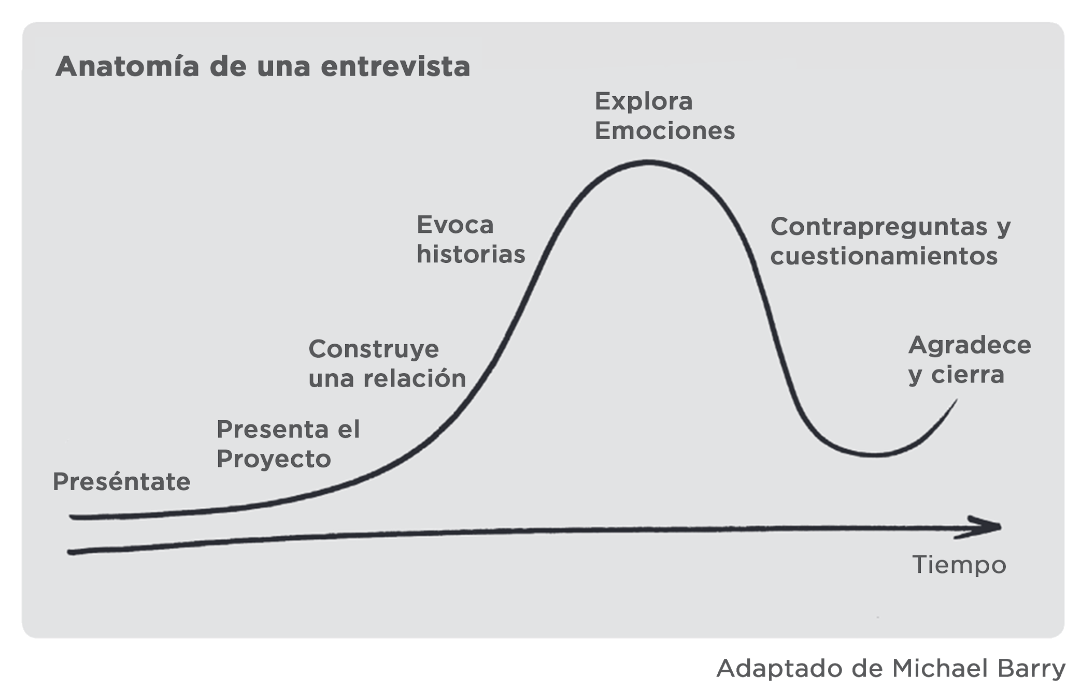

Throughout the interview you should pay attention to what he says and look for similarities. Share something personal, trying to convey as much honesty as possible to help build trust.

Do not forget to collect the information that is obtained by observation. Body language may be conveying something contradictory to what is being said.

It should be remembered that the idea is to go after stories and emotions, so in order to encourage participants to reflect and reveal what is important to them, open questions should be asked, which can go from the rational towards the emotional.

Some types of open questions

Have you thought about…?
Exploratory: They force expansion into new vantage points and unexplored areas.

How do you feel about ...?
Affective: They reveal feelings about something.

What do you think causes ...?
Reflective: They encourage further elaboration of response.

Can you describe how ...?
Investigating: They invite a deeper inspection.

What are the causes of…?
Analytical: They look for the roots of the problem.

So, by that you mean ...?
Explanatory: They help to be aligned and avoid misunderstandings.

Finally, it is important to collect the information in a way that helps to continue with the creation and development process, for example, if you are working with a mixed sample, the results of men and women should be collected separately, so as not to lose sight of the results. wishes, interests and expectations of both groups.

- To find out the importance of using information disaggregated by sex, visit tool 1. Creation and development of products with a gender perspective, located in this same lens.

Once the interviews are finished and as part of the information processing, the following matrix is filled out with the entire team that participated in the interviews (not the people interviewed) , each response must be on a sticky note. You can use a different color forr each person on the team.

¿QUÉ HAS DESCUBIERTO QUE NO SUPIERAS?
¿QUÉ CREES QUE TE FALTO POR DESCUBRIR?
¿QUÉ TE HA IMPACTADO?
¿DÓNDE TE GUSTARÍA PROFUNDIZAR? ¿QUÉ DUDAS TE HAN QUEDADO?

As it is a matrix that collects impressions and analyzes, it could also be affected by biases and gender stereotypes inherent in the people who make up the team, hence the importance of having these trained personnel.

If it is taken into account that the objective of the tool is to carry out an in-depth exploration, and then work on solutions based on it, then coloring the way in which the information of the interviewee is collected can be triggered by social conventions. all subsequent work lacks assertiveness and ends up repeating biases and increasing inequality gaps.

It is convenient to review the checklist for this tool once more:

To create the script

Diverse Team, parity and knowledge about gender equality: same number of men and women, able to identify possible stereotypes, ideally the innovation and development committee.
Brainstorming material to come up with the script (sticky notes and markers or web app)
Relaxed and stimulating environment. You can play some music, for example.
Definition of the questions: they must be formulated according to the objective, it is important to pay attention to how they are stated, maintaining an inclusive language will help to give visibility to all people.
Organization: In what order the questions will be asked so that it feels like a conversation, remembering that there should be some flexibility.

always ask:
why?

And music?

Music is another powerful
tool that helps increase
productivity and ideation.

Accompany this session with a
song. Here is a recommendation:

EXPRESS YOURSELF
CHARLES WRIGHT & THE WATTS

Scan this code from the Spotify application to access the recommended song to come up with the tool's script:

- To learn more about inclusive and non-sexist communication, visit the tools on this topic in lens 4: 2. Inclusive and non-sexist language for companies and 3. Inclusive and non-sexist digital communication for companies.
Still not ready to call girls and boys?
find the full article at the end

To conduct the interview

People to interview: minimum 4 to have an interesting sample. Check out the profile selection section for a better guide.
Pair up interviwers, (2 interviewers): it is difficult to connect with someone and keep the score at the same time.
Choose a comfortable environment for the interviewee, ideally related to the project. For example, for a dog walker, the interview might take place in a park.
Ask one question at a time, giving them time to answer.

Respect the silences, do not fear them and do not suggest answers.
Do not ask in a biased way or delving into gender stereotypes. Although it is true that the questions will already be prepared taking into account an inclusive language, as it is a conversation that lends itself to being flexible, it is important to practice self-awareness first. Experiences, prejudices and identities impact what is asked and how the answers and stories are heard. Exploring what one's background looks like can influence vision before embarking on interviews.
Ask the interviewee for permission to record the interview. It is advisable to record the entire interview, from the beginning to the last moment. Sometimes it happens that interesting things are discussed at the farewell.

Finally, it is good to emphasize the importance of a tool like this that empathically collects information from the people for whom the products are created. Through this tool, it is possible to have relevant information to discern a correct market segmentation and lay the foundations for the development of products that meet the true and different needs, desires and desires of the hitherto neglected groups.

How a Kid’s Perspective Improves Design Research. Léelo en:
https://www.ideo.com/blog/how-a-kids-perspective-improves-design-research
Share your experience using the hashtag: #why

Tool 3. Person’s Path of understanding

Empathy is a fundamental element in the development of a product. Users interact in different ways and in different contexts with products and services. The path of understanding the person is a tool that is based on real previous data and research methods, always with the aim of identifying and generating various non-stereotyped profiles of users and thus analyzing their steps and needs individually.

The different profiles of the target users are considered and a specific route is proposed for each one. This manages to visualize situations from new points of view and is very beneficial to understand different groups in more detail and take their needs into account. This tool focuses the dynamics on real data and allows work teams to make inclusive decisions about users, since the areas of opportunity are generated from the analysis of the environments of each type of real profile and not from opinions, assumptions or stereotypical figures.

Tool benefits

The path of understanding of the person allows to detect areas of opportunity and improvement directly related to the desires and needs of each user profile analyzed. It is possible to understand the person more thoroughly, develop greater empathy and see specific situations from the point of view of other people. It is possible to understand why the different profiles behave in certain ways. This is possible taking into account their contexts, identities and ideologies. It is applied when you want to have a better overview of habits, feelings and perspectives in order to add greater value to the product to be designed or redesigned.

Explain it for a being from another world
This tool focuses on the ability of lateral thinking and the ability to put yourself in someone else's shoes to see and understand things from a new perspective. By way of preparation, the “Explain to a being from another world” activity helps to stimulate a non-traditional way of thinking.

- The activity must be carried out in pairs, one part will play the alien and the other part will play the interpreter.
- Let's imagine that we have just met an extraterrestrial being and he is amazed by all the things that he does not know about our planet. The alien being understands the language well, but is not familiar with anything in our world.
- The interpreter tries to explain to the alien habits, actions, objects or inventions that those of us who inhabit the earth usually take for granted. For example: why do we live in houses? What is a car?
- The explanation will last at least 5 consecutive minutes in order not to assume that certain terms or descriptions are understood, the extraterrestrial being will be free to ask anything that he does not understand during the explanation.

What is needed to put this tool into practice?

- This tool should be based on real data previously obtained from social networks, staff experiences, observation of users, interviews or another research method.
- Can be used to synthesize information after conducting surveys, in-depth interviews, or other techniques.
- Data on the behavior and context of target users need to be disaggregated by sex.
- It is suggested to carry out the steps as a group or with the innovation and development committee in order to obtain more complete findings.
- It is highly recommended that the people who make up the team are 50% women and 50% men, and that they have knowledge about gender equality, stereotypes and gender roles.
- The use of this tool is approximately 45 minutes, but you can lengthen the dynamics as long as you want.

Steps for implementation

- Profile creation

  - Based on data, select the profile or profiles that represent the target user of the product or service. The separation of profiles must be carried out when there is a specific characteristic that is of interest to the product or service and it is necessary to seek to stay within a margin of one and five profiles. Unless the nature of the company or the product indicates that, without stereotypes, the product or service is directed to a particular sex, it is important to represent both men and women in the classification of profiles.

  - It is essential to understand that profiles are being segmented according to the representations of a group of people, but this is always with the aim of having greater empathy with each group and avoiding the stereotypes that may become associated with them. In the event that the product or service has been planned to be directed to a particular sex, it is necessary to ensure that this differentiation is essential and is not based on socially assigned roles and stereotypes about what is feminine and what is male. When segmenting the market, it is advisable to think about the functionality of the product and the need to be satisfied through its use, not about preconceived ideas about behaviors and attitudes that are culturally considered appropriate for women and men, and that may be reproducing gender stereotypes.

  - Establish a name, age and a brief description for each of the selected profiles.

  - Select a real face for each profile. Putting a face will make the team more empathetic and understand its users more deeply. Do not use caricatures or images of celebrities as these can cause the dynamics not to have the desired impact. Likewise, it is necessary to pay attention not to reproduce stereotypes about the appearance of people, but to reflect the diversity of women and men that make up the market.

  - Write a biography paragraph for each profile. Relevant data from previous research should be included here, but as a description.

  - After writing the profile bio, the team should reflect on whether they are not reproducing gender stereotypes in them. For this step, it must be questioned whether the diversity of women and men that exists within the represented group is made visible.

Some triggering questions that the team can use for this analysis about the use of gender stereotypes in biographies are:
    - What adjectives are women being described with? Are you using some commonly associated with the feminine, such as: sensitive, dedicated, affectionate?
    - What adjectives are you describing men with? Are some commonly associated with the masculine being used, such as: strong, intrepid, providers?
    - What activities do women and men of each profile carry out? Do they as well as they participate in all kinds of occupations and activities, whether productive or domestic and caregiving?

If this questioning causes a relevant divergence in a profile, it is best to subdivide that profile into two different profiles.

- The route map

  - Establish the range that the route will cover. Define a specific moment or situation in which the user interacts with the service or product, it is possible to create the route on the entire moment of interaction or on a particular section.

  - Define in columns the stages within the route of use that has been selected previously. The stages that are commonly used are "Before", "During" and "After" the use or interaction with the product or service. It is also possible to use more detailed stages or add sub-stages.

  - Add the categories. Each company can add or remove as many categories as they are useful, but the minimum advisable are the following:
    - Actions: narration of the detailed actions of the profile during the defined interaction.
    - Objectives: what the person wants to achieve at this stage.
    - Contact points: parts and branches of the product or service that are in contact with him and the user during the stage.
    - Emotions or satisfaction: understanding of how the profile feels at this point. It is advisable to capture emotions graphically.
    - Opportunities: potential discoveries and opportunities related to the information in each row and column.

In this step it is also essential that the team reflect on the gender approach, so that the actions, objectives, points of contact, emotions or satisfaction and opportunities are not described based on stereotyped ideas about the behaviors and attitudes that are considered appropriate. for women and men, but taking into account the real data obtained from social networks, staff experiences, observation of users, interviews, or other previous research methods.

  - Together with the team, examine the results obtained in the "opportunities" table for each profile and discuss whether these could be future areas for improvement applicable to the product.

Tool application example

Each of the steps of the path of understanding of the person is exemplified below through the practical case of a platform for buying and selling baby clothes.
Previous data
Most of the consumers are in the age range of 27 to 55 years of age. | Most of the consumers are in the age range of 35 to 42 years old. | 25% of users work from home, 60% work in offices or establishments and 15% do not work. | 60% of users have more than one son or daughter. | 68% of the profiles that answered "could improve the service" were within the category of users who work in offices or establishments. | 80% of the registered recommendations come from co-workers.

- Profile creation

  - Based on data, select the profile or profiles that represent the target user of the product or service. The separation of profiles must be carried out when there is a specific characteristic that is of interest to the product or service and it is necessary to seek to stay within a margin of one and five profiles. Unless the nature of the company or the product indicates that, without stereotypes, the product or service is directed to a particular sex, it is important to represent both men and women in the classification of profiles.

  - It is essential to understand that profiles are being segmented according to the representations of a group of people, but this is always with the aim of having greater empathy with each group and avoiding the stereotypes that may become associated with them. In the event that the product or service has been planned to be directed to a particular sex, it is necessary to ensure that this differentiation is essential and is not based on socially assigned roles and stereotypes about what is feminine and what is male. When segmenting the market, it is advisable to think about the functionality of the product and the need to be satisfied through its use, not about preconceived ideas about behaviors and attitudes that are culturally considered appropriate for women and men, and that may be reproducing gender stereotypes.

  - Set a name, age and a short description for each of the selected profiles.

Romina Díaz  26 YO  Web developer | Mario Ruíz  38 YO  Veterinarian

  - Select a real face for each profile. Putting a face will make the team more empathetic and understand its users more deeply. Do not use caricatures or images of celebrities as these can cause the dynamics not to have the desired impact. Likewise, it is necessary to pay attention not to reproduce stereotypes about the appearance of people, but to reflect the diversity of women and men that make up the market.

Romina Díaz  26 YO  Web developer | Mario Ruíz  38 YO  Veterinarian

  - Write a biography paragraph for each profile. Relevant data from previous research should be included here, but as a description.

  - After writing the profile bio, the team should reflect on whether they are not reproducing gender stereotypes in them. For this step, it must be questioned whether the diversity of women and men that exists within the represented group is made visible.

Some triggering questions that the team can use for this analysis about the use of gender stereotypes in biographies are:
- What adjectives are you describing women with? Are you using some commonly associated with the feminine, such as: sensitive, dedicated, affectionate?
- What adjectives are you describing men with? Are some commonly associated with the masculine being used, such as: strong, intrepid, providers?
- What activities do women and men of each profile carry out? Do they as well as they participate in all kinds of occupations and activities, whether productive or domestic and caregiving?

If this questioning causes a relevant divergence in a profile, it is best to subdivide that profile into two different profiles.

Romina Díaz  26 YO  Web developer | Mario Ruíz  38 YO  Veterinarian | Perla García  48 YO  Real Estate Agent
Romina lives in Mexico City and works as a web developer for a logistics company. She has a one-year-old daughter and a 4-month-old baby and she is very happy that her job gives her the opportunity to manage her schedule and to be able to work from home whenever she wants. Romina's goal in the medium term is to invest, but for this she will have to save a few more months. One of her savings strategies is to make smarter purchases and this includes buying pre-owned clothes for her babies, she believes that this is an excellent idea since the clothes are in perfect condition and at a lower price. | Mario loves animals and the environment. He spends most of his day working in a veterinary clinic in the city of Aguascalientes. He does not have his own car since he considers it unnecessary and polluting, but this is not a problem since the clinic is 2 blocks from his house and it is very easy for him to walk back and forth. Mario has 2 daughters, one a year and a half and the other 7 months and he is amazed at how fast they both grow. Mario is concerned because he knows that one of the most polluting industries is textiles and he does not feel comfortable with the idea of buying so many new baby clothes. | Perla spends most of her day touring different parts of the city, works in a large real estate office, but more than half of her workday she is visiting potential properties for her clients and showing houses and land. Perla has 2 older children who are already in college and a younger son, just 9 months old. She is not a new mother so she knows very well the great expense and the amount of products that a baby needs, for this reason she has chosen to shop wisely relying on technology, applications and social networks.

It can be noted that one of the profiles has been subdivided in order to better represent the groups. Both men and women were present, but the age range of women was broader and the team determined that a single profile would not cover it well enough.

- The route map

  - Establish the range that the route will cover. Define a specific moment or situation in which the user interacts with the service or product, it is possible to create the route on the entire moment of interaction or on a particular section.

  - Define in columns the stages within the route of use that has been selected previously. The stages that are commonly used are "Before", "During" and "After" the use or interaction with the product or service. It is also possible to use more detailed stages or add sub-stages.

Romina Díaz  26 YO  Web developer | Romina lives in Mexico City and works as a web developer for a logistics company. She has a one-year-old daughter and a 4-month-old baby and she is very happy that her job gives her the opportunity to manage her schedule and to be able to work from home whenever she wants. Romina's goal in the medium term is to invest, but for this she will have to save a few more months. One of her savings strategies is to make smarter purchases and this includes buying pre-owned clothes for her babies, she believes that this is an excellent idea since the clothes are in perfect condition and at a lower price.

Scope of the route to be analyzed: From looking for the garments in the application to having the product in your hands.

 | Before | During | After

  - Add the categories. Each company can add or remove as many categories as they are useful, but the minimum advisable are the following:
    - Actions: narration of the detailed actions of the profile during the defined interaction.
    - Objectives: what the person wants to achieve at this stage.
    - Contact points: parts and branches of the product or service that are in contact with him and the user during the stage.
    - Emotions or satisfaction: understanding of how the profile feels at this point. It is advisable to capture emotions graphically.
    - Opportunities: potential discoveries and opportunities related to the information in each row and column.

In this step it is also essential that the team reflect on the gender approach, so that the actions, objectives, points of contact, emotions or satisfaction and opportunities are not described based on stereotyped ideas about the behaviors and attitudes that are considered appropriate. for women and men, but taking into account the real data obtained from social networks, staff experiences, observation of users, interviews, or other previous research methods.

Romina Díaz  26 YO  Web developer | Romina lives in Mexico City and works as a web developer for a logistics company. She has a one-year-old daughter and a 4-month-old baby and she is very happy that her job gives her the opportunity to manage her schedule and to be able to work from home whenever she wants. Romina's goal in the medium term is to invest, but for this she will have to save a few more months. One of her savings strategies is to make smarter purchases and this includes buying pre-owned clothes for her babies, she believes that this is an excellent idea since the clothes are in perfect condition and at a lower price.

Scope of the route to be analyzed: From looking for the garments in the application to having the product in your hands.

 | Before | During | After
Substages | Log in or Sign up | Filters and searches Selection Payment | Pick up the clothes Use the product Recommen-dation
Actions | Access the digital platform using the name and password | Compare alternatives Add items to the shopping cart Pay | Go to pick up the clothes purchased at the indicated point Trying on baby clothes on her child Share her experience
Goals | Quick and easy log in process | Find products that meet her needs Easily identify if she has already added the product or not Accumulate benefits, know how much she has saved | Being able to receive her orders in more convenient places Get a product according to the description Share her satisfaction and give feedback
Contact point | Splash screen and Sign up or Log in | Product catalog, filters, product details Product description, shopping cart Shopping cart, receipt details | Delivery details, messages, customer service Second hand clothes Word of mouth, social media
Emotions
Frustrations | Long loading periods | - Not being able to see in real time what she has spent in her cart Lack of point or benefit programs for frequent customers | Lack of time and willingness to leave home and get around - She recommends it to her friends and family through social media.
Opportunities | Optimize technology to be faster | Have a more extensive catalog Provide exclusive and seasonal offers Generate greater benefits to frequent customers | Add shipping or packaging option Add a photo of the product received in user reviews Use a # or a channel where she can share her experience

  - Together with the team, examine the results obtained in the "opportunities" table for each profile and discuss whether these could be future areas for improvement applicable to the product.

Romina's profile was used for the step-by-step example above, but the team developed all three profile paths in the same session. The following are also those of Mario and Perla.

Mario Ruíz  38 YO  Veterinarian | Mario loves animals and the environment. He spends most of his day working in a veterinary clinic in the city of Aguascalientes. He does not have his own car since he considers it unnecessary and polluting, but this is not a problem since the clinic is 2 blocks from his house and it is very easy for him to walk back and forth. Mario has 2 daughters, one a year and a half and the other 7 months and he is amazed at how fast they both grow. Mario is concerned because he knows that one of the most polluting industries is textiles and he does not feel comfortable with the idea of buying so many new baby clothes.

Scope of the route to be analyzed: From looking for the garments in the application to having the product in your hands.

 | Before | During | After
Substages | Log in or Sign up | Filters and searches Selection Payment | Pick up the clothes Use the product Recommen-dation
Actions | Access the digital platform using the name and password | Browse the catalog, filter options, search for promotions on social media Add items to the shopping cart Pay | Go to pick up the clothes purchased at the indicated point Trying on baby clothes on his daughter Rate the platform. Upload clothes to the platform
Goals | Quick and easy log in process | Discover products that catch your eye Get feedback when adding an article Make the payment quickly and safely | Contact the user outside the platform to pay for the shipment Being able to upload the product back to the platform once it is no longer needed Share his experience and be part of the people who upload clothes
Contact point | Splash screen and Sign up or Log in | Product catalog, filters, product details, social media Product description, shopping cart Shopping cart, delivery details | Delivery details, messages, Second hand clothes Word of mouth, social media
Emotions
Frustrations | Long loading periods | The way to filter the content does not contain an environmental category Be redirected to the shopping cart when adding an item No home delivery option available | Its location is not favorable to pick up garments in registered places - Upload products to the platform that had already been previously registered
Opportunities | Optimize technology to be faster | Optimize the filter system Review the architecture and flow of the page Add shipping or packaging option | Add shipping or packaging option Add the option to re-upload the product once used Access a channel where you can promote your garments for being in good condition and being ecological.

Perla García  48 YO  Real estate agent | Perla spends most of her day touring different parts of the city, works in a large real estate office, but more than half of her workday she is visiting potential properties for her clients and showing houses and land. Perla has 2 older children who are already in college and a younger son, just 9 months old. She is not a new mother so she knows very well the great expense and the amount of products that a baby needs, for this reason she has chosen to shop wisely relying on technology, applications and social networks.

Scope of the route to be analyzed: From looking for the garments in the application to having the product in your hands.

 | Before | During | After
Substages | Log in or Sign up | Filters and searches Selection Payment | Pick up the clothes Use the product Recommen-dation
Actions | Access the digital platform using the name and password | Find offers and pickup locations based on your work routes Add items to the shopping cart Pay | Go to pick up the clothes purchased at the indicated point Trying on baby clothes on her son Share her experience
Goals | Quick and easy log in process | Plan how to optimize her time and expenses See more details about the selected clothing Clearly understand how much she will spend | Combine delivery points with her work routes Get a product according to the description and photography Write her review of the products on the platform
Contact point | Splash screen and Sign up or Log in | Product catalog, filters, product details, locations. Product description, shopping cart Shopping cart, delivery details | Delivery details, messages, customer service Semi new clothes Platform, comments, opinions
Emotions
Frustrations | It is more confortable on Tablets | She has to switch platforms to see the locations on the map The descriptions are good but detailed photos of the products are missing - | You has to contact sellers one by one and this takes time away - She tells her colleagues about how much she saves
Opportunities | Optimize technology to be faster | Integrate a map search. Add zoom function on product photos. Generate greater benefits to frequent customers | Implement pickup time option Add a photo of the product received in user reviews Integrate referral program

Resources

Journey Mapping 101
https://www.nngroup.com/articles/journey-mapping-101

A Beginner’s Guide to User Journey Mapping
https://uxplanet.org/a-beginners-guide-to-user-journey-mapping-bd914f4c517c

Format suggestion for chart and table layout

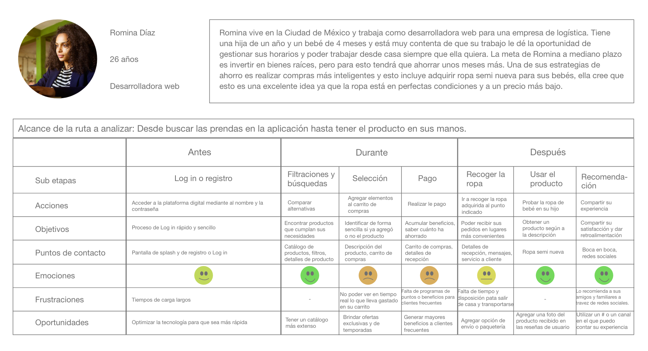

Tool 4. Empathy map

The next phase of the creation and development process is focused on the identification of problems whose solutions will be crucial to obtain an innovative product or service with a gender perspective.

The birth of insights will occur when processing and synthesizing the information that has been previously collected and with which the design problem will be faced. The following tool helps to synthesize the observations and discover those unexpected insights.

Many tangible product and service industries, despite good intentions, continue to neglect women and other discriminatory groups. In many cases it has been shown that it is not about creating different products but about how they target their clientele and what needs they are seeking to satisfy.

Having one person in mind when creating product strategies or trying to solve a problem is a strong reminder that everything is finally done for consumers.

This tool seeks to increase empathy with the target clientele or clientele to facilitate the creation of products that meet those needs and alleviate pain points that are not being addressed.

In the creation and development of products, there is a tendency to think that women are complicated and that is why the development of any solution aimed at this group seems to be tinged with a certain complexity. This tool helps to elucidate the true needs of people and to understand that the misnamed “complexity” depends on the lens with which it is viewed.

The challenge of creating and developing gender-sensitive products might seem like embarking on a journey with an elusive goal, but it is worth remembering that early in the history of product design, in the late 19th century, improvements or Changes in a product were made based on satisfying the needs of the user or to generate efficiencies in its manufacture and marketing. Nowadays, with the evolution of marketing strategies, faster consumption and more aggressive markets, products seek the desired differentiation at the cost of everything, and with that, unnecessarily differentiated products by gender arise, based on preconceptions that, Instead of generating efficiencies and better costs for the consumer society, together they deepen the gaps by generating more expensive products for a particular sex.

Companies, by taking up existing ideas in society about the behaviors and attitudes that are considered appropriate for women and men, can transfer stereotypes and gender roles to the design of their products, thus helping to promote them. Faced with social changes and the need to make equal opportunities for everyone a reality, there are new business opportunities in the design of products that are free from stereotypes and that meet the real needs of women and girls.

“Companies that make sex-differentiated products will no doubt argue that they are giving people what they demand. If the public demanded undifferentiated products, then the companies would surely be offering them that ".
This statement can be interpreted as a reflection of a business force that has no intention of taking responsibility for the messages it sends to society through its products, but with these tools it is intended to create that social responsibility in companies and demonstrate that having a Gender perspective is beneficial both for her and for society.

Although it seems that it is proposing to forget about the market demands collected by conventional research methodologies, what is sought is to feed the data with a closer look and a deeper understanding to contribute to closing the inequality gap between men and women

What do you need to put this tool into practice?

- Organize a short collaborative session, 30 minutes suggested.
- Gather all the information you have about customers and potential customers. The reason why many products continue to contribute to gender stereotypes and gaps between both sexes is due to the lack of information about the true needs of people, especially women, and the biases in the data that is collected about them .
- The tools in this toolkit are aimed at helping to collect as much information as possible on all the diversity of people, in a disaggregated manner, considering the situation differentiated by sex in the analysis. It is important that data is collected in this way to make better decisions and lay the foundations for gender-sensitive product development.
- Convene a team, so that there is a great variety of views. To carry out the development of a product with a gender perspective, it is important to have equal participation of men and women in the team, to listen to the voices of everyone, and that this group of people is trained to identify stereotypes and advocate on gender equality throughout the process. It is advisable to join the innovation and development committee.

- To learn more about how to collect information disaggregated by sex and how to create an innovation and development committee, visit tool 1. Creation and development of products with a gender perspective, located in this same lens.

Some guidelines that can help to implement the empathy map in the best possible way are:
- Everyone must participate: everyone must have a marker and sticky notes or do it in the chosen web application.
- Avoid alternative conversations: use an area to put ideas that are not part of the topic
- Maintain focus: attention goes to the user
- Write before speaking: first put thoughts in writing and then speak or explain about them
- There are no bad ideas: diverging is key in this phase and then converging to take them.
- Yes, and…: Instead of dismissing or dismissing ideas, build on other people's ideas.
- Respect the time agreed for this tool

Taking these elements into account, the team is ready to go.
Steps for implementation

- Divide the space into four quadrants and place: Say, Do, Think and Feel in each quadrant.
A snack?
Bitter chocolate, blueberries, walnuts & green tea
The antioxidants in blueberries improve the connection between brain cells favoring creativity, the flavonoids in dark chocolate increase positive feelings and improve mood, while the L-Theanine and polyphenols in green tea reduce anxiety and increase relaxation and the Omega-3 in walnuts helps to have a sharper memory.
Accompany this session with a snack that activates your brain!

- Place a drawing or photograph of the user in the middle. Give him a name and a short description of who he is and what he does. At this point it is suggested to pay attention to how the person is described so as not to reproduce gender stereotypes.

- Everyone writes down what they know about the user on a sticky note. A note for observation, placing them in the corresponding quadrant.

- Group the observations within the same quadrant that can be seen to be related by trying to find patterns.

- Imagine that you are in the shoes of that user and how different aspects of your life can influence what you need.

practice self-awareness again
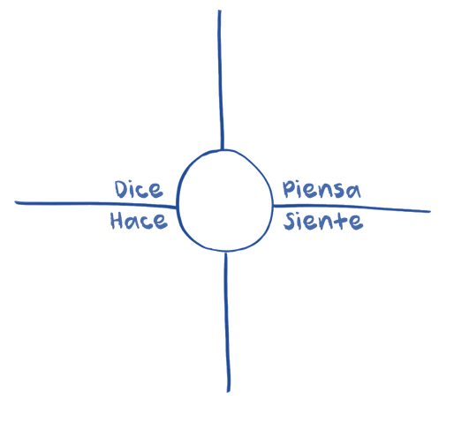
What do you mean by Say (Dice), Do (Hace), Think (Piensa) and Feel (Siente)?

What the user thinks throughout the experience.
What seems to occupy his mind? What does it matter to you?
It is possible that what he says and thinks are the same, but perhaps there are certain ideas that he does not want to vocalize. Why could this be?

What the user says out loud in an interview or some other usability study. Ideally, it contains direct, verbatim quotes from the research.

It includes the actions carried out by the user.
This information can be obtained from an observation of the user's experience.
What are you doing physically? As it does?

It is the emotional state of the user. It should be placed as an adjective accompanied by a short sentence that explains the context.
What worries the user? What excites you? How does the user feel about the experience?

- A good source of information to carry out this tool is in-depth interviews. To find out how to carry them out, visit tool 2. In-depth interview, in this same lens

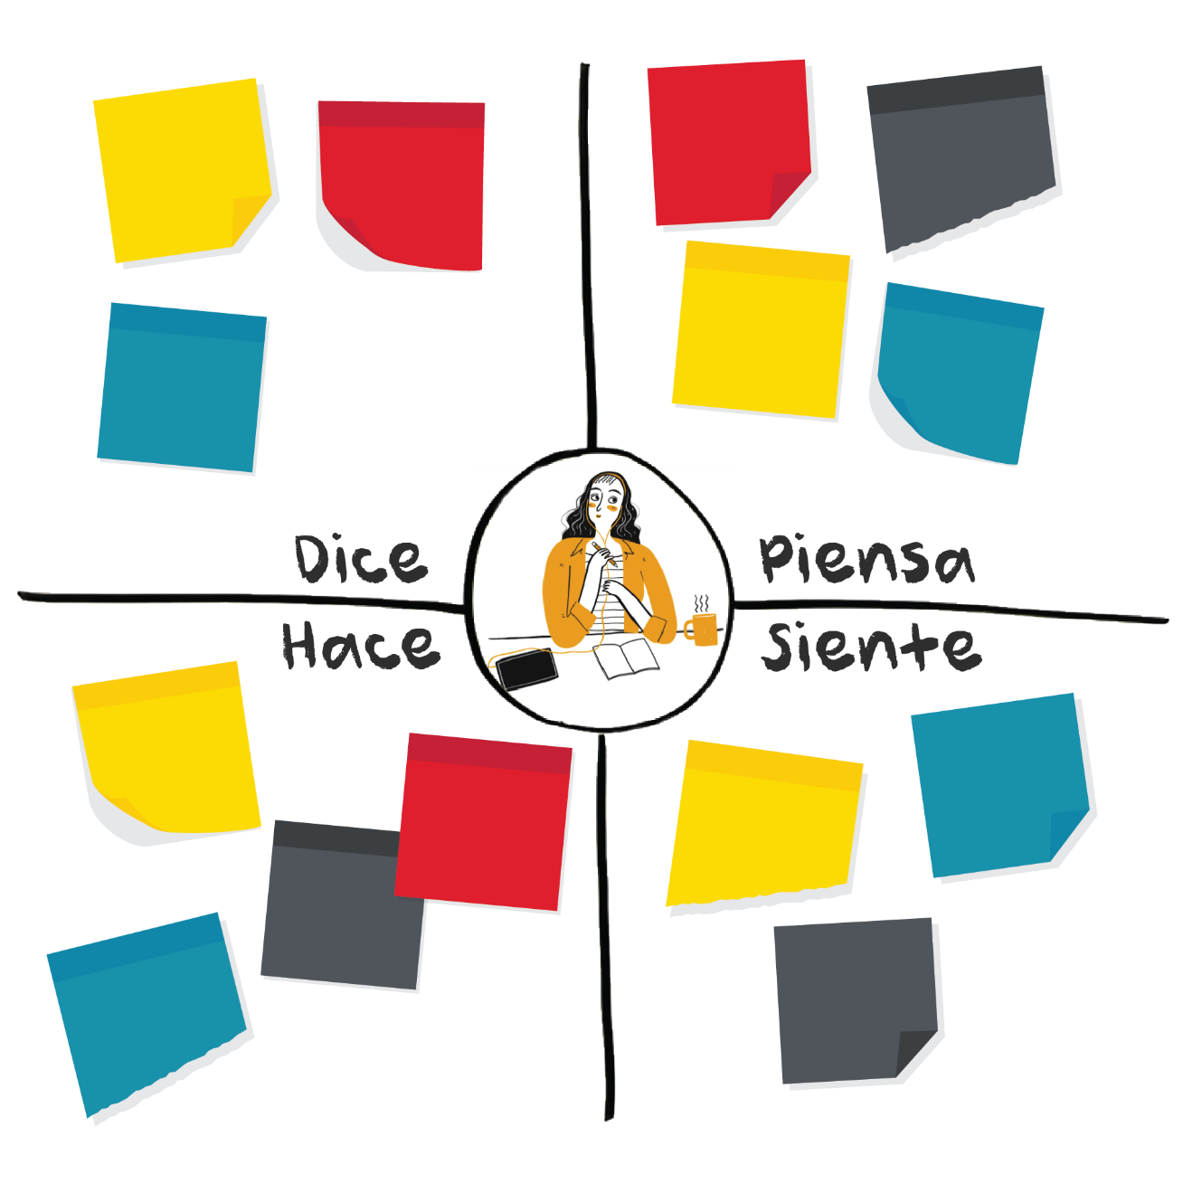
LOOK FOR PATTERNS
X AMBIGUITY MAY EXIST, IT'S OK ...

YOU ARE NOT THE USER.
Challenge some observations:
IS THIS TRUE?

Tool application example

Bianca is a master's student who is busy all the time. She drinks coffee in the morning and sometimes at lunch. She is usually at school from 10am to 8pm and orders take out for lunch and sometimes for dinner. If she doesn't order takeout for lunch, she cooks something when she gets home. She is always looking for ways to save time throughout the day.
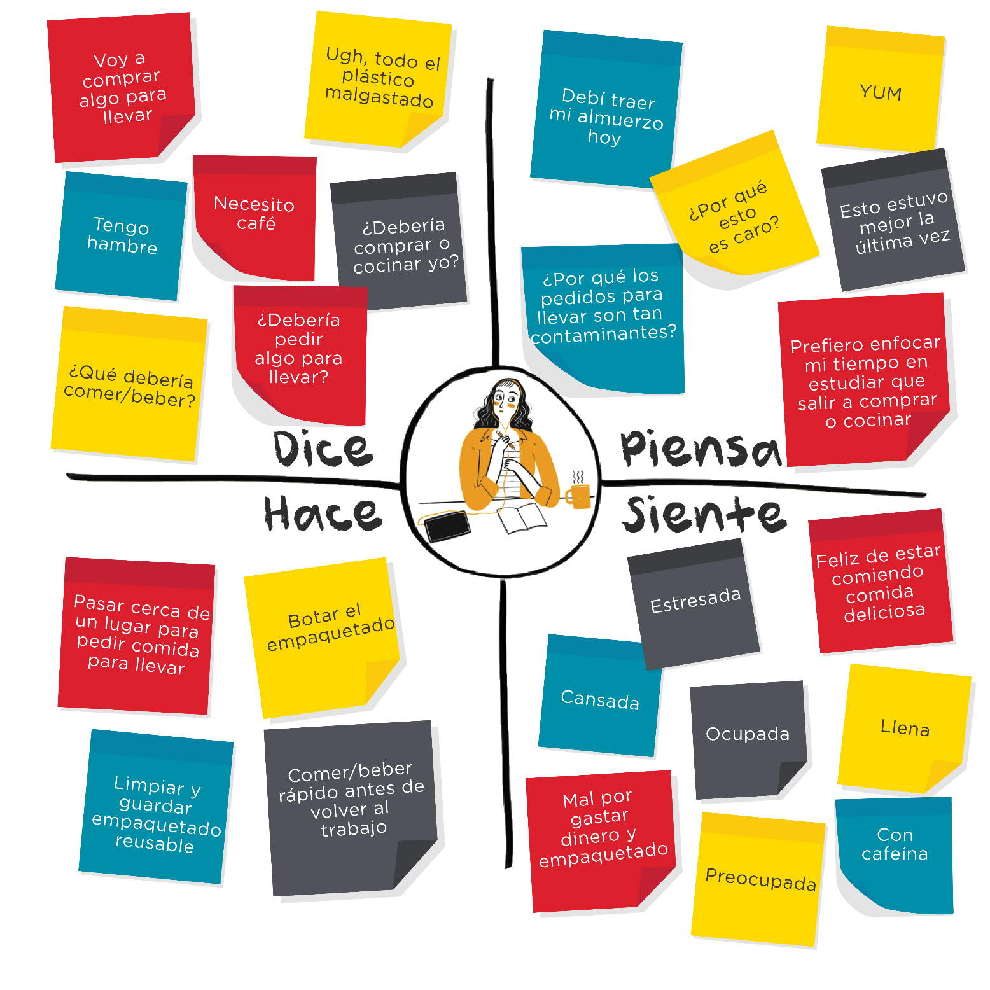

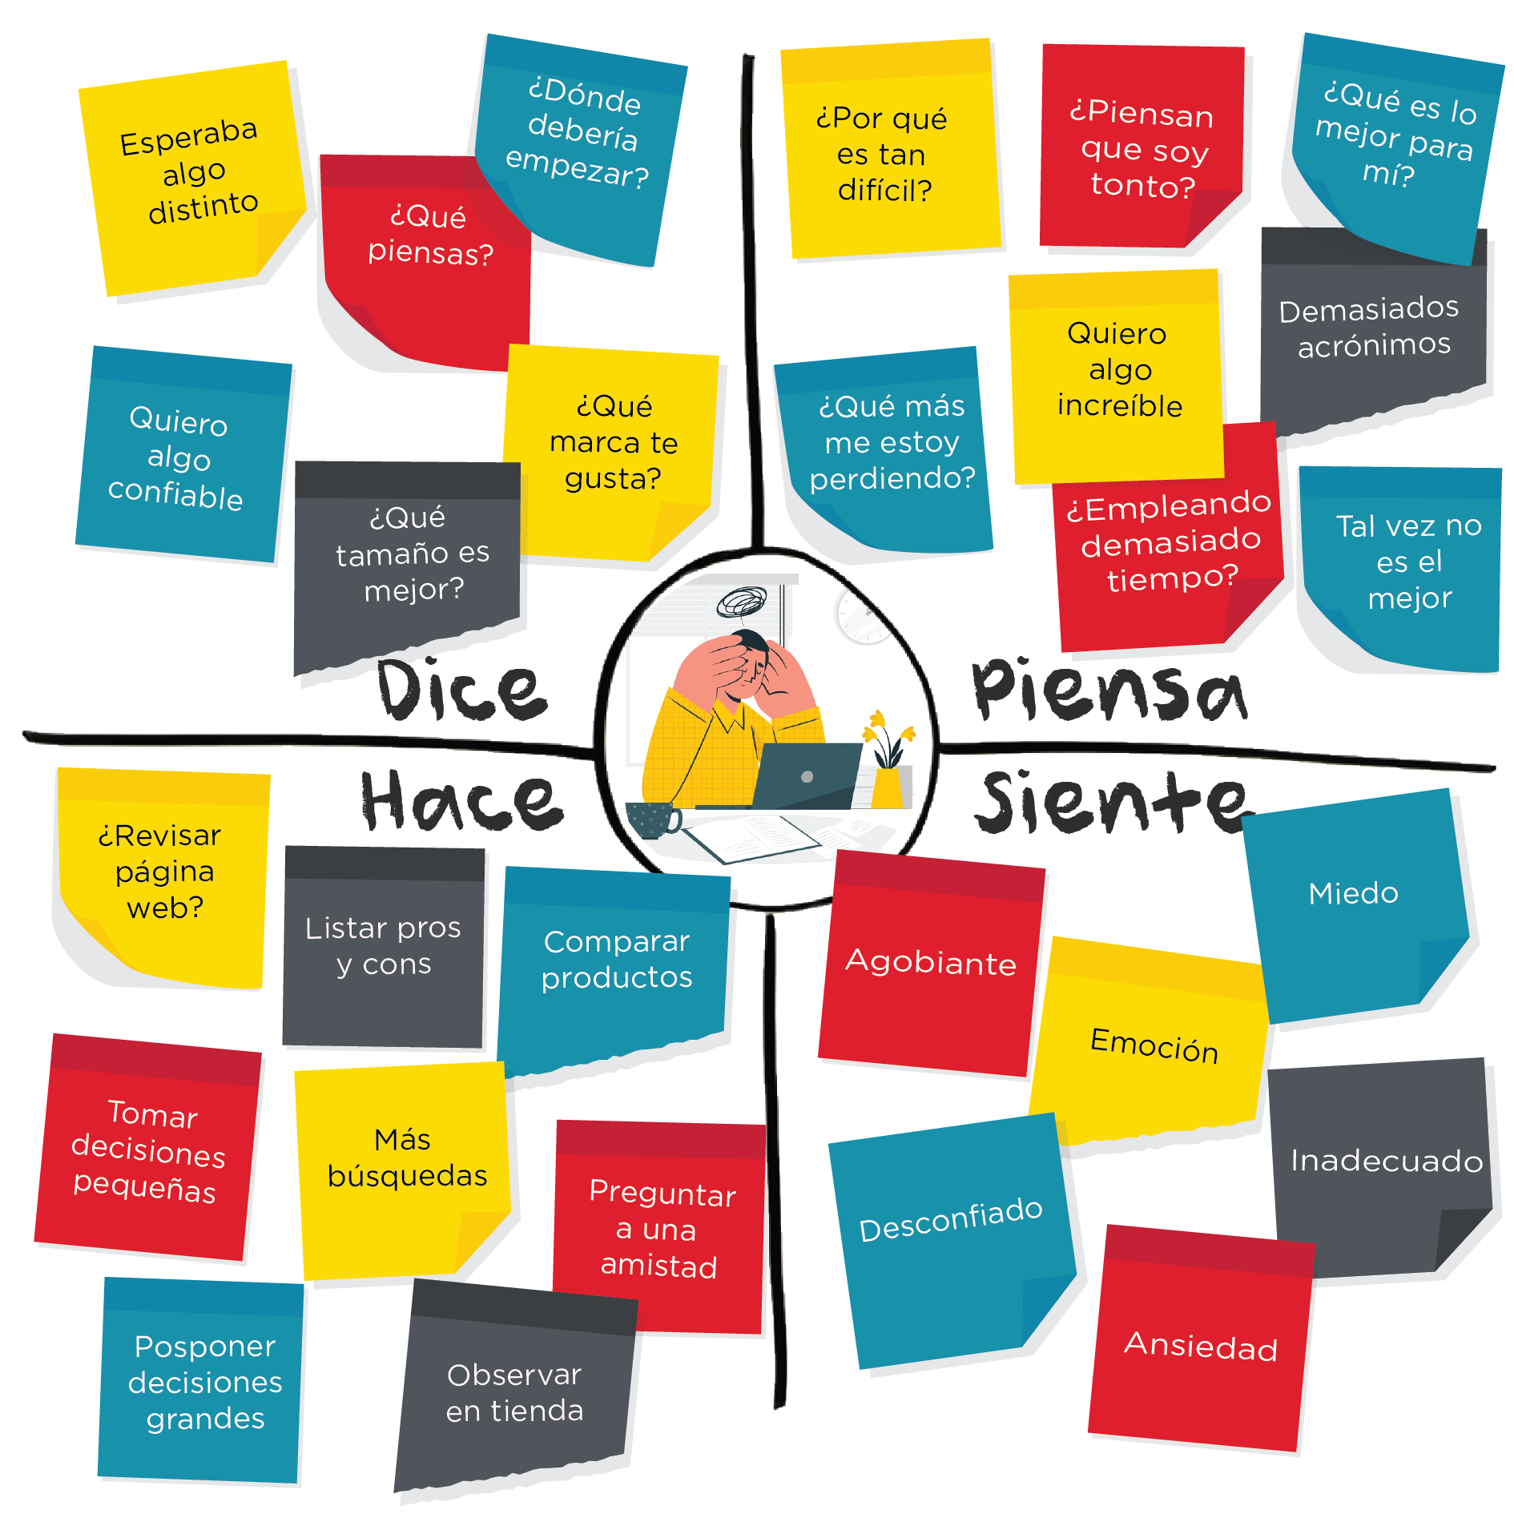
Jorge is a young engineer who works for a transnational packaging manufacturing company. He has a wide variety of day-to-day responsibilities and many future travel and study plans. He is looking to buy his first television.

The products and services that least reflect the values, preferences and lifestyles of women and girls are products with a certain technological complexity, since this field has been dominated by men for years, and they inadvertently carry their "blindness" on the needs. from the other half of the population to product development.

In a study carried out by designers of products and interaction, promoted by the Danish government , the preferences of each sex regarding the use of advanced technology products were examined. The project sought to show the commercial and business potential by directing these types of products also to satisfy the needs of women.

An important finding –which illustrates quite well the economic benefits of not continuing to reproduce gender roles– was that the skills and inclinations for the use and consumption of technology and financial solutions are related to the motivation that the person has and that, in their turn, Again, it depends on whether or not it fits with the gender role assigned by society. As a strategy to eliminate gender stereotypes in the products developed in this project, different profiles of women were included, as stated in the tools of this toolkit.

Having different representations of women and men helps to break with the preconceptions that one has about the sexes, so it will be essential to look for a wide diversity of profiles of one and the other.

The empathy map collects information, ensures and provides visibility into people's true needs and pain points that need to be resolved by products and services, free of stereotypes and with a gender focus.

Share your experience using the hashtag: #empathy

Tool 5. From findings to opportunities

Data is the result of all good research, but on its own it usually doesn't tell much. This tool marks the path of analysis that goes from reading isolated findings to creating specific areas of opportunity that require greater attention. Throughout this process, the team will manage to outline and direct previously collected information to guide it not to reproduce gender stereotypes, to take into equal consideration the needs of both men and women and to solve problems related to the inclusion of gender in the process. of product design.

Tool benefits

With it, it is possible to generate guides or ideas for new implementations in product design, it provides a way to turn isolated findings into actionable areas of opportunity. It helps to process information through a qualitative methodology that synthesizes and detects the current challenges of the product. The way of processing information is reformulated to reach another area of understanding and it is ensured that the gender perspective is considered.

What do you need to put this tool into practice?

- It can be used after a research stage or with previous information or data that the company already has and wants to examine from a perspective focused on innovation and gender equality.
- Real data disaggregated by sex can be obtained from social networks, staff experiences, user observation, interviews, or some other research method.
- It is suggested to carry out the analysis in a group way or resorting to the innovation and development committee to obtain more complete findings.
- It is highly recommended that the people who make up the team are 50% women and 50% men, and that they have knowledge about gender equality, stereotypes and gender roles.
- The approximate duration is 30 minutes, but the team will be able to extend the dynamics as much as they wish.

- To learn more about how to collect information disaggregated by sex and how to create an innovation and development committee, visit tool 1. Creation and development of products with a gender perspective, located in this same lens.

People are not a homogeneous group, women and men have different needs, perceptions and realities, so it is necessary to make all this visible through information disaggregated by sex, which helps to identify the gender gaps that may exist. The data used as inputs for the design of products must be available with a breakdown by women and men, it is also essential that the analysis made of them considers the differentiated situation between them.

Steps for implementation

- Based on information and data from previous research, each team member should record the findings they have detected on sticky notes. A note should be used per find. There is no minimum or maximum number of findings to write per member.

- Draw on a large surface, four columns with the letters H, P, E and O respectively on each one. H for Findings, P for Patterns, E for Understanding, and O for Opportunities.

- In no particular order, the team will put all the scores in the Findings column.

- A moderator and a person representing the gender analysis category will be assigned. The team can add one or a maximum of two more categories and representatives for them if they consider them necessary for the dynamics.

- The facilitator should read the notes and discuss with the other members how to accommodate and categorize similar findings into patterns. The patterns will be determined not only according to the previously established categories, but also obeying new categories that will be created organically according to the notes of the findings.

- The representatives will be especially attentive to form their patterns according to the categories assigned with the notes that best fit them. It is essential that in this step the team uses its criteria to identify key aspects that a person outside the company would not detect. If two or more findings represent the same, it is possible to group one over the other to reduce the space and if a finding applies to two categories, it is also possible to repeat it.

- Once the findings have been arranged, a name must be given for each of the categories found and put in a note on column P. The categories will vary according to each study, but since we are working on the design of products with a approach to gender equality, the category gender analysis should always be present.

- In column E, write one or two sentences of understanding related to each pattern found. For this step it is very important that the team first discuss each pattern found and the analysis process leads them to formulate one or more specific sentences.

- Write in column O, the opportunities related to each sentence of understanding. To facilitate this step, the technique, How could I?. Each sentence will begin with "How could I ...?" And it will be completed with what the team considers most appropriate in relation to one of the phrases of understanding.

- The team should reflect on the importance of the gender focus in the sentences created for column O, for this the person representing the gender analysis category should read the sentences, but adding questions at the end such as:
- Would this reinforce stereotypical figures?
- Are women's needs different from men's? Are they being cared for?
- How would this affect or contribute to equality between men and women?

If necessary, these questions can be written on notes and added to one side of each sentence.

For more information on the application of the “How could I?” technique, go to:
https://www.designkit.org/methods/3

- Analyze the matrix and discuss if the team agrees with the results. The final sentences created in the opportunities column should be powerful enough to invite the team to think about their solutions and possible implications.

Tool application example

Each of the steps is exemplified below, through the practical case of an app to find and offer houses for rent.

- Based on information and data from previous research, each team member should record the findings they have detected on sticky notes. You should use one note per finding. There is no minimum or maximum number of findings to write per member.

Findings
The average stay in a rented house is 2 years | The popularity of eco-friendly colonies is on the rise | The biggest inconvenience of those who put a property for rent is having to charge in person | 75% of those who rent a house wait until the last day (within the allowed range) to make the monthly payment | Who rents a house feels insecure if they do not meet the real estate agent or the owners in person
Who rents a house does not want to pay long-term maintenance | 1 in 4 houses is over 50 years old | 25% of those who want to advertise their homes are women between 65 and 80 years of age | 140 people have suggested giving access to relatives (sons and daughters) to manage the property account on the platform | Several houses are very old
66% of the people registered as owners on the platform are women | Whoever rents a house does not want to take care of maintenance | There is mistrust when carrying out rental processes completely through a digital platform | Customer service answers many calls about questions about the platform | People stay between 1 and 3 years in a rented house
In the last year, those who rent a house usually have a greater preference for areas located on the outskirts of cities | The company receives an average of 25 calls a day requesting help or guidance with the steps to follow on the platform | The tenants who are most late in payments assure that it is due to poor financial planning | Homes with green areas are worth approximately 30% more | 60% of those who rent say that their main concern is not to get back what they have invested in the deposit
The most common excuse for late payments is to forgetting the dates | Properties located in very noisy areas are the least rented | It is avoided to rent to those who are still studying since it is usually related to a profile that does not take proper care of the house | 17% of the rental processes do not go beyond the stage in which the guarantee deposit is made

- 2. Draw on a large surface, four columns with the letters F, P, U and O respectively on each one. F for Findings, P for Patterns, U for Understanding, and O for Opportunities.

- In no particular order, the team will put all the scores in the Findings column.

F | P | U | O
The average stay in a rented house is 2 years | The popularity of eco-friendly colonies is on the rise | The biggest inconvenience of those who put a property for rent is having to charge in person | 75% of those who rent a house wait until the last day (within the allowed range) to make the monthly payment | Who rents a house feels insecure if they do not meet the real estate agent or the owners in person
Who rents a house does not want to pay long-term maintenance | 1 in 4 houses is over 50 years old | 25% of those who want to advertise their homes are women between 65 and 80 years of age | 140 people have suggested giving access to relatives (sons and daughters) to manage the property account on the platform | Several houses are very old
66% of the people registered as owners on the platform are women | Whoever rents a house does not want to take care of maintenance | There is mistrust when carrying out rental processes completely through a digital platform | Customer service answers many calls about questions about the platform | People stay between 1 and 3 years in a rented house
In the last year, those who rent a house usually have a greater preference for areas located on the outskirts of cities | The company receives an average of 25 calls a day requesting help or guidance with the steps to follow on the platform | The tenants who are most late in payments assure that it is due to poor financial planning | Homes with green areas are worth approximately 30% more | 60% of those who rent say that their main concern is not to get back what they have invested in the deposit
The most common excuse for late payments is to forgetting the dates | Properties located in very noisy areas are the least rented | It is avoided to rent to those who are still studying since it is usually related to a profile that does not take proper care of the house | 17% of the rental processes do not go beyond the stage in which the guarantee deposit is made

- A moderator and a person representing the gender analysis category will be assigned. The team can add one or a maximum of two more categories and representatives for them if they consider them necessary for the dynamics.

- The facilitator should read the notes and discuss with the other members how to accommodate and categorize similar findings into patterns. The patterns will be determined not only according to the previously established categories, but also obeying new categories that will be created organically according to the notes of the findings.

F | P | U | O
The average stay in a rented house is 2 years The popularity of eco-friendly colonies is on the rise The biggest inconvenience of those who put a property for rent is having to charge in person 75% of those who rent a house wait until the last day (within the allowed range) to make the monthly payment Who rents a house feels insecure if they do not meet the real estate agent or the owners in person  Who rents a house does not want to pay long-term maintenance 1 in 4 houses is over 50 years old 25% of those who want to advertise their homes are women between 65 and 80 years of age 140 people have suggested giving access to relatives (sons and daughters) to manage the property account on the platform Several houses are very old  66% of the people registered as owners on the platform are women Whoever rents a house does not want to take care of maintenance There is mistrust when carrying out rental processes completely through a digital platform Customer service answers many calls about questions about the platform People stay between 1 and 3 years in a rented house  In the last year, those who rent a house usually have a greater preference for areas located on the outskirts of cities The company receives an average of 25 calls a day requesting help or guidance with the steps to follow on the platform The tenants who are most late in payments assure that it is due to poor financial planning Homes with green areas are worth approximately 30% more 60% of those who rent say that their main concern is not to get back what they have invested in the deposit  The most common excuse for late payments is to forgetting the dates Properties located in very noisy areas are the least rented It is avoided to rent to those who are still studying since it is usually related to a profile that does not take proper care of the house 17% of the rental processes do not go beyond the stage in which the guarantee deposit is made | *Gender Analysis  *Environment

In the example you can see that the team chose to add the environment category as well.

- The representatives will be especially attentive to form their patterns according to the categories assigned with the notes that best fit them. It is essential that in this step the team uses its criteria to identify key aspects that a person outside the company would not detect. If two or more findings represent the same, it is possible to group on top of another to reduce the space and if a finding applies to two categories, it is also possible to repeat it.

- Once the findings have been arranged, a name must be given for each of the categories found and put in a note on column P. The categories will vary according to each study, but since we are working on the design of products with a approach to gender equality, the category gender analysis should always be present.

Some triggering questions that may serve the team are:
- Are the different needs of women and men regarding the use of the product or service considered?
- What activities do women and men carry out? Do they as well as they participate in all kinds of occupations and activities, whether productive or domestic and caregiving?
- Are we allowing our ideas about what women and men are like to be reflected in the analysis?

F | P | U | O
The popularity of eco-friendly colonies is on the rise Properties located in very noisy areas are the least rented Homes with green areas are worth approximately 30% more In the last year, those who rent a house usually have a greater preference for areas located on the outskirts of cities  The average stay in a rented house is 2 years Who rents a house does not want to pay long-term maintenance Whoever rents a house does not want to take care of maintenance 1 in 4 houses is over 50 years old Avoided renting to students since it is usually related to people that does not take proper care of the house  The biggest inconvenience of those who put a property for rent is having to charge in person 75% of those who rent a house wait until the last day (within the allowed range) to make the monthly payment The tenants who are most late in payments assure that it is due to poor financial planning The most common excuse for late payments is to forgetting the dates  25% of those who want to advertise their homes are women between 65 and 80 years of age 140 people have suggested giving access to relatives (sons and daughters) to manage the property account on the platform The company receives an average of 25 calls a day requesting help or guidance with the steps to follow on the platform 25% of those who want to advertise their homes are women between 65 and 80 years of age 66% of the people registered as owners on the platform are women  There is mistrust when carrying out rental processes completely through a digital platform 17% of the rental processes do not go beyond the stage in which the guarantee deposit is made 60% of those who rent say that their main concern is not to get back what they have invested in the deposit Who rents a house feels insecure if they do not meet the real estate agent or the owners in person | Environment  Added value to nature  Product characteristics  Lack of care for the property  Financial  unpunctuality in rent payments  Gender approach  Elderly women as main owners  Fears  Concern when making the deposit

- 8. In column U, write one or two sentences of understanding related to each pattern found. For this step it is very important that the team first discuss each pattern found and the analysis process leads them to formulate one or more specific sentences.

F | P | U | O
The popularity of eco-friendly colonies is on the rise Properties located in very noisy areas are the least rented Homes with green areas are worth approximately 30% more In the last year, those who rent a house usually have a greater preference for areas located on the outskirts of cities  The average stay in a rented house is 2 years Who rents a house does not want to pay long-term maintenance Whoever rents a house does not want to take care of maintenance 1 in 4 houses is over 50 years old Avoided renting to students since it is usually related to people that does not take proper care of the house  The biggest inconvenience of those who put a property for rent is having to charge in person 75% of those who rent a house wait until the last day (within the allowed range) to make the monthly payment The tenants who are most late in payments assure that it is due to poor financial planning The most common excuse for late payments is to forgetting the dates  25% of those who want to advertise their homes are women between 65 and 80 years of age 140 people have suggested giving access to relatives (sons and daughters) to manage the property account on the platform The company receives an average of 25 calls a day requesting help or guidance with the steps to follow on the platform 25% of those who want to advertise their homes are women between 65 and 80 years of age 66% of the people registered as owners on the platform are women  There is mistrust when carrying out rental processes completely through a digital platform 17% of the rental processes do not go beyond the stage in which the guarantee deposit is made 60% of those who rent say that their main concern is not to get back what they have invested in the deposit Who rents a house feels insecure if they do not meet the real estate agent or the owners in person | Environment  Added value to nature  Product characteristics  Lack of care for the property  Financial  unpunctuality in rent payments  Gender approach  Elderly women as main owners  Fears  Concern when making the security deposit | The properties with noise pollution are the hardest to rent The green area is a decisive point for those who rent a house.  The parties involved do not fully understand what their responsibilities are The nature of each property and each renter profile, influence the probability of damages  Those who rent a house are not usually in a hurry to pay the first days of the month.  Older women have complications interacting with the platform The older adult owners of the properties prefer guidance or help when carrying out the processes  The point of greatest distrust for those who rent a property is to pay the security deposit

- Write in column O, the opportunities related to each sentence of understanding. Each sentence will begin by asking "How could I ...?" And it will be completed with what the team considers most appropriate in relation to one of the phrases of understanding.

F | P | U | O
The popularity of eco-friendly colonies is on the rise Properties located in very noisy areas are the least rented Homes with green areas are worth approximately 30% more In the last year, those who rent a house usually have a greater preference for areas located on the outskirts of cities  The average stay in a rented house is 2 years Who rents a house does not want to pay long-term maintenance Whoever rents a house does not want to take care of maintenance 1 in 4 houses is over 50 years old Avoided renting to students since it is usually related to people that does not take proper care of the house  The biggest inconvenience of those who put a property for rent is having to charge in person 75% of those who rent a house wait until the last day (within the allowed range) to make the monthly payment The tenants who are most late in payments assure that it is due to poor financial planning The most common excuse for late payments is to forgetting the dates  25% of those who want to advertise their homes are women between 65 and 80 years of age 140 people have suggested giving access to relatives (sons and daughters) to manage the property account on the platform The company receives an average of 25 calls a day requesting help or guidance with the steps to follow on the platform 25% of those who want to advertise their homes are women between 65 and 80 years of age 66% of the people registered as owners on the platform are women  There is mistrust when carrying out rental processes completely through a digital platform 17% of the rental processes do not go beyond the stage in which the guarantee deposit is made 60% of those who rent say that their main concern is not to get back what they have invested in the deposit Who rents a house feels insecure if they do not meet the real estate agent or the owners in person | Environment  Added value to nature  Product characteristics  Lack of care for the property  Financial  unpunctuality in rent payments  Gender approach  Elderly women as main owners  Fears  Concern when making the security deposit | The properties with noise pollution are the hardest to rent The green area is a decisive point for those who rent a house.  The parties involved do not fully understand what their responsibilities are The nature of each property and each renter profile, influence the probability of damages  Those who rent a house are not usually in a hurry to pay the first days of the month.  Older women have complications interacting with the platform The older adult owners of the properties prefer guidance or help when carrying out the processes  The point of greatest distrust for those who rent a property is to pay the security deposit | How coul I…  Reduce sound filtration in houses located in noisy areas? Add new green spaces to properties?  Evaluate each property according to its particular characteristics? Measure the percentage of risk on each tenant or tenant profile? Make clear the responsibilities of who offers a property and who rents it?  Motivate someone who rents a house to pay as soon as possible? Help someone who rents a house to remember the payment dates?  Redesign the platform to make interaction easier? Offer more guidance to older users during the process? Ensure that the platform is understandable and friendly for all profiles?  Generate greater confidence in who rents a house during the process? Improve the process to mitigate the doubts and concerns of those who rent a property?

- 10. The team should reflect on the importance of the gender focus in the sentences created for column O, for this the person representing the gender analysis category should read the sentences, but adding questions at the end such as:
- Would this reinforce stereotypical figures?
- Are women's needs different from men's? Are they being cared for?
- How would this affect or contribute to equality between men and women?

If necessary, these questions can be written on notes and added to one side of each sentence.

- Analyze the matrix and discuss if the team agrees with the results. The final sentences created in the opportunities column should be powerful enough to invite the team to think about their solutions and possible implications.

F | P | U | O
The popularity of eco-friendly colonies is on the rise Properties located in very noisy areas are the least rented Homes with green areas are worth approximately 30% more In the last year, those who rent a house usually have a greater preference for areas located on the outskirts of cities  The average stay in a rented house is 2 years Who rents a house does not want to pay long-term maintenance Whoever rents a house does not want to take care of maintenance 1 in 4 houses is over 50 years old Avoided renting to students since it is usually related to people that does not take proper care of the house  The biggest inconvenience of those who put a property for rent is having to charge in person 75% of those who rent a house wait until the last day (within the allowed range) to make the monthly payment The tenants who are most late in payments assure that it is due to poor financial planning The most common excuse for late payments is to forgetting the dates  25% of those who want to advertise their homes are women between 65 and 80 years of age 140 people have suggested giving access to relatives (sons and daughters) to manage the property account on the platform The company receives an average of 25 calls a day requesting help or guidance with the steps to follow on the platform 25% of those who want to advertise their homes are women between 65 and 80 years of age 66% of the people registered as owners on the platform are women  There is mistrust when carrying out rental processes completely through a digital platform 17% of the rental processes do not go beyond the stage in which the guarantee deposit is made 60% of those who rent say that their main concern is not to get back what they have invested in the deposit Who rents a house feels insecure if they do not meet the real estate agent or the owners in person | Environment  Added value to nature  Product characteristics  Lack of care for the property  Financial  unpunctuality in rent payments  Gender approach  Elderly women as main owners  Fears  Concern when making the security deposit | The properties with noise pollution are the hardest to rent The green area is a decisive point for those who rent a house.  The parties involved do not fully understand what their responsibilities are The nature of each property and each renter profile, influence the probability of damages  Those who rent a house are not usually in a hurry to pay the first days of the month.  Older women have complications interacting with the platform The older adult owners of the properties prefer guidance or help when carrying out the processes  The point of greatest distrust for those who rent a property is to pay the security deposit | How could I…  Reduce sound filtration in houses located in noisy areas? Add new green spaces to properties?  Evaluate each property according to its particular characteristics? Measure the percentage of risk on each tenant or tenant profile? Make clear the responsibilities of who offers a property and who rents it?  Would this reinforce stereotypical figures?  Motivate someone who rents a house to pay as soon as possible? Help someone who rents a house to remember the payment dates?  Redesign the platform to make interaction easier? Offer more guidance to older users during the process? Ensure that the platform is understandable and friendly for all profiles?  Would this reinforce stereotypical figures?  Generate greater confidence in who rents a house during the process? Improve the process to mitigate the doubts and concerns of those who rent a property?  How would this affect or contribute to gender equality?

Resources

How Might We
https://www.designkit.org/methods/3

Format suggestion for layout

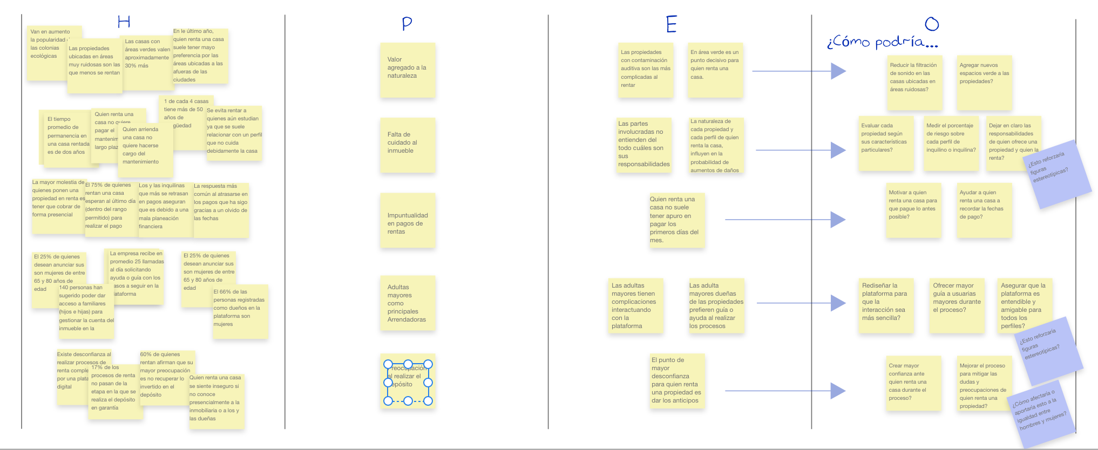

Tool 6. Storyboard: The product idea

The envisioning stage in the design thinking process is intended to generate as many solution options as possible. In this phase the ability to “think outside the box” will be tested. The proposed tool, as well as any other tool that is part of this phase, favors expansive thinking, which is why really bizarre ideas will emerge. It is suggested to make a special effort to put on the glasses of childhood to face this phase with curiosity and without value judgments.

At the moment of product or service envisioning, when the needs and the problem to be solved and for whom are already defined, it is easy to lose sight of the user and their motivations. This tool raises graphically and narratively the path that the user will go through to reach their goal. The main focus will be the person.

This tool allows the company to plan the path from the motivations and goals of the user, going through the incident or problem, diagramming the internal and external struggles through which it passes, seeing it reach the moment of crisis, followed by a solution to your problem and finally a change and victory in the process thanks to the product or service offered.

As it is an ideation tool, possible solutions or products with a gender focus will emerge from here. These products and services may have the following objectives in order to address this perspective:
- The product must not reproduce gender stereotypes
- The product satisfies a need of women and girls that was previously not being met with any product or service on the market.
- The product contributes to the advancement of gender equality.

The storyboard, as an ideation tool, also allows to raise findings and insights in addition to provoking discussions about weaknesses and opportunities of the product or service with a view to its improvement.

In this tool it will be of vital importance to iterate on the solution.

What do you need to put this tool into practice?

The storyboard not only works as a way of presenting an idea but also as a way of ideation, in which empathy and concentration on the user will be more present.

Any ideation tool, and especially one with a gender focus, will find the best way to work in teamwork. It is recommended to convene the innovation and development committee or to assemble a team with equal participation of men and women, with the greatest variety of skills, it is preferable that it be multidisciplinary and that people are trained to identify stereotypes and advocate for gender equality throughout the process.

- To learn more about the innovation and development committee, in this same lens you can visit tool 1. Creation and development of products with a gender perspective.

The storyboard will serve to discuss as a team each phase that the user goes through, then questions will arise about whether it was placed in the correct setting or if there are other scenarios that can be contemplated to build different paths towards the solution, if the emotion embodied in each phase is the correct one, the way in which you encounter the product for the first time, what emotions should you experience at the end of the process and what problems could arise in each phase that perhaps are being lost from sight.

The interesting thing about this tool is that it can result in multiple solutions or ways of dealing with the problem. Teamwork is really enriching and it could be said that it is necessary for this phase of ideation.

It is really a matter of attitude. Making a storyboard may seem tedious, but a low-fidelity drawing will be enough, it must be remembered that in the creation and design of products it is allowed to make mistakes.

Steps for implementation

For a successful storyboard:

- Gather as much information as possible. You can use the information collected from the interviews, the empathy map or other tools in this toolkit. It is advisable to use information that has the results of men and women separately, so as not to lose sight of the wishes, interests and expectations of both groups or the interest group.

- Choose the level of loyalty. Take into account the objective and the audience of the storyboard. Using quick pictures to communicate a sequence in the ideation stage can be very helpful. Remembering that each scene can be created on a different sticky note for a divergent team ideation session; the inclusion of more points of view will enrich this tool. The goal is to form a shared understanding, rather than a polished and refined artifact. Only for a product presentation should a higher fidelity.

- Define the basic elements. Define the person and the setting or history of the users represented.
you didn't put the woman in the kitchen, did you?

To begin with, the profiles of the users will be chosen, these can be only men or only women if it is a product aimed at a particular sex, otherwise, it is recommended to have parity in the chosen profiles, a man and a woman.

Then the scenario (s) corresponding to each profile will be chosen. The setting must be specific and must correspond to the path of a single person, so that the storyboard does not split in several directions. For complex multi-path scenarios, it is good to keep a 1 to 1 rule: one storyboard for each path the user takes (it is not a flow chart, it is a story).

In this step of defining basic elements, it is suggested to pay close attention to the gender stereotypes that may be being included in the ideation process. Designing a product with a gender focus implies avoiding stereotypes that exist in society about the characteristics, behaviors and needs of women and men. It is valid and even necessary to question how a product can contribute to reducing gender inequality.

The products and services that surround us on a day-to-day basis can contribute to widening the gaps and power relations that already exist or they can have a favorable impact by creating equal opportunities and including women in spaces where they would not traditionally be found. . Tools like this can help companies to think in scenarios free of gender stereotypes, and not fall into common places like illustrating women unnecessarily in the kitchen or by default in charge of housework. Let us remember that gender stereotypes are learned and in the same way they can be unlearned.
CAN WE ASSUME THE ONLY HE GOES TO THE OFFICE?
WHY IS SHE AUTOMATICALLY RESPONSIBLE FOR CLEANING UP?

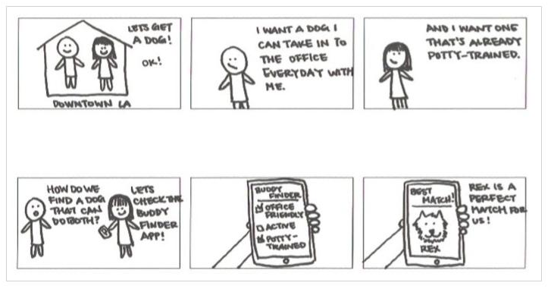

Source: Buddy Match.

- Plan the steps. If going directly to the drawing seems daunting, it will help to start by writing the steps and connecting them with arrows before going directly to the storyboard template. Then add the emotional state as an icon at each step. This technique will help you begin to visualize what each visual frame or scene will include.

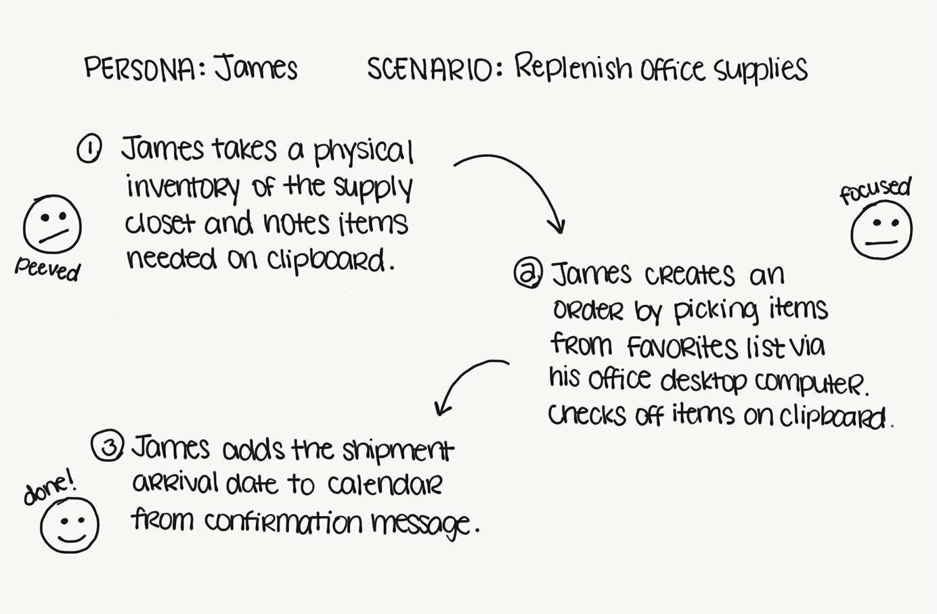
Source: Rachel Krause.

In each scene of the storyboard, the steps the user goes through must be reflected from the moment they experience the problem to the moment they discover their needs covered. It is highly recommended to work each scene of the storyboard on a different sticky note, this will allow the participants to discuss how each phase of the story is taking place and replace them or add more scenes to make sense of the proposed solution.

It is suggested to start working with a scheme of 6 scenes and it will be very important to always place the name of the person in the work area, as well as the name of the project.

PERSON: SCENE:

PROJECT:

- Create images and add captions. It is fine to use stick figures or very basic sketches, but if these do not help to fully convey the idea, it is possible to rely on captions written under each scene.

- Share and iterater. Share the storyboard with more people, either part of the company or interested people to request comments. In an ideation process, this step can be repeated as many times as necessary.

What does a storyboard look like?

Below is a graph, similar to the anatomy of an in-depth interview that features highlights and less emotionally charged moments. In this graphic you can see the moments that form part of a storyboard that goes from the beginning to the end of the story of the person interacting with the solutions proposed.
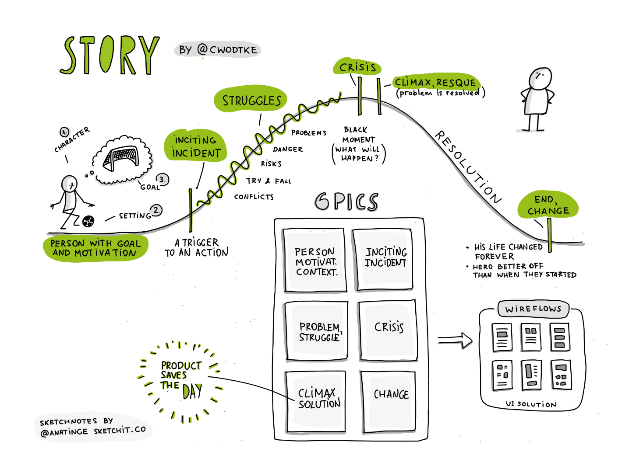
Source: Anna Lurchenko.

Is it really necessary to draw?

By transferring an emotion of the user, on paper and as an image, on the way to the solution, it allows those involved in the process to internalize the information about that emotion in a more profound and empathetic way.

Reading "sad woman" is not the same as visualizing it in an image. The connection that is created with the person allows for greater empathy and importance to the creation process.

Being a tool in the ideation phase, it must be as agile as possible, so a low-fidelity drawing, with very simple lines, that does not take a long time to create, will be the best way because it will allow iteration of the different solutions.

And how did she find out about the app?

Is money a variable as well?
Source: Buddy Match.

However, if the computer is preferred or if the definition level needs to be higher to sell the story to another team or stakeholder, the following link will be very useful. It is a site that allows you to quickly put together a storyboard with much more detail and with greater fidelity.

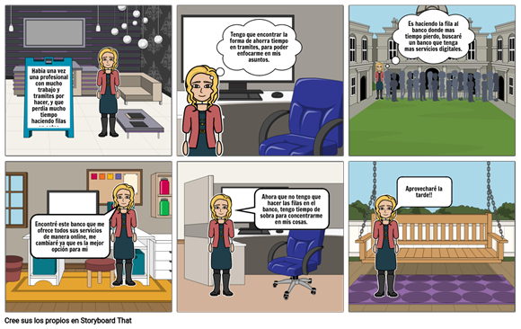
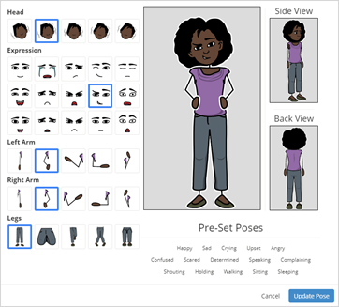

Click on the logo to be directed to the site or scan the QR code with your mobile phone.

The importance of the senses in this creative phase

John Cleese understands and defines the creative process as learning to switch between two states or modes: open and closed. When we are under pressure and stress to meet a delivery or result, as is the case in our daily work life, we are in closed mode. When we are in relaxation, away from problems and in a more playful mode, we are in open mode. The open state allows you to develop creative ideas and the closed state then works to plan and implement the idea.

Therefore, research would indicate that the best environments in which creativity can be incubated are:
- When we are in touch with our emotional responses
- When dopamine is released
- When we are relaxed and relaxed
- When we get distracted from the routine

Dopamine is also released during exercise, when we are in relaxation, when we feel pleasure, and at times such as listening to music.
Mmm… It smells good….
People have a strong connection to the sense of smell. Pleasant aromas help relaxation and productivity.
To carry out this tool we recommend being relaxed. Essential oil recommendations:
lemon verbena, lavender, bergamot and vetiver.

To finish this stage of envisioning, after having multiple ideas, it will be time to define the way forward to move to the next prototyping phase. It is worth asking yourself:
- What elements in common were found in the multiple stories? The ones that included different people and different settings.
- How can the stories converge in a shared vision about the future user experience?
- What assumptions are there in the storyboards that the team still needs to validate?

When choosing the ideal solution, it will be important to pay attention not to define a specific gender for the person using the product when this is unnecessary, especially if it is based on stereotypes.

"Critically, even seemingly positive stereotypes, such as women being kinder than men and Asians being good at math, can generate negative emotions and provoke negative reactions from the people you want to reach."

Similarly, if within the proposed solutions, for example, the use of a bot (interactive assistance software through repetitive actions) is suggested, special care must be taken in assigning it a woman's name and making it permissive to attacks or Sexual harassment will be reinforcing gender stereotypes in a negative and dangerous way.

The benefits of using tools such as the storyboard, in an ideation stage, which graphically reflects the person, their emotions, their difficulties, problems and conflicts, are to keep the person as the focus of all decisions in relation with the way in which the needs of the same are satisfied.

This will lead to solutions with a gender focus and focused on addressing the objectives described at the beginning of the tool.

Share your experience using the hashtag: #productidea

Tool 7. Three-dimensional balance

Products have unavoidable impacts in the different contexts in which they interact. Objects are a large part of our perception of the world and they bear part of the responsibility to avoid repeating gender stereotypes. A responsible and inclusive product development is one that examines, reflects and replants in advance the effects that it will have in different areas or dimensions, including gender equality.

Tool benefits

The analysis proposed here establishes a panorama in which an idea or concept is individually analyzed from the perspective of three main dimensions and seeks a balance between them. First, the vision of the company, which describes the objective that it has and keeps the actions aligned with the final expectations. Second, the gender approach, which analyzes the concepts from an inclusive perspective for women and men and invites us to contemplate their implications from the early stages of the ideation process. Finally, the economic benefits, since these mark the feasibility of the development of the idea within the company.

What do you need to put this tool into practice?

- This tool can be applied individually or in groups.
- It is highly recommended that, if this tool is carried out in a group, the people who make up the team are 50% women and 50% men. In both cases, it is desirable to have knowledge about gender equality, stereotypes and gender roles.
- The use of the tool is approximately 45 minutes.

We recommend followinig the steps on this template.

General idea:
Vision: |  | Vision:
Gender approach: | Generate a profit  Avoid sexist terms or concepts  Equal participation  Encourage inclusion  Prevents discrimination  Avoid using stereotypes | Gender approach: | Generate a profit  Avoid sexist terms or concepts  Equal participation  Encourage inclusion  Prevents discrimination  Avoid using stereotypes
Economic benefit: | Generate income  It is economically sustainable  It is economically viable  It is profitable  Is scalable  Innovative and replicable | Economic benefit: | Generate income  It is economically sustainable  It is economically viable  It is profitable  Is scalable  Innovative and replicable

Steps for implementation

- Generally write the idea or concept at the top of the template.

- In the first column describe the idea or concept and add more details regarding each section: Company vision, Gender focus and Economic benefit.

- Objectively rate the idea described according to the criteria in the next column, with 1 being the most negative rating and 5 being the most positive. The table referring to the vision of the company will be weighted according to the criteria that the team decides since they may vary a lot.

- Analyze the scoring and rephrase the ideas in each section so that the score is higher in each dimension. Write this new description in column 3.

- In column 4, rate the criteria for the new idea described.

- Analyze whether the team has been satisfied with the score. If not, it is possible to repeat steps 4 and 5 as many times as necessary.

- Fill in the areas of convergence that are between the dimensions:
- In which it is described what the idea has in common according to the vision and the idea according to the gender perspective.
- In which it is described what the idea has in common according to the gender perspective and the idea according to the economic benefit.
- In which it is described what the idea has in common according to the economic benefit and the vision.

- The areas of convergence are the results of the concepts or the bases of future concepts that contemplate the balance between the three dimensions.

Tool application example

This case study exemplifies each of the steps by analyzing a voice reminder integration service through a virtual assistant.

- Generally write the idea or concept at the top of the template.

General idea: Integration of voice reminders through a virtual assistant
Vision: |  | Vision:  Convergence 1
Gender approach: | 5 4 3 2 1  Generate a profit  Avoid sexist terms or concepts  Equal participation  Encourage inclusion  Prevents discrimination  Avoid using stereotypes | Gender approach:  Convergence 2: | 5 4 3 2 1  Generate a profit  Avoid sexist terms or concepts  Equal participation  Encourage inclusion  Prevents discrimination  Avoid using stereotypes
Economic benefit: | 5 4 3 2 1  Generate income  It is economically sustainable  It is economically viable  It is profitable  Is scalable  Innovative and replicable | Economic benefit:  Convergence 3: | 5 4 3 2 1  Generate income  It is economically sustainable  It is economically viable  It is profitable  Is scalable  Innovative and replicable

- In the first column describe the idea or concept and add more details regarding each section: Company Vision, Gender Approach and Economic Benefit.

- Objectively rate the idea described according to the criteria in the next column, with 1 being the most negative rating and 5 being the most positive. The table referring to the vision of the company will be weighted according to the criteria that the team decides since they may vary a lot.

General idea: Integration of voice reminders through a virtual assistant
Vision:  The voice of a virtual assistant as a support resource to generate empathy in the girls and boys who use the educational platform. This voice will serve as a guide to create good organizational habits for the future. | 5 4 3 2 1  Encourage organization  Help the student's development  Create good habits for the future  Support in education  It is formative | Vision:  Convergence 1: | 5 4 3 2 1  Encourage organization  Help the student's development  Create good habits for the future  Support in education  It is formative
Gender approach:  Reminders and support transmitted through voice elements that build trust and students. The female voice can be adjusted to sound neutral. | 5 4 3 2 1  Generate a profit  Avoid sexist terms or concepts  Equal participation  Encourage inclusion  Prevents discrimination  Avoid using stereotypes | Gender approach:  Convergence 2: | 5 4 3 2 1  Generate a profit  Avoid sexist terms or concepts  Equal participation  Encourage inclusion  Prevents discrimination  Avoid using stereotypes
Economic benefit:  The voice of the virtual assistant automates the process of reminding students of their assignments and to-dos. In this way, it will be possible to reduce more and more the intervention of human operators and eventually operating costs will be 18% lower. | 5 4 3 2 1  Generate income  It is economically sustainable  It is economically viable  It is profitable  Is scalable  Innovative and replicable | Economic benefit:  Convergence 3: | 5 4 3 2 1  Generate income  It is economically sustainable  It is economically viable  It is profitable  Is scalable  Innovative and replicable

- Analyze the scoring and rephrase the ideas in each section so that the score is higher in each dimension. Write this new description in column 3.

- In column 4, rate the criteria for the new idea described.

General idea: Integration of voice reminders through a virtual assistant
Vision:  The voice of a virtual assistant as a support resource to generate empathy in the girls and boys who use the educational platform. This voice will serve as a guide to create good organizational habits for the future. | 5 4 3 2 1  Encourage organization  Help the student's development  Create good habits for the future  Support in education  It is formative | Vision:  Element of voice reminders as a support resource to generate empathy in the girls and boys who use the educational platform. This voice encourages the creation of future habits in the students and it will be possible to choose the frequency with which they appear, so the student will eventually be able to acquire the habit by himself.  Convergence 1: | 5 4 3 2 1  Encourage organization  Help the student's development  Create good habits for the future  Support in education  It is formative
Gender approach:  Reminders and support transmitted through voice elements that build trust and students. The female voice can be adjusted to sound neutral. | 5 4 3 2 1  Generate a profit  Avoid sexist terms or concepts  Equal participation  Encourage inclusion  Prevents discrimination  Avoid using stereotypes | Gender approach:  Genderless voice reminders from a genderless robotic entity. The reminders always refer to the students and do not make use of descriptive stereotypes. Voice memos are accompanied by a written description in case students have trouble hearing commands. There is the possibility of configuring the reminder times to fit in with different life routines.  Convergence 2: | 5 4 3 2 1  Generate a profit  Avoid sexist terms or concepts  Equal participation  Encourage inclusion  Prevents discrimination  Avoid using stereotypes
Economic benefit:  The voice of the virtual assistant automates the process of reminding students of their assignments and to-dos. In this way, it will be possible to reduce more and more the intervention of human operators and eventually operating costs will be 18% lower. | 5 4 3 2 1  Generate income  It is economically sustainable  It is economically viable  It is profitable  Is scalable  Innovative and replicable | Economic benefit:  Voice reminders automate the process of reminding students of their assignments and to-dos. In this way, it will be possible to reduce more and more the intervention of human operators and eventually operating costs will be 18% lower.  Convergence 3: | 5 4 3 2 1  Generate income  It is economically sustainable  It is economically viable  It is profitable  Is scalable  Innovative and replicable

Despite the fact that each idea developed in each dimension has changed to improve the score, it can be seen how special attention was paid to the gender focus area, since the tool promoted reflection on each point to ponder and the team quickly fell Note that they were reproducing the bias that women are helpful. Given all this, the team will make it clear in its product that the robotic entity does not have sex and therefore the tone of voice will be neutral.

- Analyze whether the team has been satisfied with the score. If not, it is possible to repeat steps 4 and 5 as many times as necessary.

- Fill in the areas of convergence that are between the dimensions:
- In which it is described what the idea has in common according to the vision and the idea according to the gender perspective.
- In which it is described what the idea has in common according to the gender perspective and the idea according to the economic benefit.
- In which it is described what the idea has in common according to the economic benefit and the vision.

General idea: Integration of voice reminders through a virtual assistant
Vision:  The voice of a virtual assistant as a support resource to generate empathy in the girls and boys who use the educational platform. This voice will serve as a guide to create good organizational habits for the future. | 5 4 3 2 1  Encourage organization  Help the student's development  Create good habits for the future  Support in education  It is formative | Vision:  Element of voice reminders as a support resource to generate empathy in the girls and boys who use the educational platform. This voice encourages the creation of future habits in the students and it will be possible to choose the frequency with which they appear, so the student will eventually be able to acquire the habit by himself.  Convergence 1:  Use of reminders via voice and text (without gender) to encourage empathy with the platform and the creation of good habits of organization and responsibility in boys and girls. | 5 4 3 2 1  Encourage organization  Help the student's development  Create good habits for the future  Support in education  It is formative
Gender approach:  Reminders and support transmitted through voice elements that build trust and students. The female voice can be adjusted to sound neutral. | 5 4 3 2 1  Generate a profit  Avoid sexist terms or concepts  Equal participation  Encourage inclusion  Prevents discrimination  Avoid using stereotypes | Gender approach:  Genderless voice reminders from a genderless robotic entity. The reminders always refer to the students and do not make use of descriptive stereotypes. Voice memos are accompanied by a written description in case students have trouble hearing commands. There is the possibility of configuring the reminder times to fit in with different life routines.  Convergence 2:  Boys and girls receive gender-free text and voice reminders to use the platform more regularly and conveniently. | 5 4 3 2 1  Generate a profit  Avoid sexist terms or concepts  Equal participation  Encourage inclusion  Prevents discrimination  Avoid using stereotypes
Economic benefit:  The voice of the virtual assistant automates the process of reminding students of their assignments and to-dos. In this way, it will be possible to reduce more and more the intervention of human operators and eventually operating costs will be 18% lower. | 5 4 3 2 1  Generate income  It is economically sustainable  It is economically viable  It is profitable  Is scalable  Innovative and replicable | Economic benefit:  Voice reminders automate the process of reminding students of their assignments and to-dos. In this way, it will be possible to reduce more and more the intervention of human operators and eventually operating costs will be 18% lower.  Convergence 3:  The element of voice interaction generates better and more meaningful ties between users and the digital product. | 5 4 3 2 1  Generate income  It is economically sustainable  It is economically viable  It is profitable  Is scalable  Innovative and replicable

- The areas of convergence are the results of the concepts or the bases of future concepts that contemplate the balance between the three dimensions.

Resources

People Planet Profit
https://toolkits.dss.cloud/design/method-card/people-planet-profit/

Format suggestion for layout
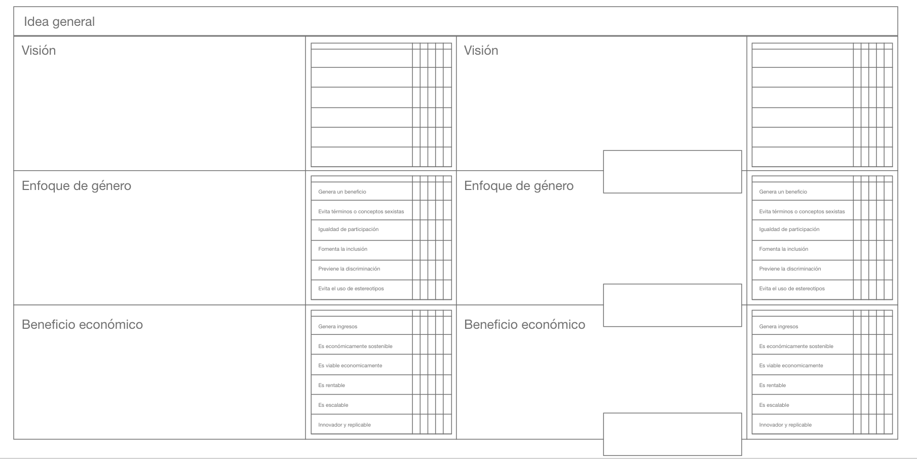

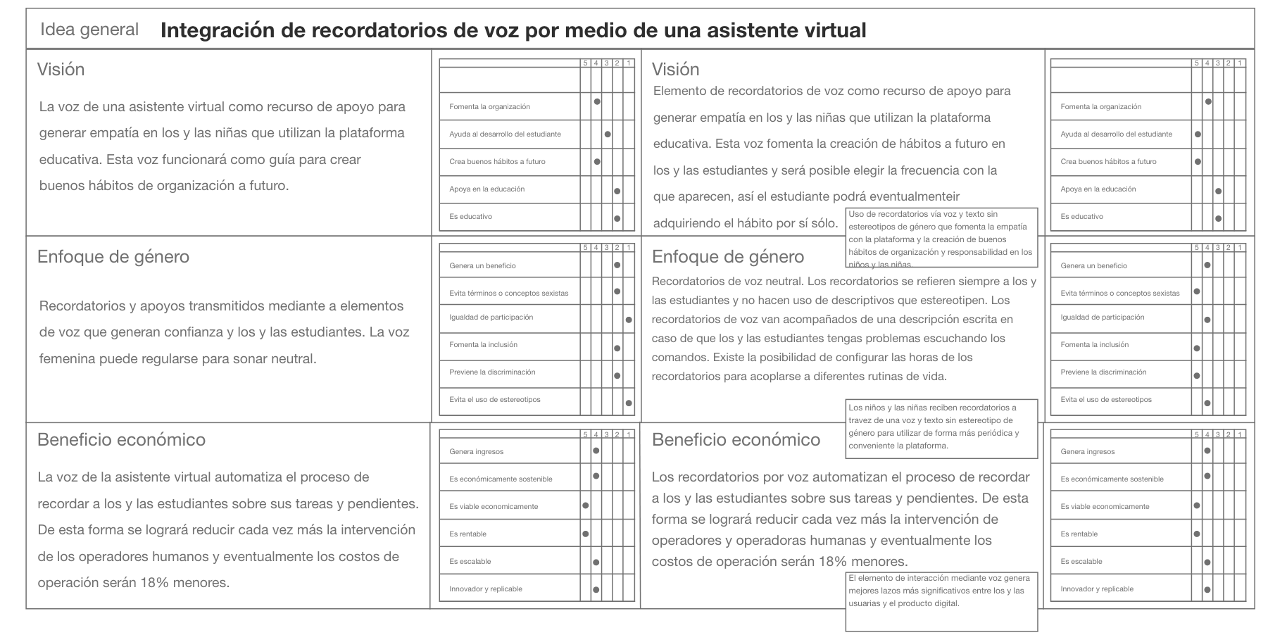

Tool 8. Prioritization of ideas

Just as group ideation tends to produce better results, idea prioritization processes also lead to valuable and inclusive observations when conducted in gender-balanced settings. This tool encourages the perspective of potential ideas for a product to focus on the most crucial areas for the company and always keep reflection from a gender perspective in high regard.

The matrix creates a hierarchy with different elements that are considered for a design or redesign of the product. This tool lists the main ideas to be implemented and invites those who carry it out to think about the next steps for their execution, but not without first analyzing them from a gender inclusion perspective and asking whether the proposed idea contemplates meeting the needs and attacking the benefits of women and men alike.

Tool benefits

This technique allows generating a hierarchy of elements based on the needs of the users and the feasibility of its execution. It prevents making decisions based on assumptions, as it encourages reflection based on data and information that already exists in the company, asks questions about gender inclusion and later generates a detailed list or an action plan with the most important elements that must be added to product design.

What do you need to put this tool into practice?

- Used after you have a series of potential ideas or concepts that you want to add to a product. To apply this tool it is also necessary that the person or persons who carry it out already have sufficient knowledge, information, statistics and / or real previous data regarding the behavior of the company (or similar companies) and its markets, since in this way they will be taken well-informed final decisions.
- It is suggested to carry out the following steps as a group to obtain more complete findings. It is highly recommended that the people who make up the team are 50% women and 50% men, and that they have knowledge about gender equality, stereotypes and gender roles.

Worst possible idea
This tool deals directly with disruptive and innovative ideas and concepts. The main suggestion is to avoid being prejudiced when ideas are unusual. For this, it is recommended to perform the technique of The worst possible idea, which promotes creative thinking and eliminates stigmas in the perception of concepts.

- The activity must be carried out in groups.
- Each round one member will propose a random topic or problem and the rest of the group will have 5 minutes to write the worst ideas that can occur to them.
- The team will share their worst possible ideas, among all of them they will have a dialogue to conclude if any of those ideas would be, in fact, a good idea.

For more information about this activity, go to:
https://www.interaction-design.org/literature/topics/worst-possible-idea

Steps for implementation

- Individually, each member of the team will write their specific ideas for the product, a sticky note for each idea. There is no minimum or maximum of ideas.

- A person representing the category of gender analysis will be assigned. This person will have the responsibility of advocating throughout the entire dynamic for equality between men and women. In addition, she will have the right to audit the process at any time to generate or propose corrections. This person must be trained and sensitized to gender and inclusion issues.

- The representative of the gender approach will read each note and, if necessary, will ask to detail or reformulate any idea to make it more inclusive. To facilitate understanding, you can provide the following questions for people on the team to work with:
- Are you starting from sexist ideas about the needs, expectations and behaviors of women and men?
- Are uses of the product being promoted that contribute to reproducing gender stereotypes?

- Like a MoSCoW chart , create a diagram with the following 4 quadrants: Must have, Should have, Could have and Would like but won't get. On the right hand side of the quadrants, add a column that says Priorities.
For more information on the traditional MoSCoW method, visit:
https://toolkits.dss.cloud/design/method-card/moscow/
https://www.browserlondon.com/blog/2019/11/04/power-of-moscow-method/

- Each member must arrange their ideas in the quadrants taking into account the following logic:
- Must have: essential elements of the product. Without the features in this quadrant, users are unlikely to consider purchasing the product.
- Should have: important features that generate great extra value, but without them the product could still function and meet the basic needs of users.
- Could have: elements that could be added or implemented to the product, but these do not add as much value for people or for the business.
- Would like, but won’t get: features that do not add a specific value or that are very complex in implementation compared to the benefit they generate.

For more information on the four quadrants, visit:
https://www.youtube.com/watch?v=WitQtcSXFlE

- Once the different characteristics have been rated, discuss with the team whether they agree with the position of each item.

- If there is an idea that someone on the team disagrees with, it can be put to a vote. Each member will give their opinion and propose in which section that idea should be found.

- Within the Priorities column, create a list and specify for each idea in the Must have / quadrant, which sequence of steps would be the next to develop each idea. No need to create detailed steps, this section will help you get a better idea of how to turn these ideas into action.

- The person representing the gender perspective should invite the team to reflect on the list written in the Priorities column and ask themselves if the ideas and their respective next steps contemplate and consider both the needs of men and women. If not, the ideas or next steps will need to be reformulated.

Tool application example

Each of the steps is exemplified below with the practical case of a team analyzing a travel backpack.

            - Individually, each member of the team will write their specific ideas for the product, a sticky note for each idea. There is no minimum or maximum of ideas.

            - A person representing the category of gender analysis will be assigned. This person will have the responsibility of advocating throughout the entire dynamic for equality between men and women. In addition, she will have the right to audit the process at any time to generate or propose corrections. She must be trained and sensitized in gender and inclusion issues.

Notes created by team members
Option to transform into suitcase with wheels | Color change with the sun | Anti-theft locks | Compartments
Padlock closures | Enough space for a change of clothes | Fire resistant | Integrate a brand App
Geolocation | Personalized with the initials of the buyer | Adventurer version with more resistant materials and dark colors | Ergonomic shape on the back
Easy access to travel documents | Comfortable suspenders | Replacement padlocks | External battery for phones

In the example, the person representing the gender approach considered that the note "Version for adventurers with more resistant materials and dark colors" is not appropriate since it falls into the stereotype that adventurers and people in need of more resistant materials are only the men.

            - The representative of the gender approach will read each note and, if necessary, will ask to detail or reformulate any idea to make it more inclusive. To facilitate understanding, you can provide the following questions for people on the team to work with:
- Are you starting from sexist ideas about the needs, expectations and behaviors of women and men?
- Are uses of the product being promoted that contribute to reproducing gender stereotypes?

Option to transform into suitcase with wheels | Color change with the sun | Anti-theft locks | Compartments
Padlock closures | Enough space for a change of clothes | Fire resistant | Integrate a brand App
Geolocation | Personalized with the initials of the buyer | Adventurer version with more resistant materials and dark colors | Ergonomic shape on the back
Easy access to travel documents | Comfortable suspenders | Replacement padlocks | External battery for phones
Difficult-to-drill materials

To correct the above, the note was rewritten as two individual ideas proposing waterproof materials and difficult-to-drill materials.

            - Create a diagram with the following four quadrants: Must have, Should have, Could have and Would like, but won’t get. On the right hand side of the quadrants, add a column that says Priorities.

Must have | Should have | Priorities
Could have | Would like, but won’t get

            - Each member must arrange their ideas in the quadrants, taking into account the following logic:
- Must have: essential elements of the product. Without the features in this quadrant, users are unlikely to consider purchasing the product.
- Should have: important features that generate great extra value, but without them the product could still function and meet the basic needs of users.
- Could have: elements that could be added or implemented to the product, but these do not add as much value for people or for the business.
- Would like, but won’t get: features that do not add a specific value or that are very complex in implementation compared to the benefit they generate.

Must have  Comfortable suspenders Compartments  Enough space for a change of clothes Ergonomic shape on the back Easy access to travel documents | Should have  Waterproof material Padlock closures  Anti theft closures Difficult to drill material | Priorities
Could have  External battery for phones Option to transform into suitcase with wheels  Replacement padlocks | Would like, but won’t get  Color change with the sun Fire resistant Integrate a brand App  Personalized with the initials of the buyer Geolocation

            - Once the different characteristics have been rated, discuss with the team whether they agree with the position of each item.

            - If there is an idea that someone on the team disagrees with, it can be put to a vote. Each member will give their opinion and propose in which section that idea should be found.

            - Within the Priorities column, create a list and specify for each idea in the Must have quadrant, which sequence of steps would be the next to develop each idea. No need to create detailed steps, this section will help you get a better idea of how to turn these ideas into action.

Must have  Comfortable suspenders Compartments  Enough space for a change of clothes Ergonomic shape on the back Easy access to travel documents | Should have  Waterproof material Padlock closures  Anti theft closures Difficult to drill material | Priorities  Comfortable suspenders Research of possible materials  Compartments  Create new sketches contemplating the division of spaces  Enough space for a change of clothes Measure and document the average sizes of passports, airline tickets, and train tickets  Ergonomic shape on the back
Could have  Batería externa para teléfonos Opción de transformar a maleta con ruedas  Candados de repuesto | Would like, but won’t get  Color change with the sun Fire resistant Integrate a brand App  Personalized with the initials of the buyer Geolocation | Do tests on the current product and verify if the capacity and volume are adequate  Ergonomic shape on the back  Get the relevant anthropometric tables

            - The person representing the gender perspective should invite the team to reflect on the list written in the Priorities column and ask themselves if the ideas and their respective next steps contemplate and consider both the needs of men and women. If not, the ideas and / or the next steps should be reformulated.

Must have  Comfortable suspenders Compartments  Enough space for a change of clothes Ergonomic shape on the back Easy access to travel documents | Should have  Waterproof material Padlock closures  Anti theft closures Difficult to drill material | Priorities  Comfortable suspenders Research of possible materials and anthropometric tables for men and women  Compartments  Create new sketches contemplating the division of spaces  Enough space for a change of clothes  Measure and document the average sizes of passports, airline tickets, and train tickets  Ergonomic shape on the back
Could have  Batería externa para teléfonos Opción de transformar a maleta con ruedas  Candados de repuesto | Would like, but won’t get  Color change with the sun Fire resistant Integrate a brand App  Personalized with the initials of the buyer Geolocation | Do tests on the current product considering different types of garments and verify if the capacity and volume are adequate  Ergonomic shape on the back  Get the anthropometric tables for men and women

In the example, the following steps corresponding to “Comfortable suspenders”, “Enough space for a change of clothes” and “Ergonomic shape in the back” have been modified. Clarifications have been written to carry out research on different types of garments and integrate anthropometric tables for women and men. This is an example of how from very early stages in the design the gender approach is present and thanks to this the product will cover the needs in an inclusive way in the future.

Format suggestion for layout
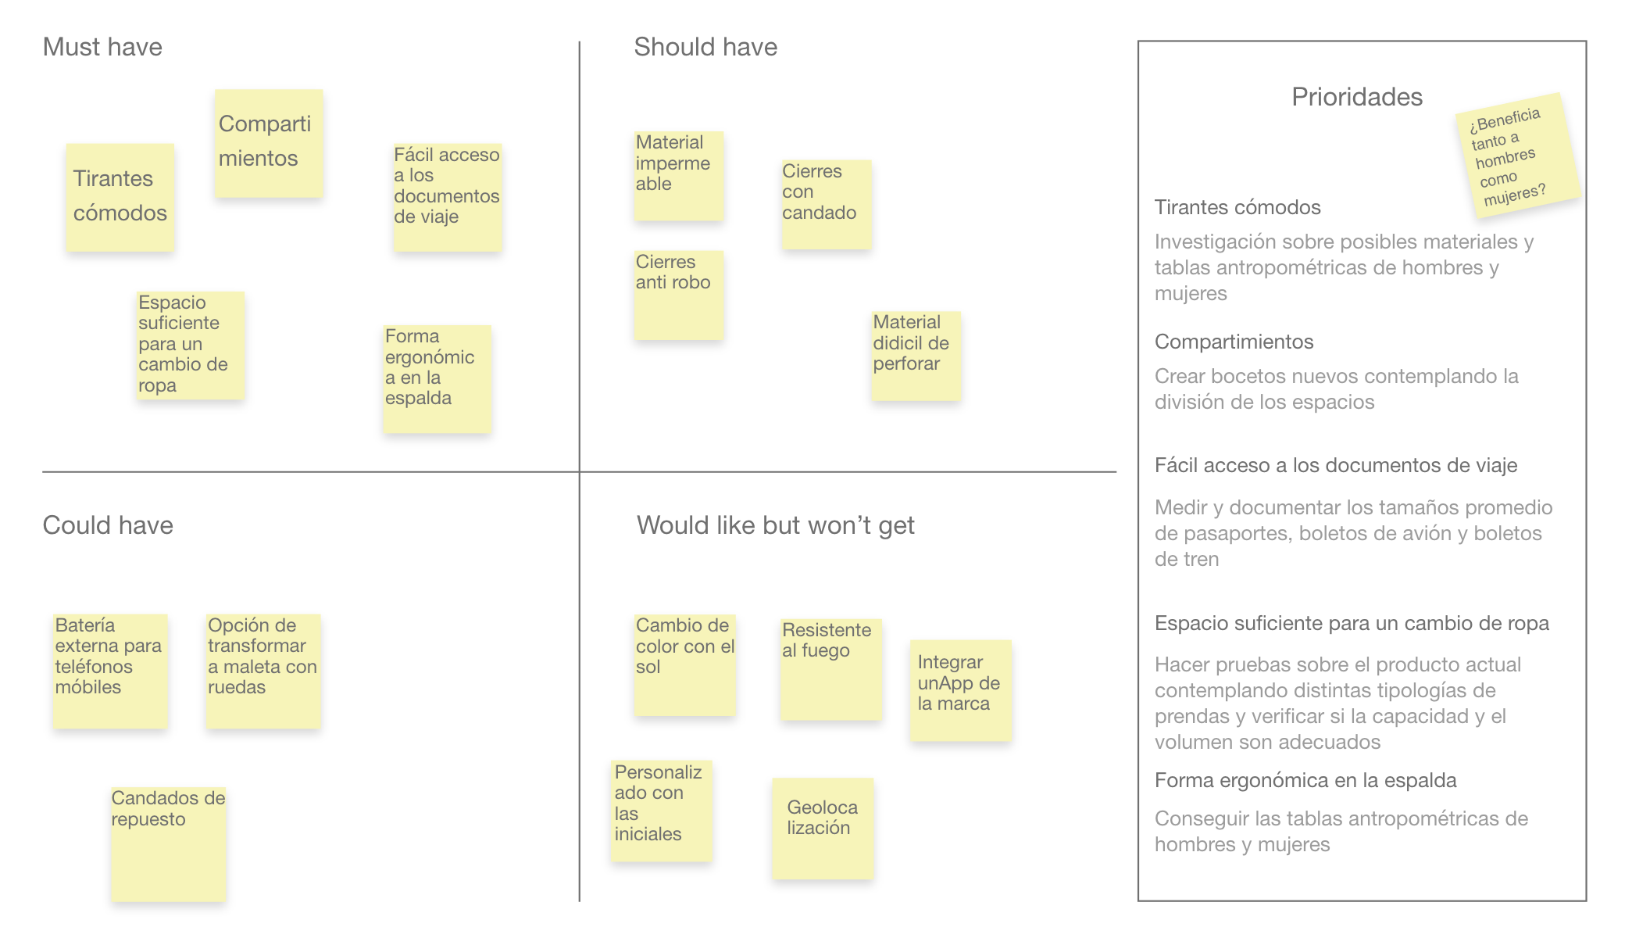

Tool 9. Role play

In the prototyping stage, ideas become reality and the function of the tool is to validate the ideas generated. Despite being presented as one of the last phases of the process of creating and developing a product, this can occur throughout the entire creation project in parallel with the empathy, definition and ideation phase.

When you have a proposed solution to the chosen problem, it is imperative to prototype this proposal. This stage helps companies identify improvements in a proposed solution before launching it on the market. It is here that the ideas raised in the storyboard or other ideation tools become reality.

The tool chosen to prototype the product idea obeys the mission of this toolkit to develop products with a focus on gender equality. A tool of this type, more belonging to the performing arts, allows the last vestiges of gender stereotypes that may be taking shape in the solutions to be made visible.

The exercise of literally putting oneself in the role of the user and facing the problem together with the proposed solution is an excellent way of reflecting on gender roles, which will help to have a look that seeks to achieve equal opportunities and opportunities. deal between men and women.

There are multiple ways of prototyping ideas, for example, if it is a tangible product, the ideal would be to make a model or simulate the product in low resolution so that possible improvements can be identified internally. And if we are talking about a service, an excellent way is to have the user interaction map, also called the person's understanding route, where the stages through which the user passes, the actions carried out in the user, will be identified. each one and with what emotions and thoughts it faces.

It is important to know that the prototype you choose to make will evolve throughout the process. It is the end for which it is created.

Many times it is perceived as a conquest of this prototyping phase to have the user interaction map or the physical product mockup, however, when creating, developing and designing with a gender perspective, these prototypes will not be enough to continue building empathy towards the user.

Design with a gender approach demands a greater level of empathy and knowledge about the differentiated situation of women and men, which must continue to be built in each phase.

For this, it will be necessary to carry out a representation of the solution, a role play or role playing, since failure to do so may lose opportunities for improvement, insights and findings that will only come to light after a tool like this and not just imagining the interactions or imagining the use of the products.

Prototyping, ideation, and testing tools require constant feedback from other people. In particular, if you seek to work with a gender perspective, it will be advisable to convene the innovation and development committee. If you do not have one, you can build a team with equal participation of men and women, with the greatest variety of skills, preferably multidisciplinary, and that people are trained to identify stereotypes and advocate for gender equality throughout the process.

- To learn more about the creation of the innovation and development committee and the use of information disaggregated by sex, visit tool 1. Creation and development of products with a gender perspective, located in this same lens. And to better understand the user experience, tool 3. Person’s path of understanding is recommended.

What do you need to put this tool into practice?

- Have the product idea and all the information that helps to carry out the interpretations with the greatest possible fidelity. It is highly recommended to use information that has the results of men and women separately, so as not to lose sight of the wishes, interests and expectations of both groups or the interest group.

- Define the roles. Assign each person on the team the role they will have in representing the solution. The roles to take into account can be:
  - The user.
  - The person with whom you interact as part of the solution (only in the case where the product includes the attention or participation of someone else).
  - The person in charge of recording and recording. A single person or more can perform this role. It will depend on the size of the team.

- Recreate the scenarios in the most accurate way with components that seem real. As in the other tools, it is important to pay attention to the chosen scenarios and that these do not increase the inequality gap between women and men.
Have you created scenarios with women doing housework?

- Actresses and actors must interact with the product or service.

You have to be very careful with the staging. Is it possible that stereotypes are being used about the way women or men behave? Are hero or alpha male personalities being used to represent a man? Is a woman's voice being used to represent an electronic resource for assistance?

On this last point there are many myths that a woman's voice is innately easier to understand. This is based on other myths that a higher voice register is easier to hear, or that they are easier to hear despite a noisy environment and many more.

To learn more about gender stereotypes regarding voice assistants, visit the following link with an article entitled "No, women's voices are not easier to understand than men's":
https://gizmodo.com/no-siri-is-not-female-because-womens-voices-are-easier-1683901643

Being aware of this will help to iterate on the solution without adding biases that end up adding unnecessary components that reproduce gender stereotypes to the product or service. For example, representing a woman with body gestures exaggerating attributes of delicacy, contributes to continue forming the idea that women have to be perceived as delicate people, and for this reason, some products fall into common places when using pastel or pink colors for tangible products, or stereotypical motivations such as "always have a perfect makeup" when designing a service.

- The team should be asked to express their ailments and joys in the most real way possible at each moment of interaction.

- It is important to take turns to interpret the roles, you can define a garment that characterizes the user to be used by each member in their turn to interpret it. This will provide complementary ideas to the participants of the tool.

- Have a device to record the session, it can be a cell phone or a camera.

- The proposed duration is 120 minutes.

Dress up and get ready to perform!

What to do during the session?
Wow… looking good!
Color is a component with a lot of emotional charge, taking advantage of the fact that you must dress up for this tool, choose the colors that can convey the mood.
Whoever directs the tool must inject energy into the rest, so we recommend an accessory or garment in RED.
Accompany this tool with garments that convey the emotions of the user in each phase of Role playing.
UNDERSTAND

Do not lose sight of the objective and channel all efforts to achieve it. Pay close attention to what you have to look at.

EMPATHIZE

Learning from experience should be the most important result of this tool. Put yourself in the shoes of your customers to feel their joys and sorrows.

EXPLORE

Give a little more. Go one step further to find new opportunities, solution ideas and uses.

How to analyze the information?

Once the role play has been carried out, it is necessary to analyze the information obtained.

- Evaluate. Examine if the solution is meeting some of the objectives of the design of products and services with a gender perspective:
  - The product must not reproduce gender stereotypes.
  - The product satisfies a need of women and girls that was previously not being met with any product or service on the market.
  - The product contributes to the advancement of gender equality.

- Choose. Determine what improvements and opportunities can be reflected in the final model or final understanding map. It is important to determine the learnings and ideas that came out of this tool.

- Iterate. Repeat the process with the improvements made. Prototyping the new version is important before moving on to the last phase of testing with the end customers.

It should not be assumed that the product or service is perfect after an improvement, the more times that improved role play is repeated, the closer the product will be to meeting the needs of the user and emotionally connecting with them.

- Tool 10. Usability test, available in this same lens, presents another test proposal in the prototyping stage.

You can also see this tool as a brainstorming projected using the body, it can be called bodystorming.

To see an example of role play applied to the prototype of a product or service, here is a video:
https://www.youtube.com/watch?v=NXLKgUgr6qI

Share your experience using the hashtag: #bodystorming

Tool 10. Usability test

To evaluate the performance and performance of a product in the most effective way possible, it is necessary to recreate an environment as close to the reality in which it will be used. For this, it is essential not only to consider an inclusive and balanced environment between men and women, but also to elaborate and test hypotheses of its intended use, its good interaction and how the product does not reproduce gender stereotypes, it satisfies a need of women who previously did not was being cared for or contributes to the advancement of gender equality.

The usability test evaluates specific criteria of the product and takes into account the experience of end users. It uses a population sample referring to the desired target user, so the participation of men and women should be considered equally.

In the event that the product or service has been planned to be directed to a particular sex, it is necessary to ensure that this differentiation is essential and is not based on socially assigned roles and stereotypes about what is feminine and what is male.

When segmenting the market, it is advisable to think about the functionality of the product and the need to be satisfied through its use, not about preconceived ideas about behaviors and attitudes that are culturally considered appropriate for women and men, and that may be reproducing gender stereotypes.

Tool benefits

This test generates a list of opportunity areas for the product. The list is created from the opinion, interaction and comments of a representative sample of the target users. Inclusion and gender equality are promoted since the sample of users to be recruited must be 50% women and 50% men. Unless, without stereotypes, the product or service is directed to a particular sex, it is necessary to represent both men and women as part of the population.

What do you need to put this tool into practice?

- It is applied after having a final product, a prototype or a mockup of which you want to test the performance.
- To test the prototype in a real environment it is necessary to have 6 people to carry out the usability tests. 3 women and 3 men, unless the target population identified by the company details another proportion.
- The range of users with whom the product will be tested should ideally be between 6 and 10.
- It is recommended to record the interaction with people to later analyze the content, it is necessary to ask for their authorization before doing so.
- It is suggested to work as a team to obtain more complete findings.
- It is highly recommended that the people who make up the team are 50% women and 50% men, and that they have knowledge about gender equality, stereotypes and gender roles.
- El desarrollo completo de esta herramienta se logra en aproximadamente 1 a 4 días.

Creative unclog
Part of the success in executing usability tests is the naturalness and fluidity of the dialogue between the two parties. To achieve this with better results, it is suggested to perform the following dynamic:

- The activity must be carried out in pairs and once it is finished the roles will be reversed.
- One person in the couple will come up with an initial approach to a seemingly pointless conversation. For example:
"I heard that tomorrow the color of the sea will change to purple."
"The new president of the country will be Spider-Man."
- From the approach, the other person must begin to tell an anecdote for 5 consecutive minutes.
- Whoever is not narrating the anecdote should provide words out of context to his partner. Whoever is narrating should listen to these words, but without stopping the narration and integrating them into the story in the most natural way possible, regardless of the absurdity of the story.

Steps for implementation

- If you do not have the final product, create a reference object that makes direct reference to the most notable characteristics of the product to be tested. For physical objects, some important characteristics to represent are usually sizes and volumes, and for digital products, the arrangement of information and the selection of words / copy.

- 2. Having a tangible prototype will also help the team to reflect more clearly if the product reproduces any gender stereotype, for example, in the colors, the packaging, the proposal for use, the language or the images used. If so, it is necessary to redesign the prototypes and/or mockups.

Some of the questions the team can ask themselves to reflect on gender stereotypes include the following:
- Are you starting from sexist ideas about the needs, expectations and behaviors of women and men?
- Are uses of the product being promoted that contribute to reproducing gender stereotypes?
- Are colors, language or images traditionally associated with the feminine or masculine being used?

- Define the objective and the hypotheses to be tested. It is recommended to formulate a series of premises regarding the product that the team has in mind and wants to test. At least one hypothesis must be added about the validation of the product from the gender analysis, for example:
- The product does not reproduce gender stereotypes.
- The product satisfies a need of women that was not being met before.
- The product contributes to the advancement of gender equality.

- Recruit users. For this step it is necessary to maintain the actual proportion of the desired audience. For recruitment it is recommended to avoid people close to or closely related to the project as this can affect impartiality.

Tip: It is often easier to recruit people when they are given something of value in return, discounts, exclusive offers or gift cards.

- Design the layout or the guide to be taken during the usability test. The team must determine what questions and actions to ask users and what information they want to obtain from each of them. These tasks and questions will be the most important instrument to validate both the correct use and interaction of the product and to verify if gender stereotypes are not being reproduced. It is advisable to divide the test into tasks and evaluate each one separately.

The structure of the guide is made up of:
- A brief introduction, in which the dynamics are explained to the participants, they are made to enter into confidence and feel welcome and welcome.
- The body of the guide is the one that encompasses the tasks and questions to be asked.
- A conclusion or closing in which people are thanked for their participation.

This layout should be designed to last no more than 1 hour, as users start to lose their attention. It is advisable to add times to the guide and practice it before to check that everything goes well.

- Execute the test previously designed in the layout. It is important to have a solid guide, but it is advisable to be flexible and adapt it to each person, that is why it is relevant to know the guide and not read it, this will allow us to be flexible and add, remove or extend the parts of the test in a natural way .

There are a number of guidelines that must be adhered to when running usability tests:
  - Record voice and video for later analysis. For this, it is necessary to first request the authorization of the users.
  - Avoid correcting people during the process. It is tempting to want to correct or guide them through tasks, but you just want to try a natural interaction.
  - Asking the person to share their thoughts out loud will help you get more information.
  - Remind him that there are no right and wrong actions and that he or she will not be tested.
  - Ask for honesty and clarify that the comments will not be taken badly.
  - Avoid reading the guide too systematically. This can create a much less free dynamic and therefore the results will be more limited.
  - Try to be in a controlled environment free of distractions.

- Analyze the results disaggregated by sex and according to the metrics established by the team. The analysis can be carried out individually or in a group, at this stage the videos are re-watched and analyzed in detail. Some metric references are:
7.1. Completion rate: the requested task was completed successfully or not.
7.1. Number of errors: the number of times the person made errors in each task and why is evaluated.
  - Completion time: the time it took the user to perform each task is evaluated and analyzes if it took much more or less than expected and why.
  - Net Promoter Score: asks on a scale of 1 to 10 if the person would recommend the product to someone else.

- Reach conclusions on the initial hypotheses as a group, verify if these are validated or invalidated according to the results obtained with the test. Analyze if any difference was identified between women's and men's behavior or use of the product and document the findings.

Tool application example

This practical case exemplifies each of the steps through the usability test of an interactive book with an education platform.

- If you do not have the final product, create a reference object that makes direct reference to the most notable characteristics of the product to be tested. For physical objects, some important characteristics to represent are usually sizes and volumes, and for digital products, the arrangement of information and the choice of words / copy.

- Having a tangible prototype will also help the team to reflect more clearly if the product reproduces any gender stereotype, for example, in the colors, the packaging, the proposal for use, the language or the images used. If so, it is necessary to redesign the prototypes and / or mockups.

Some of the questions the team can ask themselves to reflect on gender stereotypes include the following:
- Are you starting from sexist ideas about the needs, expectations and behaviors of women and men?
- Are uses of the product being promoted that contribute to reproducing gender stereotypes?
- Are colors, language or images traditionally associated with the feminine or masculine being used?
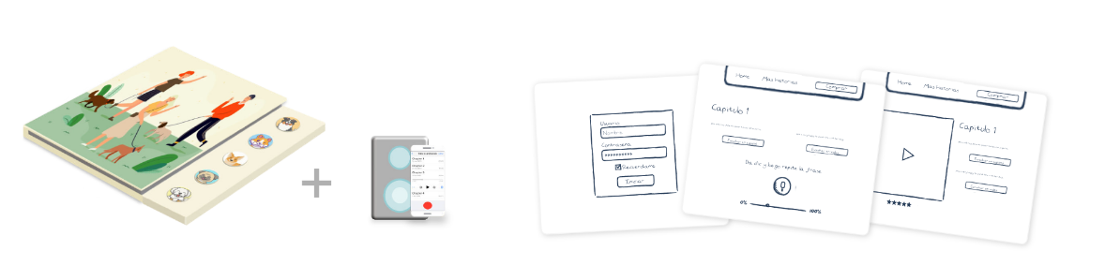
In this example, colors without gender stereotypes were integrated and an equal representation of women and men as characters was sought.

- Define the objective and the hypotheses to be tested. It is recommended to formulate a series of premises regarding the product that the team has in mind and wants to test. At least one hypothesis must be added about the validation of the product from the gender analysis, for example:
- The product does not reproduce gender stereotypes.
- The product satisfies a need of women that was not being met before.
- The product contributes to the advancement of gender equality.

Hypothesis for the usability test of an interactive book with an education platform

- The physical product attracts the attention of boys and girls between 2 and 4 years of age.
- Integrating sounds in a book will make girls and boys prefer this product over other books.
- It is feasible for boys and girls to use the learning platform and activate the correct commands.
- Learning a second language will be something that will generate a lot of value to parents.
- Equal representation in characters is a notable element for boys and girls.
- For the girl users, the message of gender equality and integration that is promoted throughout the stories told in the book is clear.

- Recruit users. For this step it is necessary to maintain the actual proportion of the desired audience. It is recommended to avoid people close to or closely related to the project, as this can affect impartiality.

- Design the layout or the guide for the usability test. The team must determine what questions and actions to ask users and what information they want to obtain from each of them. These tasks and questions will be the most important instrument to validate both the correct use and interaction of the product and to verify if gender stereotypes are not being reproduced. It is advisable to divide the test into tasks and evaluate each one separately.

This layout should be designed to last no more than 1 hour, as users start to lose their attention. It is advisable to add times to the guide and practice it before to check that everything goes well.

Layout for the usability test of an interactive book with an education platform

7 minutes for introduction
Hello, welcome and welcome to the KdsBks offices. Thank you very much for being here, I am _______ and I am part of the team that will be with you today. Do not hesitate to make any questions or comments to me or to any of my colleagues.
First I will explain a little about the dynamics of today. I will give you an object that will simulate one of our books with audio and throughout the test I will ask you to perform certain actions.
This is a test, but remember that what we are testing is the product and not you, there are no right or wrong actions and all comments are more than welcome. Tell me out loud everything that goes through your mind while you do the tasks.
Before starting, I would like you to tell me a little about yourself. What is your favorite animal? Do you have puppies in your house? Do you like picture books?

5 minutes for task number 1
In front of you there is a product that simulates a book. I would like to ask you to open the book and listen to the content of chapter 3.
What did you think of what you heard?
What do you think happens when I click the next button? Was that action what you expected?
Do you like the character of the dog? Why?

10 minutes for task number 2
Now I would like to ask you to use the digital platform and follow the instructions corresponding to chapter 3.
Did you have any questions to find this section?
How do you think it would be clearer to identify the buttons?

10 minutes of for task number 3
Still within the digital platform I would like to ask you to find the section "Name your characters" and then give them the name you want.
Did you have any questions to find this section?
Why did you choose that particular name? Why do you think that character is female / male?

5 minutes for task number 4
From the entire book, go to the page that most catches your attention and tell me which character is your favorite and why.
What do you think of that character?
Does it remind you of someone special?

10 minutes for final questions
Which chapter did you like the most? Why?
What part of the homework was the most fun for you?
Which sound do you think is the best?
Do you think any of the characters are good or bad?
Do you think any of the sounds are weird or funny?
What do you think of the colors? You like them? Which ones would you have chosen for your favorite character?
Which book do you find the most difficult to understand? Why?
If I gave you two of these books, who would you give the second to?
What did you think of the story in which the father dog took care of the children? Why?
What did you think of the story in which the lioness was queen of the jungle? Why?
If you could choose someone as king or queen of the jungle, who would you choose? Why?

5 minutes for the conclusion and closing of the interview
______, I want to thank you for participating in this test, we are done with the questions and activities. You have helped us a lot with your comments and we will use them to improve our product.

- Execute the test previously designed in the layout. It is important to have a solid guide, but it is advisable to be flexible and adapt it to each person, that is why it is relevant to know the guide and not read it, this will allow us to be flexible and add, remove or extend the parts of the test in a natural way.

Taking into account the guidelines that must be met when executing the usability tests mentioned in the steps, in this example the users are minor children, so their parents must be there during the process and must authorize if it is possible to record the session or not.

- Analyze the results disaggregated by sex and according to the metrics established by the team. The analysis can be carried out individually or in a group, at this stage the videos are re-watched and analyzed in detail. In the example, most of the hypotheses were found to be correct.

- Reach conclusions on the initial hypotheses as a group, verify if these are validated or invalidated according to the results obtained with the test. Analyze if any difference was identified between women's and men's behavior or use of the product and document the findings.

Analysis of the usability test results of an interactive book with an education platform

- A. The physical product attracts the attention of boys and girls between 2 and 4 years of age. Correct: 85% of boys and 95% of girls preferred this product in the first instance.

- Integrating sounds in a book will make girls and boys prefer this product over other books.
Incorrect: The item that generated the highest preference in both groups was the cover of the book. The sounds were not so obvious to them and them in the first instance. 60% of the boys and 75% of the girls were carried away by the striking photos and images.

- It is feasible for boys and girls to use the learning platform and activate the correct commands.
Correct: 90% of boy users and 90% of girl users of these ages understand well how to use the buttons and the commands are clear enough for them.

- Learning a second language will be something that will generate a lot of value to parents.
Correct: Fathers expressed 75% and mothers 80% that they have a preference for the product that can teach useful things to their sons and daughters.

- Equal representation in characters is a notable and appreciated element for boys and girls.
Correct: 70% of the children expressed good understanding and appreciation for the equal presence of characters. Likewise, 95% of the girls expressed their great pleasure in the presence of female characters such as the leaders.

- For the girl users, the message of gender equality and integration that is promoted throughout the stories told in the book is clear.
Correct: 55% of the boys and 75% of the girls understood and expressed clearly, but on their own terms, their understanding of the importance of equality between men and women in the stories.

Resources

How to make fast product prototypes:
https://www.youtube.com/watch?v=k_9Q-KDSb9o

How to make fast paper prototypes:
https://www.interaction-design.org/literature/topics/paper-prototyping
https://www.youtube.com/watch?v=8mo3A6hUJSc

Usability testing with fast prototypes:
https://www.youtube.com/watch?v=9wQkLthhHKA

Types of metrics and how to apply them:
https://usabilitygeek.com/usability-metrics-a-guide-to-quantify-system-usability/

Tool 11. Elevator pitch: The sales pitch

In the final phase of the creation and development of a product or service, the objective will be to see if the solution that has been reached will work when it is submitted to the user. Thanks to this phase, the company avoids investing large sums of money before knowing if the product or service will really satisfy the needs of the customers and if it will ultimately connect with their motivations.

As the last phase of the process of creating and developing a product, it is not exempt from the commitment to continue helping to transform gender roles to achieve the desired equal opportunities and treatment between women and men.

The commercialization and sale of a product, normally known as the last mile, is loaded with ideas that exist in society and that companies take up as behaviors and attitudes that are considered appropriate for women and men. This causes gender stereotypes to be transferred to marketing strategies.

This tool helps companies to publicize the value of the product in a few words and without falling into gender stereotypes. This is possible because the objective of the elevator pitch or sales speech is to concretely communicate the value proposition without the need to resort to identity appeal tricks to achieve it.

Since it is a strategy to expose ideas with very defined characteristics, the elevator pitch is useful to counteract the confidence gap that exists between women and men. This gap, which may be the cause of some of them stopping in search of opportunities, has its origin in gender stereotypes, since socially women are expected to be modest, patient and not raise their voices, which creates an unfavorable environment for them to express their opinions and be assertive.

An interesting data collected by HP reveals that women in this company only applied for a position when they had reached 100% of the requirements requested for the job, while men were willing to apply with 60% compliance with the requirements.

Design thinking, being a methodology that idolizes error and invites you to be part of the creation process, is ideal for building in women the idea that it is not necessary to have everything perfect to jump into doing something. Under this principle, recovering from a mistake will be easier, and that is one of the reasons why men advance professionally more, self-confidence helps them not to sabotage themselves.

On the other hand, the different situations of power experienced by men and women in the world of work, in which they are interrupted more frequently, questioned for their opinions or required to prove their competence, can be addressed with tools that help to build trust and speak from a new perspective

The power poses (body language) added to the elevator pitch, can help build confidence in women to sell their ideas and make themselves heard from a more secure, assertive and open position to make mistakes.

Where does the elevator pitch concept come from?

It was born in the United States and its name comes from the fact that it takes place in an elevator, the only place and time in which you could have access to the CEO of the company or an investor and comment on the idea of a product or service for try to convince you to buy or invest in it

Although it is true this tool was created mainly to expose the project to an interest group, such as investors or boards of directors, the intended use as part of this toolkit is to define the product's sales message and increase confidence in the women by expressing their ideas in a selling way.

The product sales pitch should guide everyone involved in creating the promotional campaign. Here it is important to warn about the possible gender stereotypes that could get filtered in this pitch. Having clear and concise the value proposition, both of the product and of the idea that it is trying to transmit, it will be easier to communicate it to those interested or in charge of marketing and selling the product.

The elevator pitch should last a maximum of 2 minutes, ideally 60 seconds.

It is really challenging, so it will be beneficial to involve more people to do a session where everyone can contribute ideas about how to verbalize the solution or product created. This group should have equal participation of women and men, with the greatest variety of skills, preferably multidisciplinary and with people trained to identify stereotypes and who advocate for gender equality throughout the process.

- For this task, the innovation and development committee described in tool 1. Creation and development of products with a gender focus can be convened within this same lens.

Steps for implementation

- Get to know the audience. Notice what value judgments are being assigned to the people who will hear the sales pitch.
Pay attention to how you describe or categorize it

- Create a speech that mentions:
- The target person for whom the product or solution is intended.
- The need to be satisfied.
- The name of the product or service.
- The category to which the product or service belongs.
- The key benefit, the reasons for creating them.
- The differential with respect to the competition or market alternatives.
- How the product meets the needs of women and girls, closes gender gaps, or promotes gender equality.

- Do not have a single sales pitch, it is good to have several pitches on the same product idea.

- Remember to be brief, no more than 120 seconds.

Presenting the value proposition of a product designed with a gender perspective requires that the categorization criteria of the target person and the type of message do not contain gender stereotypes. Not only as a position of the company to improve our society, but because commercially it can be counterproductive.

A Harvard Business School study suggests that there is a threat in unintentionally categorizing people into a single identity. This even has a negative effect. People do not like to be categorized, even when they do feel part of that identity. In groups that are not marginalized or stereotyped, these appeals will not generate negative reactions, perhaps even a reason for grace. But a gratuitous categorization can backfire if the person belongs to a group usually discriminated against and if the appeal evokes a stereotype of that identity.

To carry out a good sales pitch with a gender perspective, it will be very important not to assign a stereotype to the audience. Therefore, one should avoid assuming that just by being part of a certain social category will the person appreciate the benefits of the value proposition.

Tool application example

Using the following structure when verbalizing the solution or product proposal will be helpful.

For (target person), who has (person's need), (product name) is a (market category) that (a key benefit), unlike (competition), the product (differentiator) and helps / improves society / environment to the (reason why the product helps transform gender roles and inequality / reason why it positively impacts the environment)

Lani Lazzari, a recent high school graduate, used the elevator pitch to convince the Shark Tank USA jury in 2013 to invest in her natural sugar-based skincare line Simple Sugars, focused primarily on sensitive skin.

Lani is currently the CEO of Simple Sugars and has managed to turn it into a million dollar business. During her 1 minute pitch on the show, Lani goes through the following points:

- Product motivation: Lani had suffered from eczema since she was 11 years old and could not find a product that will work on her sensitive skin and smell good.

- Product results: using her creams, she managed to remove her eczema and rough skin.

- Why invest in it? The product was popular with her family and friends, has 100% natural ingredients and gently exfoliates while deeply hydrating the skin.

- Commitment to the product: she emphasizes that she has been focused on her entrepreneurship since high school and that she is willing to do anything to get her business going.
Click the following link or YouTube icon:
https://www.youtube.com/watch?v=_2hcGWDQMVM

Share your experience using the hashtag: #elpitch

Tool 12. Data analytics for my company

The objective of this guide is to introduce the organization to the value of incorporating data analytics tool in the daily use of its work teams. It is focused on managerial profiles, has a low level of complexity and does not require prior knowledge.

The guide explains how to identify if the company has an adequate data analytics tool (this term will be used hereinafter, as it is more common) or should consider adding some for the exploration of its data. In addition, she will explain how to select the appropriate tool and how to take the first steps to use it.

People who analyze and make decisions based on data in organizations often depend on information technology teams to obtain it. The introduction of data analytics tools such as Power BI, Tableau, among others, to the market, made it possible for the tasks of data extraction, cleaning and visualization to be carried out in a much simpler way and without the need for long years of technical training. Thanks to these tools, nowadays, in a few steps you can make a connection to the databases of customers / human resources / sales / operations and begin to analyze them based on the direct gaze of those who make decisions in companies, empowering those people in the implementation of data analytics solutions.

Tool benefits

This paradigm shift in knowledge management within companies presents a unique opportunity to make more and better decisions based on information. In particular, adding a look from the gender perspective to these data is key so that decision-makers have in an accessible way the possibility of exploring various crossings of information and visualizations to identify and evaluate the gender gaps that may exist, relying on explanatory variables (after differentiating the population by sex, exploring the age or some other demographic characteristic of clients, work teams, etc.), which allows the implementation of targeted and evidence-based policies.

For example, the work teams of the companies can analyze by their own means if there are gender gaps in positions and areas of the company, in their clientele, in the design of products and / or services, or if communication actions and sales are being unintentionally directed toward one sex. Specifically, the opportunity for decision-making teams to analyze company data is also an opportunity to analyze information with new and varied approaches.

What are data analytics tools?

They are tools that allow us to manipulate, model and visualize company data:

- • Manipulate means that they allow us to prepare the data and make it ready for analysis. For example, sometimes it is necessary to combine data from various sources (various Excel files, from the web, from a system database). Data analytics tools allow you to unify the various data sources and automate that process. In terms of the gender approach, it is key in this regard to ensure that the information is collected and stored with adequate criteria for subsequent analysis. For example, ensure that the variable gender (male / female) and the age of the people are stored as a minimum, as well as other variables of interest when possible.

- Modeling means that, from an analysis of our data in the past, we can predict how some variables of the organization will perform in the future. For example, from an analysis of the historical sales of a company based on investment in advertising, we can create a model that allows us to estimate what sales will be like in the future for different levels of investment in advertising. In terms of the gender approach, it is key to think about what techniques can be used to visualize whether the design of products and / or services have unwanted gender biases.

- Visualize means that we can create graphs that are easy and simple to interpret and that are useful for decision making. In terms of the gender approach, it is important to know how to choose which visualizations are the ones that best show the existing gender gaps.

There are several tools that allow you to carry out these three tasks in combination. Every year the Gartner company compares the various existing data analytics tools. In 2021, the leading tools are those developed by Microsoft (Power BI), Tableau and Qlik. As can be seen in the following graphic, Microsoft is the main one and that is why in this guide we guide how to start using it.

The graph shows four quadrants based on the completeness of vision and the ability to execute for each of the tools: the upper left quadrant shows the tools that are challenging the market; On the lower left are tools that have a sector or niche focus; In the upper right quadrant are the leading tools; and at the bottom the tools with a greater business vision.

Graph 1. Gartner Magic Quadrant for Data Analytics Tools
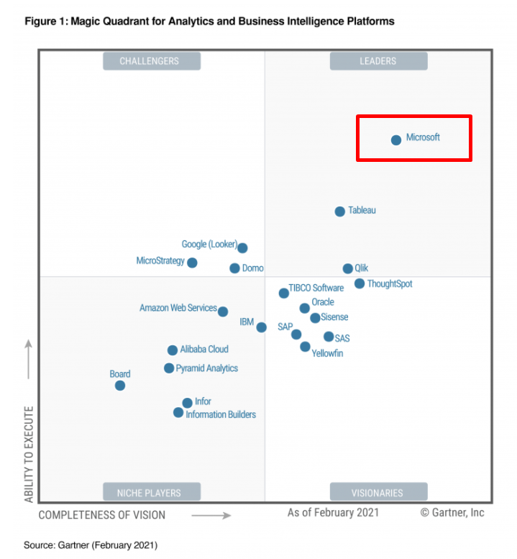
Source: Gartner, Inc. (2021). Gartner Magic Quadrant for Analytics and Business Intelligence Platforms. Disponible en: https://www.gartner.com

When are they used?

Data analytics tools can be used in all areas of the company to answer various questions based on data. And for each of these questions within each area of the company it is worth understanding whether there are gender gaps and how they can be eliminated.

Questions that can be answered with a data analytics process with a gender perspective:
- Analysis of a specific event. What happened? Are there gender gaps?
- Automated reporting. What's going on? What is the trend of gender gaps over time?
- Strategic analysis. What is happening and why? What variables explain the existing gender gaps?
- Predictive analysis. What's going to happen? What will be the future trend of gender gaps?
- Prescriptive analysis. How can we make something happen? What can we do to close gender gaps?

Example of using data analytics tools

Below are examples of the use of data analytics tools in different areas of a company with a gender focus.

Company area | What happened? | What's going on? | What is happening and why? | What's going to happen? | How can we make it happen?
Sales | Sales evolution report per month in the last 3 years. What is the ratio of men to women in my clientele? | Report with automatic update of daily sales. What is the trend among my clients according to gender? | Analysis of which variables explain the growth in sales. What variables explain the differentiated behavior of sales according to the sex of my clients? | Estimation of how sales will evolve based on variables external to the company. What is the sales projection taking into account the gender distribution of my clientele? | Analyze what changes should be made to increase sales without presenting unwanted gender gaps.
Human Resources | Report on the incorporation of collaborators to an organization in the last year. What is the ratio of men to women among the people hired per position? | Report with automatic update of income and expenses of collaborators in a company, per month. | Analysis of the characteristics of the jobs where the highest levels of turnover occur. What variables explain the gender gaps in my company? Are there masculinized sectors? Why? | Projection of the hiring of new collaborators based on key variables of the company. What is the projected trend in the next hiring of the organization in terms of balance according to sex? | Analyze how to improve the talent retention rate. What actions have been taken to guarantee gender equality among the company's employees? What effects will it have on talent management in general?

Steps to select the right tool for my company

From the experience of using the two main data analytics tools, it is possible to identify that the choice of which one to use is a function of which other tools should be integrated with them. For example, if all my company information is hosted on Microsoft Azure servers (cloud environment), it is recommended to use Power BI; On the other hand, if the data management of my organization is based on solutions in the cloud of the Google environment, it is possible that the integration with Tableau is simpler.

The following flowchart presents some of the questions (not all) that we can ask ourselves to reflect on which tool to choose.
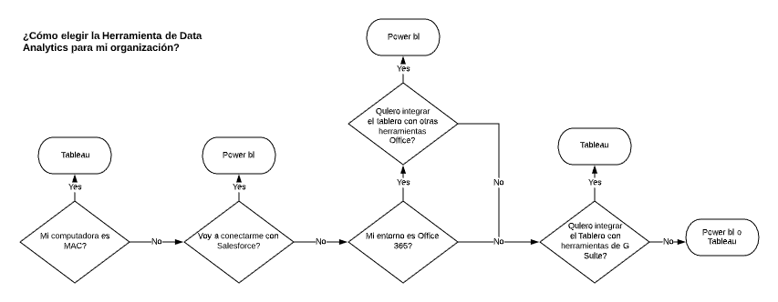

How to start a data analysis with Power BI?

- Step 1> To start using Power BI Desktop, you need to download the application for free from the Microsoft site, at this link: https://powerbi.microsoft.com/en-us/downloads/

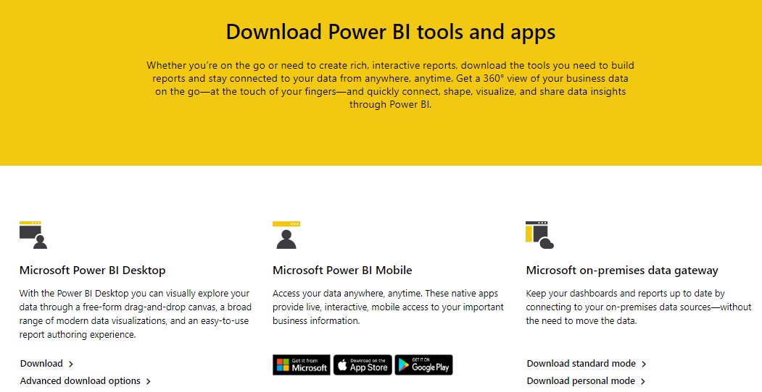

- Step 2> Once downloaded, the installation must be carried out. Then the application should be opened and connected to a data source.

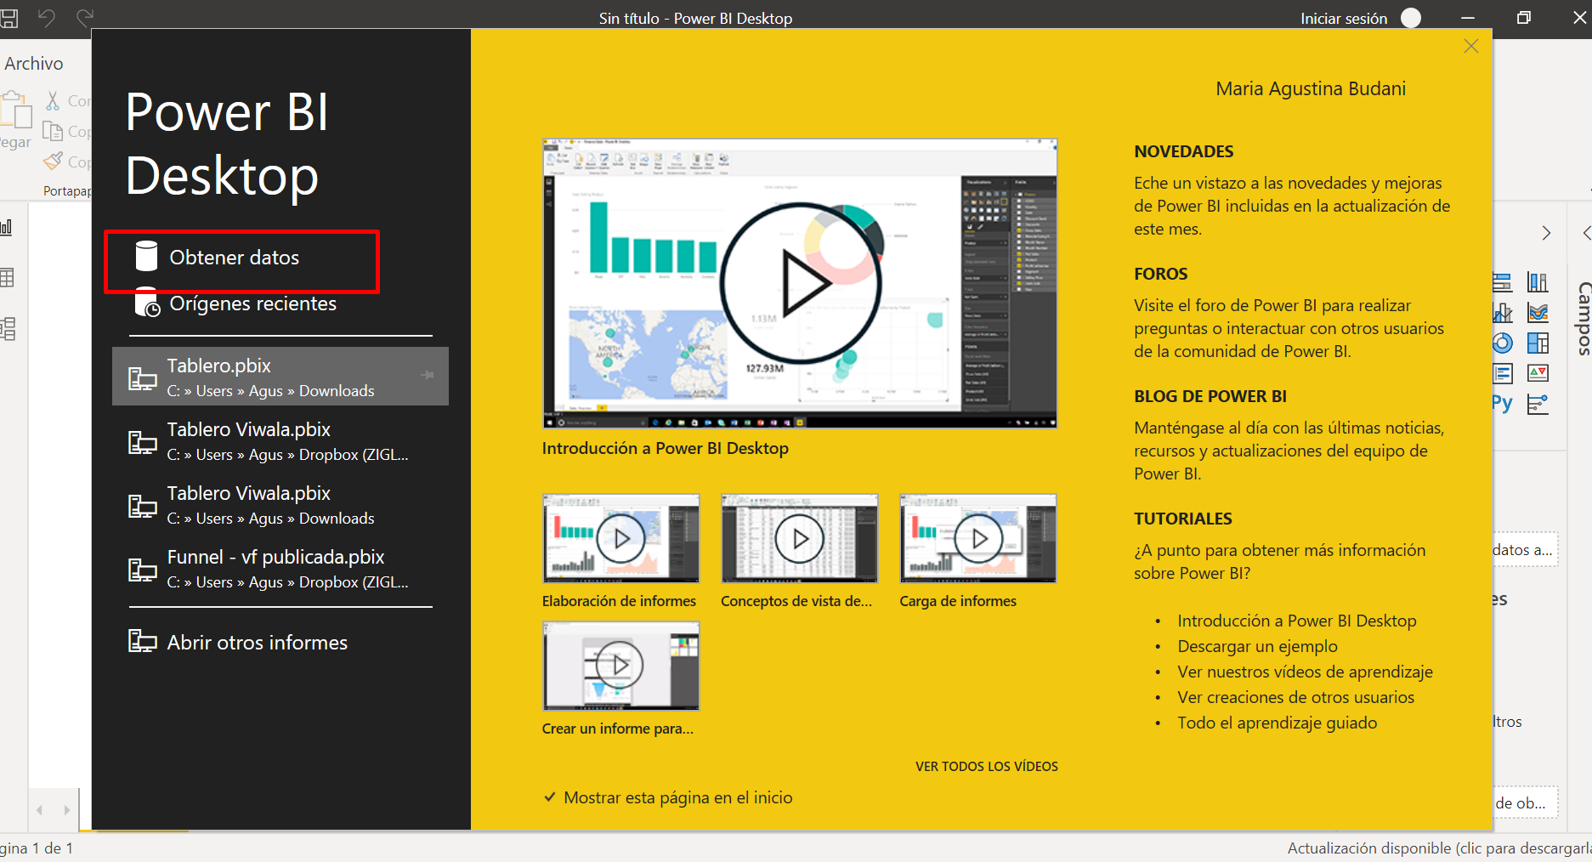

- Step 3> Choose the type of data source to which we are going to connect. In this case we are going to connect to an Excel file.

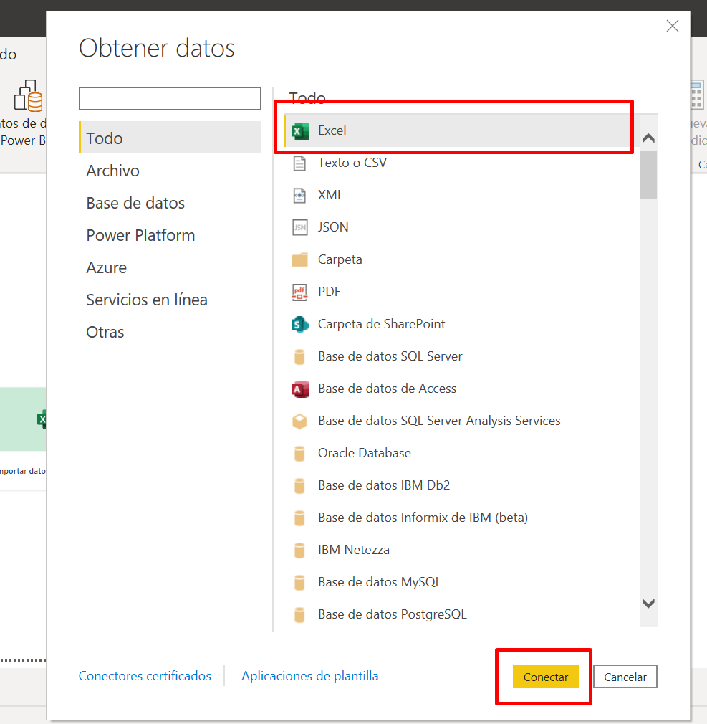

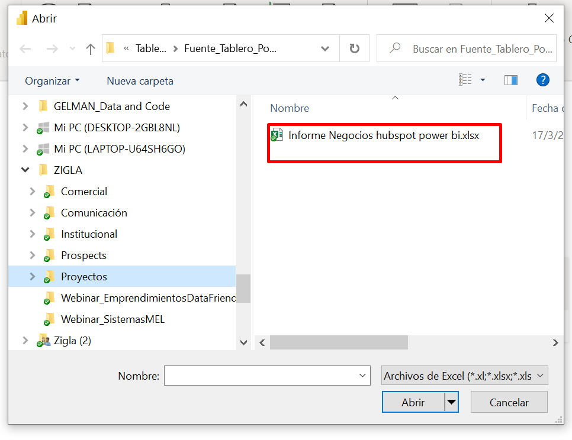

- Step 4> Choose the data sheet within the Excel file with which we want to work. We are going to use a database available in Power BI.
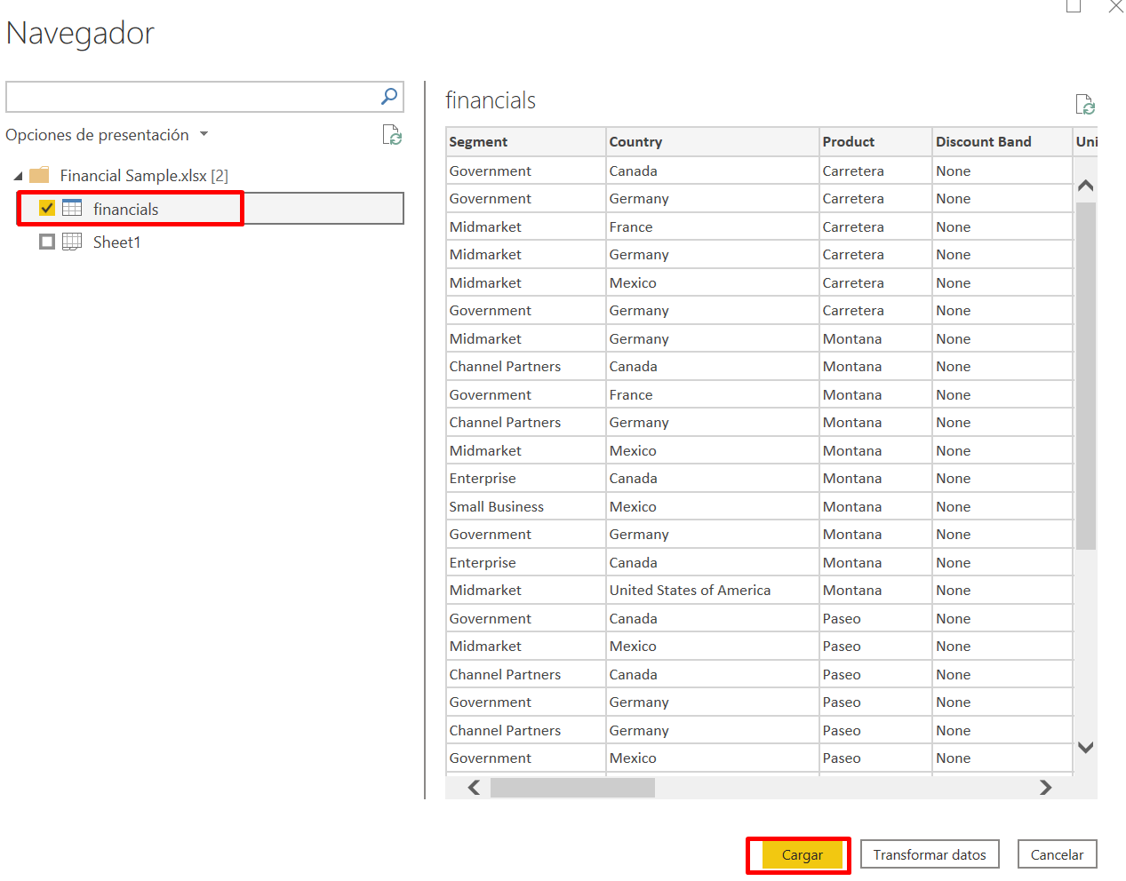

- Step 5> Select the data sheet in the Power BI file to be able to see all the fields that the Excel file where we connect to has.

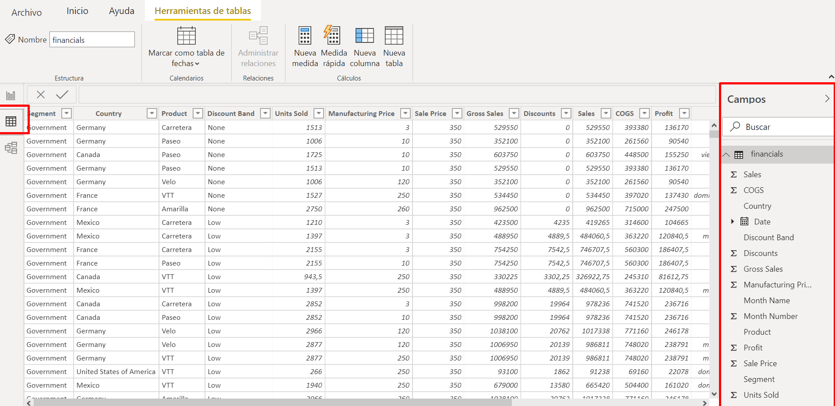

- Step 6> Select the report panel and see the types of visualizations that we have available in Power BI to perform.

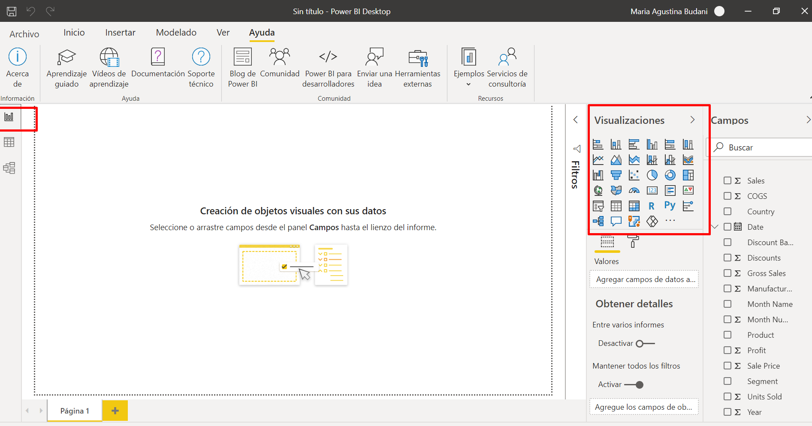

- Step 7> Select the graph we want to make and the data we want to show in it.

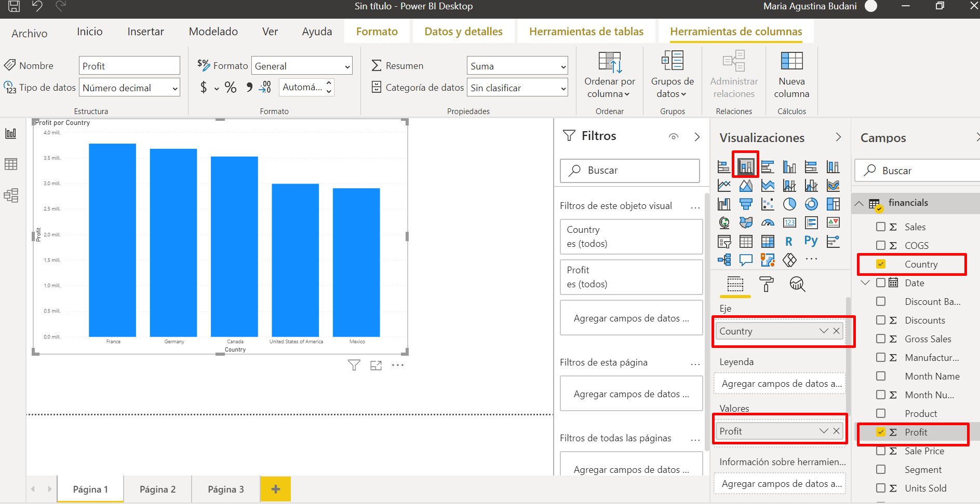

Tool application example

In order to show how to connect to a database and start making the first charts in Power BI, we are going to use the results of a company's customer satisfaction survey. We are going to make three simple graphs in a first board with data filters.

Video-tutorial (in Spanish)

In the following link you can see a tutorial that explains the steps to start a data analysis with Power BI:
https://drive.google.com/file/d/1m1bOnEWuz9zyVtLrvcYRZTcdHzur3VTf/view?usp=sharing
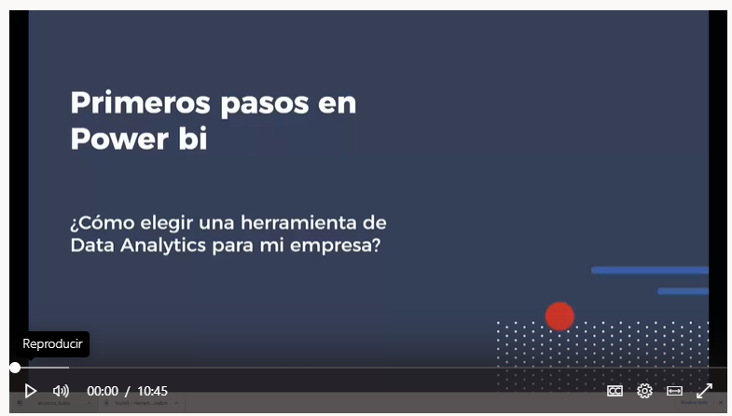

Database used for the case

In the following link you can download the Excel file with the data to replicate the video example:
https://drive.google.com/file/d/1Ga1TsvaGbzD1akj2xQIl8vl-J824kGaI/view?usp=sharing

Resources

Power BI has a free guided self-study platform in Spanish. In the following link you can start the learning path of the tool: https://powerbi.microsoft.com/en-us/learning/.

Tool 13. Analysis of gender gaps in the sales process

The objective of this tool is to explain how to make a sales funnel and analyze the importance of including disaggregation by sex and age in the process of selling a product or service.

It has a medium level of complexity and requires a basic knowledge of Power BI Desktop. It is intended to be used by a company's management staff, sales analyst team, or business planning team.

- ✓ In the tool 12. Data analytics for my company, from lens 3, it is presented how to get started in Power BI.

This guide explains what the sales funnel is and why it should be considered gender-sensitive. It also explains how to design a sales funnel with Power BI with an example based on a fintech (a company that provides financial services based on a web platform).

Every company that sells a product or service to end consumers or to other companies has a process that begins with a contact and ends successfully with the sale. In the middle of the process there are several steps that are usually filters to be able to make the sale. For organizations, it is key to know the evolution of their customers in the sales process and to know in which steps the greatest losses of customers tend to occur. Likewise, it is interesting to know if the evolution in the sales process is different depending on the characteristics of the clientele, such as sex, age, geographical location. The sales funnel is a tool that allows you to visualize this in a simple way.

Tool benefits

Assuming that the evolution in the sales process is indistinct from the characteristics of the clientele can lead companies to lose sales or not be able to boost them. By incorporating a gender analysis with disaggregated information and comparing different sales processes in light of the gender variable, you can boost your arrival in a broader market.

From the point of view of the businesses that offer these products and services, it is key to be able to analyze whether the purchase has distinctions in terms of the sex of the people: is my product or service accessible to men and women equally? Are there gender gaps among my potential clientele? Is the sales process inclusive or does it have a gender focus? How is the disaggregation by sex of my potential clients throughout the sales process? By answering these questions, companies have the opportunity to reach more consumers and ensure the accessibility of their products and services.

In the event that the product or service has been planned to be directed to a particular sex, it is necessary to ensure that this differentiation is essential and is not based on socially assigned roles and stereotypes about what is feminine and what is male.

When segmenting the market, it is advisable to think about the functionality of the product and the need to be satisfied through its use, not about preconceived ideas about behaviors and attitudes that are culturally considered appropriate for women and men, and that may be reproducing gender stereotypes.

What is a sales funnel?

It is a marketing tool that visualizes how the potential clientele of a company goes through the different phases of prospecting until they become clients. A sales funnel, which is also called a marketing funnel or conversion funnel, represents the idea that all sales start with a large number of potential customers and end with a much smaller number of people who end up buying the product. or service.

It is called a funnel because it is usually shaped like this, since of all the people who enter the funnel as potential consumers, only a few end up becoming customers.

The following graphic shows conceptually how different contacts arrive at the sales process by marketing actions and they are filtered as they go through the stages of the process.

Gráfico 1. Diagrama conceptual del embudo de ventas
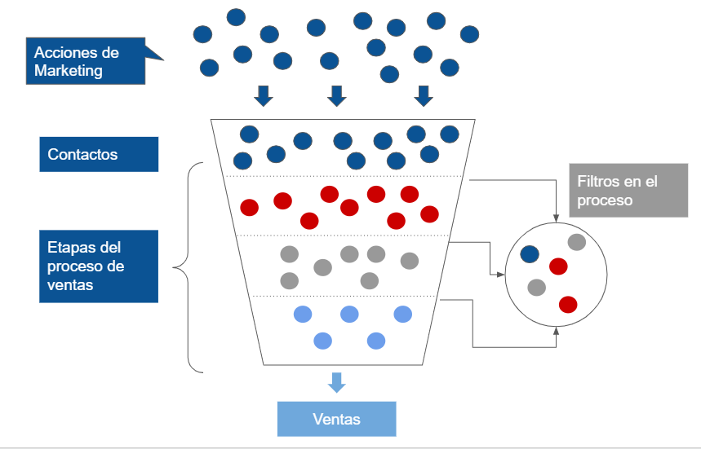
Source: Own elaboration based on information from Wikipedia (2021). Sales funnel. Available at: https://es.wikipedia.org/wiki/Embudo_de_ventas

The sales funnel is visualized using a funnel chart that can be developed in data analytics tools. This implies that a company can design and automate its sales funnel in such a way that it can monitor what the bottlenecks are and / or what are its conversion rates of its sales actions. Likewise, the analysis of the sales funnel can be improved by delving into the characteristics of the people who go through the different phases, for example, gender or age. In this way, the funnel allows us to see if there are bottlenecks and also if those who do not advance in the process or phase have common characteristics. Analyzing these behaviors allows us to correct processes so that they are more inclusive or reach all the people we intend to reach with our services or products.
When is it used?

Beyond tracking sales, funnel charts are a great option when your data is sequential and moving through at least four phases. For example, we may want to show the phases in a production process to be able to detect bottlenecks in a linear process. Likewise, these types of graphs are widely used to track the workflow of a shopping cart and to track the progress and success of marketing and advertising campaigns with click-through.

Tool application example

In order to explain how to calculate a sales funnel, we use an example of a company that offers online financial services, a fintech. The financial product sales process is in 9 stages from the first contact. The funnel aims to show how many of the people who are interested in the product in stage one become customers in stage 9.

Of the following graphs, the one on the left shows the evolution in the sales process of companies that apply for credit and are led by women. It can be seen that, out of 491 applicants, 8 reach the end of the process (they go through the 9 stages). While the graph on the right shows the evolution in the sales process of organizations that apply for credit and are led by men. Of 394 companies that start the process, none go beyond stage 7 (the process is up to stage 9).

Graph 2: Sales funnel based on the gender of the person who runs the company.
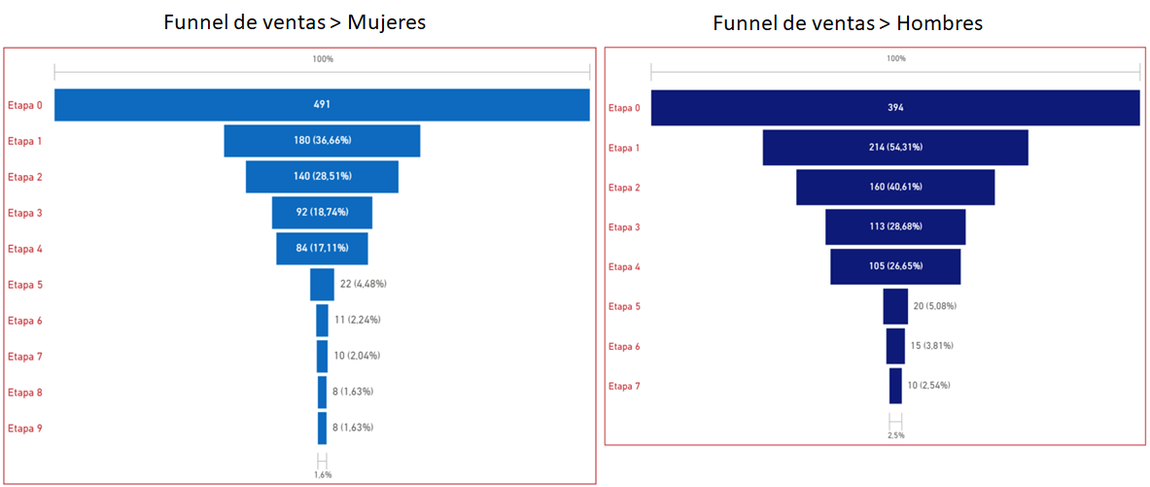Source: Own elaboration based on the information on the study case.

The sales funnel allows us to see that there is a bottleneck (an important filter between those who start in stage 0 and those who continue the process) for women in stage 1, while for men the bottleneck occurs mainly in stage 5. In terms of the gender approach, it is important for this company to understand why these filters are so marked in the process and to answer questions such as the following:
- What happens in stage 1 so that the proportion of women who advance in the process is lower than among men?
- How is the sales process being managed at this stage?
- What sales communication messages are used to offer the product to women? Is it adequate in terms of the realities of the women to whom it is offered?
- What changes can be made at this stage of the process to increase the proportion of women who move on to the next?
- What characterizes stage 5 so that few men (in proportion to women) can advance from this stage?

Steps to create a sales funnel in Power BI

- Prepare the data sources

Ideally, you should have two data sources: first, the main database, which will contain information per person / company on the following variables: stage in the sales process, rejection / non-rejection status, sex ( if it is a company, the gender of the person who runs it or the gender of the person who manages the sale within the organization), the stage at which it was rejected, any other variable that is considered relevant to later filter the funnel.

The second base (base of stages) should contain a complete list of the stages of the sales process. It is important that all the stages are present, even if no one is in any of them. In addition, this database must have an index column that numbers the stages.

- Connect data sources to the model in Power BI

When connecting the data sources, a relationship of the two bases must be created using the stage name field of the staging database and the reject stage field of the main database. This relationship must be one-to-many. Additionally, the stage name column of the stage base must be sorted by the index column of the same base.

- Create calculation index for the "Values" field

This index must have the following structure:
Index = CALCULATE(COUNTA(Base principal[ID contacto]), FILTER(ALL(Base etapas), Base etapas[Columna índice] >= MIN(Base etapas[Columna índice])))

- Create the funnel

The sales funnel uses the funnel chart type, which comes within the default visualization package in Power BI. To create it, it is necessary to have at least two fields: the "Group" field, which will be fed by the stage name variable from the stage base; and the "Values" field, which will be fed by the measure created in the previous step.

- Required filter

To complete our funnel, it is necessary to open the filters tab and in the stage name field, select all the values except "blank". This is based on the fact that we are taking only rejected people / companies, so the column of reject stage (or similar) will be blank for all those that have not yet been rejected, and will distort the graph.

- Add filter card

In order to give it a gender focus, another object must be added to accompany the funnel: a filter card using the sex field of the main base. This will help to analyze if there are differences by sex in the stages in which people / companies are rejected. In statistics, the sex variable takes the categories: woman / man.

Video-tutorial (in Spanish)

In the following link you can see a tutorial that explains the steps to create a sales funnel with Power BI:
https://drive.google.com/file/d/1orVyo50gDh2swfQzWZG1Hkp3TmjZ4QaG/view?usp=sharing

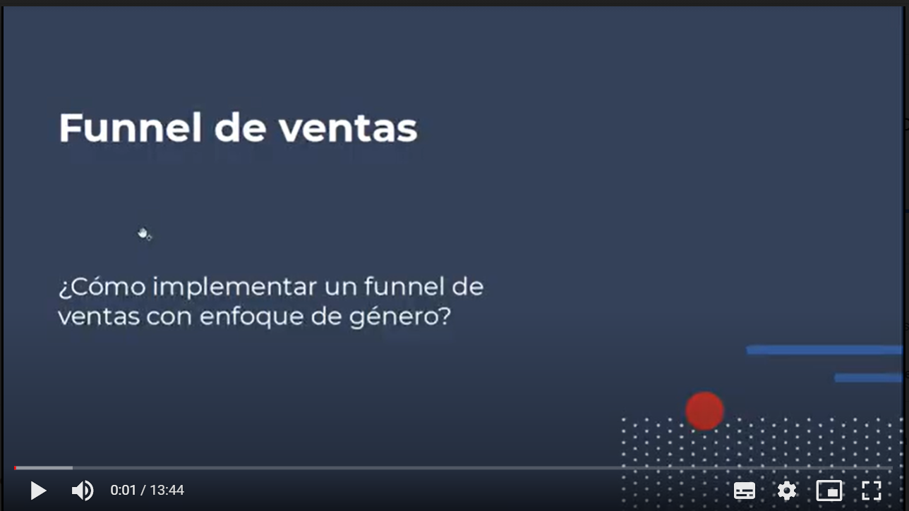

Databases used in the example

In the following link you can download the databases used in the example of the video tutorial:
https://drive.google.com/file/d/1g_PT3gLT9R3iZVLa1DLWWSrlQtall_6b/view?usp=sharing

Resources

Microsoft Power BI. Creation and use of funnel charts:
https://docs.microsoft.com/es-mx/power-bi/visuals/power-bi-visualization-funnel-charts

Microsoft Power BI Community. Forums: Get Help with Power BI Desktop:
https://community.powerbi.com/t5/Desktop/Cummulative-Measure-for-Funnel/m-p/203273#M89468

Tool 14. Customer segmentation

This tool aims to show the way to combine the analysis of customer segmentation using the RFM tool and the gender approach. It involves a high level of complexity, and requires medium knowledge of Power BI and knowledge of statistical analysis to execute. It is aimed at the managerial profiles and the marketing team of a company.

- Tool 12. Data analytics for my company, from lens 3, is an introduction to data analysis or data analytics.

This guide explains what the RFM (Recency / Frequency / Monetary Value) tool is and why it is key when analyzing customer bases in a segmented way to design loyalty plans. Likewise, it proposes combining the RFM analysis with sociodemographic variables of the clients, such as sex and age, to enrich it.

Companies that sell products or services to large groups of clients have the challenge of generating loyalty programs that allow them to be closer to their most valuable clientele. For this, the marketing areas need to be able to know who their clientele is and segment them based on different characteristics: one of them is the relationship between the client and the organization. The RFM tool allows us to analyze three characteristics of this relationship simultaneously and thus group customers based on the value they represent for the company. Another complementary way is to analyze the customer base based on their sociodemographic characteristics such as sex and age. By combining both segmentation criteria, more information is generated in order to design more personalized loyalty plans.

Tool benefits

People are not a homogeneous group. Women and men have different realities from which the company-client relationship can be deepened and personalized. In this sense, the tool proposes adding an analysis of the sociodemographic characteristics to an RFM analysis, so that businesses can improve the way they reach their customers and add value to them through their products or services.

In terms of the gender approach, there is the opportunity to consider the sociodemographic characteristics of the people at the same time as segmenting the clientele based on the value for the company. This makes it possible to design loyalty plans that improve people's satisfaction with the products or services offered to them. Likewise, by being able to plan in a more personalized way the generation of value by the company to different segments of people, it is possible to positively affect the lives of the people who use the products or services offered.

What is RFM?

The RFM tool seeks to optimize actions for different customer segments and thus be able to maximize commercial results with it.

It is called RFM because it analyzes simultaneously:
- R-recency (when the last purchase was made);
- F-frequency of purchases (how often are purchases made, it can be in days, months or years); Y
- M- monetary value of purchases (price of purchases made).

For each of these variables, a score from 1 to 5 is calculated, where 5 is high and 1 is low. Once the different scores are obtained for each of the three variables, the clientele can be grouped according to these and begin to segment them.

When is it used?

RFM analysis is used when it is necessary to segment, order and / or group customers to think about specific loyalty actions in each of the segments.
The following table shows some examples of the types of clientele groups from the RFM calculation combined with the sex of the people. On these, loyalty plans can be designed that combine value for the company and a gender perspective.

Table 1. Examples of customer segmentation using RFM and gender.
Recency Level | Frequency Level | Monetary level | Distribution of people according to sex | Segment
High | High | High | What is the ratio of women to men among the best clientele? Why? | Star. People who bought recently, bought frequently and spent a lot.
 | High |  | What is the ratio of women to men among the most loyal clientele? Why? | Loyal People who are your most frequent shoppers. (It may or may not rate something in the other two variables.)
 |  | High | What is the ratio of women to men in this segment? Why? | High Rollers. This group has spent a great deal of money in their lifetime as a customer.
High | Low | High | What is the ratio of women to men in this segment? Why? | Star potentials. They made significant purchases on their first order.
 | High | Under | What is the ratio of women to men in this segment? Why? | Old Faithful. They shop frequently but don't spend much when they do.
Low | High | High | What is the ratio of women to men in this segment? Why? | Lost clients. They used to be valued customers who shopped frequently and spent a lot, but stopped.
Medium | High | High | What is the ratio of women to men in this segment? Why? | Client at risk. This group used to be a valuable clientele, but they haven't made a purchase in a while and are at risk of becoming a lost client.
 | Low | High | What is the ratio of women to men in this segment? Why? | Blue Moons. These people don't shop very often, but when they do they tend to spend a lot.
Low | Low | Low | What is the ratio of women to men in this segment? Why? | Long Shots. These people spent very little, bought very few times, and last ordered a long time ago.

Tool application example

In order to explain how to calculate the RFM, we use an example of a bicycle shop that has a history of customers who have purchased products from it. The database has data on the purchases made and the characteristics of the clientele in terms of sex and age.

In order to know which customers have the most value for the company, the RFM is calculated and then displayed on a dashboard that groups customers by different clusters. A cluster is a specific grouping of observations (in our case, clients and clients) based on some variables.

By means of a statistical technique, the observations that "most resemble each other" are grouped considering the selected variables. The clusters are analyzed based on the sex and age of the people. To do this, a dashboard is built where the clusters are displayed along with different filters.

Board

In the following link you can view the dashboard with the analysis of the three variables:
- R> Average days elapsed
- F> Average amount of transactions
- M> Average price

You can also select on the gender of the people and see how the position of the clusters is modified based on this variable.

https://app.powerbi.com/view?r=eyJrIjoiYjM2Y2Q4ZTMtMDQwNC00MjM3LWEwN2EtOTdmMTMwMjM4M2Q5IiwidCI6IjRmYWM5MTAxLWRlOWItNGI4Ny1iZDQ2LTA2OTYyNDk5MTRhYSJ9

Dashboard display:

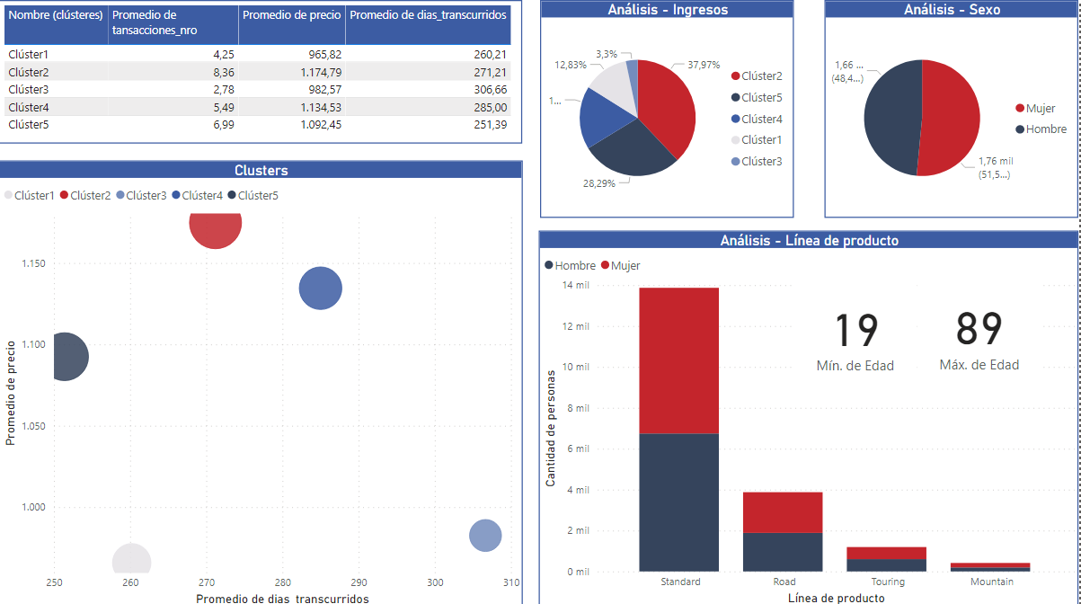

After calculating the R, F and M scores, clustering can be applied, as shown in the video tutorial, and segmenting the clientele groups by sex.

Video-tutorial (In Spanish)

In the following link you can see a tutorial that explains step by step how to calculate the RFM and how to visualize the results based on clusters of clients and clients. Everything done in Power BI:
https://drive.google.com/file/d/1xRwsoEMN6erqeQDAaUfFKHcLdN-YjUUk/view?usp=sharing

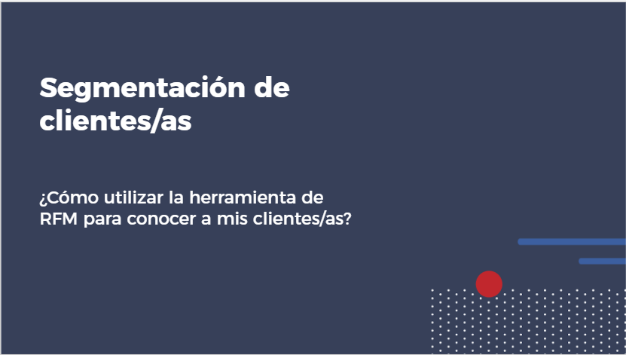

The following graph shows the distribution of the clientele according to 5 clusters (or groups) that emerge when analyzing the RFM variables.

For example, cluster 2 is a group that makes purchases for high prices (M high) and they have made them not long ago (R medium). On the contrary, cluster 3 includes people who have bought for a long time (R low) and for low prices (M low), that is, at the moment they are generating little value for the company. Cluster 4 is made up of people who have made purchases at high prices (M high) but have not bought in a long time (R low). Since these people used to generate value for the company, it would be interesting to be able to recover them.

Graph. Clusters from RFM analysis
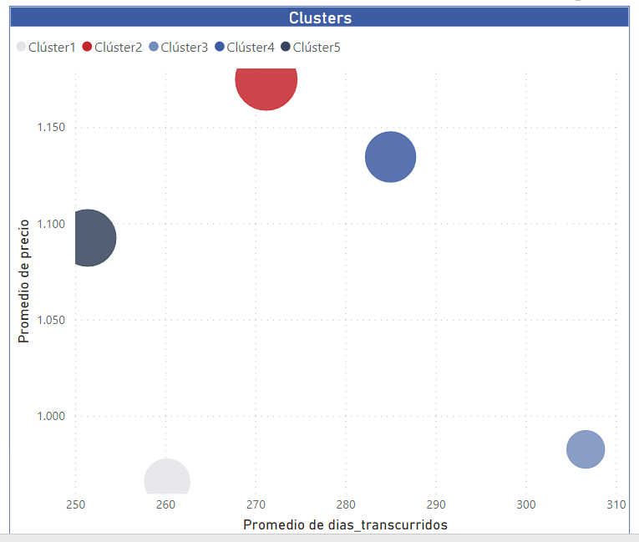

Steps to calculate the RFM

For the calculation of the RFM it is necessary to have a transaction database that, as a minimum, contains the following data:
- ID of the client person (alternatively it can have the name or the identification number).
- Transaction ID (or transaction number).
- Basic information of the product / service: name, type, price, ID.
- Basic information of the client: age, sex.
- Basic information on transactions: date, amount.

Data basess

In the following link you can access the databases used in the example:
https://docs.google.com/spreadsheets/d/e/2PACX-1vROKCtuqIgGQH_2hnhhoU3Ad5-_3SU0dVSJvjJbj1RHgrKUsMtfAi7LmuvK5KcR5Yz-eyKgG-mxhWrL/pub?output=xlsx

For RFM analysis, first of all, we must sort the records based on the date of the transactions from lowest to highest. Next, we need to calculate a series of measures using DAX in Power BI. These measures are detailed below:

- Total revenue / sales per customer:
totalIngresos = SUM(Transacciones[precio])

- Number of transactions:
cantidadTransacciones = COUNT(Transacciones[transaccion_id])

- Date of the first transaction:
primeraFecha = FIRSTNONBLANK(Transacciones[transaccion_fecha], [totalIngresos])

- Date of the last transaction:
ultimaFecha = LASTNONBLANK(Transacciones[transaccion_fecha], [totalIngresos])

- Difference in months between the first and the last transaction:
diferenciaMeses = DATEDIFF([primeraFecha], [ultimaFecha], MONTH)

- Difference in days between the date of the last transaction and the current date:
diferenciaDias = DATEDIFF([ultimaFecha], [hoyFecha], DAY)

- Average frequency of transactions per month:
FrecuenciaPromMes = DIVIDE([cantidadTransacciones], 'Medidas (2)'[diferenciaMeses], 0)

- Recency Scale:
escalaR = SWITCH(TRUE(), [diferenciaDias] > 365, 1, [diferenciaDias] > 180, 2, [diferenciaDias] > 120, 3, [diferenciaDias] > 90, 4, 5)

- Frequency Scale:
escalaF = SWITCH(TRUE(), [FrecuenciaPromMes] > 2, 5, [FrecuenciaPromMes] > 1.5, 4, [FrecuenciaPromMes] > 1, 3, [FrecuenciaPromMes] > 0.5, 2, 1)

- Amount Scale:
escalaM = SWITCH(TRUE(), [totalIngresos] > 15000,5, [totalIngresos] > 10000,4, [totalIngresos] > 5000,3, [totalIngresos] > 2000,2, 1)

Once all these measures have been generated, it is possible to start making filters and visualizations that allow segmenting the clientele according to the values obtained in the three measures.

Resources

Explanation on the RFM analysis and its interpretation:
https://docs.google.com/presentation/d/1n-cbebc5LscZWUBJu32Ejn_2lESN42pyM1ao-ZtoFuo/edit?usp=sharing

Tool 15. A/B testing: Product testing

This tool seeks to publicize what A / B testing is, how to calculate it and why it is key in the design of products and services. It presents a high level of complexity, and its management requires advanced knowledge of Power BI and knowledge of statistics.

- Tool 12. Data analytics for my company, from lens 3, is an introduction to data analysis or data analytics.

This guide explains what A / B testing is and why it is key when designing products and services with a gender perspective. The tool is explained on two levels: a first general level, with the aim of guiding product design teams to understand the relevance of this tool in the design phases; and a second specific level, with the purpose of guiding those who occupy technical positions in the step-by-step application of these tests. For the technical profile it is necessary to have knowledge of inferential statistics and advanced use of Power BI.

Growing or consolidated companies that are designing new products or services are challenged to know which changes or innovations are the ones that have the best results for their customers. For this case, being able to implement A / B testing in the design process of those products or services can provide concrete evidence about what works best and for whom. There are women and girls who do not have access to various products and services and many companies are designing new value propositions in order to reduce gender gaps. In such a way that when introducing products and services to customer profiles who were not previously accessing them, it is key to be able to verify what works best in order to reach more people.

Tool benefits

Using A / B tests with the parameterization of relevant / interest variables such as sociodemographic variables is a key aspect if products or services are being designed with a gender perspective. This is because it allows to quickly know the level of response to the design or the way of communicating a product or service based on the sex and age of the clients.

A / B tests are particularly useful if the company designs products that are sold online or provides services on web platforms, since they are quick to implement and the benefits of carrying out this test are visible in the short term.

In terms of the gender approach, it is key to be able to design products or services that are tailored to the people we want to reach. For example, if we are designing a new product or service aimed at women and we want to verify which communicational message works best in terms of sales conversion, then performing an A / B test will allow us to test different messages and select the one that worked best with the profile of desired women. Another ideal situation to use these tests is when it is known that some products or services are not reaching the profile of women who are wanted to be considered. In this case, a test can be designed that compares the performance of different messages or characteristics in both men and women, and then compares which ones work better in each group.

As postulated by the gender approach, people are not a homogeneous group. Women and men have different needs, perceptions and realities. For this reason, A / B tests allow the design of products or services that adapt to the various characteristics of both groups.

What are A / B tests?

It is known as A / B testing or A / B testing, the creation of two (or more) versions of a product or service to determine which of them best meets the objectives that have been set. It is widely used for the development of web pages and applications, where communication messages, page layout, the inclusion or not of certain elements can improve the achievement of objectives.

In an A / B test, content “A” is randomly shown to half of the users and content “B” to the other half, to then measure and analyze the results of each one of them based on certain variables, such as conversion, engagement and / or rebound.

In the web application development environment, A / B testing is commonly used when the objective is to:
- Dispense valuable information about what people prefer. The first goal of A / B testing is to find out what users prefer. That is, what type of elements or messages make them more likely to click on an ad, become potential customers, make a purchase or stay on a website. In terms of the gender approach, it is used to verify if there are preferences based on the sex of the people for the different elements or messages to be piloted.

- Increase the conversion rate. A / B testing is one of the main tools of the CRO or Convertion Rate Optimization, which refers to a series of systematic improvements so that a content generates more leads, subscriptions, conversions, clicks, etc. In terms of the gender approach, the obstacles that prevent women and girls from having full access to the products and services offered can be identified. From this analysis, it is possible to compare what changes should be introduced to a sales, communication or positioning process to generate greater arrival or loyalty to the product / service among women.

- Improve the user experience. Finally, A / B tests allow us to perfect the content that we offer to those who visit us so that their user experience is more and more personalized and according to their expectations and needs. In terms of the gender approach, it is possible to compare what changes should be made to the value proposition to generate higher levels of satisfaction among women.

The following table explains in a conceptual way three examples of design and pilot of products with a gender perspective in which the use of A / B tests is key.

Table 1. Cases of application of A / B tests with a gender perspective
Sector  Theme | Health | Education | Finance
Context | A company has a product aimed at managing feminine hygiene that has proven benefits on women's autonomy, is environmentally friendly, and is cheaper than other commonly used alternatives. The company offers the product in different cities of a country. | A company offers programming training courses to people aged 18 and over. The only requirement to enroll is to have completed middle school (secondary level). The proportion of women enrolled in the courses is considerably lower than that of men. They want to expand the scope of the courses by getting more women to enroll and thus reduce the gender gap in their courses. | A company offers loans to companies. He has noted that the proportion of organizations led by women applying for credit is lower than those led by men. She wants to expand the scope of her loans and reach more businesses led by women. After several attempts to promote products aimed at businesswomen, it has not been able to increase the proportion of women applying for loans, at the same time that official data from the country where the product is offered indicates that there is an unsatisfied demand for credit.
Challenge | The product has been successfully incorporated in some cities, however, the company faces challenges in successfully inserting the product in other cities with a different demographic context. The company needs to implement a communication campaign about the benefits of the product and wants to verify which messages are the ones that best convey the benefits of the product to women. | Get a higher proportion of women to enroll in its programming courses. The company has launched several ads targeting young women, but has failed to improve enrollment rates. She has decided to make an alliance with a social organization that has proposed working with reference models: cases of successful women who managed to develop their professional careers in programming. These types of campaigns have been developed successfully in other countries and the organization wants to verify what type of model they should choose to achieve higher enrollments in the country where it offers the courses. | Design a product that is attractive enough geared towards the needs of these women. In such a way that the businesswomen request it and grow their business.
Why use an A / B test? | The company can use A / B tests to test multiple communicational messages simultaneously and select the one that obtains the best receptivity among women in the cities where the product is to be inserted. | The company can use A / B testing to test various benchmarks and see which women they target have the most empathy and drive the most enrollments. | Two products have been designed with minimal differences in terms of payment conditions and flexibility. They want to test which one is the most attractive to businesswomen before launching a massive nationwide campaign.
How to design the experiment | At least two messages must be defined to be tested. It can be more than two messages and the test will compare multiple cases at the same time. You must select a sample of women on whom to do the communication experiment. It is important that the sample is representative of the population of women in the cities where the product is to be inserted. Then demographic information that characterizes the women participating in the experiment should be recorded. It is important to be able to interpret the results. You must define the variable on which you want to measure the effect of the message. For example, we could define that the message is displayed on the web together with a button that invites you to explore more about the product. You could define the number of clicks on that button as a target variable. The women in the sample to whom the messages are shown are randomly selected. | The reference models on which to carry out the experiment must be defined. Where and how the promotional campaigns for the courses based on the models should be designed. If they are disseminated in the later years of middle schools, a random selection should be made of the schools where the campaign is going to be introduced and make sure that the people who attend the schools are representative of the population of women to whom you want to offer them. the courses. The objective variable on which to measure the effect of the experiment must be defined. In this case it may be the number of registrations per school. For this, it is key that when the registration information is recorded, information is obtained from the schools and thus validated which reference model of the experiment was the one they saw. Likewise, it is key that demographic information is recorded on those who enroll in order to interpret the results based on that data. | The A / B test allows the company to verify which of the two products generate the largest credit applications. You can verify this before launching the campaign to promote your credits nationwide and thus be able to make sure that they will offer the product that best suits the needs of your potential clients.
How to use the results | After running the experiment, we are going to analyze with which message the most clicks were obtained on the button to explore more about the product. In addition, the women who clicked the most on one message versus the other should be demographically characterized. This is necessary to interpret the results with greater context. As the experiment was applied on a sample, we will use the selected message to scale it to the entire population of women targeted by the communication campaign. | The experiment may end with a higher percentage of female enrollments in some schools versus others. It is key to interpret the results knowing the sociodemographic characteristics of the people who attend the schools. | The two products offered must be clearly defined. They must be aimed at the same client profile, so that the comparison of A / B tests is valid. The objective variable of the experiment must be defined, in this case it may be the loan application. If the experiment is carried out in a web campaign, it is decisive that the product offered to each person is recorded, along with their sociodemographic characteristics, such as sex, age, level of education of the person requesting the loan, as well as some characteristics basic organization, such as productive sector, size and seniority. The allocation of products to offer in the experiment must be random, that is, each person who sees the message has the same probability of seeing either of the two messages. The experiment must ensure that the products were offered to similar profiles of women and companies.

Example of the technical calculation of the A / B test

The following explains how the calculations are performed in order to verify the results of an A / B test. The video explains step by step how to do the A / B experiment calculation using Power BI. For this, it is recommended that those who carry out the technical exercise have advanced knowledge of Power BI and knowledge of inferential statistics.

To simplify the explanation, the case of an advertising campaign via Facebook is used. You are going to promote a product from the catalog and, before launching the campaign, you want to pilot which content is the one that will generate the most conversions (clicks on the buy button). To do this, they design an A / B test, where they will show an advertisement for their product to a group of users and another advertisement to another group. The selection of which advertisement to show to each user is random, that is, each one has a 50% probability of seeing either of the two advertisements to be piloted.

Video-tutorial (in Spanish)

In the following links you can see a tutorial that explains step by step how to perform an A / B test using Power BI:
- Part I
https://web.microsoftstream.com/video/7fc56c3c-1a63-411e-9a81-51777e834121
- Part II
https://web.microsoftstream.com/video/5caae921-b538-4198-905b-0b97e2327bfd
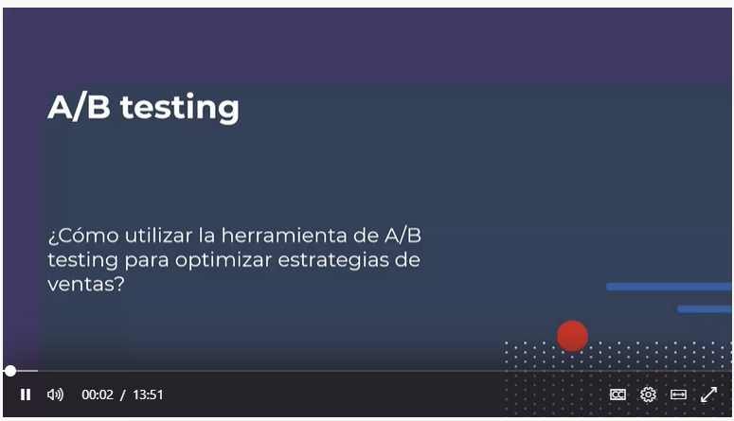

Board used in the video tutorial:
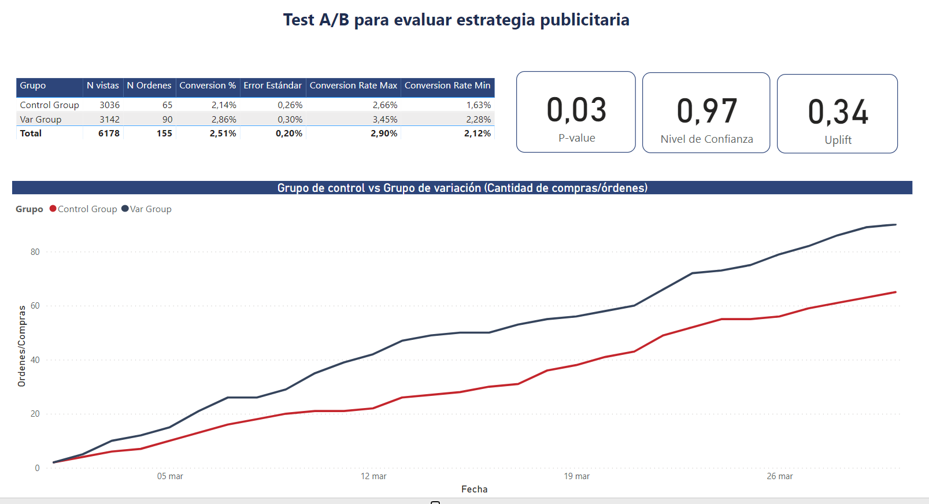

To access the dashboard:
https://app.powerbi.com/view?r=eyJrIjoiZTY5ODU5NzEtZjQ1Mi00YmNjLTgyZGYtNjU4NWM4ZmQ4MGI0IiwidCI6IjRmYWM5MTAxLWRlOWItNGI4Ny1iZDQ2LTA2OTYyNDk5MTRhYSJ9

Steps for the implementation of A / B testing in the design of products / services

Here is the code to be able to perform an A / B testing in Power BI:

Databases

In the following link you can access the databases used in the example:
https://docs.google.com/spreadsheets/d/e/2PACX-1vQQWBcYKD_aY3mqRY9nnO4yYKtp9A-PSrAIIkiUVy13JiYxlP9ueKNlgDpYkDZX0Sm8K4OmPQ3I2_aI/pub?output=xlsx

- Calculation of the number of orders (purchases)
nb Order = calculate(COUNTROWS(AB_testing),AB_testing[IsConvert]=1)

- Calculation of the number of views (visits)
Nb Views = countrows(AB_testing)

- Calculation of the conversion rate
conversion% = AVERAGE(AB_testing[IsConvert])

- Calculation of the conversion rate per group
Ctrl Group Conversion % =
CALCULATE (
[conversion%],
AB_testing[test_assignment] = "Control Group"
)

Var Group Conversion % =
CALCULATE (
[conversion%],
AB_testing[test_assignment] = "Var Group"
)

- Calculation of the standard error
std_Error = SQRT ( ( [conversion%] * ( 1 - [conversion%] ) / [Nb Views] ) )

- Calculation of the standard error for each group
Ctrl SE =
CALCULATE (
[std_Error],
AB_testing[test_assignment] = "Control Group"
)

VAR SE =
CALCULATE (
[std_Error],
AB_testing[test_assignment] = "Var Group"
)
- Calculation of the confidence interval
Conversion Rate Max =
[conversion%]
+ [std_Error] * 1.96
Conversion Rate Min =
[conversion%]
- [std_Error] * 1.96

- Calculation of the z-score
Z Score =
VAR ctrl_Conv = [Ctrl Group Conversion %]
VAR test_Conv = [Var Group Conversion %]
VAR ctrl_SE = [Ctrl SE]
VAR test_SE = [Var SE]
RETURN
( test_Conv - ctrl_Conv )
/ SQRT ( POWER ( ctrl_SE, 2 ) + POWER ( test_SE, 2 ) )

- Calculation of the uplift
Var vs Ctrl % Diff =
DIVIDE ( [Var Group Conversion %], [Ctrl Group COnversion %] ) - 1

- Calculation of the p-value and the confidence level
P-value = 1 - ABS ( NORM.DIST ( [Z Score], 0, 1, TRUE ) )
Nivel de C = 1- [P-value]

- Calculation of accumulated orders / purchases
Cumulative Orders =
CALCULATE (
[nb Order],
FILTER (
ALL (AB_testing[EventDate]),
AB_testing[EventDate]<= MAX ( AB_testing[EventDate])
)
)

Resources

Presentation about A / B testing:
https://docs.google.com/presentation/d/17aiYgngCfmaMqm69AgF5ErN2O_tkLuZzMQD8LIF-MG0/edit?usp=sharing

AB Tasty. The AB testing guide
https://www.abtasty.com/es/ab-testing/?creative=262961936353&keyword=a%2Fb%20tests&matchtype=p&network=g&device=c&gclid=CjwKCAiAu_LgBRBdEiwAkovNsGdfmOdcsWfHYxEpxZio-T5lKzdLVvt6PlZBRePE1SLOj8eGtiEz8RoCPJwQAvD_BwE

Optimizely. Otipedia – Optimization Glossary. A/B Testing:
https://www.optimizely.com/optimization-glossary/ab-testing/

Standard normal table:
https://en.wikipedia.org/wiki/Standard_normal_table

Google Optimize
https://marketingplatform.google.com/intl/es/about/optimize/

In case of A / B tests on a web page, Google has a free product called Optimize, which is part of the Marketing platform for companies. With Google Optimize, A / B tests can be designed without the need for advanced statistical knowledge as other tools do.

For example, if an organization has designed a shopping cart for its products on a website and would like to test which sales messages generate the most purchases, then it can test various messages using this tool. The main advantages of using this tool is that it allows you to configure the entire A / B test from one place and the results are generated automatically with the Google tool.

The statistical knowledge required to use the tool is minimal and is only required to analyze the results, since Google Optimize performs the calculations automatically. Also, there is no need to design and host two web pages in parallel. From the tool itself you can edit the site and Google takes care of showing the different versions randomly to the different users.

Lens 4. Equality in the value chain and advocacy practices

This lens promotes the generation of business opportunities for businesses led by women, collaboration with civil society, local or global organizations and companies that work for equality and the empowerment of women, and communication in an inclusive and non-sexist way as a transverse axis.

It is made up of the following tools:
- Guide to creating an inclusive value chain
- Inclusive and non-sexist language for companies
- Inclusive and non-sexist digital communication for companies

Tool 1. Guide to creating an inclusive value chain

This guide seeks to provide a simple guideline to mainstream the gender approach in the company's value chain. List the points to consider and invite reflection.

This is a typical value chain:

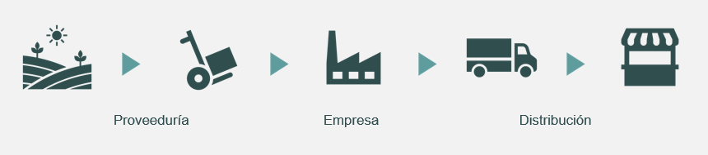

To include the gender approach, we must ask ourselves: what impact do the company's actions have on the lives of women and men who make up the organizations in my company's value chain?

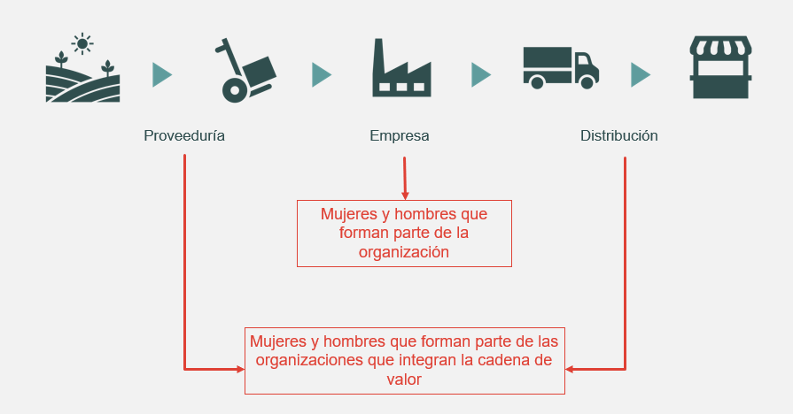

The gender approach is a look that analyzes the impact of an action or situation in the lives of women and men, which can be integrated into all internal and external processes of the company to promote equal opportunities and treatment. This analysis can be done based on two questions: how are the lives of the women and men who make up the company affected? And how are the lives of the women and men who make up the value chain organizations affected?

How are the lives of the women and men who make up the company affected?

Challenges. Regarding the first question, there are still multiple challenges to achieve equal participation in the workplace:
- There is a lower proportion of women than men in managerial positions.
- Unconscious stereotypes and biases persist about positions and responsibilities that women and men should have.
- There is difficulty in having joint responsibility between work life and personal life.
- Care permits are rarely used by men.
- The organizational culture sometimes allows workplace violence, harassment, and sexual harassment.

Actions. Some measures that organizations can implement to face these challenges and promote gender equality are:

1. Human capital management with equal opportunities and treatment
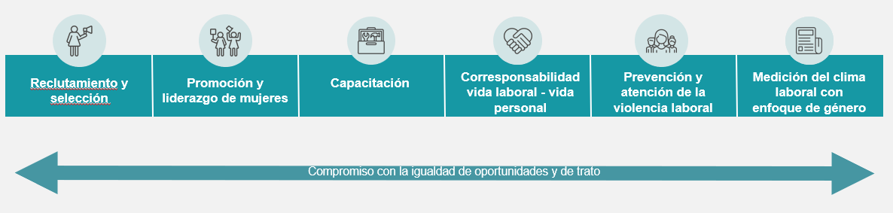

- Visit the lens tools 2. Equality in the workplace to learn about strategies related to this topic.

2. Use of sex-disaggregated information
- Understand the differentiated situation of women and men.
- Make informed decisions: plan, prioritize, monitor.
- Exploit the available data including the sex variable.
- Specify population, indicators and targets disaggregated by sex in a systematic way.

- Visit the section on data analytics of the lens 3. Products and services that benefit women and girls to learn about tools related to this topic.

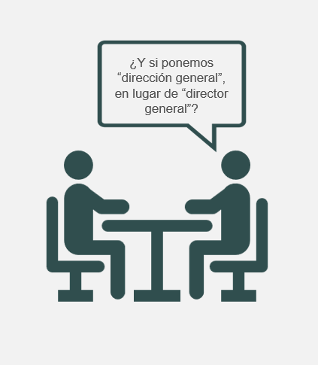
3. Inclusive communication in language and images
- Using non-sexist and inclusive language and images makes women's participation in the organization and the market visible.
- Explore the options: abstracts, articles, occupations in feminine.
- Put the word “person” before when talking about groups in situations of discrimination.
- Show the diversity of women and men without stereotypes.

- The tools on inclusive communication are in this same lens, get to know them!

How are the lives of women and men who make up the value chain organizations affected?

Challenge. Regarding the second aspect, companies led by women receive less than 1% of the amount that large companies invest in supplies and services, and they face greater challenges to join the value chains of companies due to factors such as the following:
- They are fewer, in a greater proportion of micro size and in the informal sector.
- They have less access to financing and capital.
- They face difficulties to establish solid commercial networks, they resort to informal contacts.
- Stereotypes and unconscious biases prevail about sectors and responsibilities in which women and men should work.
- They experience conflicts to make time spent in business compatible with personal life.

Actions. Some measures that organizations can implement to promote gender equality in their value chain, helping to eliminate the obstacles exposed, are:
- Carry out a gender diagnosis on supplier and distribution companies.
- Take advantage of the influence of the company to promote gender equality.
- Communicate the equality and inclusion agenda to staff, business partners and other interested parties, establishing a dialogue that guarantees support for the company's actions.
- Standardize the procedures to become a supplier or distributor company.
- Gather information on relevant criteria: company ownership, equality policies, proportion of women and men.
- Collaborate with associations of businesswomen, organizations that promote purchases with a gender perspective and companies that share the values of equality and inclusion.
- Establish special measures for companies that meet equality and inclusion criteria (led by women, with equality policies, with a high proportion of women): goals, indicators, quotas, higher scores, prequalification, detection of needs, events to establish contact .
- Support the development of women-led businesses to meet the criteria for participation.
- Give feedback to companies that do not win a bid.

Women-owned businesses
The proposed definition contains several criteria that a business must meet in order to be considered women-owned:
One or more women must unconditionally own at least 51% of the business.
One or more women should exercise control over long-term decision-making and the day-to-day management and administration of business operations.
The business must operate without relying on other businesses that are not owned by women.

Gender diagnosis on supplier and distribution companies

Among the actions mentioned is the elaboration of a gender diagnosis on supplier and distribution companies, for which it is necessary for the organization to ask itself the following questions about its value chain:
- Were any gender equality criteria used for the selection?
- Who owns the business and who makes the decisions?
- What is the value of the contracts of women's companies?
- What proportion of women and men are there at the managerial and operational level?
- Do women and men have the same access to productive resources?
- What activities do women and men do? Are there stereotypes or expectations about appropriate sectors and tasks for each other?
- Do they allow co-responsibility work life-personal life?
- Do they have equality policies between women and men?
- Is there interest in working for gender equality?
- Is there information on the ownership of the companies that are out of the tenders?

Index

In order to measure the impact of the actions, it is necessary to follow up with specific indicators. Indicators can measure quantity (quantitative) or quality (qualitative). Here are some examples taken from the UN Women guide “The Power of Procurement: How to Buy Products and Services from Women-Owned Businesses”.

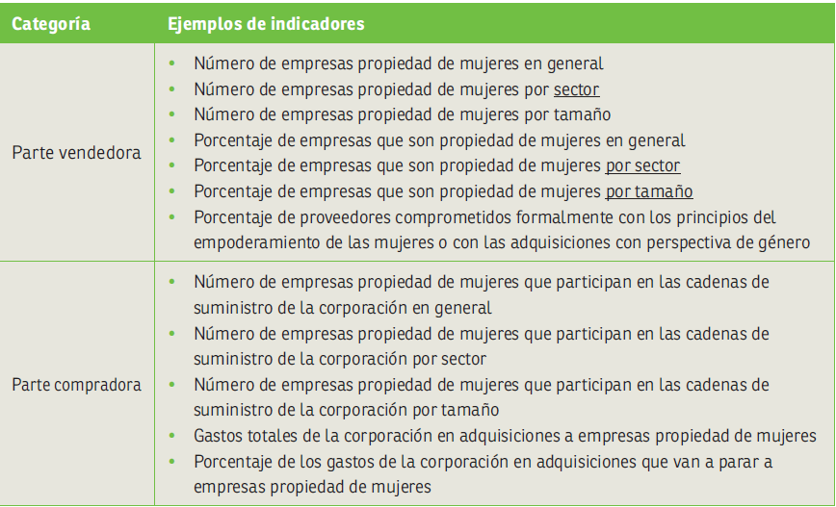

Actions for equal opportunities in the value chain:
good practices in companies
- Take advantage of the influence of the company to promote gender equality.
The 5 & 5 by ’25 initiative of the SAP company encourages companies around the world to have the same goal: 5% of the supply amount comes from social companies and 5% from companies with diversity.
https://www.sap.com/about/company/purpose/social-entrepreneurship.html#buysocial

- Collaborate with business associations and organizations that promote purchases with a gender perspective.
WeConnect International is an organization that identifies, supports and certifies women's companies to generate business opportunities with multinational corporations.
https://weconnectinternational.org/

- Establish special measures for companies that meet equality and inclusion criteria: indicators, goals, scores, tiebreaker criteria, detection of needs, training. At UN Women, in the event of a tie, preference is given to women-owned businesses and offers online training to women's businesses and purchasing professionals. The Whirlpool company and its Consulado da Mulher program support women in poverty, moving forward to become providers of the organization's cafeterias and catering for their events.

To find out more cases of companies that are carrying out these actions, go to:
- Santander
https://www.bancosantander.es/particulares/generacion-81
https://www.santander.com/es/stories/somos-una-pieza-fundamental-para-impulsar-el-papel-de-las-mujeres-en-la-sociedad
- AB InBev
https://www.fundes.org/wp-content/uploads/Informe_-El-caso-sabmiller.pdf

Check list

It is useful to prepare a checklist that makes it easier to identify the actions that already exist or are being carried out in the company, which are pending and could be carried out, as well as having the set of measures that organizations can implement to promote gender equality in its value chain.

Check list
Identify what actions already exist in the company and which ones you could take.

- I manage human capital with equal opportunities and treatment.
- I have information or data disaggregated by sex.
- I communicate inclusively with both language and images.
- I have a gender diagnosis on supplier and distribution companies.
- I take advantage of the influence of my company.
- I have indicators that allow me to monitor the impact of my actions.
- I collaborate with businesswomen associations and organizations that promote purchases with a gender perspective.
- I have established special measures for companies that meet equality and inclusion criteria.

Resources

Gender-Responsive Procurement:
https://www.weps.org/resource/gender-responsive-procurement

The Power of Procurement: How to Purchase Products and Services from Women-Owned Businesses:
https://lac.unwomen.org/es/digiteca/publicaciones/2018/12/guia-adquisiciones-con-perspectiva-de-genero-para-empresas

Strengthening Support of Women Entrepreneurs in COVID-19 Response and Recovery: Advocacy Tool:
https://www.weps.org/resource/strengthening-support-women-entrepreneurs-covid-19-response-and-recovery-advocacy-tool

Tool 2. Inclusive and non-sexist language for companies

Inclusive and non-sexist language as a booster to your company

To this day, there are ways of communicating that contribute to reinforcing prejudices and biases within companies. Using language and expressing ourselves in an inclusive and non-sexist way not only generates a positive environment, but also a better performance within the organization. When a company incorporates the practice of inclusive communication within the organization and in its external communication strategies, including marketing and sales, it generates benefits:
- Increased innovation and creativity within the company: According to a McKinsey report, teams that are diverse have up to a 35% chance of financially outperforming teams that are not.
- Increasing the diversity of the company: through the use of non-sexist and inclusive messages in job offers, a culture of inclusion of the company is reflected.
- The creation of high-quality “more precise” products and services that meet the needs of the clientele, which are not based on gender roles and stereotypes: when you have a team that reflects the diversity of the clientele, a rapprochement is achieved. more personal creating greater satisfaction from it.
- Companies that implement an inclusive marketing strategy for their products or services position themselves and are identified as promoters of gender equality.

Recommendations for inclusive communication in language

1. Avoid the use of the generic masculine and choose to use collective nouns or abstract terms
It is recommended not to use the generic male because, through this, women and their contributions are invisible and excluded. (THE EXAMPLES BELOW HAVE A BIGGER IMPACT IN THE SPANISH LANGUAGE, DUE TO THE GENDER APPLIED TO EACH WORD)

Instead of saying: Los trabajadores (the workers/the employees)
We suggest: El personal o la plantilla (the staff)
Example: Most of our staff is made up of women

Instead of saying: Los clientes (the clients)
We suggest: La clientela/ Las clientas y los clientes (the clientele)
Example: Our products seek to give the best experience to the company's clientele.

Instead of saying: Los jefes (The bosses)
We suggest: La jefatura /Quien toma las decisiones (the leaders / those who make decisions)
Example: The leadership of our company gives way to the digital transformation that we need to continue growing.

2. Doubling for inclusion
It is the use of nouns or two articles, including masculine and feminine, in order to make both women and men visible. (THE EXAMPLES BELOW HAVE A BIGGER IMPACT IN THE SPANISH LANGUAGE, DUE TO THE GENDER APPLIED TO EACH WORD)

Instead of saying: Los colaboradores (The collaborators)
We suggest: Las y los colaboradores (The collaborators)
Example: We value the work of our company's collaborators.

Instead of saying: Los expertos (The experts)
We suggest: Las y los expertos (The experts)
Example: Our design strategy is based on the recommendations of the experts.

3. Trades, professions and positions
Trades, professions and positions must match the sex or gender identity of the person. (THE EXAMPLES BELOW HAVE A BIGGER IMPACT IN THE SPANISH LANGUAGE, DUE TO THE GENDER APPLIED TO EACH WORD)

Instead of saying: La presidente (the president)
We suggest: La presidenta (the presidente)
Example: The president of the organization congratulates the staff for their high performance.

Instead of saying: La abogado (The lawyer)
We suggest: La abogada (The lawyer)
Example: The lawyer in charge of the case should be consulted.

4. People in a situation of discrimination
We must avoid expressions that can marginalize and feed prejudices. It is important to adopt criteria in accordance with international human rights instruments and to attend to the consensus reached by the people of each group and, above all, to listen and consider how each person wants to be named.

Instead of saying: Los discapacitados (The disabled)
We suggest: People with disabilities

Instead of saying: Transgéneros (“The transgenders”, by its informal interpretation to English)
We suggest: Transgender people / LGBTIQA+ community

It is not necessary to refer to a person as a transgender woman or man, unless the context requires it or the person does so.

The power of visual communication

Visual communication is an important element as it reflects the image of the company, its culture and its values. When developing advertising, and the marketing strategy of products and services, it is important to implement a fair, dignified, inclusive, balanced and non-sexist representation.

Recommendations for inclusive communication in images

1. The use of images that break with stereotypes and gender roles
2. Balanced representation of all people
3. Representation of diversity of women and people

Surely you have heard these terms, here we tell you what they mean:

Victim-blaming
It happens when a person who is the victim of a harmful or abusive act is found guilty for what has happened to him. In other words, it is when it is questioned or suggested that the victim could have done something to prevent what happened. This type of behavior has caused many people not to report some type of abuse. In the case of sexual abuse, it is important to be clear that no woman is guilty of the violence that the man has committed against her.

Mansplaining
It happens when a man gives an explanation to a woman on some subject in a condescending way, without taking into account that she knows more about the subject and that he does not know or knows very little about the subject.

Manterrupting
It happens when a man constantly and unnecessarily interrupts a woman when she is speaking or giving a speech.

Yes means yes
This in relation to explicit consent in sexual relations, but also in any interaction between two or more people, especially when there are very marked power dynamics.

Internalized sexism
It happens when there is involuntary appropriation of beliefs that feed stereotypes and biases against women, for example, believing that women are inferior to men.

Resources

Inclusive and non-sexist communication in companies (Women's Institute):
https://www.igualdadenlaempresa.es/actualidad/boletin/docs/BIE_54_Comunicacion_incluyente_no_sexista_empresas.pdf

Non-sexist and inclusive language manual (Oxfam Mexico):
https://bit.ly/LenguajeOxfamMexico

Guide for a more inclusive communication. How to develop messages with a gender perspective (Prodigioso Volcán / Fundación del Español Urgente):
https://www.prodigiosovolcan.com/wp-content/uploads/2019/06/Guia_comunicacion_inclusiva.pdf

Inclusive communication guide (Barcelona City Council):
https://ajuntament.barcelona.cat/guia-comunicacio-inclusiva/es/

Recommendations for the inclusive and non-sexist use of language (National Council to Prevent Discrimination / National Commission to Prevent and Eradicate Violence against Women / National Institute of Women):
https://www.conapred.org.mx/documentos_cedoc/GuiaBasica-Uso_Lenguaje_Ax.pdf

Non-sexist communication manual. Towards an inclusive language (National Institute of Women):
http://cedoc.inmujeres.gob.mx/documentos_download/101265.pdf

Tool 3. Inclusive and non-sexist digital communication for companies

For companies, it is imperative to have a digital external communication strategy with a gender perspective, in order to position the brand, strengthen the identity of the company and thus create a sustainable relationship with clients. It is essential to always incorporate this approach when developing content and participating in digital spaces since it generates:
- An identity and image of the organization that reflects inclusion, attracting more customers.
- More precise, high-quality products and services that meet customer needs, which are not based on gender roles and stereotypes: when you have a team that reflects this diversity of customers, a more personal approach is achieved creating greater satisfaction by this.
- Diversity of the company: through the use of non-sexist and inclusive messages in job offers, a culture of inclusion is reflected.

To put inclusive digital communication into practice, it is necessary to:
- Evaluate the current content and structure of your website.
- Evaluate the digital strategy of your social networks.

Tips to implement inclusive digital communication

Web page
- Have an inclusive design that appeals to a diverse group of people.
- Avoid androcentric vision when designing logos or icons.
- Add links and resources related to the issue of inclusion and gender in order to express the company's interest in addressing these issues.

Social Media
- It is important that the company is vocal in its commitment to advance gender equality inside and outside the organization.
- Represent all people in a balanced way both in images and in the messages published on the platforms.

Contents (videos, articles, audios)
- Use different voices in the video or audio locution.
- Invite different experts when writing blogs or articles.
- Use diverse resources in order to bring different voices.

Resources

Non-sexist and inclusive language manual (Oxfam Mexico):
https://bit.ly/LenguajeOxfamMexico

Guide for a more inclusive communication. How to develop messages with a gender perspective (Prodigioso Volcán/Fundación del Español Urgente):
https://www.prodigiosovolcan.com/wp-content/uploads/2019/06/Guia_comunicacion_inclusiva.pdf

Inclusive communication guide (Barcelona City Council):
https://ajuntament.barcelona.cat/guia-comunicacio-inclusiva/es/

Recommendations for the inclusive and non-sexist use of language (National Council to Prevent Discrimination / National Commission to Prevent and Eradicate Violence against Women / National Institute of Women):
https://www.conapred.org.mx/documentos_cedoc/GuiaBasica-Uso_Lenguaje_Ax.pdf

Non-sexist communication manual. Towards an inclusive language (National Institute of Women):
http://cedoc.inmujeres.gob.mx/documentos_download/101265.pdf

Pro Mujer (2020). GLI LatAm Forum: Gender Lens Investing Forum. Available at: https://promujer.org/content/uploads/2020/03/GLI_CONCLUSIONS_FINAL.pdf
Banco Interamericano de Desarrollo [BID] (2019). El futuro del trabajo en América Latina y el Caribe. ¿Cómo será el mercado laboral para las mujeres? Available at: https://publications.iadb.org/es/el-futuro-del-trabajo-en-america-latina-y-el-caribe-como-sera-el-mercado-laboral-para-las-mujeres
Pro Mujer (2020). Pro Mujer hosts the first gender-lens investing forum in Latin America. Available at: https://promujer.org/2020/01/28/pro-mujer-celebra-30-anos-y-lleva-cabo-el-primer-gsi-forum-latam-foro-de-inversion-inteligente-con-enfoque-de-genero/
Pro Mujer (2020). What is gender lens investing and how does it impact women-led businesses? Available at: https://promujer.org/2020/04/14/gender-lens-investing-impact-women-led-businesses/
Value for Women (2019). Panorama de la inversión de impacto con enfoque de género en América Latina. Available at: https://v4w.org/wp-content/uploads/2019/09/Panorama-de-la-Inversion-de-Impacto-con-Enfoque-de-Genero-AL.pdf BID Invest y ESADE (2019). Inversión con un enfoque de género: Cómo las finanzas pueden acelerar la igualdad de género para América Latina y el Caribe Available at: https://idbinvest.org/es/publications/reporte-inversion-con-lentes-de-genero-como-las-finanzas-pueden-acelerar-la-igualdad
UN Women (2017). El poder de las adquisiciones: Cómo adquirir productos y servicios de empresas que son propiedad de mujeres. Available at: https://lac.unwomen.org/es/digiteca/publicaciones/2018/12/guia-adquisiciones-con-perspectiva-de-genero-para-empresas
Value for Women (2019). Panorama de la inversión de impacto con enfoque de género en América Latina. Available at: https://v4w.org/wp-content/uploads/2019/09/Panorama-de-la-Inversion-de-Impacto-con-Enfoque-de-Genero-AL.pdf
World Economic Forum (2019). Global Gender Gap Report 2020. Available at: http://www3.weforum.org/docs/WEF_GGGR_2020.pdf
Comisión Económica para América Latina y el Caribe [CEPAL] (2019). Cepalstat. Estadísticas e indicadores. Available at: https://estadisticas.cepal.org/cepalstat/WEB_CEPALSTAT/estadisticasIndicadores.asp
CEPAL y International Labor Organization [OIT] (2019). Coyuntura Laboral en América Latina y el Caribe: Evolución y perspectivas de la participación laboral femenina en América Latina. Available at: https://www.cepal.org/es/publicaciones/44916-coyuntura-laboral-america-latina-caribe-evolucion-perspectivas-la-participacion
ILO (2019). Panorama Laboral Temático 5: Mujeres en el mundo del trabajo. Retos pendientes hacia una efectiva equidad en América Latina y el Caribe. Available at: https://www.ilo.org/americas/publicaciones/WCMS_715183/lang--es/index.htm
BID (2019). El futuro del trabajo en América Latina y el Caribe. ¿Cómo será el mercado laboral para las mujeres? Available at: https://publications.iadb.org/es/el-futuro-del-trabajo-en-america-latina-y-el-caribe-como-sera-el-mercado-laboral-para-las-mujeres
Observatorio Estratégico de la Alianza del Pacífico (2018). Mujeres del Pacífico. Primer Informe Programas de Apoyo al Emprendimiento Femenino en la Alianza del Pacífico. Available at: https://home.mujeresdelpacifico.org/uploads/library/5b96f4d0a1270_1er-Informe-MdP-ASELA-OAP.pdf
BID (2019). El futuro del trabajo en América Latina y el Caribe. ¿Cómo será el mercado laboral para las mujeres? Available at: https://publications.iadb.org/es/el-futuro-del-trabajo-en-america-latina-y-el-caribe-como-sera-el-mercado-laboral-para-las-mujeres.
UN Women (2016). Trabajo doméstico y de cuidados no remunerado. Available at: https://mexico.unwomen.org/es/digiteca/publicaciones/2016/01/trabajo-domestico
Deloitte (2019). Women in the boardroom. A global perspective. Available at: https://www2.deloitte.com/global/en/pages/risk/articles/women-in-the-boardroom-global-perspective.html
BID (2019). El futuro del trabajo en América Latina y el Caribe. ¿Cómo será el mercado laboral para las mujeres? Available at: https://publications.iadb.org/es/el-futuro-del-trabajo-en-america-latina-y-el-caribe-como-sera-el-mercado-laboral-para-las-mujeres
ILO (2019). Las mujeres en la gestión empresarial. Argumentos para un cambio. Available at: www.ilo.org/global/publications/books/WCMS_700977/lang--es/index.htm
Own Calculations base don the World Bank (2021). Database from Women, Business and the Law 2021. Available at: https://wbl.worldbank.org/en/data/exploretopics/wbl_sj
Instituto Nacional de las Mujeres (2016). Sistema de Indicadores de Género. Temas: Violencia. Available at: http://estadistica.inmujeres.gob.mx/
Observatorio Contra el Acoso Chile (2020). Radiografía del acoso sexual en Chile. Available at: https://www.ocac.cl/wp-content/uploads/2020/07/Informe-encuesta-OCAC-2020.-Radiograf%C3%ADa-del-acoso-sexual-en-Chile.pdf
Impacto económico del acoso por razón de sexo en el lugar de trabajo en América Latina. Available at: http://ganarganar.lim.ilo.org/en/america-latina-y-el-caribe/
Cerda Cristerna, A. (2018). Reconocimiento del trabajo doméstico y de cuidados. Available at: https://issuu.com/todas_milenio/docs/todas_jul2018
Novta, N y Wong, J. (2017). Women at Work in Latin America and the Caribbean. Available at: https://www.imf.org/en/Publications/WP/Issues/2017/02/14/Women-at-Work-in-Latin-America-and-the-Caribbean-44662
GSMA (2020). The Mobile Gender Gap Report 2020. Available at: https://www.gsma.com/r/gender-gap/
Vázquez, E. A. y Sherman, A. J. (2013). Buying for Impact: How to Buy from Women and Change Our World. Advantage Media Group, en UN Women (2017). El poder de las adquisiciones: Cómo adquirir productos y servicios de empresas que son propiedad de mujeres. Available at: https://lac.unwomen.org/es/digiteca/publicaciones/2018/12/guia-adquisiciones-con-perspectiva-de-genero-para-empresas
CEPAL (2021). La autonomía económica de las mujeres en la recuperación sostenible y con igualdad. Available at: https://www.cepal.org/es/publicaciones/46633-la-autonomia-economica-mujeres-la-recuperacion-sostenible-igualdad
WeConnect International (2020). Encuesta global de WeConnect International sobre el impacto de COVID-19 en las empresas de mujeres. Available at: https://weconnectinternational.org/encuesta-global-de-weconnect-international-sobre-el-impacto-de-covid-19-en-las-empresas-de-mujeres/
McKinsey & Company y Lean In (2020). Women in the Workplace. Available at: https://wiw-report.s3.amazonaws.com/Women_in_the_Workplace_2020.pdf
Comisión Interamericana de Mujeres [CIM] y EUROsociAL (2021). COVID-19 en la vida de las mujeres: Los cuidados como inversión. Available at: http://www.oas.org/es/cim/docs/CuidadosCOVID19-ES-Corto.pdf
McKinsey (2020). COVID-19 and gender equality: Countering the regressive effects. Available at: https://www.mckinsey.com/featured-insights/future-of-work/covid-19-and-gender-equality-countering-the-regressive-effects
UN Women (2020). COVID-19 en América Latina y el Caribe: Cómo incorporar a las mujeres y la igualdad de género en la gestión de la respuesta a la crisis. Available at: https://lac.unwomen.org/es/digiteca/publicaciones/2020/03/covid-como-incorporar-a-las-mujeres-y-la-igualdad-de-genero-en-la-gestion-de-respuesta
UN Women(2020). COVID-19: Respuesta con igualdad de género en el ámbito laboral. Available at: https://mexico.unwomen.org/es/digiteca/publicaciones/2020-nuevo/covid19-respuesta-igualdad-de-genero-en-ambito-profesional
Comisión Económica para América Latina y el Caribe (2021). La autonomía económica de las mujeres en la recuperación sostenible y con igualdad. Available at: https://www.cepal.org/es/publicaciones/46633-la-autonomia-economica-mujeres-la-recuperacion-sostenible-igualdad
Organización para la Cooperación y el Desarrollo Económicos (2020). Women at the core of the fight against COVID-19 crisis. Available at: https://read.oecd-ilibrary.org/view/?ref=127_127000-awfnqj80me&title=Women-at-the-core-of-the-fight-against-COVID-19-crisis
CIM y EUROsociAL (2021). COVID-19 en la vida de las mujeres: Los cuidados como inversión. Available at: http://www.oas.org/es/cim/docs/CuidadosCOVID19-ES-Corto.pdf
CARE y ONU-Mujeres (2020). Análisis Rápido de Género para la Emergencia de la COVID-19 en ALC. Available at: https://lac.unwomen.org/es/noticias-y-eventos/articulos/2020/06/analisis-rapido-de-genero-care-onu-mujeres
Ostry, J. D., Alvarez, J., Espinoza, R. y Papageorgiou, C. (2018). Economic Gains from Gender Inclusion: New Mechanisms, New Evidence. Available at: https://www.imf.org/~/media/Files/Publications/SDN/2018/SDN1806.ashx
Bustelo, M, Flabbi, L., Piras, C. y Tejada, M. (2019). Female Labor Force Participation, Labor Market Dynamic, and Growth. Available at: https://publications.iadb.org/en/female-labor-force-participation-labor-market-dynamic-and-growth-lac-0
Instituto Mexicano para la Competitividad (2021). ¿Cuáles son los beneficios económicos de sumar a más trabajadoras? Available at: https://imco.org.mx/cuales-son-los-beneficios-economicos-de-sumar-a-mas-trabajadoras/
ILO (2019). Las mujeres en la gestión empresarial. Argumentos para un cambio. Available at: www.ilo.org/global/publications/books/WCMS_700977/lang--es/index.htm
Value for Women (2019). Panorama de la inversión de impacto con enfoque de género en América Latina. Available at: https://v4w.org/wp-content/uploads/2019/09/Panorama-de-la-Inversion-de-Impacto-con-Enfoque-de-Genero-AL.pdf
Pro Mujer (2020). A gender lens investing scorecard helps investors and companies advance gender equality. Available at: https://promujer.org/2020/08/26/gender-lens-investing-scorecard-helps-investors-companies-advance-gender-equality/
Worldwide organization with more than 3,500 members that make up around 8,500 boards of directors. It has 72 branches around the world, including in Brazil, Chile, Colombia, Guatemala, Mexico, Panama, Peru, and Uruguay.
International Labor Organization (2017). La mujer en la gestión empresarial: Cobrando impulso en América Latina y el Caribe. Available at: https://www.ilo.org/public/spanish/dialogue/actemp/downloads/events/2017/lima_conf/wibm_fullreport_2017_sp.pdf
The measures currently taken by the different regulatory bodies are generally classified into the following approaches: (i) by imposing quotas on the board of directors; and (ii) improving information through the "comply or explain" approach.
Bloomberg Gender-Equality Index (2021). Invest in a more equal future. Available at: https://assets.bbhub.io/company/sites/46/2021/01/992304_GEI_Booklet_FNL.pdf
In 2015, the 193 member states of the United Nations approved the 2030 Agenda for Sustainable Development, as a roadmap towards a new development paradigm in which people, the planet, prosperity, peace and partnerships have a role. primordial. The 2030 Agenda's motto is “leave no one behind” and seeks to fulfill this purpose through 17 Sustainable Development Goals, which put people at the center, have a rights-based approach and propose global sustainable development based on three pillars: economic, social and environmental. More information at:: https://www.cepal.org/es/temas/agenda-2030-desarrollo-sostenible
In this context, new business models have emerged that, from their very business model, promote inclusion and equality through the development of the workforce or the development of an inclusive value chain. These are new organizational models that combine purpose with profit: purpose-driven companies, triple impact companies, hybrid companies.
International Labor Organization (2020). Empoderar a las mujeres en el trabajo. Políticas y prácticas empresariales para la igualdad de género. Available at: https://www.weps.org/sites/default/files/2020-10/Empowering%20Women%20at%20Work-2020%20Report.pdf
International Labor Organization and UN Women (2020). Empoderar a las mujeres en el trabajo. Políticas y prácticas empresariales para la igualdad de género. Available at: https://www.ilo.org/global/meetings-and-events/events/WCMS_756718/lang--en/index.htm
United Nations. (2015). Resolución aprobada por la Asamblea General el 25 de septiembre de 2015 Nro. 70/1: Transformar nuestro mundo: la Agenda 2030 para el Desarrollo Sostenible. Available at: https://undocs.org/es/A/RES/70/1
Naciones Unidas. (2015). Resolución aprobada por la Asamblea General el 25 de septiembre de 2015 Nro. 70/1: Transformar nuestro mundo: la Agenda 2030 para el Desarrollo Sostenible. Available at: https://undocs.org/es/A/RES/70/1
UN Women. International Labor Organization (ILO). (2020). El poder de trabajar juntos. Prácticas emergentes que promueven el empoderamiento económico de las mujeres. Available at: https://www.weps.org/sites/default/files/2020-12/THE_POWER_OF_WORKING_TOGETHER_FINAL_0.pdf
Red de mujeres (2019). Sellos de Igualdad de Género. Available at: https://redmujeresjusticia.org.ar/wp-content/uploads/2019/03/documentos-interes-varias-sellos-igualdad-genero.pdf. This seal is being implemented in 11 countries in Latin America and the Caribbean, and in more than 15 in Africa, Asia and the Pacific, Eastern Europe and the Middle East.
International Labor Organization (2017). Gender diversity journey: company good practices. Available at: https://drive.google.com/file/d/1SaOq8JYsErfUMHAz1BezP2T7RosYPEIE/view?usp=sharing
Información a 2018. El Reporte 2019/2020 está próximo a salir publicado.
Information gathered in July 2020.
The term agile will be used in the text as “agile” since the concept in English has a greater diffusion and its meaning includes the key elements of culture, mentality and work practices. While the term used in Spanish is often confused with the adjective of agility or speed.
In the Scrum framework, the artifact that encapsulates this information is called the product backlog.
The Kanban board is an artifact used by the team and project leader in agile frameworks, to make work flow visible, monitor progress, identify priorities, blockages and resolve them in a timely manner in each work cycle.
Sprint is the term used in agile, particularly in the Scrum framework, to refer to short work cycles that are a minimum of 1 week and a maximum of 4 weeks.
Lean In y McKinsey & Company (2016). Women in the Workplace. Available at: https://wiw-report.s3.amazonaws.com/Women_in_the_Workplace_2016.pdf Lean In y McKinsey & Company (2019). Women in the Workplace. Available at: https://wiw-report.s3.amazonaws.com/Women_in_the_Workplace_2019.pdf Tulshyan, R. y Burey, J. (2021). Stop Telling Women They Have Imposter Syndrome. Available at: https://hbr.org/2021/02/stop-telling-women-they-have-imposter-syndrome
These meeting names are Anglicisms of the Scrum framework. Remember that it is recommended to have a basic knowledge of agile methodologies to get the most out of this tool. You can review these concepts at the following suggested links: https://www2.deloitte.com/es/es/pages/technology/articles/ceremonias-scrum.html https://www.scrum.org/resources/what-is-scrum https://scrumcolombia.org/actualizacion-de-la-guia-scrum-2020
B Team (2020). Gender Balance and Inclusive Cultures, a Guide for CEOs. Available at: https://www.bteam.org/assets/reports/The-B-Team-CEO-Guide-on-Gender-Balance-and-Inclusive-Cultures.pdf.
Corporate Women Directors International (2015). Report: Women Board Directors of 100 Largest Latin American Companies. Available at: https://globewomen.org/globalsummit/wp-content/uploads/2015/05/2015-CWDI-Latin-America-Key-Findings.pdf
Atlantic Council (2017). Women’s Leadership in Latin America. The Key to Growth and Sustainable Development. Available at: https://publications.atlanticcouncil.org/womens-leadership/AC_Women.pdf
Korn Ferry (2021). 4 Steps to Building an Inclusive Organization. Available at: https://focus.kornferry.com/leadership-and-talent/from-talk-to-action-four-steps-to-an-inclusive-organisation-for-all/
Instituto Ethos/BID (2015). Perfil social, racial y de género de las 500 empresas más grandes de Brasil y sus acciones afirmativas. Available at: https://publications.iadb.org/publications/spanish/document/Perfil-social-racial-y-de-g%C3%A9nero-de-las-500-empresas-m%C3%A1s-grandes-de-Brasil-y-sus-acciones-afirmativas.pdf
World Economic Forum (2020). Mind the 100 Year Gap. Available at: https://www.weforum.org/reports/gender-gap-2020-report-100-years-pay-equality
OCDE (2020). Policies and Practices to Promote Women in Leadership Roles in the Private Sector. Available at: https://valored.it/wp-content/uploads/2021/02/OECD-G20-EMPOWER-Women-Leadership.pdf
Deloitte (2018). The Diversity and Inclusion Revolution. https://www2.deloitte.com/content/dam/insights/us/articles/4209_Diversity-and-inclusion-revolution/DI_Diversity-and-inclusion-revolution.pdf
Deloitte (2018). The Diversity and Inclusion Revolution. https://www2.deloitte.com/content/dam/insights/us/articles/4209_Diversity-and-inclusion-revolution/DI_Diversity-and-inclusion-revolution.pdf
OECD (2017). Gender Balance Guide. Available at: https://www.oecd.org/gov/gender-balance-guide-uae-2017.pdf
AWID (2004) Interseccionalidad: una herramienta para la justicia de género y la justicia económica. Available at: https://www.awid.org/sites/default/files/atoms/files/nterseccionalidad_una_herramienta_para_la_justicia_de_genero_y_la_justicia_economica.pdf
ILO (2011). Multiple Discrimination in the World of Work. Available at: http://ilo.ch/wcmsp5/groups/public/---ed_norm/---declaration/documents/publication/wcms_170015.pdf
People analytics es usar el análisis de datos para la gestión de recursos humanos.
Forbes (2021). Solo 2% de las empresas de Norteamérica apuesta por liderazgo inclusivo. Available at: https://www.forbes.com.mx/women-empresas-norteamerica-liderazgo-inclusivo/
Korn Ferry (2021). Moving from talk to action, 4 steps to building an inclusive organization for all. Available at: https://focus.kornferry.com/leadership-and-talent/from-talk-to-action-four-steps-to-an-inclusive-organisation-for-all/
Fast Company (2016). These Companies Run Mentorship Programs That Actually Work https://www.fastcompany.com/3064292/these-companies-run-mentorship-programs-that-actually-work
Parental leave corresponds to the individual right of workers, men or women, to be absent from work due to the birth or adoption of a daughter or son. Diccionario Jurídico y Social (2021). Available at https://diccionario.leyderecho.org/permiso-parental/
Cerda Cristerna, A. (2018). Reconocimiento del trabajo doméstico y de cuidados. Available at: https://issuu.com/todas_milenio/docs/todas_jul2018
Ripani, L. Coronavirus: Un experimento de teletrabajo a escala mundial. Available at: https://blogs.iadb.org/trabajo/es/coronavirus-un-experimento-de-teletrabajo-a-escala-mundial/
Secretaría de Economía (2015). Norma Mexicana NMX-R-025-SCFI-2015 en Igualdad Laboral y No Discriminación. Available at: https://www.gob.mx/inmujeres/documentos/norma-mexicananmx-r025-scfi-2015-en-igualdad-laboral-y-no-discriminacion
BID (2019). El futuro del trabajo en América Latina y el Caribe. ¿Cómo será el mercado laboral para las mujeres? Available at: https://publications.iadb.org/es/el-futuro-del-trabajo-en-america-latina-y-el-caribe-como-sera-el-mercado-laboral-para-las-mujeres.
Kübler-Ross, E. (2013). La rueda de la vida. País: Vergara
Zeus, P., & Skiffington, S. (2004). "Coaching" práctico: guía completa de técnicas y herramientas. McGraw-Hill, Interamericana de España.
Psicología y Mente, Rueda de la vida: qué es y cómo se usa para detectar necesidades. Available at: https://psicologiaymente.com/psicologia/rueda-de-vida
Instituto Nacional de las Mujeres (2010). Desarrollo económico con perspectiva de género. buenas prácticas en la administración pública federal. Available at: http://cedoc.inmujeres.gob.mx/documentos_download/101182.pdf
Stacked bar chart description: https://datavizcatalogue.com/ES/metodos/grafico_de_barras_apiladas.html
In statistics, the sex variable takes the categories: female / male.
MJV Press. (2014). Design Thinking: Innovación en negocios. MJV Press.
Deloitte (2018). The Diversity and Inclusion Revolution. Available at: https://www2.deloitte.com/content/dam/insights/us/articles/4209_Diversity-and-inclusion-revolution/DI_Diversity-and-inclusion-revolution.pdf
Mulholland, S. (2017). Designing the Siris and Alexas of the World. Available at: https://www.ideo.com/blog/designing-the-siris-and-alexas-of-the-world
Simonet, G. (2013). Design thinking como estrategia. El caso IDEO. Available at: https://www.academia.edu/4969244/Design_Thinking_como_estrategia_El_caso_IDEO
Swire, B. (2020, enero). How a Kid’s Perspective Improves Design Research. ideo.com. Available at: https://www.ideo.com/blog/how-a-kids-perspective-improves-design-research
Barry, M., Fletcher, A., & Gonzales Dharap, C. (2014, 22 enero). Methods: Interviewing. Needfinding. Available at: http://me277-w2014.weebly.com/lectures-and-content/methods-interviewer
Institute of Design at Stanford. (2007). Need Finding Tools. Available at: https://hci.stanford.edu/courses/cs447/docs/NeedFindingCribSheet.pdf
Marquardt, M. J. (2014). Leading with Questions: How Leaders Find the Right Solutions by Knowing What to Ask. Jossey-Bass.
Thinkers Co. (2018). Entrevista cualitativa [Gráfico]. Available at: https://thinkersco.com/wp-content/uploads/2020/07/entrevista-cualitativa-plantilla-1024x724.jpg
Whitely, N., (1993), en Zarza, M., Serrano, H., & Serrano, C. (2013). Los diseños reflexivos ante los nuevos enfoques y retos: violencia simbólica, género y responsabilidad social. Available at: http://www.revista.unam.mx/vol.14/num8/art23/art23.pdf
Gibbons, S. G. (2018). Empathy Mapping: The First Step in Design Thinking. Nielsen Norman Group. Available at: https://www.nngroup.com/articles/empathy-mapping/
Schroeder, K. (2010). Gender Dimensions of Product Design. Available at: https://www.un.org/womenwatch/daw/egm/gst_2010/Schroeder-EP.13-EGM-ST.pdf
IDEO (2019). How Might We. Designkit. Available at: https://www.designkit.org/methods/3
Krause, R. (2018). Storyboards Help Visualize UX Ideas. Available at: https://www.nngroup.com/articles/storyboards-visualize-ideas/
Buddy Match. (s. f.). [Ilustration]. Available at: https://uploads-ssl.webflow.com/5f7269552ce4bcd68d05c90c/5f98d85077e9865faa378adf_Storyboards.jpg
Krause, R. (2018). Handwritten Steps [Ilustración]. Available at: https://media.nngroup.com/media/editor/2018/06/20/handwritten-steps.png
Lurchenko, A. (2016, 19 abril). Storytelling and Storyboarding in UX Design [Ilustración]. Available at: https://uxdesign.cc/. https://uxdesign.cc/6-steps-storyboard-for-ux-design-cb0999c1c45d#.lkaaqo9ch
Buddy Match. (s. f.). [Ilustration]. Available at: https://uploads-ssl.webflow.com/5f7269552ce4bcd68d05c90c/5f98d85077e9865faa378adf_Storyboards.jpg
Walsh, S. (2014). What is Creativity? Available at: https://creativity101.com
Kim, T., John, L., Barasz, K., & Norton, M. I. (2019, marzo). Calculators for Women: When Identity Appeals Provoke Backlash. Available at: https://hbswk.hbs.edu/item/calculators-for-women-when-identity-appeals-provoke-backlash?fbclid=IwAR17Q5i6MVWY1HzROzWKFG_hG2tXzwusdDyvczaaIHfWYe8vWaabbGvEEk0
MULHOLLAND, S. E. A. N. (2017, diciembre). Designing the Siris and Alexas of the World. ideo.com. https://www.ideo.com/blog/designing-the-siris-and-alexas-of-the-world
Design method toolkit (2018). People Planet Profit. Available at: https://toolkits.dss.cloud/design/method-card/people-planet-profit/
Design method toolkit (2016). MoSCoW. Design Method Toolkit. Available at: https://toolkits.dss.cloud/design/method-card/moscow/ René Morency (2019). The power of the MoSCoW method. Available at: https://www.browserlondon.com/blog/2019/11/04/power-of-moscow-method/
Mats Nyman (2017). What is the MoSCoW Method? Available at: https://www.youtube.com/watch?v=WitQtcSXFlE
Udacity (2016). Creating a paper prototype Available at: https://www.youtube.com/watch?v=8mo3A6hUJSc Interaction Design Foundation.Paper Prototyping Available at: https://www.interaction-design.org/literature/topics/paper-prototyping Quirky (2014). How to make a cardboard prototype Available at: https://www.youtube.com/watch?v=k_9Q-KDSb9o
BlueDuckLabs (2010) Example Usability Test with a Paper Prototype Available at: https://www.youtube.com/watch?v=9wQkLthhHKA
JUSTIN MIFSUD (2015) Usability Metrics – A Guide To Quantify The Usability Of Any System. Available at: https://usabilitygeek.com/usability-metrics-a-guide-to-quantify-system-usability/
Udacity (2016). Creating a paper prototype Available at: https://www.youtube.com/watch?v=8mo3A6hUJSc Interaction Design Foundation.Paper Prototyping Available at: https://www.interaction-design.org/literature/topics/paper-prototyping Quirky (2014). How to make a cardboard prototype Available at: https://www.youtube.com/watch?v=k_9Q-KDSb9o
Kay, K., & Shipman, C. (2015, 27 agosto). The Confidence Gap. The Atlantic. Available at: https://www.theatlantic.com/magazine/archive/2014/05/the-confidence-gap/359815/
McKinsey & Company. (2019). Women in the Workplace 2019. Available at: https://womenintheworkplace.com/
Chief Executive Officer, the highest executive rank in a company.
In statistics, the sex variable takes the categories: female/male.
Power BI permite la generación de clústeres a partir del algoritmo K-medias, que es un tipo de clustering no supervisado. Para conocer sobre el algoritmo ver: https://es.wikipedia.org/wiki/K-medias
In statistics, the sex variable takes the categories: female/male.
At a minimum, the variables sex and age should be included. However, to carry out an analysis that makes gender gaps visible, it is necessary to have more explanatory variables. For example, other sociodemographic variables such as place of birth, nationality, spoken language, level of education, among others can be registered. If none of these variables can explain the existing gaps, other variables should be explored and collected.
UN Women (2018). El poder de las adquisiciones: Cómo adquirir productos y servicios de empresas que son propiedad de mujeres. Available at: https://lac.unwomen.org/es/digiteca/publicaciones/2018/12/guia-adquisiciones-con-perspectiva-de-genero-para-empresas
Food and Agriculture Organization of the United Nations (2020). Desarrollo de cadenas de valor sensibles al género. Directrices para profesionales. Available at: www.fao.org/3/i9212es/I9212ES.pdf UN Women (2020). Gender-Responsive Procurement. Available at: www.weps.org/resource/gender-responsive-procurement
UN Women (2018). El poder de las adquisiciones: Cómo adquirir productos y servicios de empresas que son propiedad de mujeres. Available at: lac.unwomen.org/es/digiteca/publicaciones/2018/12/guia-adquisiciones-con-perspectiva-de-genero-para-empresas
McKinsey & Company (2015). Why Diversity Matters. Available at: https://www.mckinsey.com/business-functions/organization/our-insights/why-diversity-matters
Dastagir, A. E. (2017). A feminist glossary because we didn't all major in gender studies. Available at: https://www.usatoday.com/story/news/2017/03/16/feminism-glossary-lexicon-language/99120600/

